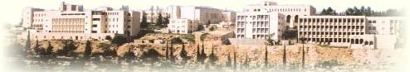[Birzeit University logo](http://www.birzeit.edu/)  
  
  
  
  
  
  
  
  
  
  
  
  
  
  
  
Faculty of Engineering and Technology   
Electrical and computer Engineering Department  
  
Engineering Simulation Laboratory  
 ENEE 4104  
  
Report about   
 Assignment.2

Controlling speed of DC-motor using mikro-c and protues programs

Instructors :  
 Dr. Jamal Syam.  
 Eng. Ibrahim Sawalhi.  
   
 Prepared by:   
 Iman Adnan Abu Ayyash ID#:1111568   
   
  
 Date :30 /10/2014 Section #1

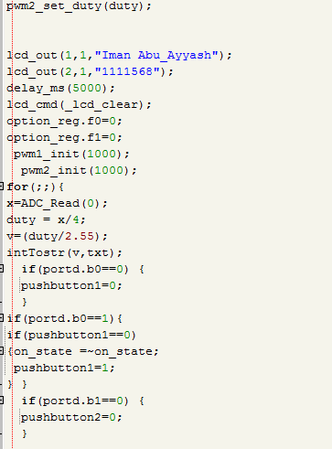Code :   
  
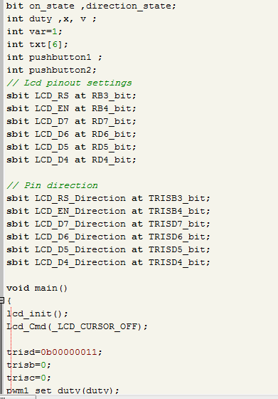

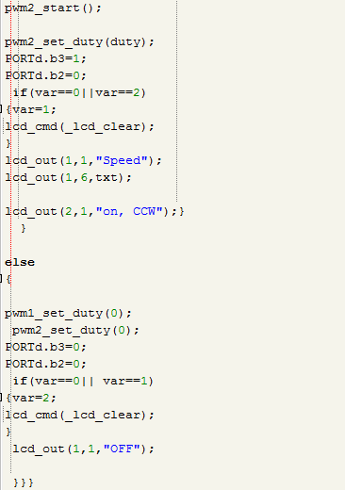  
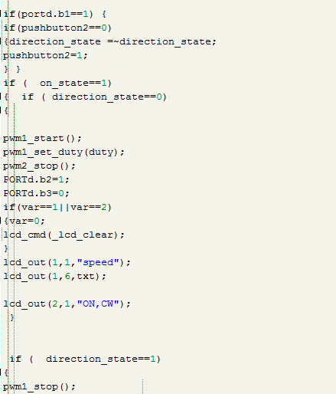

Results:  
