Q1:

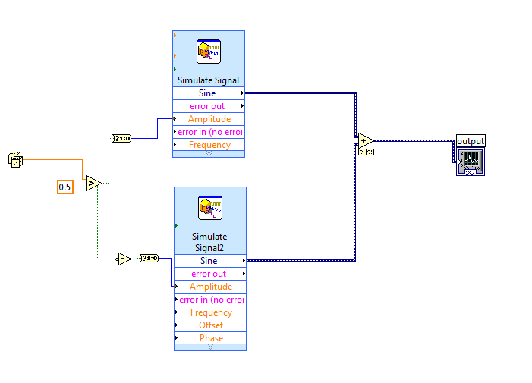

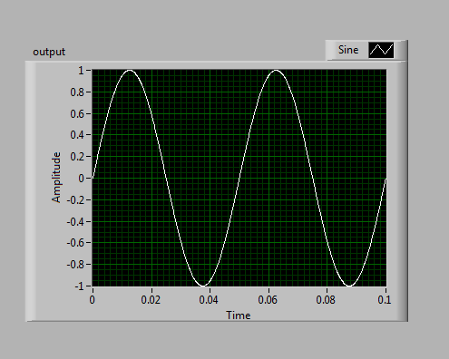

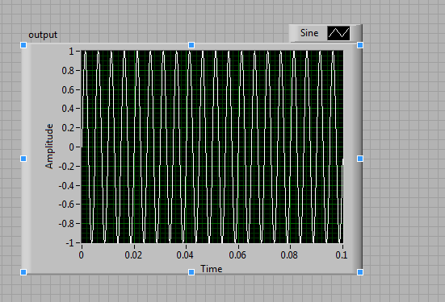

Q1-2:

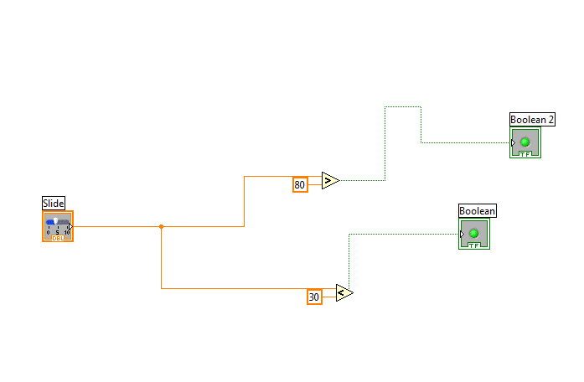

<30

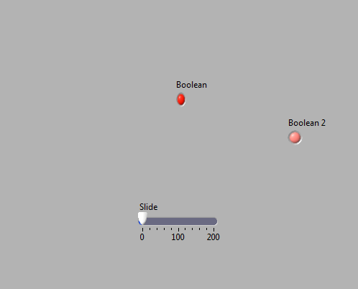

<80,>30

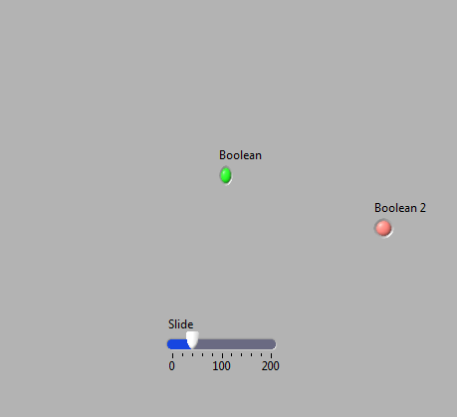

>80

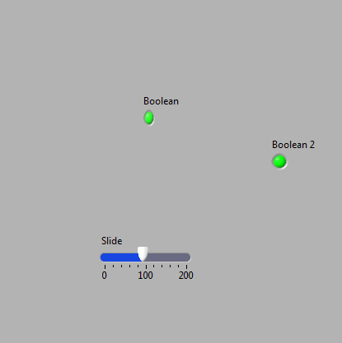

Q3:

The code:

%choose the sampling frequency to be 1500 hz

t=0:0.001:1;

s1=sqrt(2).\*sin(2.\*pi.\*100.\*t);

s2=2\*sqrt(2).\*sin(2.\*pi.\*300.\*t);

s3=3\*sqrt(2).\*sin(2.\*pi.\*600.\*t);

x=s1+s2+s3;

y=x+awgn(x,20);

sptool

amplitude spectra of y:

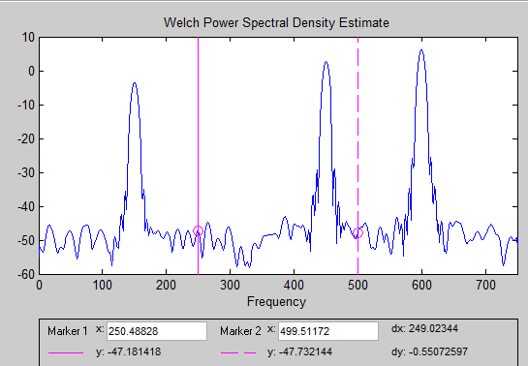

Butter worth band stop filter:

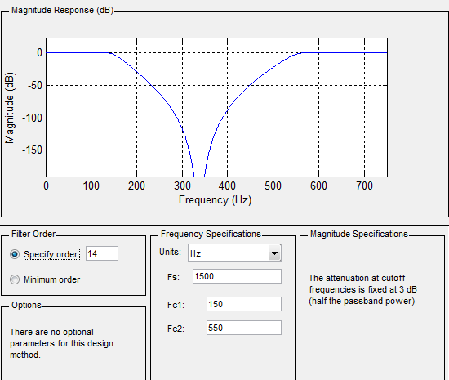

The ouput y:

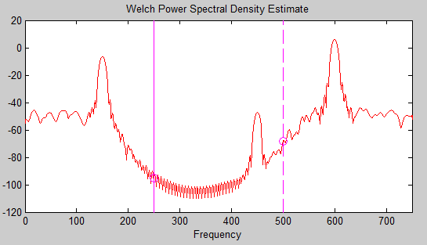

Chebyshev-11 band stop filter:

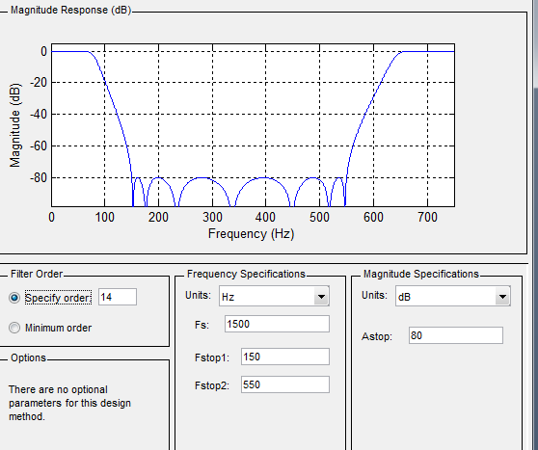

The output:

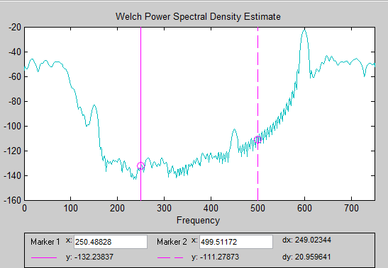

The Chebyshev filter is better than the butterworth filter because the unwanted signals have a magnitude of approximately -100db when using the Chebyshev filter.

but the unwanted signals have a magnitude of approximately -40db using butterwoth filter.

Q2:

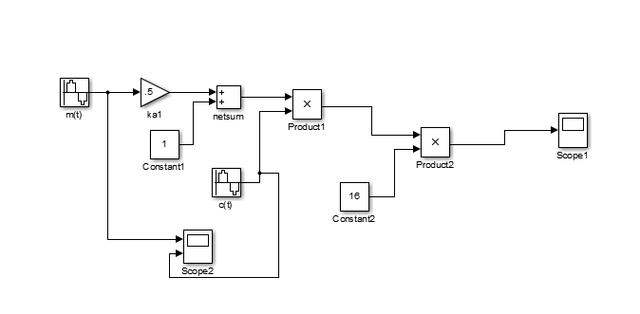

Massege signal:

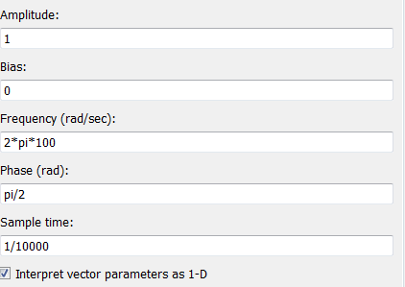

Carrier:

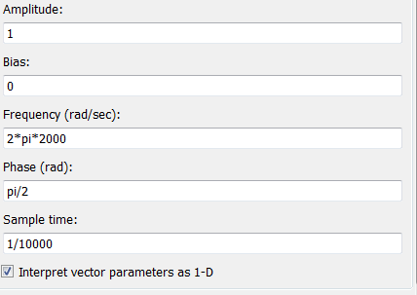

Modualeted signal:

