**Final Simulation Lab Exam**

Question 3:

Build and simulate the following system using MATLAB Simulink:

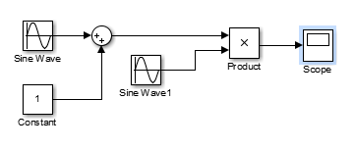

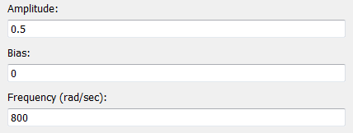

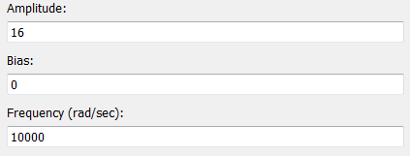

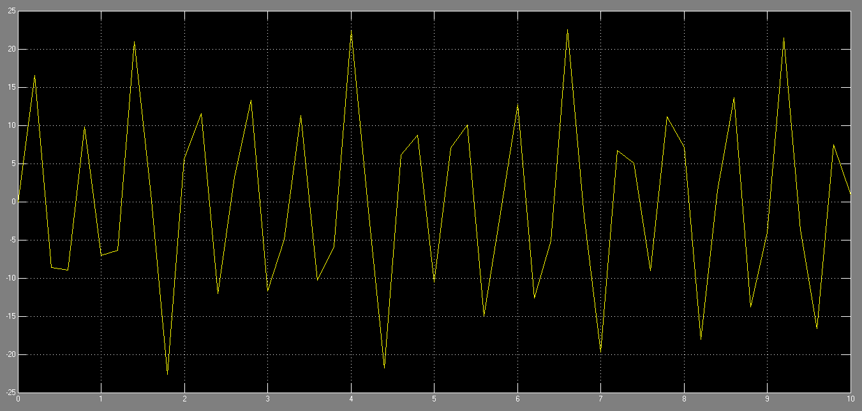

Question 2:

Write a MATLAB script that generates three sine signals of frequencies 100, 200, 350 Hz. With amplitudes 1, 2 and 3 respectively.

1. Choose appropriate sampling frequency fs?

**Answer: the appropriate sampling frequency equal 1000.**

1. Create a signal which is the sum of the three signals?

**Answer:**

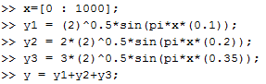

1. Create a signal which is the signal (y) with AWGN noise and signal to noise ration of 20db.

**Answer:**

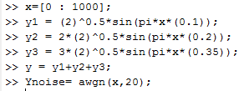

1. Plot the spectral representation of signal (Ynoise) in the frequency domain?

**Answer:**

**To find the spectra of the signal we use the (sptool).**

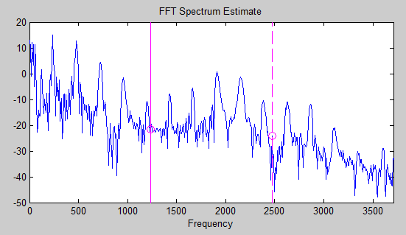

1. Design(100)

First the tenth order butterworth of the first signal:

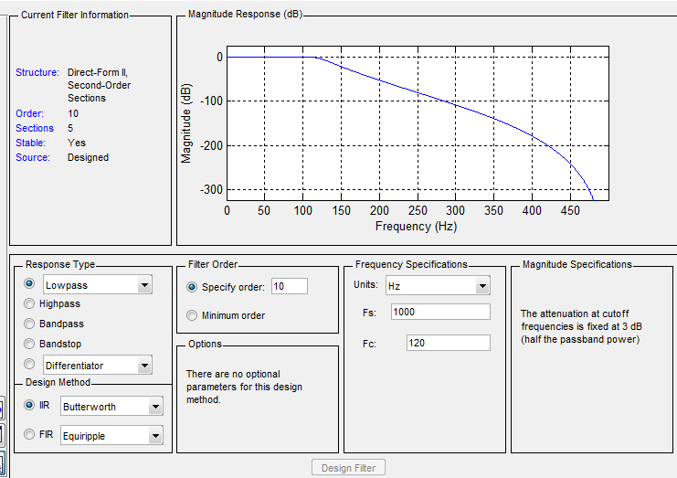

The output of the signal of tenth order butter worth :

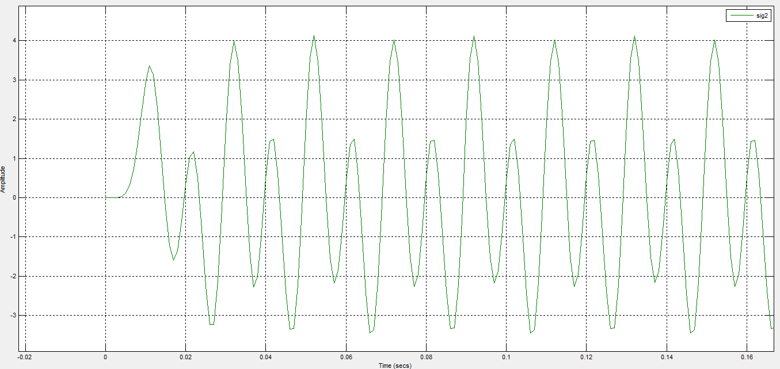

The design of chebyshec 2:

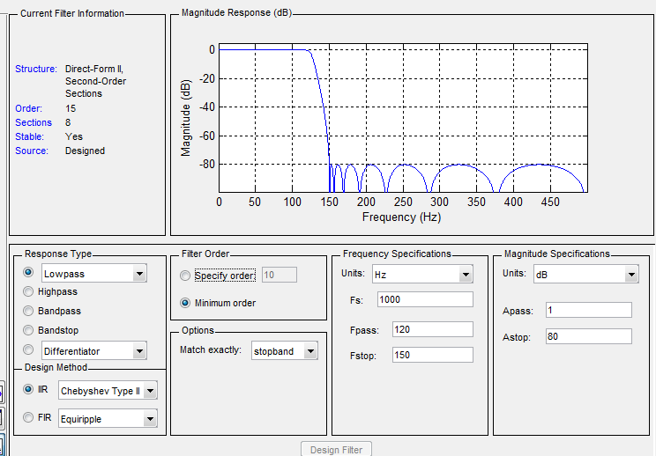

The output signal:

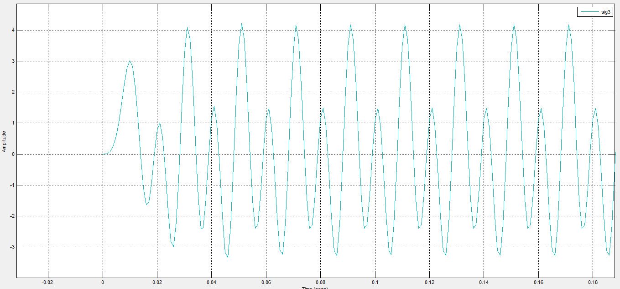

Design(350)

First the tenth order butterworth of the first signal:

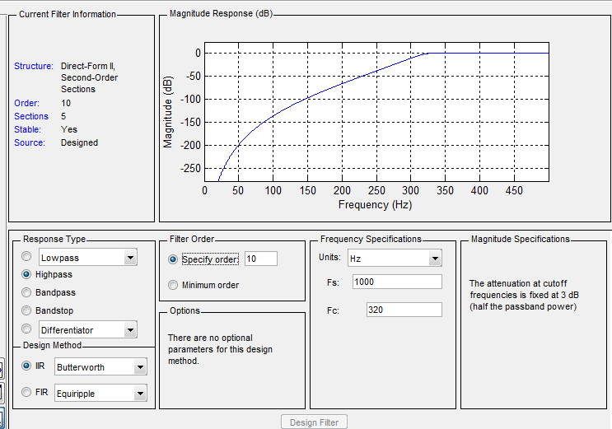

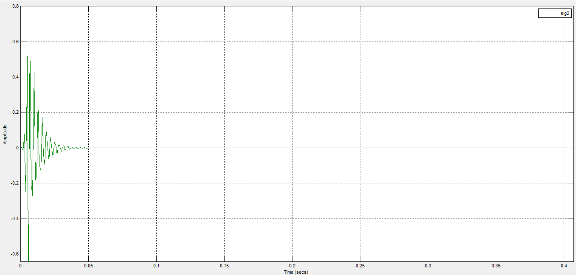

By using the second filter:

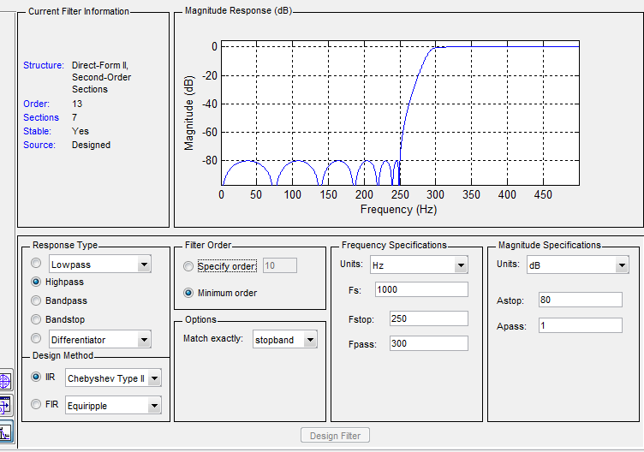

The output of the filter :

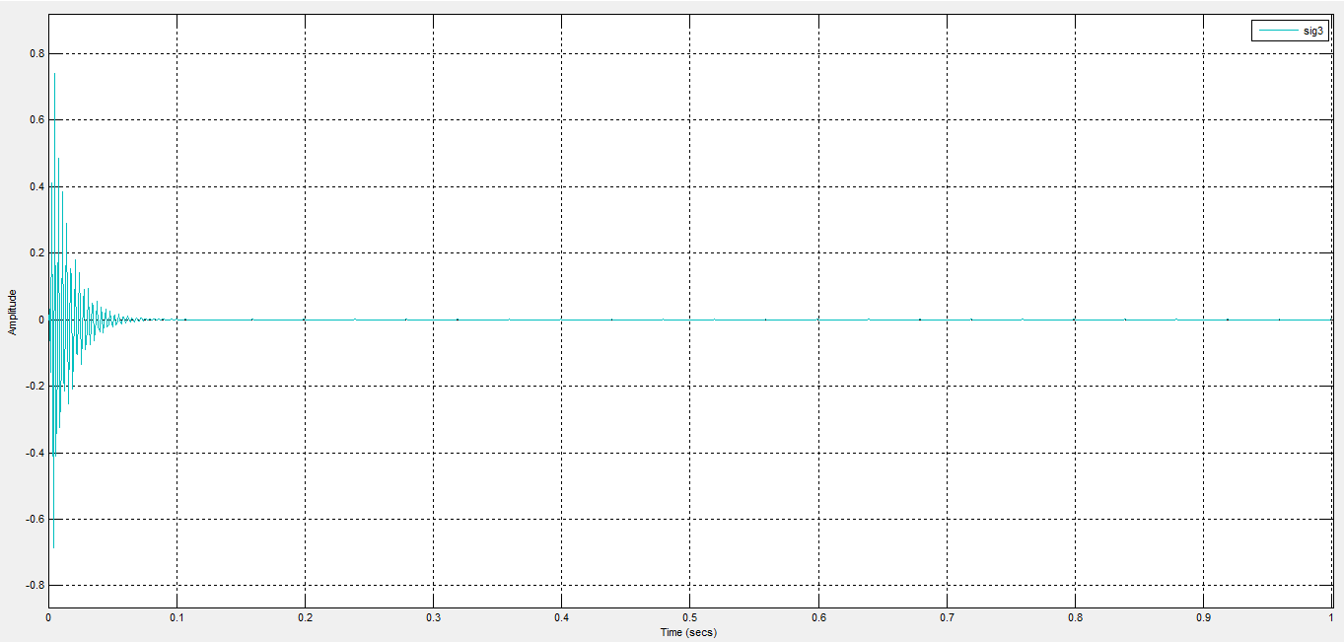

1. The chebyshev 2 filter is better than the butterworth filter . because it is more complex and the anther one .

**Question one:**

3. the type of demodulation : coherent use one oscillator

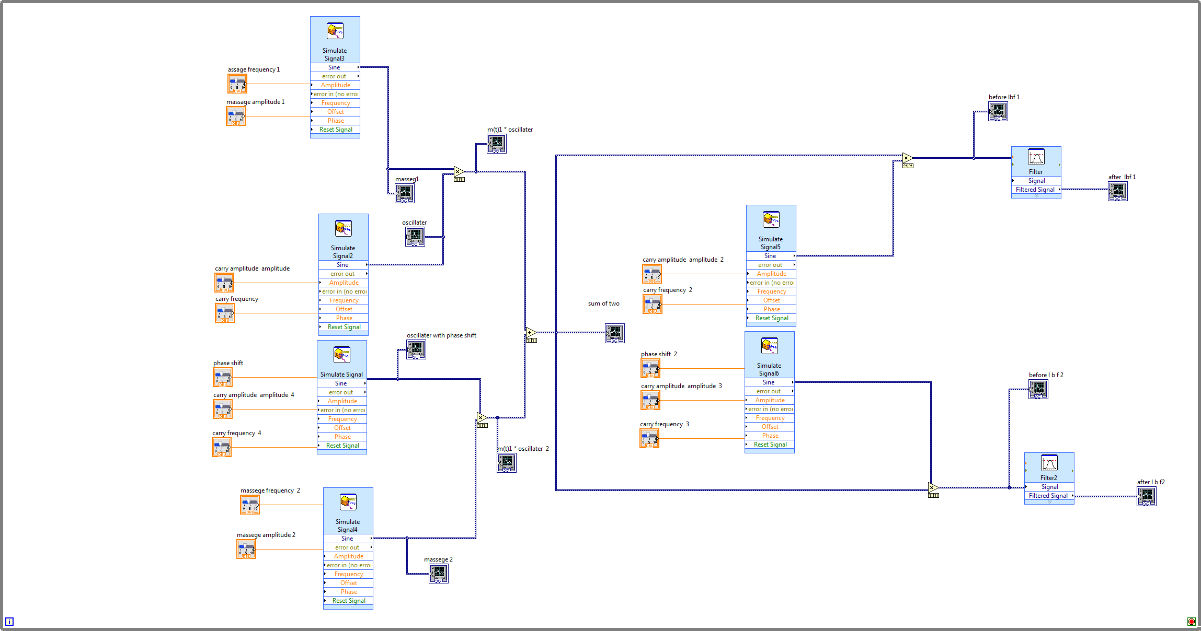

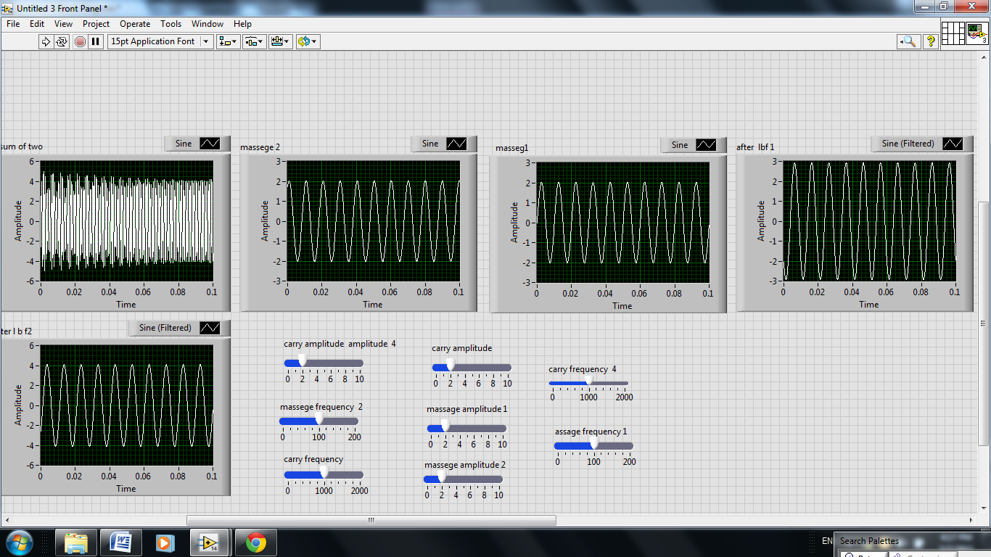

The spectra of the out put

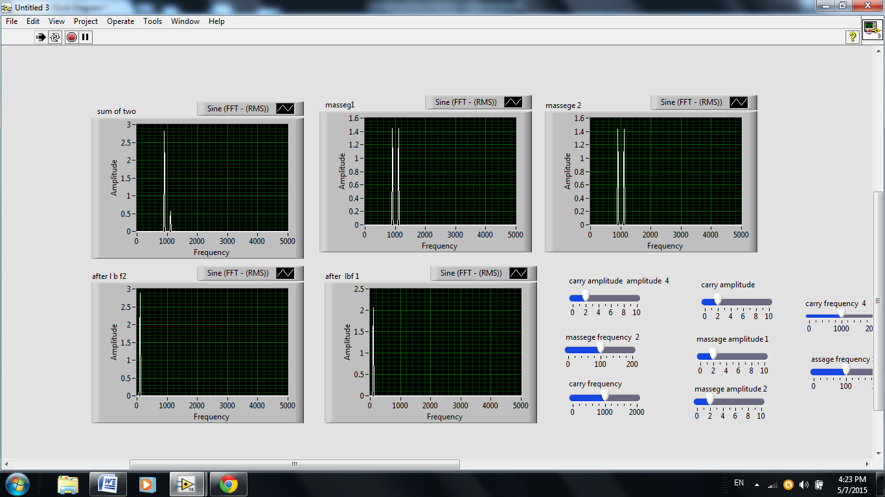

Phase shift error with 5%

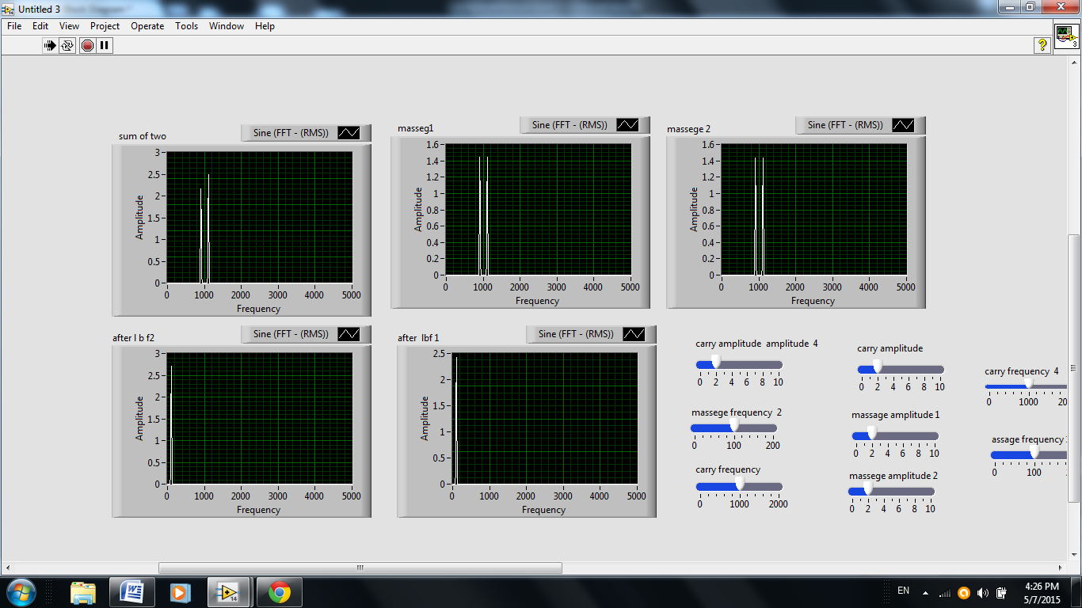

And the output of signalas .

