Midterm exam in simulation lab

Name : Anton dalu

Id : 1111252

Question #1:

What does this circuit do?

Solution:

This circuit is buck –boost converter.

Design a PCD for circuit?

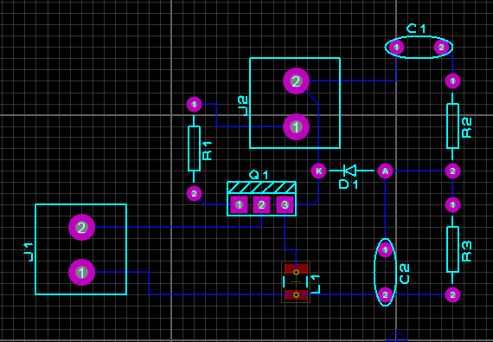

What is the effect of changing the pw value on the output voltage?

Solution :

If the pw > 0.5 the converter step up.

If the pw < 0.5 the converter step down.

Question #2:

1. Bode plot magnitude and phase
2. The step response
3. The poles and zeros of the system .

**Solution:**

num=conv([1000],conv([1 5],[1 7]));

den= conv(conv([1 0],[1 20]),conv([1 7 75],[1 50]));

zeros = roots(num)

poles = roots(den)

G =tf(num,den);

step(G)

w=logspace(-1,2,101);

Gain =freqs(num,den,w);

mag=abs(Gain);

db=20*log10(mag);

ph=angle(Gain)*180/pi;

semilogx(w,db),grid

semilogx(w,ph),grid

bode(num,den,w);

xlabel('freguency(rad/s)'),ylabel('Gain db')

zeros =

-7

-5

poles =

0.0000 + 0.0000i

-50.0000 + 0.0000i

-20.0000 + 0.0000i

-3.5000 + 7.9215i

-3.5000 - 7.9215i

THE bode plot magnitude and phase:

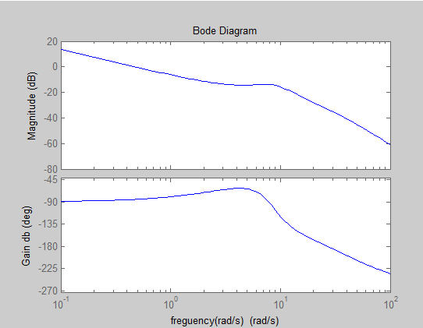

The step response :

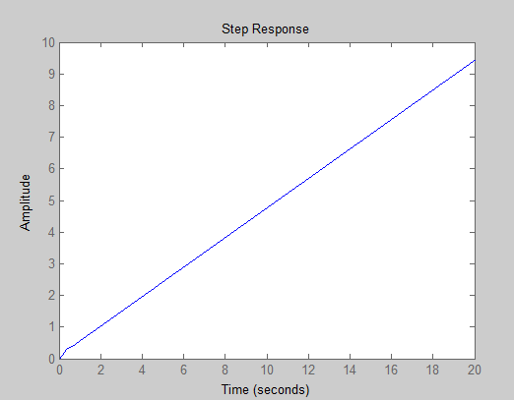

Question #3:

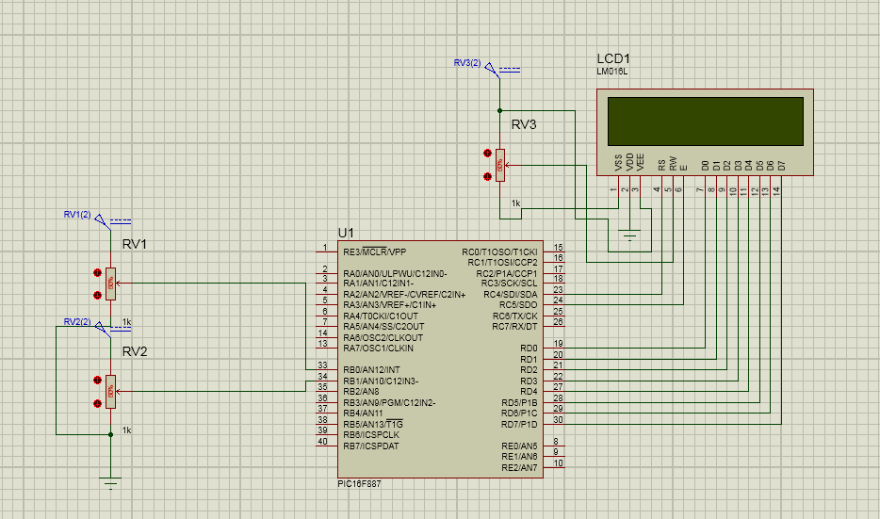

// LCD module connections

sbit LCD_RS at RB4_bit;

sbit LCD_EN at RB5_bit;

sbit LCD_D4 at RB0_bit;

sbit LCD_D5 at RB1_bit;

sbit LCD_D6 at RB2_bit;

sbit LCD_D7 at RB3_bit;

sbit LCD_RS_Direction at TRISB4_bit;

sbit LCD_EN_Direction at TRISB5_bit;

sbit LCD_D4_Direction at TRISB0_bit;

sbit LCD_D5_Direction at TRISB1_bit;

sbit LCD_D6_Direction at TRISB2_bit;

sbit LCD_D7_Direction at TRISB3_bit;

int A , B ;

void main()

{

TRISA = 0xFF; // PORTA is input

TRISB = 0X00; // PORTA is OUTPUT

TRISC = 0X00; // PORTA is OUTPUT

while(1)

{

A=ADC_Read(0);

B=ADC_Read(1);

if ( A > B )

{

PORTB = A >> 6 ;

if ( PORTB < 9 )

{

Lcd_Init();

Lcd_Out(1,1,"IT IS THE ORIGINAL CODE ");

lcd_out(2,1,"IT IS BCD");

Lcd_Cmd(_LCD_CURSOR_OFF);

PORTC = PORTB;

}

if ( PORTB > 9 )

{

Lcd_Init();

Lcd_Out(1,1,"NOT BCD");

PORTC = 0;

}

}

if ( A < B )

{

PORTB = A ;

Lcd_Init();

Lcd_Out(1,1,"ENCODER CODE");

Lcd_Cmd(_LCD_CURSOR_OFF);

}

}

}