

**Birzeit University**

**Faculty of Engineering & Techonology**

**Department of Electrical & Computer Engineering**

**ENEE**

**“Matlab Experiement Prelab”**

**Student :Mohamad Bornat #1130842**

**Instructor:Dr.Jamal Siam**

**Date: 4-3-2017**

|  |  |  |
| --- | --- | --- |
|  |  |  |
| **Abstract** |  |  |

In this prelab, Matlab software was used to analyze different circuits and controls systems, it was also used as well to derive the differential equations for some different systems.This software showed a high reliability and very goof performance in doing the desired steps.

|  |  |  |
| --- | --- | --- |
|  |  |  |
| **Plrelab** |  |  |

**Figure 1**



Figure1: Mech analysis.

To analyze the cicuit we need to apply KVL on the five meshes and so we eill get five different equations:  
  
4 = 9 I1 -2 I2 -2 I3……………..16 = -2 I1 + 10 I2 – 4 I3 – I4  – I5………….20 = - I2 + 8 I4 – 3 I5 ……………….3  
6 = I2 + 3 I4 – 4 I5…………………46 = 2 I1 + 4 I2 – 9 I3………….5

In order to get the matrix of the system we have to consideer ohm’s law which states that:

V= I*R , and so : $$\left[\begin{aligned}4 \\ 6 \\ \begin{matrix}0 \\ 6 \\ 6\end{matrix}\end{aligned}\right]=\left[\begin{matrix}9 & -2 & -2 & 0 & 0 \\ -2 & 10 & -4 & -1 & -1 \\ 0 & -1 & 0 & 8 & -3 \\ 0 & 1 & 0 & 3 & -4 \\ 2 & 4 & -9 & 0 & 0\end{matrix}\right]\left[\begin{matrix}I1 \\ I2 \\ I3 \\ I4 \\ I5\end{matrix}\right]$$

**Figure 2**

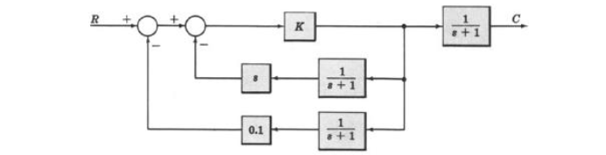*Figure2: Control System.*

to derive the transfer function we use the following code :

numg1=[1 0];deng1=[1 1];

numg2=[0 0.1];deng2=[1 1];

numg3=[0 10];deng3=[0 1];

numg4=[0 1];deng4=[1 1];

[numh,denh]=parallel(numg1,deng1,numg2,deng2);

[numf,denf]=feedback(numh,denh,numg3,deng3);

[nums,dens]=series(numf,denf,numg4,deng4);

printsys(nums,dens)

the answer is :

s^2 + 1.1 s + 0.1

--------------------------

11 s^3 + 24 s^2 + 15 s + 2

**Figure 4**

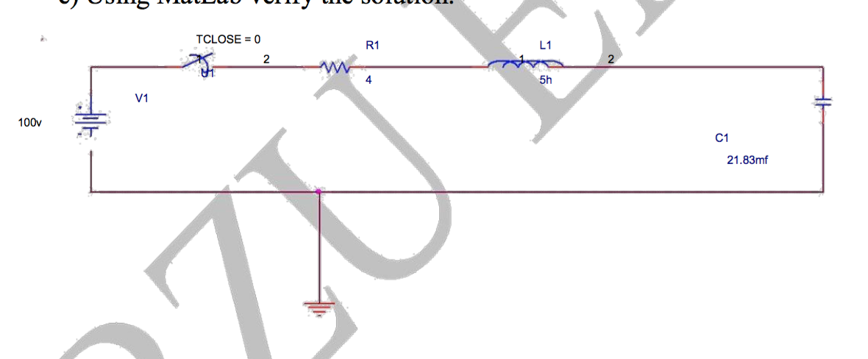Figure4

To derive the transfer function of the circuit we use voltage divider rule and laplace transformation:

$$Vc =\frac{45.808 /s}{45.808 /s+4+5s } Vi$$

We multiply by s and divide by 5

$$H\left(s\right)=\frac{Vc}{Vi}=\frac{9.1616}{s^2+0.8s+9.1616 }$$

Figure 5

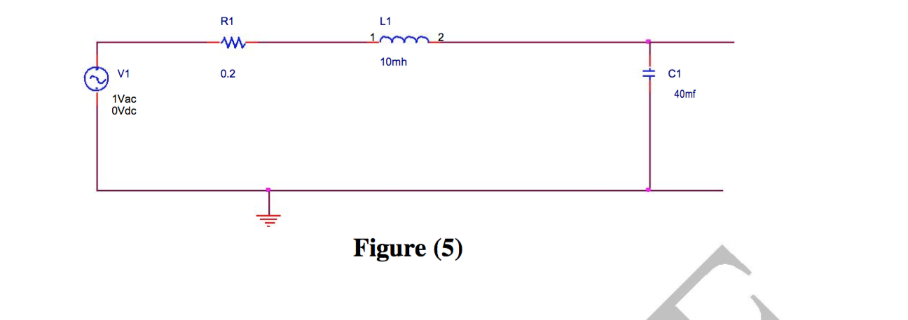

to derive the transfer function we do as we did in the last part :

$$Vc =\frac{25/s}{25/s+0.2+0.01s } Vi$$

We multiply by s and divide by 0.01

$$H(S) =\frac{VC(S)}{VI(S)}=\frac{2500}{s^2+20s+2500 }$$

|  |  |  |
| --- | --- | --- |
|  |  |  |
| **Conclusion** |  |  |

We concluded that Matlab is a very useful program in solving the mathematical equations, it is fast and reialble and can save us a much time to assign deifferent mathemetical tasks.