**Electrical and Computer Systems Engineering Department**

**Simulation Lab   
  
(ENEE4104)***Prelab of Experiment #10  
 Filter Design Using MatLab*

bIRZEIT UNIVERSITY

Name: Ali Sider  
  
Student Number: 1111829  
  
Dr.: Jamal Seyam   
   
Eng.: Al-Mutasem Bellah Omar  
  
Section: 2

20 FEB 2016

Part One: **Data creation**

1) Create a MATLAB script that generates a discrete-time signal (x) which is the sum of three sine signals of frequencies 100, 250 and 400Hz and with RMS amplitudes of 1, 2 and 3 respectively. Use the following parameters in your code:

fs = 1000 samples/sec

n = [0 1 2 3 … 1023]

Your code must be in terms of (fs) and (n).  
  
n=0:1:1023;  
fs=1000;

T1=sin(2*pi*n*100/fs);

T2=2*sin(2*pi*n*250/fs);

T3=3*sin(2*pi*n*400/fs);

s=T1+T2+T3;

stem(s)

  
*Figure -1-: Plot of the discrete sequence data.*

2) Create a signal (y) which is the signal (x) with AWGN noise and signal-to-noise ratio of 20 dB. Use the MATLAB function awgn().

y=awgn(s,20);

plot(y);  
grid;  
title('Signal+Awgn');  
ylabel('Amplitude');  
xlabel('n')  
  
  
  
  
  
  
  
  
  
  
  
3) Plot the signal (y) showing the axis labels.

  
*Figure -2-: Signal s with AWGN.*

Part Two**: Using SPTool & Importing Signal**Click on file (top left-hand side of SPTool window) Choose import. A window should appear. Select the signal (y) and the sampling frequency fs. When you are finished, click on OK. Click view under the signals column to view your signal. Show the output.  
  
➢ Signal Browser

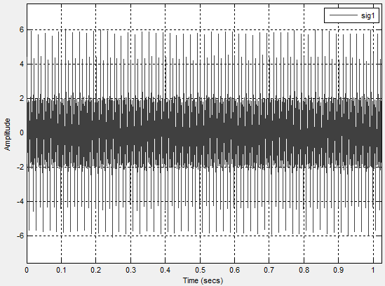  
*Figure -3-: Signal Browser.*

Part Three: **Use of the Spectrum Viewer**  
➢ signal in the frequency domain.

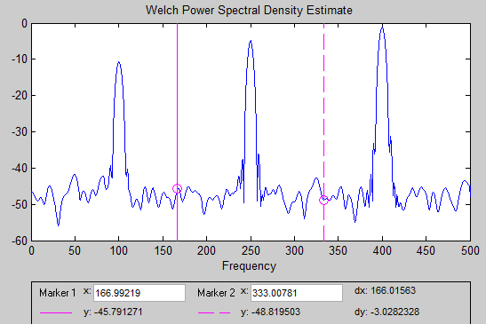

*Figure -4-: FFT Spectrum.*

Part Four: **Filter Creation**

**Low Pass Filter**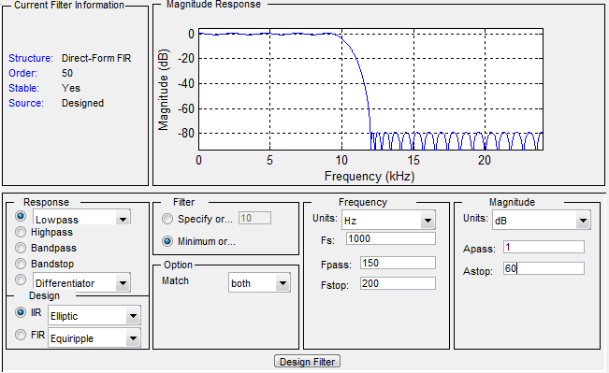*Figure -5-: Design of low pass filter.*

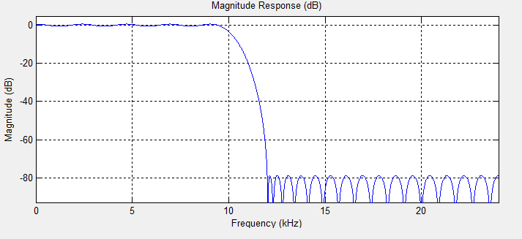*Figure -6-: low pass filter.*