

**Computer Systems and Electrical Engineering Department**

**Simulation Lab**

**Section: Saturday**

**Lab Report**

**Negative Feed Back, Modular Design and Sub-circuit design in PSpice**

**Student: Haitham Da'ana**

**Student ID: 1121331**

**Abstract**

The experiment examined the impacts of closed loop negative feedback circuit and an open looped one, on the electrical characteristics of the circuit, the experiment also was meant to practice some of the main functions of the OrCAD software in analyzing, designing circuits, such as Sub-circuit making, and Modular Design, that help user to cut short the complex circuits by simplifying, and sorting it, at an order in circuit blocks, all with help of OrCAD and PSpice Simulation softwares.

**Introduction**

The main concept of this experiment was to OrCAD in multiple of aspects, one was the simple basic circuit analysis and design, like Negative Feed Back and some other features like sub-circuits and Modular Design, that cut back on complicated circuit design, by sorting the complicated circuit into blocks, in other words simplifying it!

**Procedure**

**Part 1**: Negative Feed Back, and Open Loop Amplifier Simulation using Modular Design:

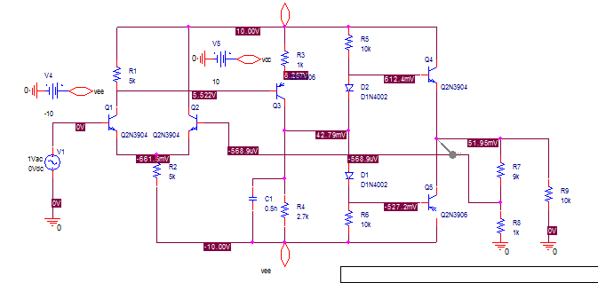

At first, a New project was created, Main Circuit was divided into two blocks called **lowfirst** and **lowsecond**, in other words, two new schematics were created, one is called **lowfirst**, and the second is **lowsecond**.

In **lowfirst** schematic folder, a new page called "lowfirst.sch" was created.

**lowfirst** schematic was drawn as follows:

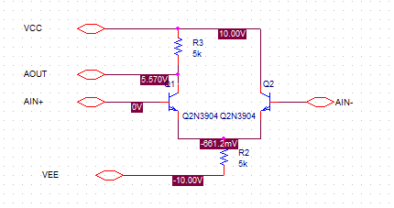

Ports were added, indicating the block's terminals.

**In lowsecond schematic folder, a new page called "lowsecond.sch" was created.**

**lowsecond** schematic was drawn as follows:

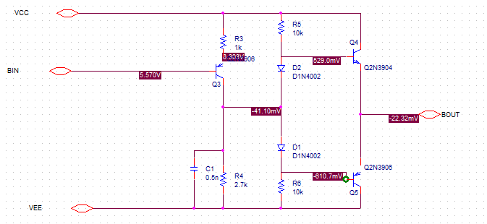

**Ports** indicate the circuit terminals.

After dividing the circuit, into two circuits lowfirst and lowsecond, a new schematic was created, along with a newpage in it, called "top.sch", this circuit was to outline the circuit's inputs, outputs, and DC Sources (BJT Amplifier).

In the new page "top.sch", a new hierarchical block was drawn, and using hierarchical pin feature, pins were placed on the hierarchical block showing the **Input**, **differential input**, **VCC**,**VEE**, and **LOAD**. (BJT Amplifier Hierarchical Block).

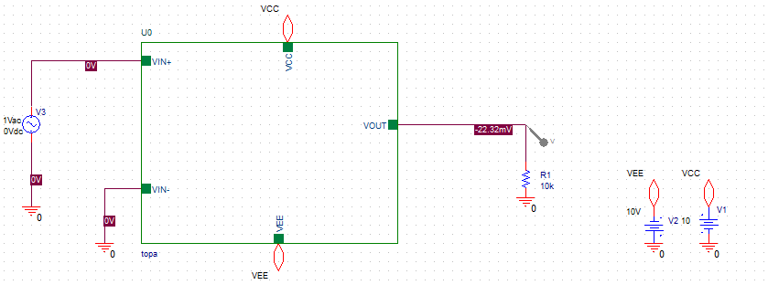VEE, and VCC ports were placed to be -10V, 10V respectively.

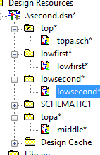"top" schematic folder was made ROOT and the hierarchical block was descended. A new page was created called "middle" that has the hierarchical pins as ports.

In the new page called middle, two hierarchical blocks were created from the lowfirst and lowsecond implementations, this resulted in two blocks that has the ports of lowsecond and lowfirst as their hierarchical pins.

Pins were sorted, top's ports were connected accordingly to the two blocks as show in figure below:

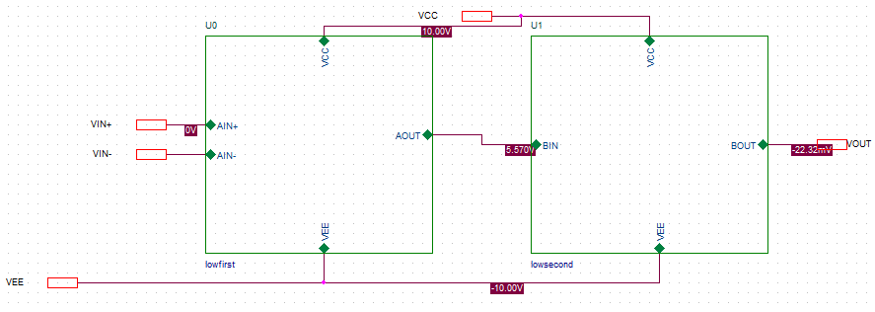

Simulation profile was created, AC Sweep analysis was chosen, a PSPice voltage probe was placed at the output!

**Part 2**: Sub-circuits

A circuit was drawn as connected on pspice as shown:

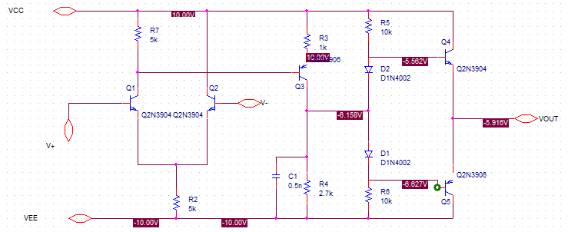

Circuit was connected without showing any of the inputs or outputs, except for their ports.

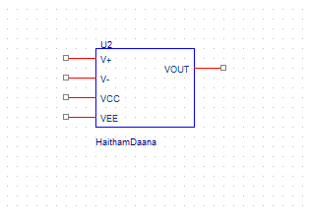Using Part Generation Feature the circuit was diminished to a mere part, with inputs pins and output pins only!

It was connected as Negative Feed Back Circuit with feedback connected to the negative terminal (V-)

Simulation was Run with the probe connected at the LOAD afterwards.

**Results**

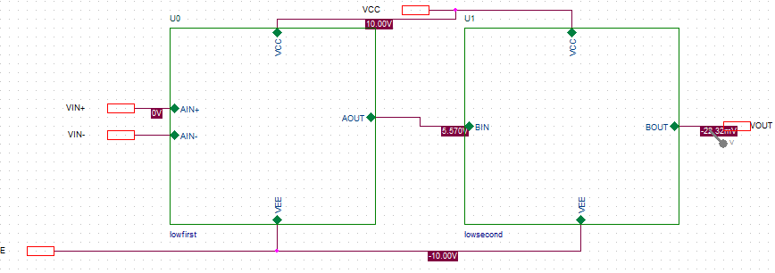The results were as shown, to find the frequency and gain characterstics of the amplifier we used AC Sweep.



Using Cursor, gain in the open loop case was 130, and with relatively low bandwidth at 216kHz, Zin at 2000Mohm, Zout at 1.2kOhm

When the circuit has negative feedback!

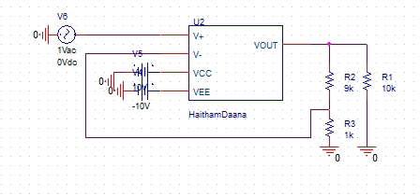



**Avmid=~9V**

**Bandwidth=3.78M**

**Input Impedence=2000M**

**Output Impedance=2.2k**

**Results Discussion**

We observe that adding negative feedback impacted by increasing the bandwidth significantly but at the cost of gain reduction, on the other hand open loop amplifier had higher gain, lesser bandwidth, those are advantages of using open-loop, but a system that lacks feedback mechanism, can be prone to external disturbances without the ability to eliminate them, a system that has a negative feedback will be able to maintain its output steady with the ability of eliminating external disturbances on the system that may interfere in such a way, in another words a better **CMRR**(Common Mode Rejection Ratio).

**Conclusion**

At the end of this experiment we were able to tell the difference between an open loop and negative feedback circuit, each has its own features, advantages and disadvantages, for systems require high accuracy, interference immune, and stability a closed loop negative feedback system would be recommended, and when accuracy is not that important, open loop system would be recommended for its simplicity, stability, and gain.

We were also able to use OrCAD to implement circuits in different ways, simpler and more efficient ways, especially when we need to design large circuits, we can divide it into blocks, each block has its own input and output and this is how it goes!