

Experiment No. 4

Introduction to MicroC Program

Simulation Lab – ENEE4104

Section: Saturday 2:00-5:00pm

Instructor: Ashraf Rimawi

Teaching Assistant: Dalal Hamdan

Student Name: Haitham Daana

Student ID: 1121331

**Date: 22/11/16**

**Abstract:**

The aim of this experiment was to create signals using MATLAB, modify, visualize these signals using SPTool, and to view frequency spectrum of these signals, and to design filters using SPTool and pass those signals into the filter designed in SPTool and to observe the output of each time.

**Introduction**:

A filter is a circuit that can be designed to modify, reshape or reject all unwanted frequencies of an electrical signal and accept or pass only those signals wanted by the circuits designer. In other words they “filter-out” unwanted signals and an ideal filter will separate and pass sinusoidal input signals based upon their frequency.[1]

3 Types of filters were set to be tested and designed in the experiment which are:

1. 1. The Low Pass Filter – the low pass filter only allows low frequency signals from 0Hz to its cut-off frequency, ƒc point to pass while blocking those any higher.
2. 2. The High Pass Filter – the high pass filter only allows high frequency signals from its cut-off frequency, ƒc point and higher to infinity to pass through while blocking those any lower.
3. 3. The Band Pass Filter – the band pass filter allows signals falling within a certain frequency band setup between two points to pass through while blocking both the lower and higher frequencies either side of this frequency band.

Using MATLAB, a signal was represented mathematically, and using some of the functions of MATLAB noise was added to it for more realistic outputs and analysis.

After these signals were made, using SPTool in MATLAB, 3 different filters were created and the signal was passed into each one of them.

**Theory**:

1. Low Pass Filter

A low pass filter is a filter that has gain equal to “1” for frequencies that are considered low for that filter, and has low gains(attenuation) for signals that have higher frequency than the corner frequency of the Low Pass Filter.[1]

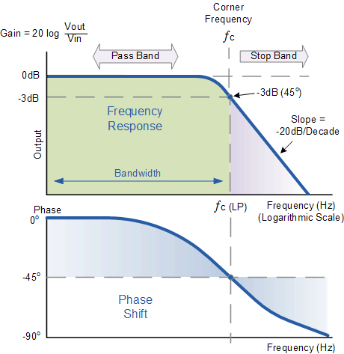

### Figure 1: Low Pass Filter Frequency Response

1. High Pass Filter:

A High pass filter is a filter that attenuates low frequency signals that are below its corner frequency, and for those signals who have higher frequency that the corner frequency are passed without attenuation.[2]

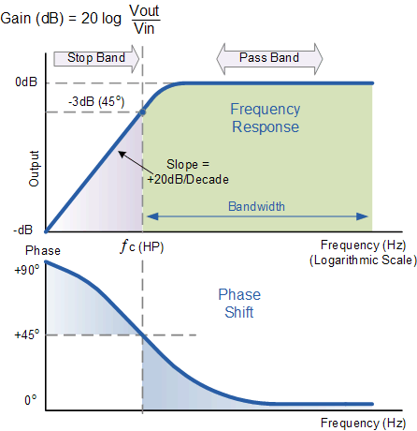

Figure 2: High Pass Filter Frequency Response

1. Band Pass Filters

These are kinds of filter that have two corner frequencies one is for Low Frequencies and one for High Frequencies, signals with frequencies above or below its corner frequencies are blocked or attenuated and those who have frequencies that are in between are passed without attenuation in their gain. [3]

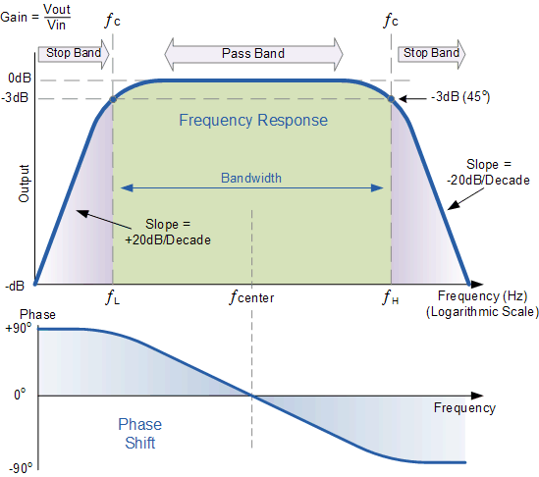

Figure 3: Frequency Response of a Band Pass Filter

**Procedure and Results :**

The following code was written in Matlab:

The code:

fs=1000;

n=0 : 1 : 1023 ;

x1=sqrt(2)*sin(2*pi*100*n/fs);

x2=sqrt(2)*2*sin(2*pi*250*n/fs);

x3=3*sin(2*pi*400*n/fs);

x=x1+x2+x3;

figure

stem(n,x,'r');

y=AWGN(x,20);

figure

stem(n,y,'b');

When the code was Run, the output was as follows:

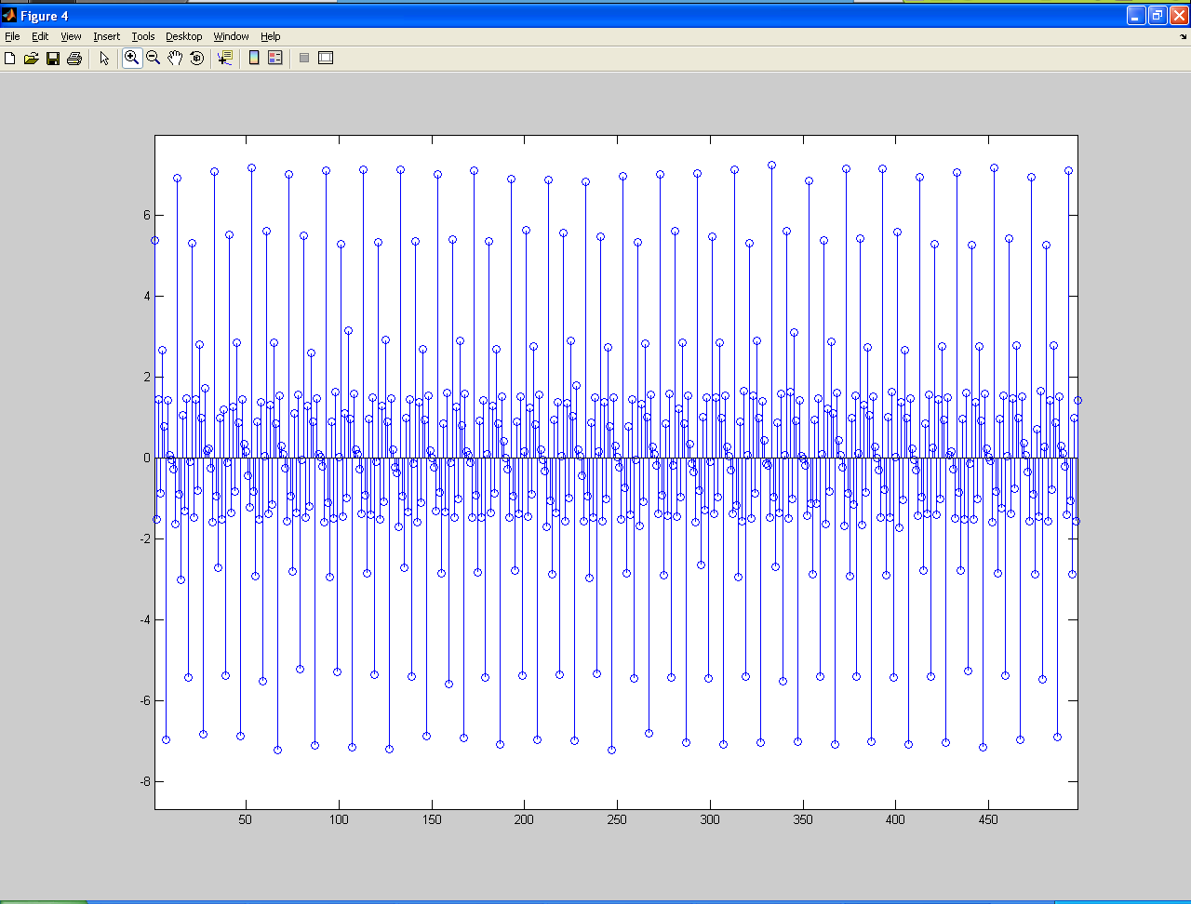

Figure 4 : The Signal without AWGN Noise

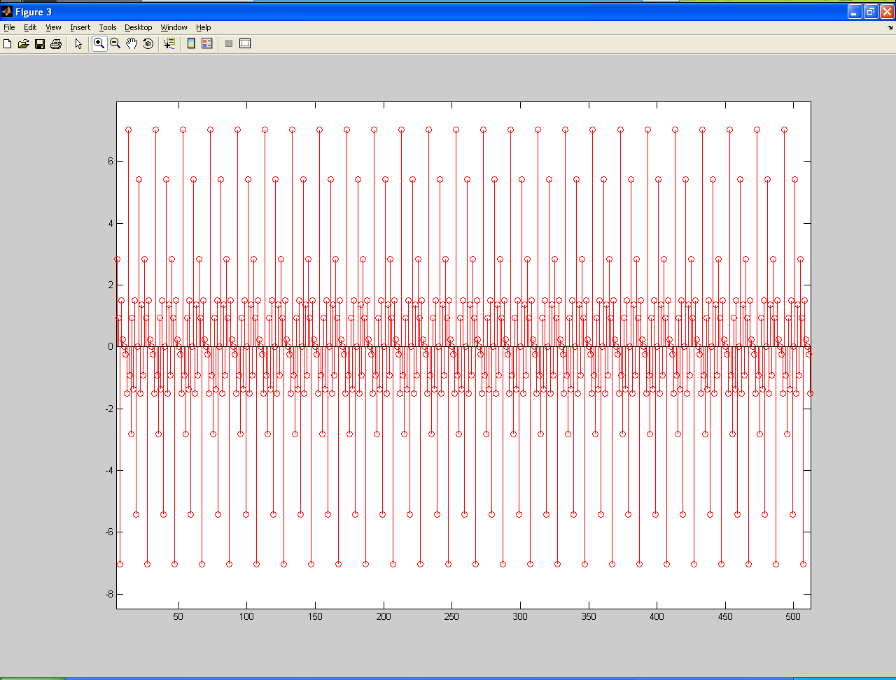

Figure 5: The signal with AWGN Noise.

SPTools was opened and and the signal was imported into the SPTools

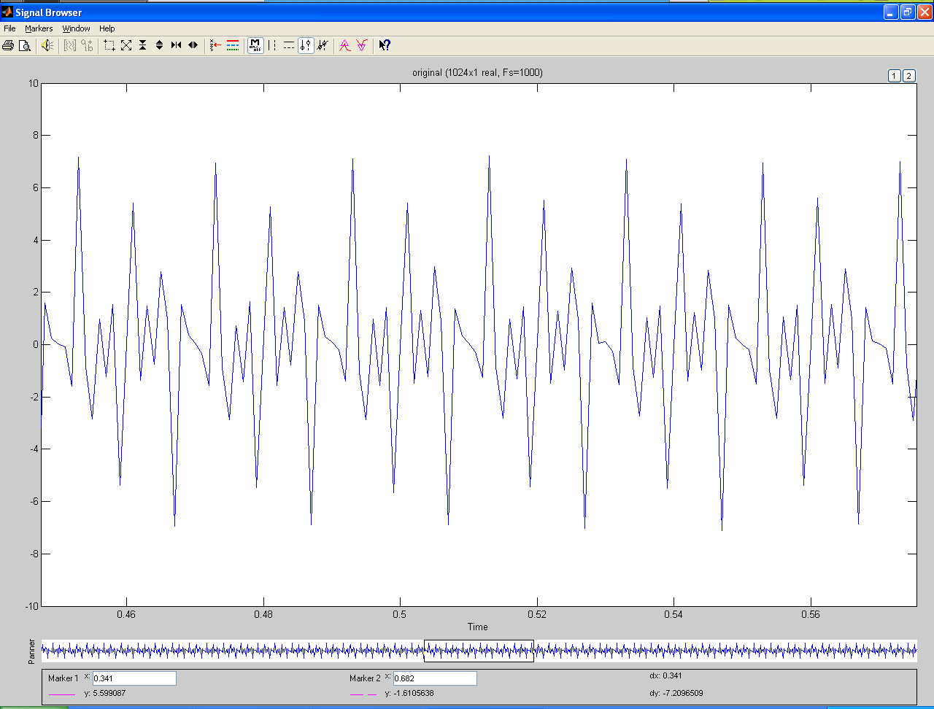

Figure 6: The Imported Signal of 1000Hz in SP-Tools

The spectrum of the signal was viewed using Spectrum Viewer feature in SPTools

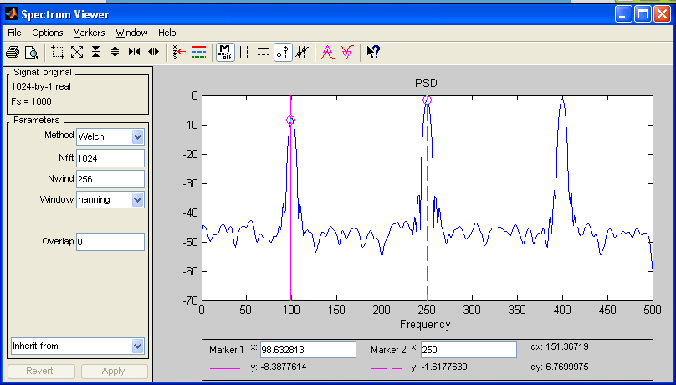

Figure 7: the spectrum viewer for the signal (The spectrum for the signal without any type of filter ).

Afterwards, three types of filter were created.

1. First the low-pass filter , the design & values :

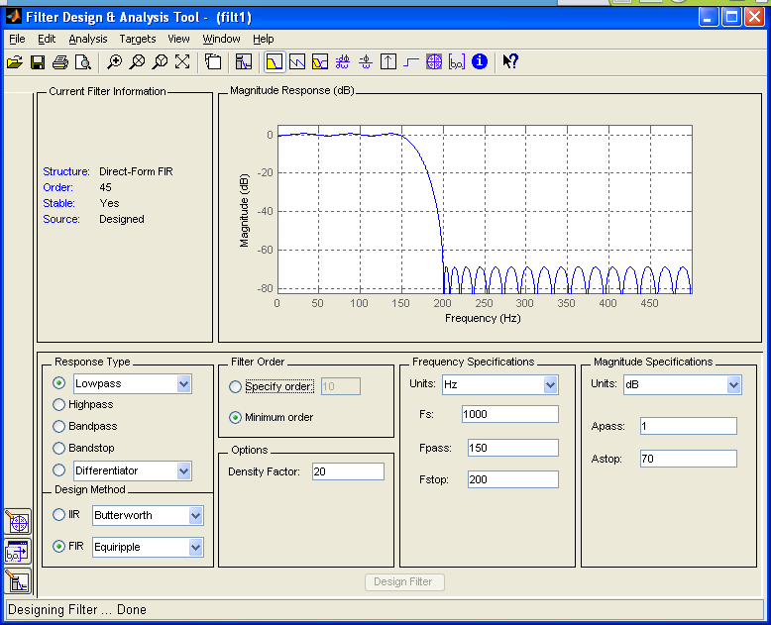

Figure 7: Low Pass Filter Design

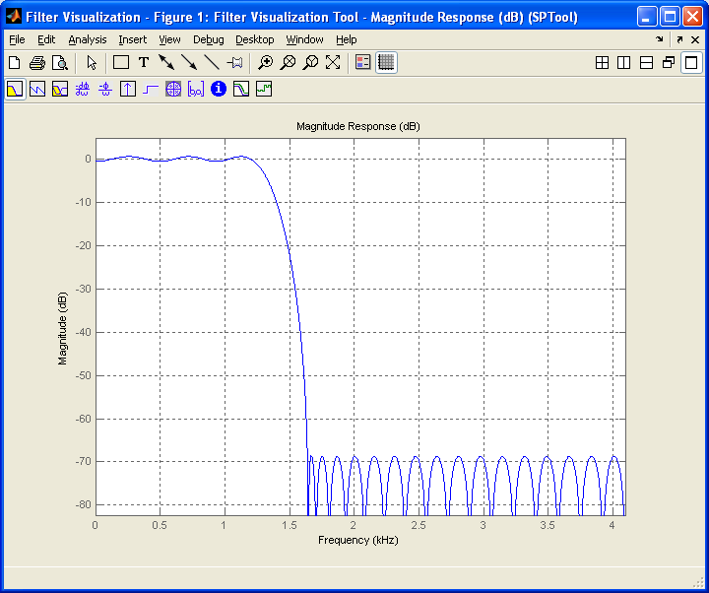

Figure 8 : Frequency Response of Low Pass Filter

The signal was passed through the designed low pass filter.

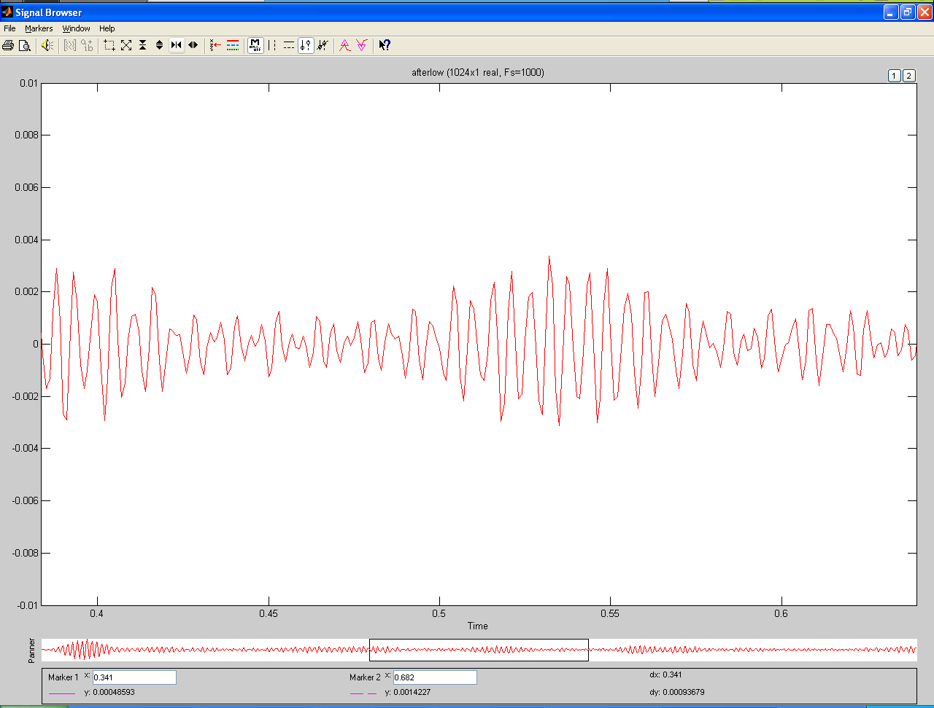

Figure 9: Output of the signal in time domain when passed through the filter

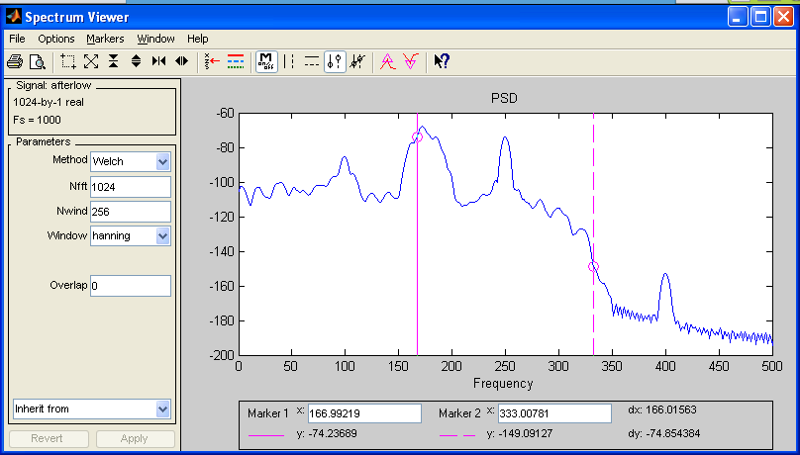

Figure 10: the spectrum of the filtered signal.

High Pass Filter was Designed afterwards:

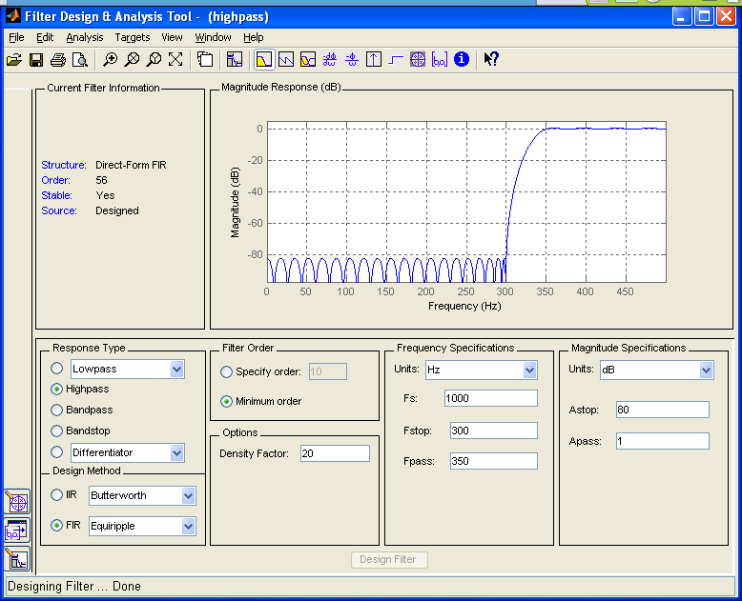

Figure 11: High Pass Filter Design

The signal was passed through HPF, and screen shot of the output was captured:

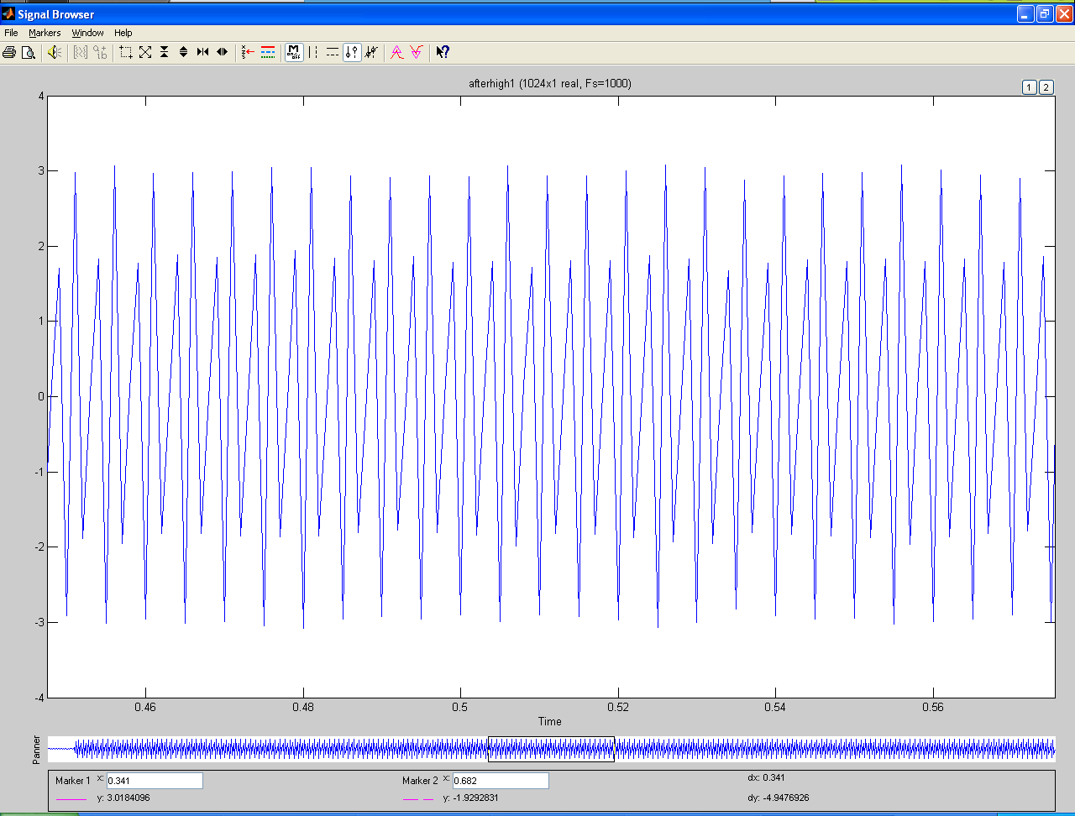

Figure 12: Filtered Signal in Time domain

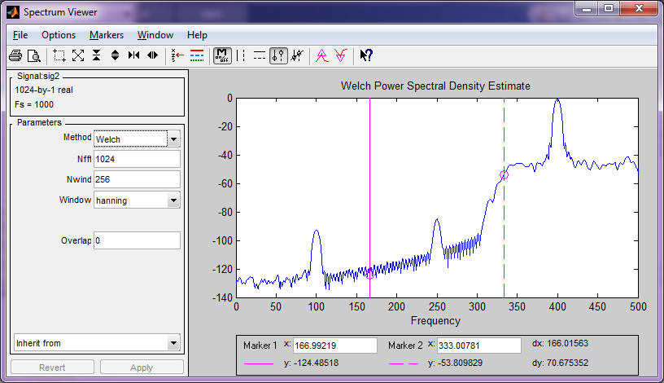

Figure 13: Filtered Signal in Frequency domain

Bandpass filter was designed as shown in the figure below:

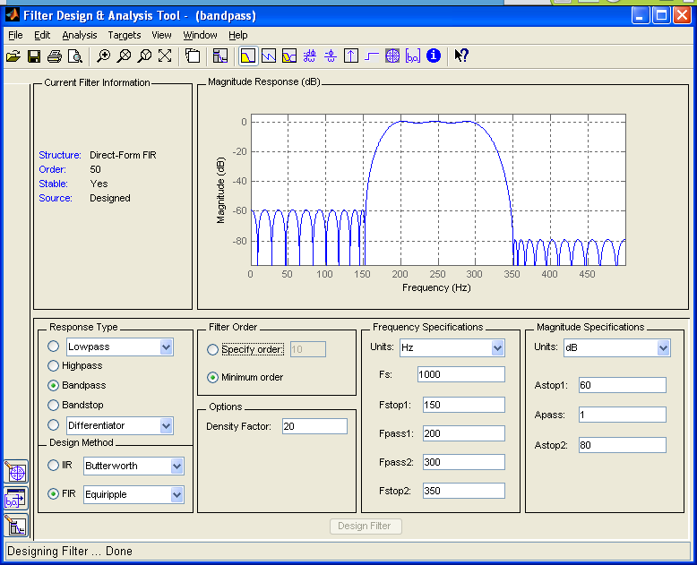

Figure 14: Bandpass Filter Design

The signal was processed and passed through the designed bandpass filter and results were as shown below:

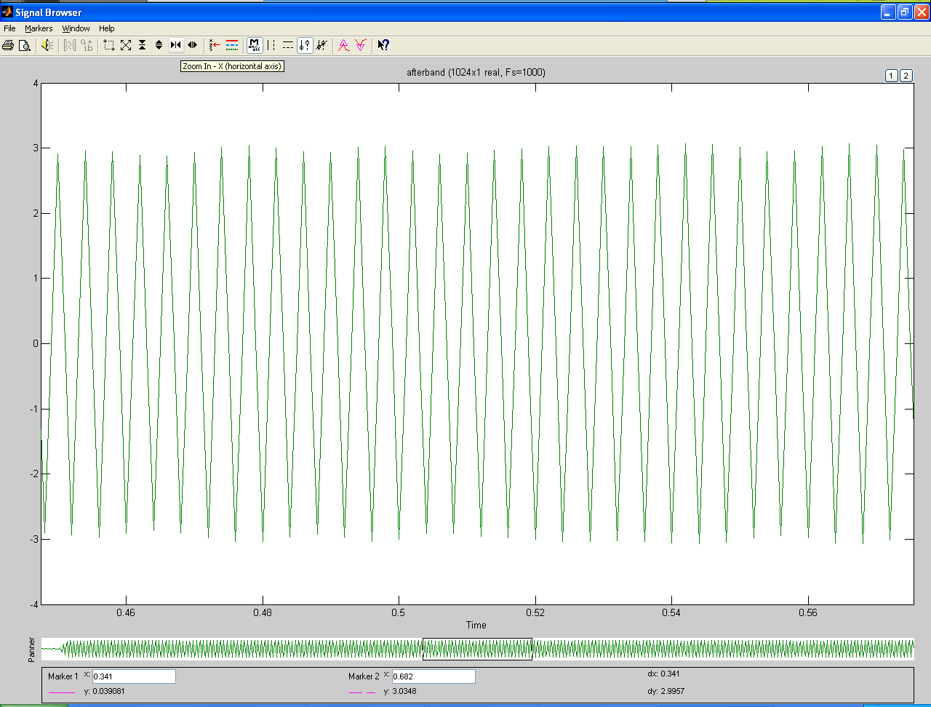

Figure 15: Filtered Signal in Time domain

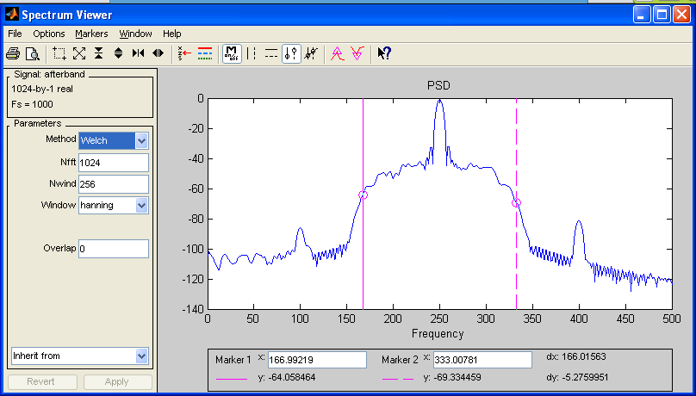

Figure 16: Filtered Signal in Frequency Domain

**Result Discussion:**

As we have noticed in the signal it had three fundamental frequencies which were 100, 250, 400Hz and when the output of filter depends on the type of the filter and frequency of the passing signal.

1. **Low Pass Filter Case:**

A low pass filter was designed with a stop frequency of 200, which means if a signal is passed through it, it’s high(Higher than 200) frequency components will be attenuated or fully blocked as we have noticed in Figure 10, the spectrum peaks at frequency below 200 once, which has a fundamental component, other components at 250, and 400Hz were attenuated.

1. **High Pass Filter Case:**

A High pass filter was designed with a stop frequency of 300Hz, which means if a signal is passed through it, it’s low(lower than 300) frequency components will be attenuated or fully blocked as we have noticed in Figure 10, the spectrum peaks at frequency above 300 once, that is because the signal has only one fundamental component at 400 Hz, other components at 250, and 100Hz were attenuated.

1. **Bandpass Filter Case:**

A Bandpass filter was designed with a stop frequency of 150, and 350Hz, which means if a signal is passed through it, it’s high and low(Higher than 350 and below 150Hz) frequency components will be attenuated or fully blocked as we have noticed in Figure 10, the spectrum peaks at frequency above 150 and below 350 once, because the signal has a fundamental component at 250Hz which passes through it, other components at 100, and 400Hz were attenuated.

**Conclusion:**

Using proper Matlab functions and using SPTools eases the job of manually designing filters, we were able to prove and view the effects of the passing a signal through various types of filters and see the spectrum and the output signal in time domain also.. However the program was limited to the filters that are already programmed into Matlab, so if we are going for a higher order we would have a problem representing the signal in SP-Tools, so other methods have to be used, this one advantage that was experienced during the experiment, however it is still a good way to view signals and effects of filters.

**References:**

[1] Retrieved from [**http://www.electronics-tutorials.ws/filter/filter_3.html**](http://www.electronics-tutorials.ws/filter/filter_3.html)

[2] Retrieved from [**http://www.electronics-tutorials.ws/filter/filter_2.html**](http://www.electronics-tutorials.ws/filter/filter_2.html)

[3] Retrieved from [**http://www.electronics-tutorials.ws/filter/filter_1.html**](http://www.electronics-tutorials.ws/filter/filter_1.html)