

**Computer Systems and Electrical Engineering Department**

**Simulation Lab**

**Section: Saturday**

**Date: 8/10/2016**

**Lab Report # 2: Power Electronic Converters in OrCAD**

**Student: Haitham Da'ana**

**Student ID: 1121331**

**Abstract:**

The aim of this of this converter was to test out and exhibit the theoretical implementation and analysis of DC converters, which were Step Down Converter, Buck-Boost Converter, and DC to DC Converters, in PSpice OrCAD, and to see the effects of chopping on different levels, while changing some of specifications in the circuit and to observe the effects on output.

DC Converters are circuits that converts DC at one level to another level, it's a practical use of Power Electronics, that uses switching methods to convert DC Voltage from a level to an another using FET's or BJT's and temporary storage devices as Inductors, Capactiors, etc.

**Introduction:**

In this experiment we will deal with different types of converters Buck, Buck/Boost, and DC to DC converter, and analyze them using OrCAD software, and see the effects of changing different parameters of circuit.

DC Converters are circuits that converts DC at one level to another level, it's a practical example of Power Electronics, they consist of at least one switching element, storage elements, output voltage will depend on different factors, and switching frequency plays a big role in this case, switching can be controlled using microprocessors, or any controlling device that can be 'programmed', in order to change switching frequency.

In many application we need to provide a constant voltage at the load, stepping it down for example, old method of achieving a constant low voltage at load, lower than the input was by adding resistors before the load which absorbs voltage difference, but this means there will be high power loss in form of heat, which is big disadvantage, furthermore, the voltage will be load dependent!

Adding a power electronic converter can avoid all of these disadvantages, and will grant the voltage a load independency.

**Theory**

1. **Buck Converter**

In a step down converter the output voltage can be varied between 0V and Vin by controlling the duty cycle of the switch, the output voltage can be expressed in terms of the duty cycle ( *ρ* ) and the input voltage as follows:

Vout = *ρ* Vin

Where *1 > ρ > 0*

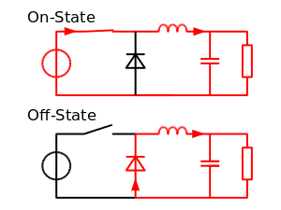

1. **Buck-Boost Converter:**

Contrary to Buck Boost, Buck-Boost Converter has the ability to deliever a higher voltage level that exceeds the input voltage level, and the ability to step it down.

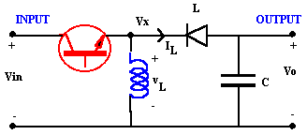

When switch is on, L charges diode blocks input from output, when switch is off, capacitor supplies load, L reverses polarity, and so on.

1. **Full Bridge Converter**

It's used as a DC-DC Converter and as a DC-AC Converter, it uses IGBT's and controllers to control it's switching strategy in order to deliver the desired output, and it goes by the following formula.



**Procedure**

**Step Down Converter:**

Circuit in Figure (1) was drawn, connected in OrCAD.

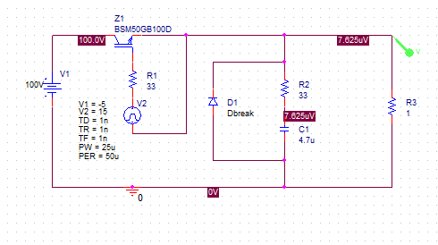For 50% duty cycle, the waveforms at the output, voltage of VCE, IGBT Gate current, and IGBT current wer recorded and saved



Figure (1.1)

Figure (1.2): Output Voltage & Its Average



Figure (1.3): VCE of IGBT



Figure (1.4): IGBT Current



Figure (1.5): IGBT Gate Current

Duty Cycle was changed by changing the gate pulse drive to have on time of 70% of the total period

Figure (1.6): Output at 70% duty cycle

FFT Analysis of the previous 70% duty cycle waveform was recorded and saved:

Figure (1.8): FFT of output at 70% duty cycle

Same procedure taken in the 70 percent was taken in the 20 percent duty cycle 

Figure (1.9): output at 20% duty cycle

A Low-pass filter was added at the output in OrCAD, IGBT Current, and Output voltage were taken recorded for different duty cycles.

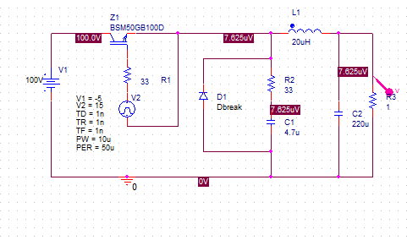

Figure (1.10): Circuit with LC filter

Figure (1.11): IGBT Current & Output Voltage

Gate drive was set to produce cycles with 50 percent duty cycle

Figure (1.12): IGBT Current & Output Voltage



Figure (1.13): IGBT Current & Output Voltage @ 70% Duty Cycle

FFT

Figure (1.14): Output Voltage FFT @ 70% Duty Cycle

Filter Size was changed and waveforms of output voltage were re-recorded again with the smaller capacitor (22uF)



Figure (1.15): Output Voltage @ 70% Duty Cycle & 22uF Capacitor 

Load Resistance was changed from 1 to 20, with capacitor set to 220uF

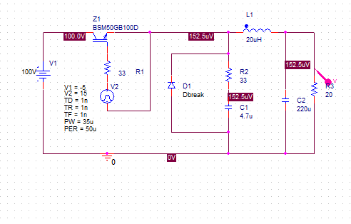

Figure (1.16): Circuit @ 70% Duty Cycle & 20ohm Load Resistance 

Figure (1.17): Output Voltage @ 70% Duty Cycle & 20ohm Load Resistance 

Part 2: Buck Boost Converter:

The Circuit in figure 2.1 was drawn on OrCAD

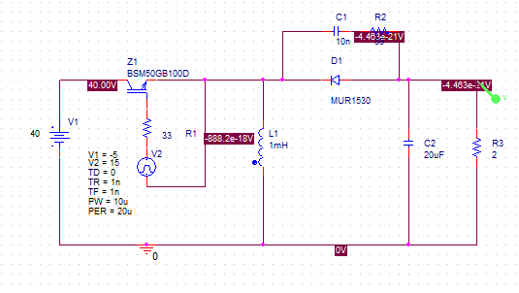

For Duty Cycle = 50%, the following output waveforms were obtained:



Igbt current



Zooming



Inductor Current

For Duty Cycle 20 percent: the following waveforms were obtained



IGBT Current

zooming



Inductor



70%

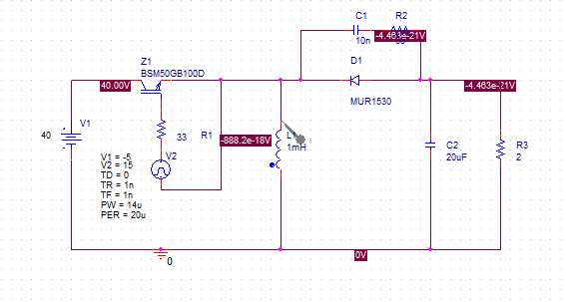

Output voltage and average



Zooming



FFT



IGBT Current



Zooming



Inductor Current



Zooming



The capacitance was changed to be 1uF instead of 20uF;

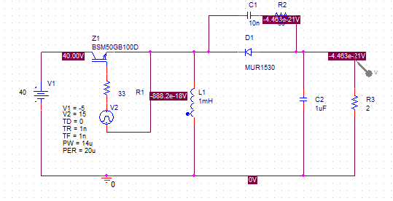







Part 3: Full Converter:

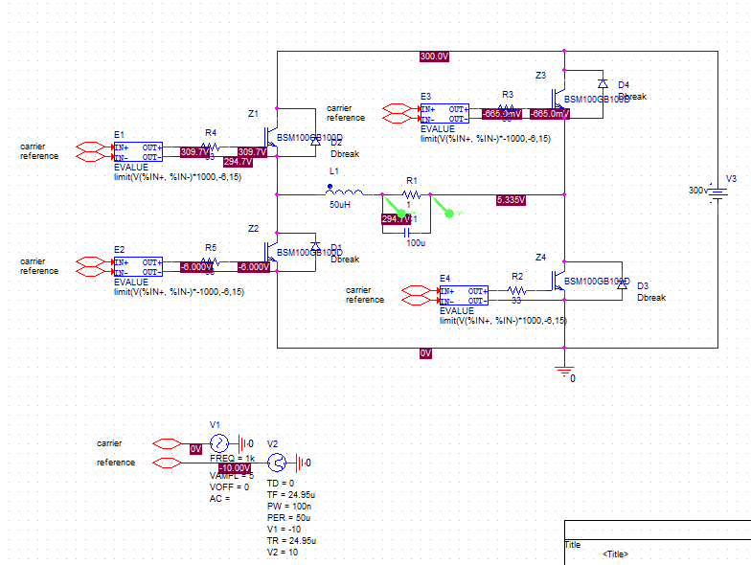

The following Circuit was drawn, with 1kHz Input signal

Output voltage across load resistor



Output across the filter:



Zooming



FOR Z1





Voltage





FOR Z4

current



zooming

voltage





GATE SIGNALS

FOR Z4



Zooming



FOR Z1



Zooming



CHANGING FREQUENCY TO 200

OUTPUT



Frequency=1/T=1/5ms=200Hz

CHANGING BACK TO 1000HZ





For 0.8



Peak = 365V



CHANGING TO 5V





Frequency=1/T=1/5u

Average = 0



**Result Discussion:**

Part I: Step Down Converter:

1. As for the Step Down converter we have seen how it was able to change the total average DC output, and it was by switching the IGBT by a drive in any desired frequency, that coincides with the total period to produce an output voltage directly proportional to the Duty Cycle. However using FFT in OrCAD we were able to see that the frequency response of the converter is highly distorted, and contains too much harmonics on output.
2. We tried to add to add low pass filter at the output in order to get rid of harmonics.

FFT before Low Pass filter was added:



After Filter



We were able to eliminate most of harmonics that have +20kHz frequencies! BIG CHANGE!

1. We then tried to change the capacitor in the LP filter to a smaller one, a smoother, less distorted output was obtained
2. At one ohm resistance the response at the output was UNDERDAMPED due to the low value resistance and had ~50V overshoot above the steady state value, whereas for the 20ohm resistance it was over-damped and had lower overshot ~20

20OHM Case:



1OHM CASE:

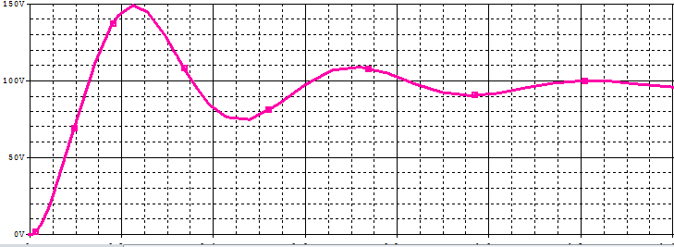

B. Buck-Boost Converter:

1. Average output results

|  |  |
| --- | --- |
| Duty Cycle | Average Output Voltage (Vin=40V) |
| 20% | ~11V |
| 50% | ~30V |
| 70% | ~70V |

2. Having a relatively large capacitance helped us avoid the unwanted harmonics, as we noticed having 1uF capacitance didn't do much about high frequencies, and didn't block it well..

C. Buck-Boost Converter:

At 1kHz carrier frequency, output voltage had ~1kHz output frequency, with 152V amplitude



When frequency was changed to 200Hz, amplitude was 135V, 200Hz Output

2. Changing Modulation Index:

For 0.2, voltage peak ~441V



For 0.8



Peak=365V

Result Discussion

1. Changing duty cycle is the main controller of the average DC voltage delievered by the converter.
2. Changing filter size accordingly plays a pivotal role in reducing harmonics.

**Conclusion**

In this experiment we used multiple softwares to simulate some the converters, and our results were convincing and correct, we saw the effects of changing filters parameters and even removing them, however due to the software of delievering