

Faculty of Engineering & technology

Electrical & computer systems Eng department

Simulation laboratory

Report for exp#3

**PCB Design & Implementation**

Student name :Mahdi alsalem

Student ID: 1121598

Instructor : dr.Jamal seyam

Date : 16th mar2016

**Table of contents**

|  |
| --- |
| Abstract ……………………………………………………………………………………3 |
| Introduction …………………………………………………………………………….3-6 |
| Methods and materials ……………………………………………………………..6 |
| Procedure and results ……………………………………………………………..7-11 |
| Discussion ………………………………………………………………………………..12 |
| Conclusion ……………………………………………………………………………….12 |
| References ……………………………………………………………………………….12 |

**Abstract**

The main objective of this experiment is to design a printed circuit board using Proteus program .

Proteus is a program that combines mixed mode spice circuit simulation ,animated components and microprocessor models to facilitate simulation of microcontroller based design .

A printed circuit board (PCB) is the board base for physically supporting and wiring the  surface-mounted and socketed components in most electronics.

In this experiment we will design a circuit board for a voltage regulator circuit using the Proteus program and PCB layout , and then we will install the gerber file into the CNC machine program to produce the required board .

**Introduction**

A Printed Circuit Board (PCB) is used to serve two main purposes in the construction of electrical system cards; it is a place to mount the components and it provides the means of electrical connection between the components A PCB consists of two basic parts: a substrate (the board) and printed wires (the copper traces). The substrate provides a structure that physically holds the circuit components and printed wires in place and provides electrical insulation between conductive parts. A common type of substrate is FR4, which is a fiberglass– epoxy laminate. Substrates are also made from Teflon, ceramics, and special polymers

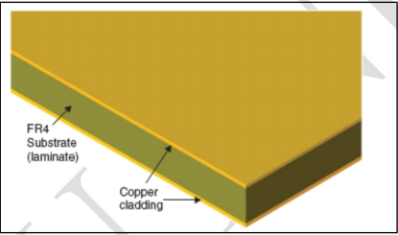

Fig2.1 A double-sided copper clad substrate

Once the layout is designed, it can be implemented on the board by several technologies The main processes in the board fabrication are :

-Removing the unwanted copper cladding such that the designed layout (tracks, pads, etc) is implemented by the copper.

-Drilling the board to place the components.

-Solder the desired connections.

The copper cladding can be removed in two main ways:

-Mechanical milling: To mill the board, a computer numerical control (CNC) machine is programmed with the digital map of the board and grinds away the unwanted copper.

-Wet acid etching: it is more common when manufacturing large quantities of boards because many boards can be made simultaneously

Selectively removing the copper with etching processes requires etching the unwanted copper while protecting the wanted copper from the etchant. This protection is provided by a

polymer coating (called photoresist) that is deposited onto the surface of the copper cladding as shown in Figure2.2 The photoresist is patterned into the shape of the desired printed circuit through a process called photolithography. The patterned resist protects selected areas of the copper from the etchant and exposes the copper to be etched

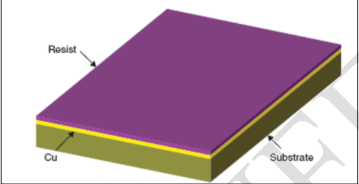

Fig2.2 A copper clad board coated with photoresist

There are two steps to photolithography, patterning the photoresist - exposing the resist to light (typically ultraviolet (UV) light) and developing it (selective removal in a chemical bath). A mask is used to expose the desired part of the photoresist. A mask is a specialized black and white photographic film or glass photoplate on which a picture of the traces and pads is printed with a laser printer. The mask is placed on top of the photoresist as shown in Figure 2.3(b), and the assembly is exposed to the UV light. The dark areas block UV light and the white (transparent) areas allow the UV light to hit the photoresist, which imprints the circuit image in to the photoresist. A separate mask is used for each layer of a circuit board. After the photoresist has been exposed with the mask and UV, it is washed in a chemical called the developer. The resist breaks down during exposure and is removed by the developer. Common developer is

sodium hydroxide (NaOH). Once the resist has been exposed and developed, a circuit image made of the photoresist is left on the copper as shown in Figure 3.4 (a)

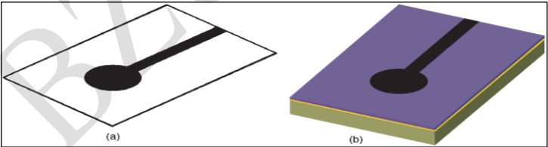

Fig3.3 (a) Photomask. (b) Photomask on photoresist-coated board

Next, the board is etched in an acid solution such as ferric chloride (FeCl3) or sodium persulfate (Na2S2O8). The etching solution does not significantly affect the photoresist but attacks the bare copper and removes it from the substrate, leaving behind the resist-coated copper as shown in Figure 3.4(b).

Finally the photoresist is cleaned from the copper with a resist stripper, leaving behind the copper traces. Figure 3.4(c) shows the final patterned copper

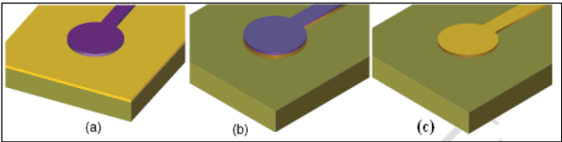

Fig3.4 (a) Developed photoresist on copper. (b) Unwanted copper removed after etching. (c) Copper pad and trace after etching and resist stripping

**Methods and materials**

Proteus program / PCB layout

Computer device

CNC machine

Printed circuit board (PCB)

**Procedure and results**

**Software**

1-the Proteus program was opened and the circuit shown in figure 3.1 was designed in the schematic capture of the program

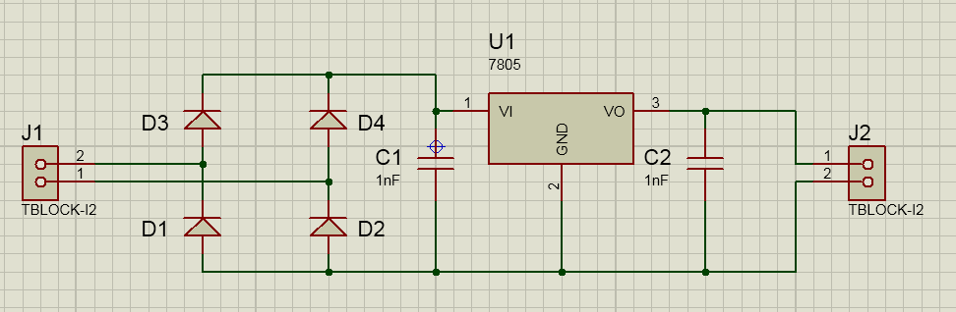

Fig3.1 schematic capture design of the circuit

2-using the PCB layout in the Proteus program the components was placed in the board and then the layout was routed and the routed board was appeared as in figure 3.2

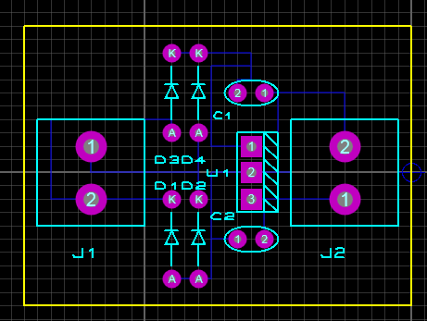

Fig3.2 routed board on PCB

3-the widths of the lines that connect the components (tracks) were chosen to be 10th ( th =0.001 In ) using the track mode in the PCB Layout

4-a gerber file was built using the window shown in figure 3.3

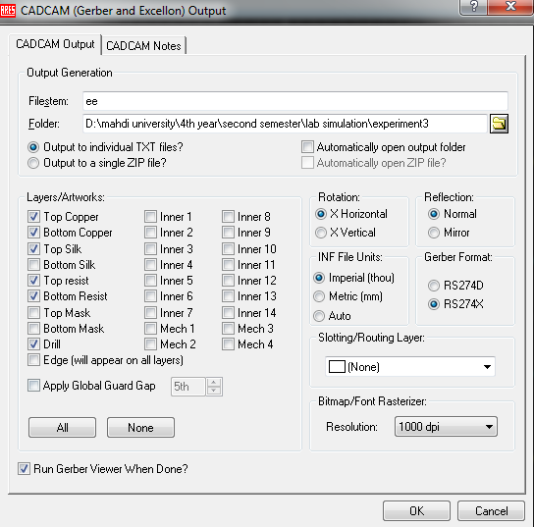

Fig3.3 window for constructing the gerber file

The gerber file as shown in Proteus is shown in figure 3.4

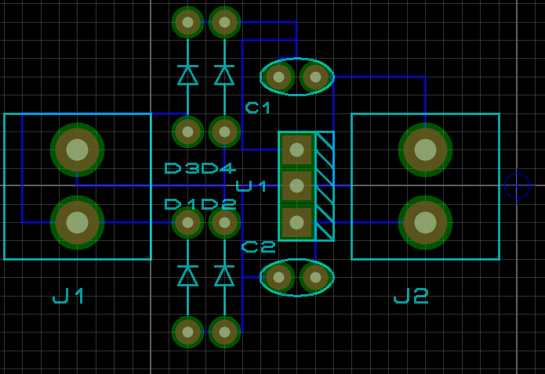

Fig3.4 gerber file

A bitmap pic was exported using the window shown in figure 3.5

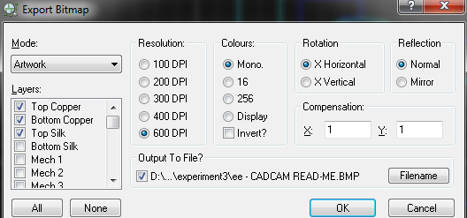

Fig3.5 window for exporting bitmap pic

The bitmap pic is shown in figure 3.6

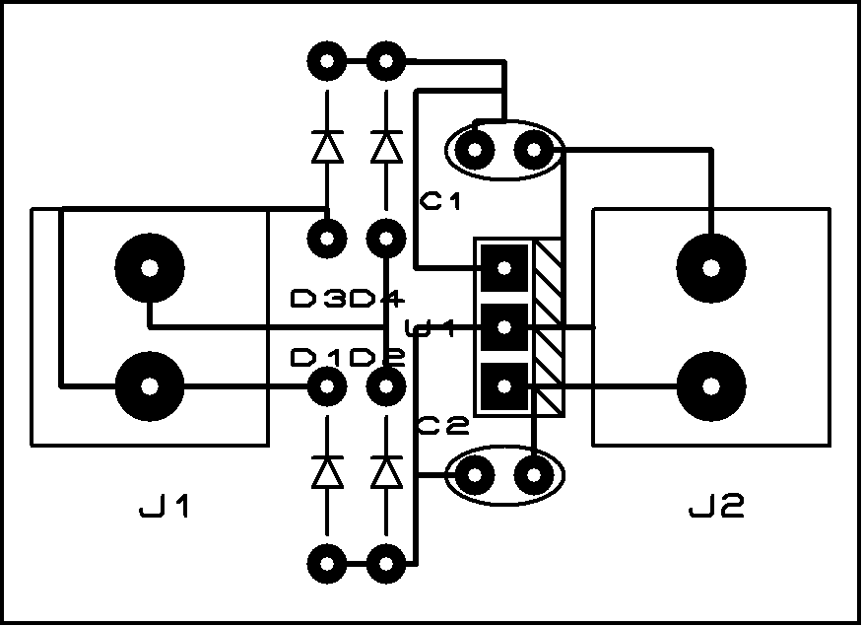

Fig3.6 bitmap pic

A 3-d view of the circuit board from bottom side and top side are shown in figure 3.7 and figure 3.8

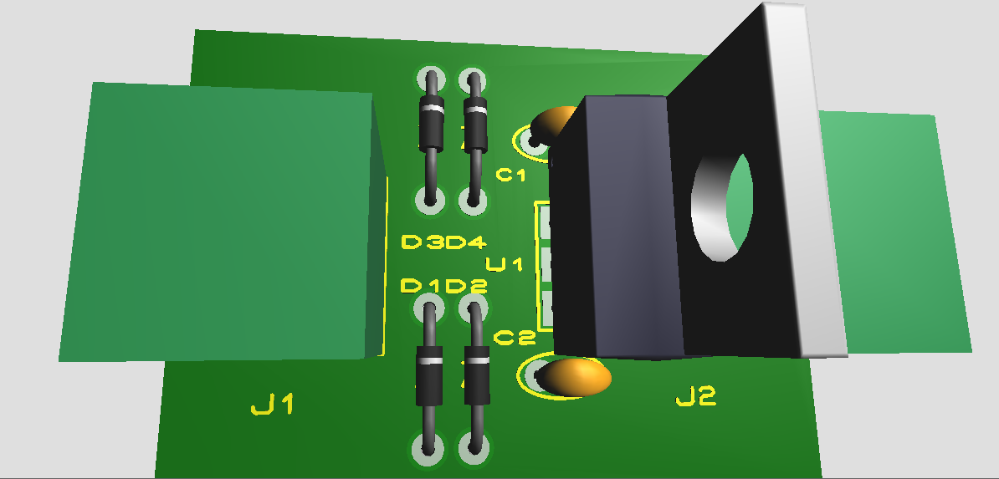

Fig3.7 3-d view for the top-side of the board

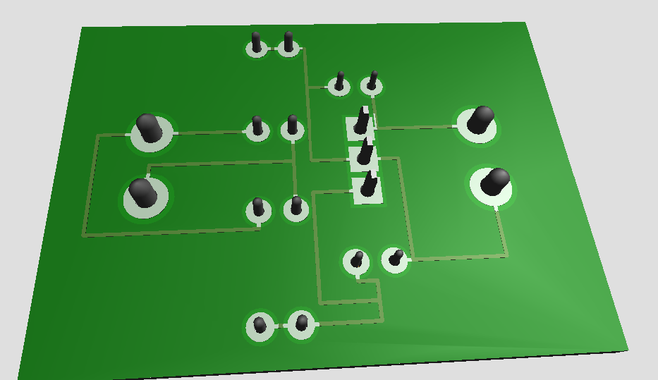

Fig3.8 3-d view from the bottom side of the board

**Hardware**

the gerber file which is built in the software part in Proteus program was loaded into the program of the CNC machine , the program give us the required feathers , then the CNC machine cut the required board from the square peace of the copper and also the CNC machine drills the required holes for the circuit .

**Discussion**

**Why the area of the board should be small ?**

Larger area means more copper required , so the cost will be increase

**Why the edges of the tracks should be 90 degree?**

90 degree angles or worse still: more than 90 degree sharp corners will always cause longer traces (higher impedance, more copper use) than traces that try to snake around obstacles. And often, your board size is limited, so you want to use as much area for the actual components, not the traces in between.

**Why the tracks should be with large width ?**

The width of the tracks should be largeto reduce the resistor of them , but in this experiment the width is chosen to be 10th to make the area of the board as small as possible . and to prevent overlapping between the components of the circuit .

**Conclusion**

In this experiment we learn how to use Proteus program to design a printed circuit board and also we learn how to use CNC machine to implement the design on the real world .

I faced many problems in class which are solved in this report :

1-the edges of the tracks are not 90 degree .

2-there are a large spaces between the components in the board .

The board designed in this report solves these problems and requires less cost than the board designed in the class .

**References**

<http://electronics.stackexchange.com/questions/76406/sharp-corners-in-pcb-traces>

lab manual