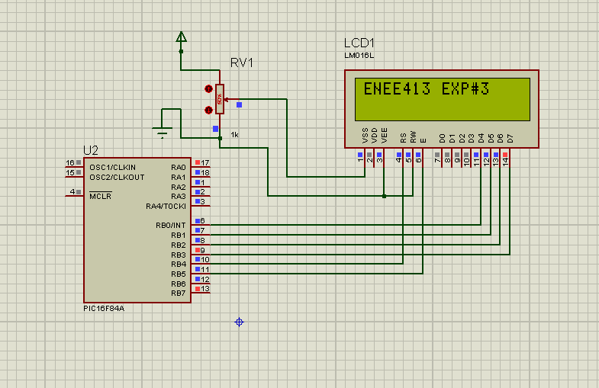

sbit LCD_RS at RB4_bit;

sbit LCD_EN at RB5_bit;

sbit LCD_D7 at RB3_bit;

sbit LCD_D6 at RB2_bit;

sbit LCD_D5 at RB1_bit;

sbit LCD_D4 at RB0_bit;

// Pin direction

sbit LCD_RS_Direction at TRISB4_bit;

sbit LCD_EN_Direction at TRISB5_bit;

sbit LCD_D7_Direction at TRISB3_bit;

sbit LCD_D6_Direction at TRISB2_bit;

sbit LCD_D5_Direction at TRISB1_bit;

sbit LCD_D4_Direction at TRISB0_bit;

void main() {

TRISA = 0x00; // set all pins of port A as output

TRISB = 0x00; // set all pins of port B as output

while(1)

{

lcd_init(); // initialize the lcd

lcd_out(1,1,"ENEE413 EXP#3"); // print this message

Lcd_Cmd(_LCD_CURSOR_OFF);

delay_ms(1000);

}

}

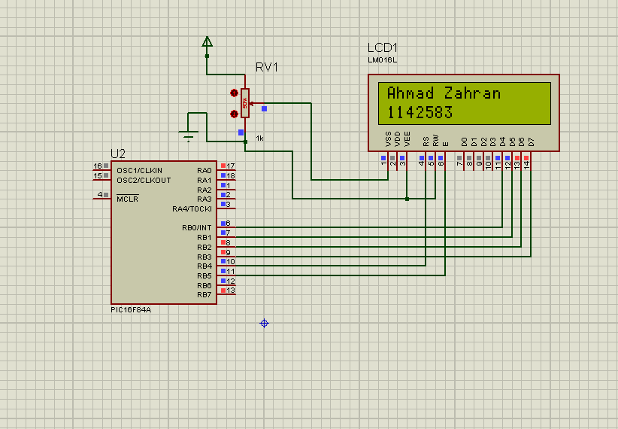

while(1)

{

lcd_init(); // initialize the lcd

lcd_out(1,1,"Ahmad Zahran"); // print this message

lcd_out(2,1,"1142583");

Lcd_Cmd(_LCD_CURSOR_OFF);

delay_ms(1000);

}

}

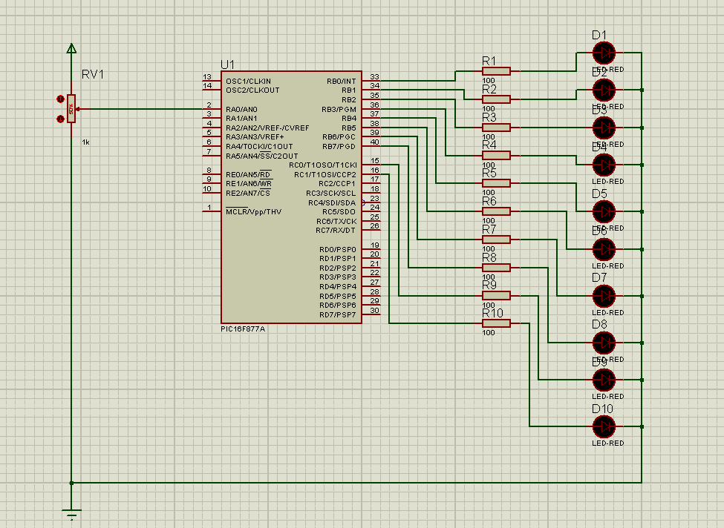

At 36%

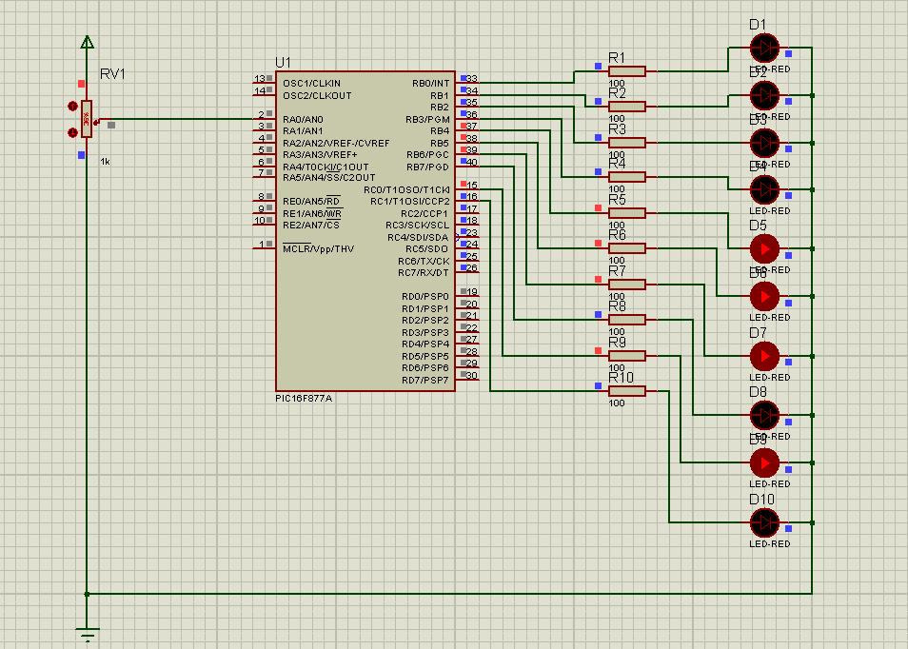

At 48%

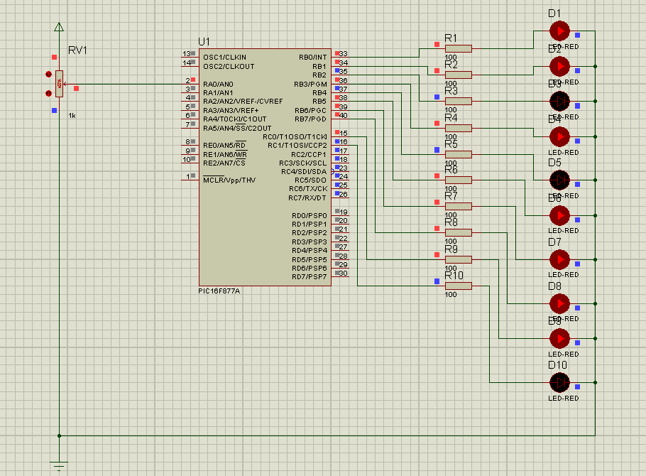

At 82%

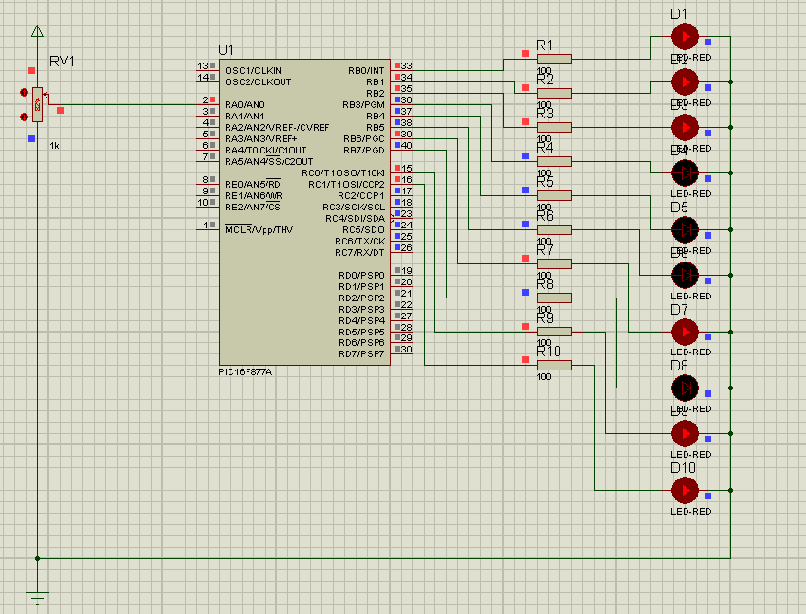

AT 99%

