

Experiment No. 5

Linear Systems Simulation in Matlab

Simulation Lab

Section: Saturday 2:00-5:00pm

Instructor: Ashraf Rimawi

Teaching Assistant: Dalal Hamdan

Student Name: Haitham Da’ana

Student ID: 1121331

**Date: 22/10/16**

**Table of Contents:**

1. Abstract - Page (3)
2. Introduction - Page (3)
3. Procedure & Results Discussion - Page (4)
4. Conclusion - Page(13)
5. References - Page(14)

**Abstract:**

1. **Objectives:**

The aim of this of this experiment was to test out and exhibit the theoretical implementation and analysis of Linear Time Invariant Systems using Matlab, along with basic arithmetic operations of Matlab, in both time and frequency domain, and to modeling circuits into Matlab, and analyze their Transfer Function in frequency domain.

1. **Method Used and Tools:**
2. Matlab

**Introduction:**

In this experiment we used Matlab to analyze circuits in frequency domain, and time domain, along with learning some basic functions in Matlab that paves the way to easier analysis and functions.

MATLAB, by MathWorks, is a high level computation and simulation language that allows easy and reliable manipulation of vectors and matrices, the more immediate objective of this report is to demonstrate the use of MATLAB in solving common problems in circuit analysis. Their solution requires a variety of computations with the following common themes:

* Vector and matrix manipulations
* Solutions of differential equations
* Display of results

**Experimental Procedure & Results:**

1. Circuit Analysis:

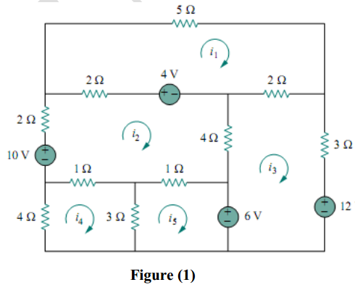

KVL was applied to every loop in the circuit in Figure 1 above and the equations obtained were as follows:

$$9I_{1}-2I_{2}-2I_{3}=4$$

$$-2I_{1}+10I_{2}-4I_{3}-I_{4}-I_{5}=6$$

$$-2I_{1}-4I_{2}+9I_{3}=-6$$

$$-1I_{2}+8I_{4}-3I_{5}=0$$

$$-1I_{2}-3I_{4}+4I_{5}=6$$

Matlab was used to solve this system of linear equations using Matrices commands and functions:

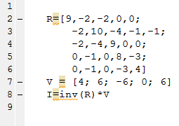

Results came as shown in the figure below:

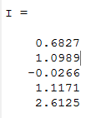

1. For the Following Transfer Function in the figure below, frequency response was obtained using Matlab’s standard plotting and complex numbers capabilities

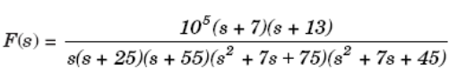

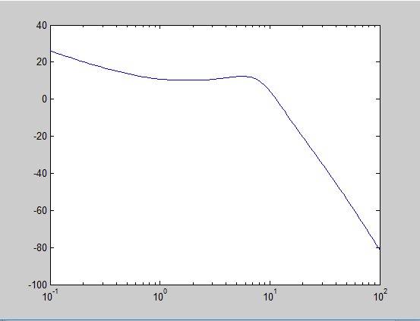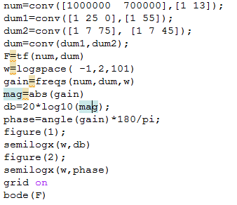

The following results were obtained:

1. Frequency Response in figure 1.

Frequency Response

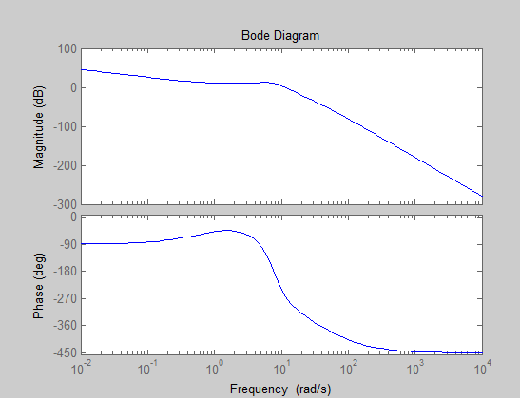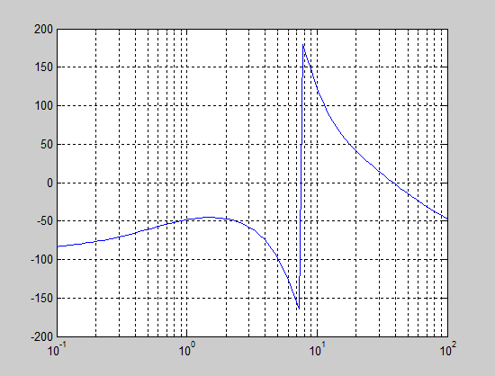

Figure 2: Phase Plot

Figure 3:Bode Plot

1. A Matlab program was written for the following control system block diagram

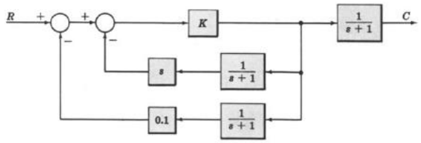

A plot of the response of the system was captured and recorded.

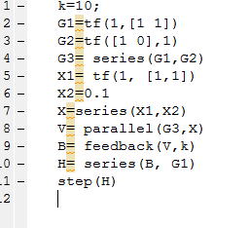

The following step response was obtained:

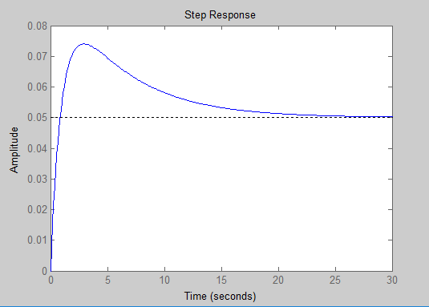

1. The following function was represented and plotted using Matlab function ‘heaviside’



The code:

t=-3:0.01:5;y=(t.*t.*((heaviside(t+1))- (heaviside(t))))+ ((t-1).*((heaviside(t))- (heaviside(t-1))))+ ((-1).*((heaviside(t-1))- (heaviside(t-2))));

plot(t,y);grid

Output waveform

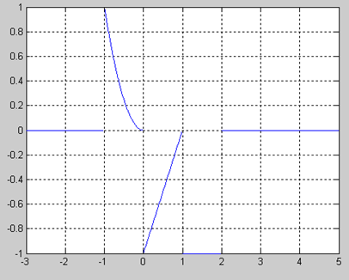

1. For the following Circuit, Transfer Function was obtained and derived and using Matlab Poles and Zeroes were obtained and it was as follows:

$$H\left(s\right)=-\frac{1.5625}{s^{2}+{10}^{4}s+1.25x{10}^{8}}$$

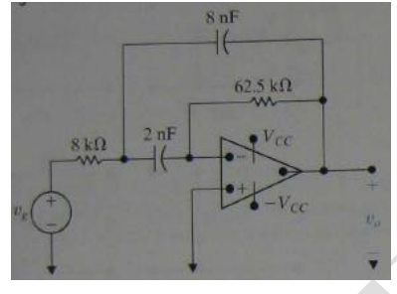

The following code was written:

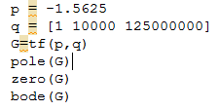

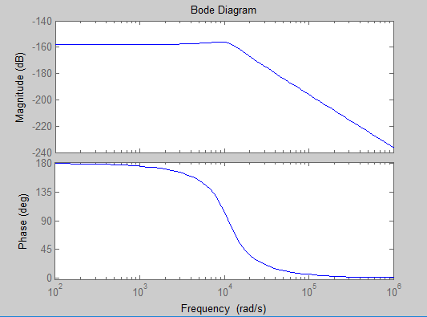

Results came as follows:

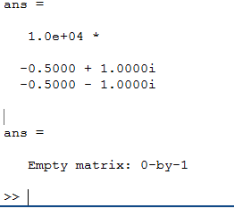

1. For the following Circuit, differential equation that describe Vc(t) of the circuit was derived.

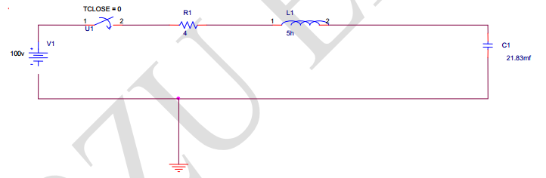

Differential Equation that describes Vc(t) was derived in s domain and it was as follows:

$$Vc(s)=\frac{9.162}{s^{2}+0.8+9.162}$$

It was represented in Matlab, poles where directly obtained through the command “pole”, and bode plot was obtained directly through the command “bode”

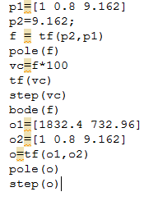

Poles were as follows:

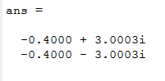

And Vc(t) is plotted in figure below

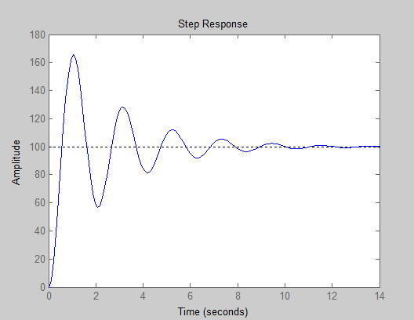

And to find current of inductor we derived the transfer function:

And it came as follows:

$$Il\left(s\right)=\frac{1832.4s+732.96}{s^{2}+0.8s+9.162}$$

And using command plot, it was plotted directly through Matlab and it’s response was as follows:

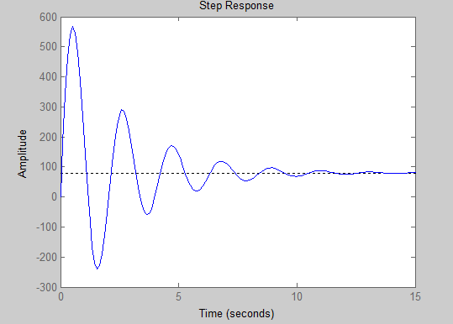

1. For the following circuit Transfer function of it was obtained:

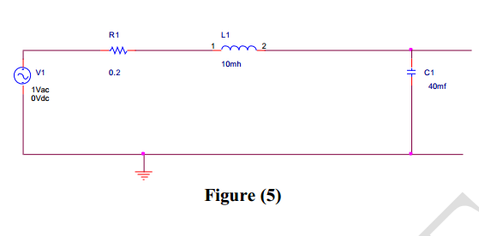

$$H(s)=\frac{VC\left(s\right)}{VI\left(s\right)}$$

$$H(s)=\frac{2500}{s^{2}+20s+2500}$$

And Using bode command, bode plots were obtained and using the cursor on the plot we were able to pinpoint the corner frequency and cut off frequencies of the filter.

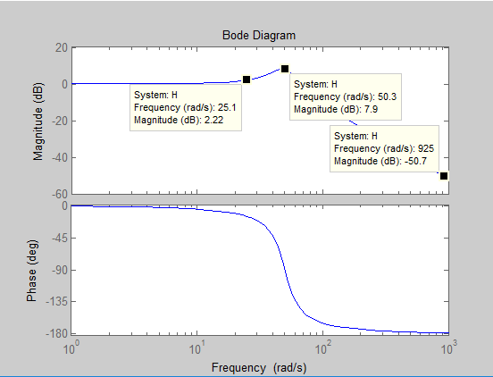

The code:

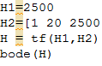

**Discussion:**

Using Matlab has helped us to obtain results and plot transfer function faster than the ordinary plotting, Matlab provided us with an alternative fast way to obtain results, our Results came as expected and they were true, the whole operations of this experiment were straight forward except for the part where we had to find the transfer function of circuits by hand, other than that it was STRAIGHT FORWARD.

**Conclusion:**

This report demonstrated the use of MATLAB for solution of various problems arising in Feedback Systems. These problems included the computation of system responses, system properties (e.g., poles), construction of simulation models, and the handling of figures. Of course, this document provides only a quick overview of the tool capabilities. We demonstrated how we can solve a system of equations in MATLAB through Matrices and so on, along with modeling circuits into the Matlab, to obtain certain Transfer Functions.

**References:**

Franklin, Powell, Emami-Naeini, *Feedback Control of Dynamic Systems*, 3rd Ed., Addison Wesley, 1994.

*MATLAB Help, (On-line documentation, Release 12)*, Copyright 1984-2000, The MathWorks.

G. Strang, *Linear Algebra and its applications*. 2nd Ed. Academic Press, NY, 1980

K. Tsakalis, “Sample Simulink models and Matlab scripts for the Lab,” in [http://www.eas.asu.edu/~tsakalis/coursea](http://www.eas.asu.edu/~tsakalis), Arizona State University, Aug. 2001.