

Experiment No. 7

AM Modulation using LabVIEW

Simulation Lab – ENEE4104

Section: Saturday 2:00-5:00pm

Instructor: Ashraf Rimawi

Teaching Assistant: Dalal Hamdan

Student Name: Haitham Daana

Student ID: 1121331

**Date: 7/12/16**

**Abstract:**

The aim of this experiment was to simulate a AM Modulation/DeModulation Systems using LabVIEW, and visualize them using LabVIEW models and features, along with introducing some of the functions in LabVIEW, and to observe the output signals out of the programmed system, and to observe the effects of changing the frequency of signal and carrier on both time domain of the signal and frequency domain.

**Introdcution:**

Modulation is a process by which characteristics of a high-frequency carrier signal are altered to convey information contained in a lower-frequency message. Though it is theoretically possible to transmit baseband signals (or information) without modulating the data, it is far more efficient to send messages by modulating the information onto a carrier wave. High frequency waveforms require smaller antennae for reception, efficiently use available bandwidth, and are flexible enough to carry different types of data. There are a variety of modulation schemes available for both analog and digital modulation.[1]

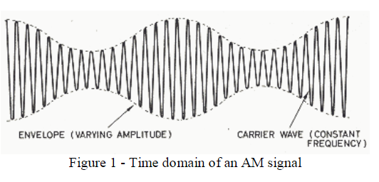

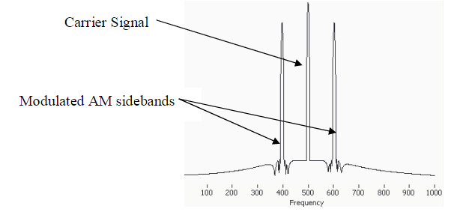

To Implement the AM Modulation scheme, LabVIEW was used. LabVIEW is a highly productive development environment for creating custom applications that interact with real-world data or signals in fields such as science and engineering.[2]

LabVIEW is commonly used for Data Acquistion and Instrumental Control and Industrial Automation on a variety of operating systems.

LabVIEW integrates the creation of user interfaces (termed front panels) into the development cycle. LabVIEW programs-subroutines are termed virtual instruments (VIs). Each VI has three components: a block diagram, a front panel, and a connector panel. The last is used to represent the VI in the block diagrams of other, calling VIs. The front panel is built using controls and indicators. Controls are inputs: they allow a user to supply information to the VI

Indicators are outputs: they indicate, or display, the results based on the inputs given to the VI. The back panel, which is a block diagram, contains the graphical source code. All of the objects placed on the front panel will appear on the back panel as terminals. The back panel also contains structures and functions which perform operations on controls and supply data to indicators. The structures and functions are found on the Functions palette and can be placed on the back panel.[3]

**Procedure and Results:**

***PART I****: Amplitude Modulation:*

1. In LabVIEW’s front panel, all the required instruments that are needed in real life to implement such experiment an equivalent model of each one of them was placed in the front panel, and these models were:
2. Four Waveform Graphs, which represented the Carrier Signal, Message Signal, AM Modulation Signal, and the FFT of the Modulated Signal.
3. Five Horizantal Slide Bars, which represented the Modulation Index, Carrier Signal Frequency, and Message Signal Frequency, Message Signals Amplitude, and Final Carrier Signal Amplitude

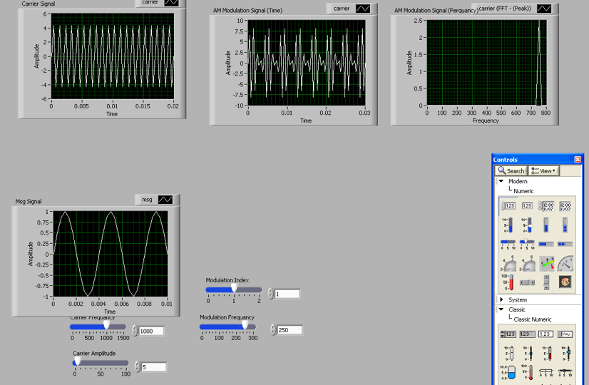

Figure 2: Final Front Panel for AM Modulation

1. In the Block Diagram, a while loop was made and inside it, all the circuit was placed so it effects of our circuit.

Two “Simulate Sig” were placed in the block diagram, which represent the carrier signal and message signal, the pointer slides were connected to the inputs of the block, so that the amplitude and frequency of the signal can be controlled in the front panel.

1. The outputs of the Simulate Sig Blocks were connected in a way to represent the following equation using mathematical blocks (Multiplication and Addition), and afterwards the required Waveform Graphs, were connected to the Message Signal, Carrier Signal, Amplitude Modulated Signal, and an Additional block was connected to AM Signal, which transforms the signal to frequency domain, and subsequently was connected to the fourth waveform graph, named “AM Signal in Frequency Domain”. As shown in figure no.3.

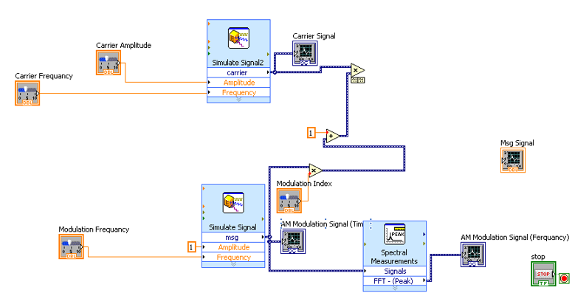

Figure(3): Block Diagram of AM Modulation

***Results*** *of PART I:*

The carrier frequency was fixed at 500Hz, and the modulation index was varied:

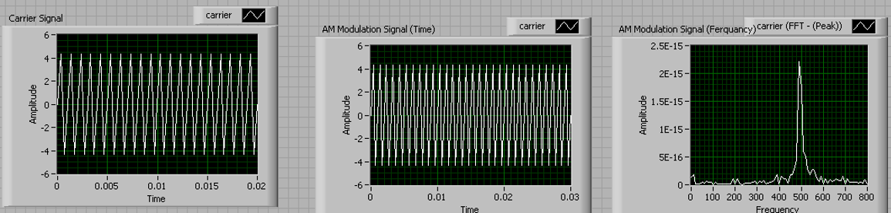**For modulation index equal to 0:**

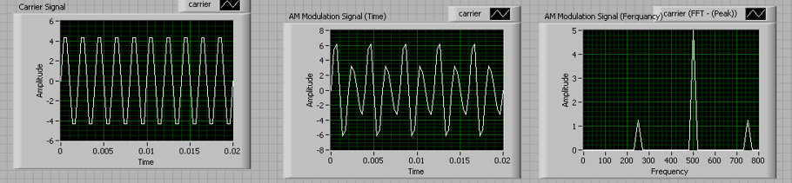**For modulation index equal to 0.5**

**:**

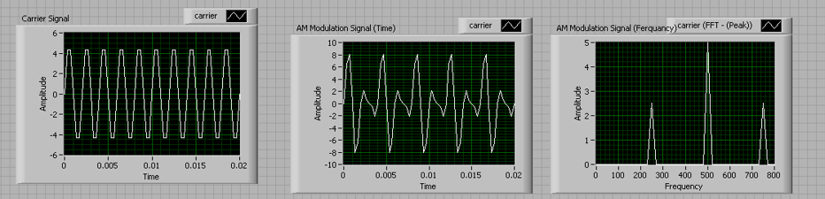**For modulation index equal to 1:**

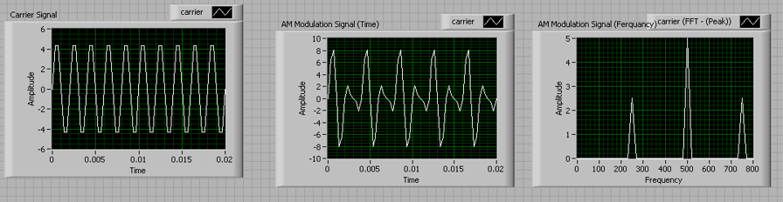**For modulation index equal to 1.5:**

***PART II****: Amplitude DeModulation:*

In this part, a demodulation block diagram was added to the previous one, in order to recover the amplitude modulated signal in the first case, so in order to implement this. The AM Signal was connected to a low pass filter along with a diode rectification method to recover the signal, this is shown in figure 4 below:

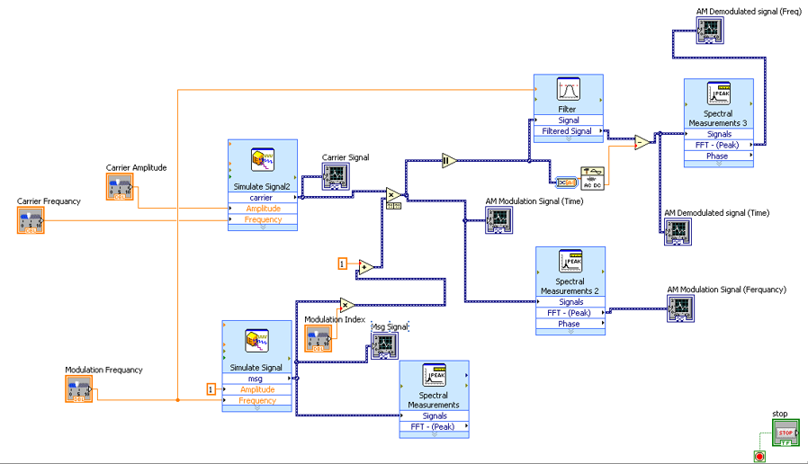

Figure 4: Block Diagram of AM & DeModulation

1. In front panel, two more Waveform Graph were added to represent the frequency and time domain of the DeModulated Signal.
2. In Block Diagram, Filter, and Rectifier were connected to the AM Modulated signal, with a subtractor, and the output was taken to waveform graph of frequency and time-domain

***PART II****: Results of Amplitude DeModulation:*

1. Carrier Frequency was fixed at 1000, and Modulation Index was varied:

For Modulation Index at 0.7

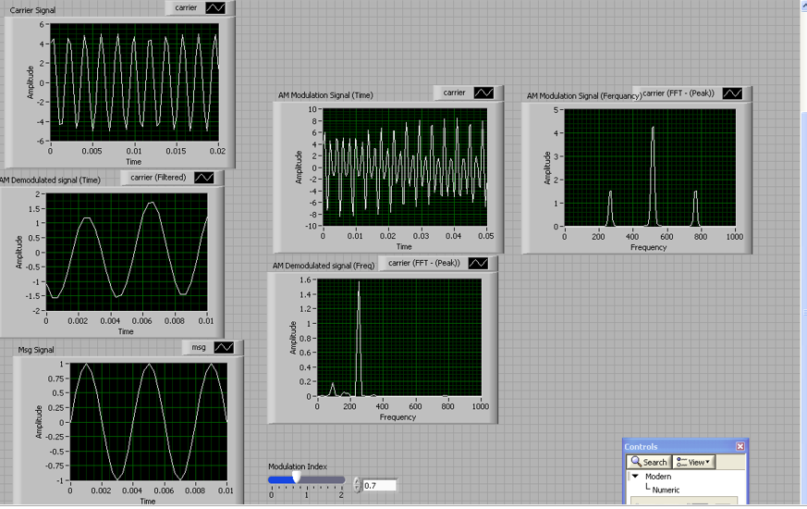

For Modulation Index at 0:

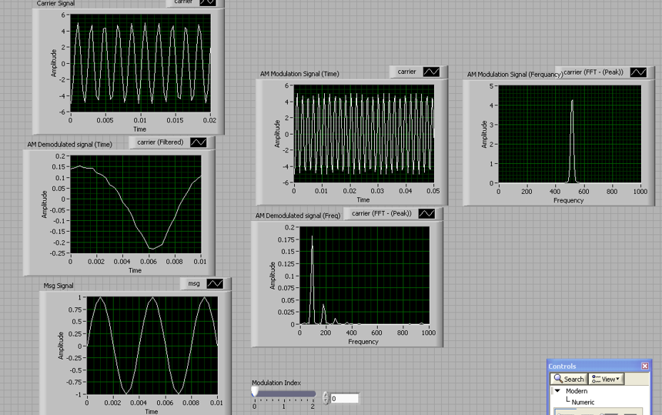

For Modulation Index at 1:

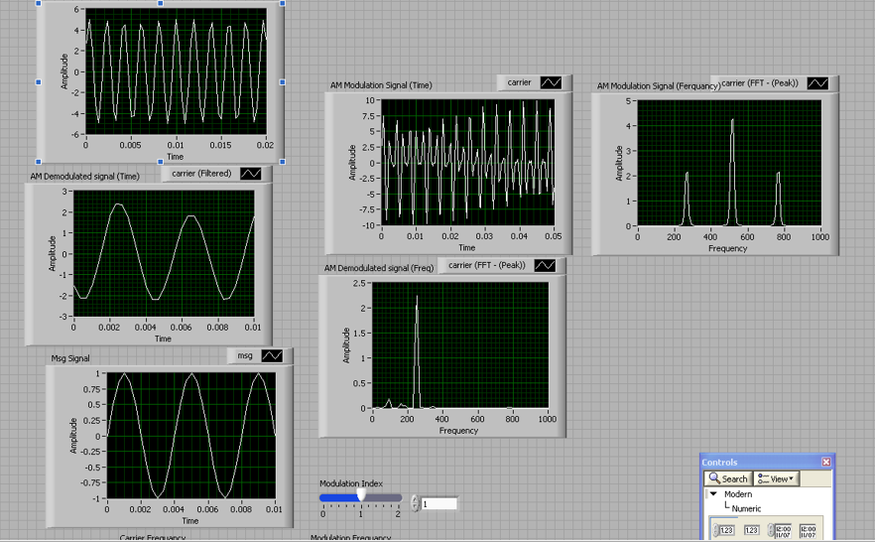

For Modulation Index at 1.5:

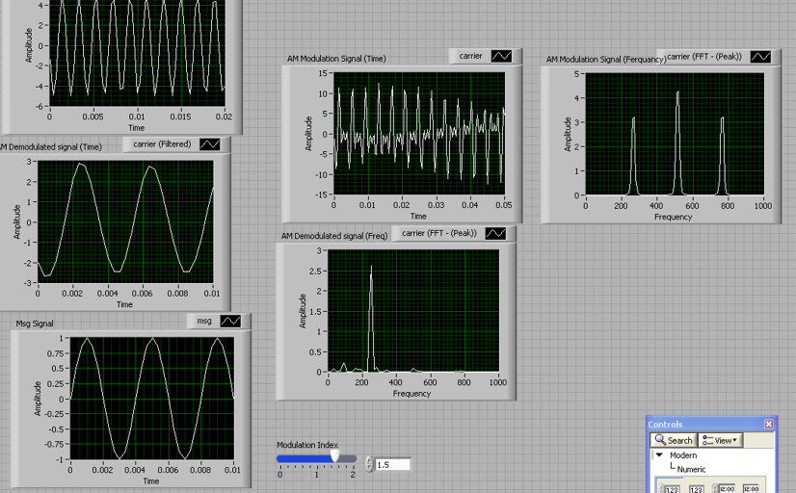

Exercise:

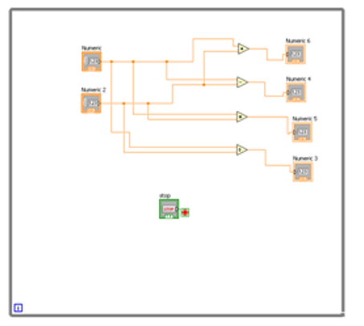

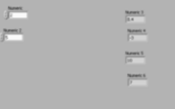

**Result Discussion:**

1. At first when the message Signal was Modulated we observed that the carrier frequency determines the frequency at which the signal is transmitted at and it’s equal to frequency of the carrier frequency plus/minus the frequency of the message signal.
2. AM Modulation has advantage of having simple circuitry and easy to implement, however, most of the power is lost in the carrier which hold no information whatsoever, and the rest is left for the message signal.
3. When Modulation Index is between 0 and 1, signal is recoverable and there is no distortion in envelope of message signal in modulated signal, however when overly modulated (>1) the signal is unrecoverable, and the modulated signal will be distorted and the de modulated message signal will have lost its original shape
4. AM Signal is vulnerable for distortion due to carrying the signal in it’s amplitude, so any distortion in amplitude or noise in amplitude will change the envelope of the signal, hence will be distorted.

**Conclusion:**

In this experiment, it was observed that AM Modulation is so simple to implement having a simple circuitry and simple mathematical form, however, due to the message signal being carried on the amplitude of the carrier signal, this makes any noise in amplitude to affect the message signal shape, hence distortion.

This can be overcome if the message signal was modulated on another thing other than amplitude, for example, FM Modulated (Frequency Modulation) it carries the modulation signal in its frequency, hence any noise on amplitude of the signal will not affect the message signal since the noise only affects the amplitude but the frequency is not affected!

Another problem lays in this scheme is that the power is lost in carrier signal (About 2/3 of the power is consumed in transferring the carrier signal which holds no information whatsoever).

**References:**

[1]: Laurence Gray and Richard Graham (1961). *Radio Transmitters*. **http://www.ni.com/newsletter/51141/en/**pp. 141ff.

[2]:  [*"Using the LabVIEW Run-Time Engine"*](http://zone.ni.com/reference/en-XX/help/371361B-01/lvhowto/using_the_lv_run_time_eng/).: Retrived from “http://zone.ni.com/reference/en-XX/help/371361B-01/lvhowto/using_the_lv_run_time_eng/”, **National Instruments.**

[3]: “What is LabVIEW?”, “http://www.ni.com/newsletter/51141/en/”., ***National Instruments***