

Faculty of Information Technology

Electrical Computer Engineer Department

Control and Power Electronics LAB

ENEE4105

**Report of Experiment 1**

**Programmable Logic Controller**

Student Name: Ahmad Bodair.  
Student ID: 1130455.

Instructor: Dr. Jaser Sa’Ed.

Eng.: Hammam Hamad.

Date: 7/3/2017

Abstract:

This experiment aims to give an introduction to the basic concepts of using Programmable Logic Controllers (PLCs), and their different operations such as (AND/OR operation, internal relay, PLC timed operation, Counter operation, jump instruction). The PLC program can be written in many languages for example, Ladder diagram, Sequential Function Charts, Function Block Diagram. In this experiment Ladder diagram is used. The PLCs are widely used in the field of protection and automation in electrical systems.

Table of Contents

Abstract I

List of Figures III

Theory 1

Procedure 2

Part A: Common connections 2

Part B: Testing the PLC 2

Part C: AND/OR operation 2

Part D: PLC internal relays 3

Part E: PLC timed operation 3

Part F: PLC counter operation 4

Part J: PLC jump instruction 5

Discussion 6

Conclusion: 6

References 7

List of Figures

Figure 1: PLC conceptual application diagram. 1

Figure 2: Ladder Programming for testing the PLC 2

Figure 3: The Ladder programming for a) AND/OUTPUT operation. b) Branched outputs 3

Figure 4: The Ladder programming for PLC internal relays. 3

Figure 5: The Ladder programming for PLC timed operation. 4

Figure 6: The Ladder programming for PLC counter operation. 4

Figure 7: The Ladder programming for PLC jump instruction. 5

Theory:

PLCs are solid-state members of the computer family, using integrated circuits instead of electromechanical devices to implement control functions. They are capable of storing instructions, such as sequencing, timing, counting, arithmetic, data manipulation, and communication, to control industrial machines and processes as shown in Fig(1) [1]. PLCs are used in many applications in electrical systems, they are used instead of relay circuits in industrial automation.

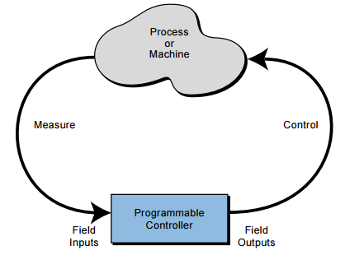

Figure 1: PLC conceptual application diagram.

In this experiment various PLC elements (input elements, output elements, internal relays, timers, counters and conditional jump relays) were used. Input elements (with addresses starting with an X) take different forms to be implemented such as (┤├) which is known as normally open switch, Output elements (with addresses starting with a Y) take different forms to be implemented such as (< >), Internal relays (with addresses starting with an M) take the forms to be implemented such as (< >) which control other input switches that have the same address, Timer, Counter, and conditional jump relays elements starting with a T, C, JC as an address[2], respectively. These elements were used in order to help the programmer to have a control on many applications that are used in the realistic life, such as the elevators, traffic light, control the machines in the Factories, and so on. Ladder logic was used in this experiment because it is widely used to program PLCs than other languages because of its simplicity, moreover it has been used in very complex automation systems.

Procedure:

Part A: Common connections:

In order to supply power to each of the switch and light on the training plane, the plane ON/OFF was set to OFF and (-24 V) was connected to light common and switch common to input common and (+24 V) was connected to output common

Part B: Testing the PLC:

The pendant was plugged into the PLC, then RUN/STOP switch on the panel was set to STOP, after that the main power switch was turned on , the LDR WR was pressing in order to enter the ladder-programming shown in Figure 2, after that CNV GO was entered to convert the program into the list language, after that PC WRITE was pressed in order to store the program into the PLC memory, then some time was token to executing the program, after the program was finished RUN/STOP switch was turned to RUN, input X401 was connected to switch “A” and output 431 was connected to light “B”, in order to test the PLC switch A was pressed and light B was lighted up.

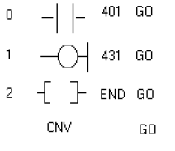

Figure 2: Ladder Programming for testing the PLC

Part C: AND/OR operation:

The ladder programming shown in Figure 3.a was entered, then switch ”E”, switch “A” , switch “F” , switch “B” , and switch “G” were connected to inputs X401, X402, X403, X404, and X405, respectively, also switch “H” was connected to the output Y430. It was noticed that the light “H” can be lighted if switch ”E” and switch “F” were pressed or if switch “G” was pressed ( this can only be achieved if the normally close input (X402,X404) were connected with normally close switch). After that, the ladder programming shown in Figure 3.b was entered, then switch ”A” and switch “B” were connected to inputs X401 and X402, respectively.

1. b-

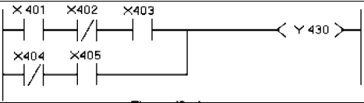 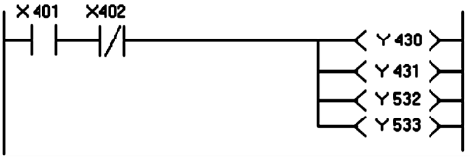

Figure 3: The Ladder programming for a) AND/OUTPUT operation. b) Branched outputs

Part D: PLC internal relays:

The ladder programming shown in Figure 4 was entered, and then switch “A”, switch “B” , switch “C”, and switch “D” were connected to inputs X401, X402, outputs Y430, Y431 respectively. After that switch “A” was pressed light “C” was lighted up, then switch “B” was pressed this activate the internal relay M103 and as a result of this light “D” was lighted up and light “C” was turned off.

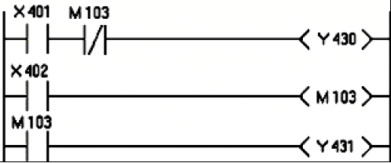

Figure 4: The Ladder programming for PLC internal relays.

Part E: PLC timed operation:

The ladder programming shown in Figure 5 was entered, and then switch “E” was connected to input X402 and switch “A” was connected to output Y430, then the timer was entered as following:

--O--| 451 go: this instruction aims to give the timer an address.  
--[ ]-- K5.0 go: this instruction is responsible for turning on the output Y430 after 5 seconds and turning off the output Y430 after 5 seconds.

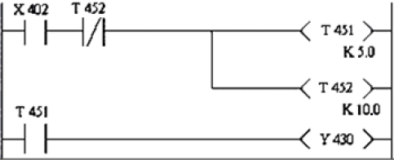

Figure 5: The Ladder programming for PLC timed operation.

Part F: PLC counter operations:

The ladder programming shown in Figure 6 was entered, and then switch “A” was connected to input X400 and switch “B” was connected to input X401 and switch “C” was connected to output Y430, in order to enter the REST --[RST C460 ]--the following instruction was written :

--[ ]--RST 460 go.

After pressing on switch “A” for ten times, the light C was lighted up, and in order to turn off the light, switch “B” was pressed. It was noticed that during the count (for counter value less than 10) if the RST switch was pressed, the counter resets its value and the operation is restarted.

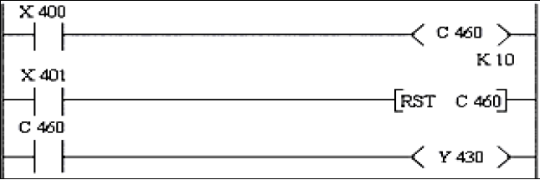

Figure 6: The Ladder programming for PLC counter operation.

Part J: PLC jump instruction:

The ladder programming shown in Figure 7 was entered, and then switch “A” was connected to input X400, switch “B” was connected to input X401, switch “C” was connected to input X402 and switch “D” was connected to input X403 and switch “E” was connected to output Y430 and switch “F” was connected to output Y431, in order to enter the --[CJB 700 ]--the following instruction was written :

--[ ]--CJB 700 go.

This operation allows the programmer to ignore a branch of the program and jump to the next branch.

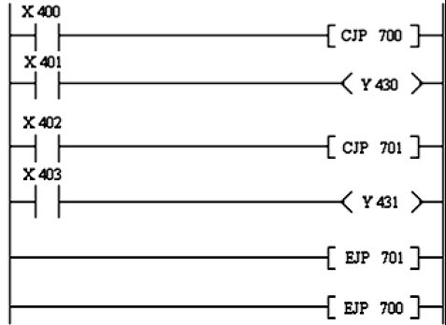

Figure 7: The Ladder programming for PLC jump instruction.

Discussion:

As noticed previously, PLCs have many useful applications which help in practice. Such as, the traffic lights which can be programmed by using a PLC timed operation shown in Figure 5 but with more Complexity and more input elements. Also PLCs are widely used in industrial life, nowadays, most of the local factories depend on PLCs to improve their work, for example a counter operations can be used for arranging soda cans in a factory, also PLCs can be used to run a conveyer belt used in airports and factories.

# Conclusion:

This experiment purposes to give an introduction to PLCs, which are used in many fields in practice, such as protection and automation in electrical systems, industrial life and controlling systems. This can be achieved by different operations such as (AND/OR operation, internal relay, PLC timed operation, Counter operation, jump instruction). These operations can be implemented and written by using different languages for example, Ladder diagram, Sequential Function Charts, Function Block Diagram.

# References

[1]L. A. Bryan, E. A. Bryan, “Programmable Contrllers Theory and Implementation “ 2nd ed. 1997.

[2] Birzeit University, “ Control and Power Electronics Lab Manual “, 2015