

ELECTRICAL AND COMPUTER ENGINEERING DEPARTMENT

ENEE4105

Control and Power Electronics Lab

Exp # 4  
Using Switch Relays in Control Circuit

Name: Ahmad Waleed Hamed

I.D #: 1120580

Instructor: Dr. Jaser Sa’Ed

Teaching Assistant: Hammam Hamad

***Table of Contents***

Abstract : 3

Theory : 4

Equipment : 5

Procedure and Discusion : 5

Conclusion: 8

References : 8

**Abstract**

In this experiment we use some of the basic elements of the control circuits such as relays, timers and contactors to build the circuits to reverse the direction of the 3-phase induction motor and to build the Y-⧍ starter for 3-phase induction motor system. At the end we use this elements to build the simple traffic lights.

**Theory**

1. **Contactors :**

Contactor is an electrically controlled switch used for switching an electrical power circuit, with high current ratings, the contactor is controlled by a control circuit which has a much lower power level than the power circuit.

A contactor has three components, the *contacts* are the current carrying part of the contactor. The *electromagnet* coil provides the driving force to close the contacts. The *enclosure* is a frame housing the contact and the coil.

When current passes through the coil, a magnetic field is produced, which attracts the moving core of the contactor. The electromagnet coil draws more current initially, until its [inductance](https://en.wikipedia.org/wiki/Inductance) increases when the metal core enters the coil. The moving contact is propelled by the moving core; the force developed by the electromagnet holds the moving and fixed contacts together. When the contactor coil is de-energized, gravity or a spring returns the electromagnet core to its initial position and opens the contacts. [1]

1. **Relays :**

A relay is an [electrically](https://en.wikipedia.org/wiki/Electric) operated [switch](https://en.wikipedia.org/wiki/Switch) use an [electromagnet](https://en.wikipedia.org/wiki/Electromagnet) to mechanically operate a switch. Relays are used where it is necessary to control a circuit by a separate low-power signal, or where several circuits must be controlled by one signal.

When current flows through the coil, a magnetic field is produced and attracts a contact and activates the power circuit. When the current flow the coil is switched off, a [spring](http://www.explainthatstuff.com/how-springs-work.html) pulls the contact back up to its original position, switching the second circuit off again. [2]

1. **Timers :**

A timer is a control device that outputs a signal at a preset time after an input signal is received. Timers have two measures of time. The preset value and the accumulated value, the first one is the length of the delay between activation of the timer and activation of the output. But the second one is the number of time units counted by the timer at any given point. [3], [4]

**Equipment**

Three phase Induction motor, relays, timers, contactors and wires.

**Procedure and Discussion**

**Part A: Switch Relays**

1. **Using switch relays to reverse the rotation direction of the induction motor**

At first, the control circuit shown in figure 1a was connected. Then the circuit was checked by the teaching assistant, after that the power was switched on to feed the circuit.

In this circuit, when "ON1" turned on the contactor "C1" was activated, then the normally open switch become closed and "C1" still activate even if "ON1" turned off and the normally close switch become open which means that contactor "C2" was deactivated. In the same way, when "ON2" turned on the contactor "C2" was activated, then the normally open switch become closed and "C2" still activate even if "ON2" turned off and normally close switch become open which means that contactor "C1" was deactivated. We can notice that "C1" and "C2" can’t be activated at the same time because if two contactor were activated at the same time then we have the short circuit on the motor. If "OFF" turned on then all contactors become deactivated.

After that, the power circuit shown in figure 1b was connected. When "ON1" was turned on the normally open switches for the contactor "C1" becomes closed and the 3-phase lines was connected to the motor and the motor rotates CCW, but when "ON2" was turned on the normally open switches for the contactor "C2" becomes closed and the 3-phase lines was connected to the motor and the motor rotates CW because L1 and L3 was replacement. 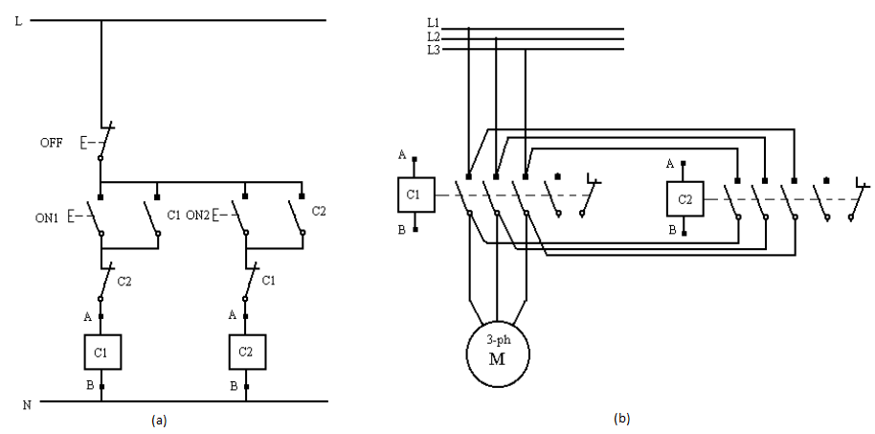

**Fig. 1 a** The control circuit of the direction reversal for 3-phase induction motor system. **b** The power circuit of the direction reversal for 3-phase induction motor system.[4]

1. **Using switch relays to apply Y-⧍ starter on the induction motor**

At first, the control circuit shown in figure 2a was connected. Then the circuit was checked by the teaching assistant, after that the power was switched on to feed the circuit.

In this circuit, when "ON" turned on the contactors "C1" and "C2" and the timer "T" were activated, then the normally open switch for "C1" become closed and the normally close switch for "C2" become open which means that contactor "C3" was deactivated. After specific time depend on the timer settings the normally close switch for "T" become open which deactivate "C2"and the normally open switch for "T" become close which activate "C3" and the "C1" still activated. If "OFF" turned on then all contactors and the timer become deactivated.

After that, the power circuit shown in figure 2b was connected. This circuit operate as Y-⧍ starter for 3-phase induction motor, first the motor windings connected as Y to limit the stating current and after the specific time the motor windings connected as ⧍ to increase the motor torque.

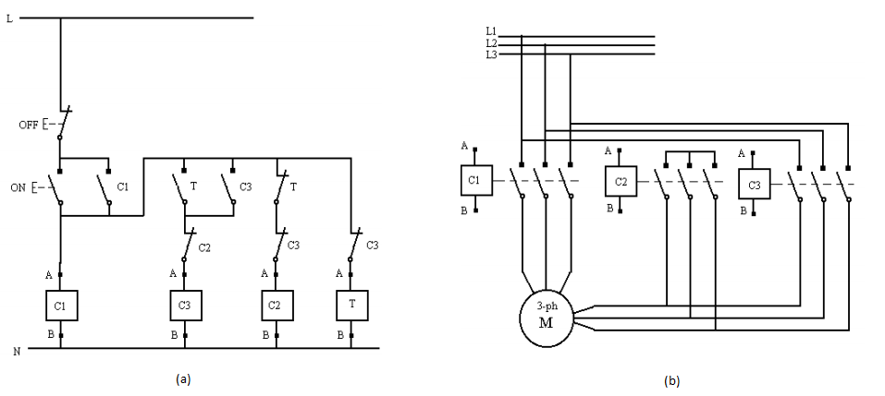

**Fig. 2 a** The control circuit of the Y-⧍ starter for 3-phase induction motor system. **b** The power circuit of the Y-⧍ starter for 3-phase induction motor system.[4]

**Part B: Timers:**

**Simple traffic light**

The circuit shown in figure 3 was connected and the timers settings was adjusted to the following values: T (reset) = 10s, T (red) = 15s, T (red+yellow) = 10s, T (yellow) = 15s, T (green) = 20s.

In this circuit, when "ON" was turned on the contactor "C" and all timers except reset timer were activated, the red light is turned on alone for 10 seconds, and then the yellow light will be activated making both the red and yellow lights on for 5 seconds . After 15 seconds was passed, the green light will be on for 5 seconds. Finally, the yellow light will turn alone for 5 seconds, and then the reset timer will be activated. We can see that the reset timer is activated depending on the time set for the red timer. For our example, the red timer is set for 15seconds, meaning that after that time, the reset timer will be activated and starts to count. The reset timer is set to reset after 10 seconds.

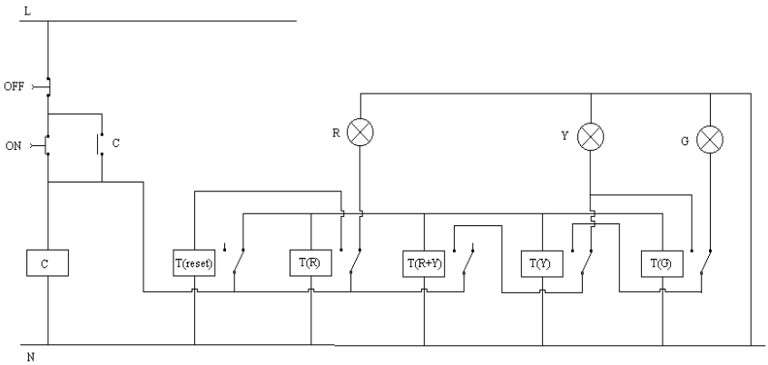

**Fig. 3** The simple traffic light circuit. [4]

### Conclusion

### As a conclusion, we were able to test and apply some functions of different types of basic elements of control circuit such as relays, contactors, and timers, and modify some changes according to desired outcomes, and we see practically how we can reverse the direction of the 3-phase induction motor, and we learn how to deal with Y-⧍ starter for 3-phase induction motor. At the end, we see how we can use timers to work as a simple traffic light.

### References

### <https://en.wikipedia.org/wiki/Contactor>

### <http://www.explainthatstuff.com/howrelayswork.html>

### <https://www.ia.omron.com/support/guide/19/introduction.html>

### ENEE4105 Lab manual.