* **Abstract :**

The aim of this experiment is to understand the meaning of noise , how it’s added to the system and how it affects it . Also , we are going to determine the signal to noise ration which indicates if the used receiver is good enough or not .

* **Table of Contents :**
* **Theory ……………………………………………………………………………..……………………………………. 3**
* **Quantization ………….....……………………………………………….……………………………………. 3**
* **Resolution ………………………………….……………………………………………………………………. 4**
* **Quantization Noise ………………………………………………………………………………………….. 4**
* **Encoding …………………………………………………………………………………………………………. 5**
* **DBCM ………………………………………………………………………………………………………………. 5**
* **Procedure …………………………………………………………………………………………………..…………… 6**
* **Part One ……………………………….…………………………..……………………………………………. 6**
* **Part Two ………………………………………………………………………………………………………… 7**
* **Part Three ……………………………………………………………………………………………………… 7**
* **Part Four ………………………………………………………………………………………………………… 8**
* **Part Five …………………………………..……………………………………………………………………… 9**
* **Part Six……………………………………………………………………………….…………………………… 10**
* **Part Seven ……………………………………………………………………………………………………… 11**
* **Part Eight…………………………………………………………………………..…………………………… 12**
* **Part Nine ………………………………………………………………………………………………………… 13**
* **Conclusion …………………………………………………………………….………………………………………….. 17**
* **References ……………………………………………………………………………..…………………………...…….. 18**

* **Theory :**

In communication systems , when sending a signal from transmitter to receiver , it’s affected by many things and noise is added to the signal . Noise arises in systems due to the random motion of electrons which this produces the current that flows .

There are types of Noise that arises , there is the thermal noise which results from the voltages and currents of the random motion of the electrons , and there is the White Noise also . White noise that has a constant power spectral density over all the frequencies and it has a Gaussian distribution . In out experiment we dealt with additive white Noise which is added to the signal when sending it .

When transmitted signal has reached the receiver , supposing that the transmitted signal is s(t) , and a white noise n(t) is appended . The received signal is r(t) which is :

**R(t) = S(t) + N(t) .**

Since minimizing the noise effects is a prime concern in analog communication , it’s required from the receiver to try to return back the original signal from r(t) as best as can and also to decrease the power of the noise since it’s consuming useless power . So ,to determine the efficiency of demodulation of the sent signal , the metric Signal to noise ratio is used .

Using this metric , the power of the original signal is taken and the power of the noise appended is calculated , then the ratio between the two values are got such that can be determined the efficiency .

The noise power of the output of filter of equivalent bandwidth is :

**Pn = (An)^2xBT .** Am : amplitude ,BT = Bandwidth .

The sinusoidal signal power is :

**Ps = Am^2/2 .** Am : amplitude .

To determine if the receiver has improved on the received signal or not , the ratio is taken before demodulation (SNR1) and after demodulation ( SNR2) , then the ratio between reference and post SNR is applied ( SNR2/SNR1) .Iif the ratio between them > 1 , then the receiver has improves on the signal in a way , if not , then it’s classified as a bad receiver since that means that the power of the recovered signal is decreased or the power of the noise signal is increased or both .

* **Procedure , Data and Calculations :**

In this experiment , we used am modulator ,am demodulator blocks ,signal generator, noise generator and the program CASSY LAB to display the signals we got .

**Part One : SNR For Single Side band Modulated signal :**

In this part we connected channel A with the DSB-SC node and Channel B with the USSB node , we set the noise generator to 0 , then we displayed the two signals on the cassy lab program .

Figure 1 shows the result :

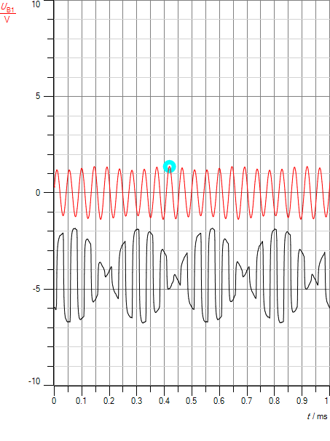

Figure above shows two signals . The red signal shows the single side band ( upper side band) modulated signal and the black signal is the double side band modulated signal . it was requested to calculate the power for both signals . So we measured the amplitude for red signal . We got Am = 1.38v .

Ps1 ( USSB ) = ( 1.38)^2/2 = .9522 watt .

After calculating power in signal , we applied noise signal with values -12db and -30db , to calculate the power in both of them . so we displayed the signal in frequency domain . we adjusted the diagram settings by setting the x-axis scale between 18khz and 22khz ( band width(BT) = 4 since it passes through low pass filter of cut off frequency ≈ 4khz) . we care about this interval only because we care only about noise in range of the USSB signal . we took the maximum amplitude of noise signal for -30db and -12db which is :

* -30db : An = .016364v .
* Pn1 = (An)^2 x BT = (.016364)^2x4 = 1.07x10^-3 watt .
* -12db : An = .14057v .
* Pn1 = An x BT = (.14057)^2x4 = .07904 watt .

Now to Calculate the Ratio of Signal to Noise :

When noise = -30db :

SNR1 = Ps1(USSB) / Pn1 = .9522 / 1.07x10^-3 = 889.8 .

When noise = -12db :

SNR1 = Ps1(USSB) / Pn1 = .9522 /07904 = 12.045 .

We notice from both results of SNR that when noise is less , ratio is larger which means better since there isn’t large noise power consumption .

**Part Two : SNR For Double Side band Modulated signal :**

In the previous part we displayed both single side band and double side band signals. We measured the amplitude and power of the USSB signal . As it’s Known that the power of DSB signal is double of the power of USSB , since it has the USSB signal and the LSSB ( upper and lower ) . Then :

Ps1( DSB) = 2xP(USSB) = 1.9044 watt .

According to the noise , the noise power for DSB signal is multiple of the noise power in USSB signal because the band width of DSB is 2x BT for SSB .

Then to calculate the noise power :

* -30db :
* Pn1(DSB) = 2xPn(USSB) = 1.07x10^-3 ^-4 x 2 = 2.14 x 10^-3 watt .
* -12db : An = .14057v .
* Pn1(DSB) = 2xPn(USSB) = .07904 x 2 = .15808 watt .

Now to Calculate the Ratio of Signal to Noise :

When noise = -30db :

SNR1 = Ps1(DSB) / Pn1 = 1.9044 / 2.14 x 10^-3 =889.9 .

When noise = -12db :

SNR1 = Ps1(DSB) / Pn1 = 1.9044 / .15808 = 12.045 .

Comparing the SNR of USSB and DSB , we notice that they have the same ratio .

Figure below shows the noise signal (-30db) in frequency domain with bandwidth between 18k and 22k :

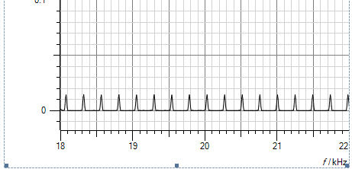

Figure 2 : Noise in frequency domain .

**Part Three : SNR For Single Side band demodulated signal :**

After calculating the ration between signal power an noise power after modulation , we need to calculate the ratio between them after demodulation . So we connected channel B to the output of the demodulator . Them , we measured the amplitude of the signal .   
  
Am = 1.57 v .

Ps2 = Am^2/2 = ( 1.57)^2/2 = 1.23245 watt .

Figure 3 below shows the demodulated signal and it’s output :

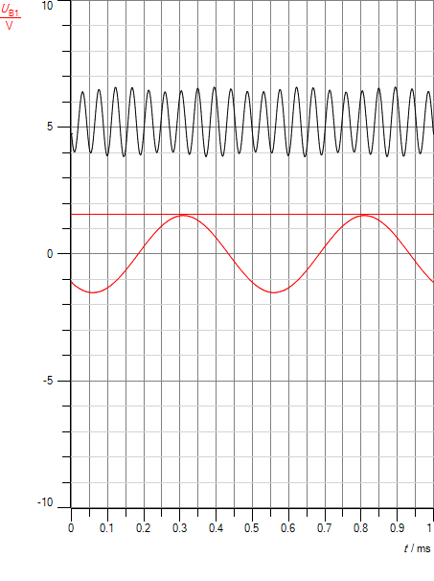

Then , we disconnected the message signal and connected only noise with demodulator , once with -30db and other with value -12db , we defined the x-axis range from 0 to 4khz , since the low pass filter passes for almost this value . Then BT = 4khz .

Figure 4 shows the demodulated noise signal in frequency domain :

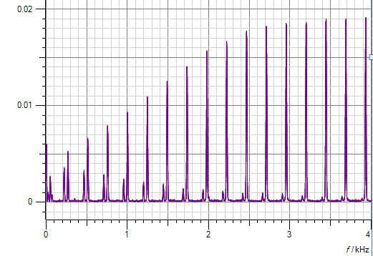

We need to calculate the noise power is to get power maximum noise in the interval we want so :

* -30db :
* Pn2 = MaxNoise(An) x BT = (.037468)^2 x 4 = 5.615x10^-3 watt .
* -12db :
* Pn2 = MaxNoise(An) x BT = (.18652)^2 x 4 = .13915 watt .

Now to Calculate the Ratio of Signal to Noise :

When noise = -30db :

SNR2 = Ps2(USSB) / Pn2 = 1.23245 / 5.6154x10^-3 = 219.4 .

When noise = -12db :

SNR2 = Ps2(USSB) / Pn2 = 1.23245 / .74608 = 8.85 .

We notice from the results of SNR above that when the noise percentage is small , the ratio is very high ( 32.9) which indicates that the noise affect is too small , while when noise percentage is -12db , the ratio is small ( 1.65 ) which means that noise power is high , so the demodulated signal is going to be distorted .

* **Conclusion :**

**By the end of this experiment , we got more familiar of what noise means and how it is transmitted with original signal . Also , we learnt how the noise affects the demodulated signal . In addition , We learnt about signal to noise ratio as a measure to know the power in the message signal compared with the power of the unwanted signal ( noise ) .**

**During this experiment , we were able to see how the noise is added to the original signal by seeing it on the Cassy Lab program , and we were able to see the demodulated signal ( that has a noise ) , we concluded that the message is affected by the amount of noise added to it . We also understood why it’s hard to calculate the power in both noise and message signal when they are applied together so we applied every type of signal alone and measured the power in .**

-------------------------------------

* **References :**

1. <https://en.wikipedia.org/wiki/Signal-to-noise_ratio>
2. <http://searchnetworking.techtarget.com/definition/signal-to-noise-ratio>