* **Abstract :**

**This report is written about the two experiments 6 and 7 which are about PCM. These experiments aim’s is to study the Quantization operation , which is a process needed to convert an analog signal to digital signal . Then , Quantization types ( linear and nonlinear ) is to be studied and investigate the difference between them . Also , we are going to understand the quantization error and DBCM type .**

* **Table of Contents :**
* **Theory ……………………………………………………………………………..……………………………………. 3**
* **Quantization ………….....……………………………………………….……………………………………. 3**
* **Resolution ………………………………….……………………………………………………………………. 4**
* **Quantization Noise ………………………………………………………………………………………….. 4**
* **Encoding …………………………………………………………………………………………………………. 5**
* **DBCM ………………………………………………………………………………………………………………. 5**
* **Procedure …………………………………………………………………………………………………..…………… 6**
* **Part One ……………………………….…………………………..……………………………………………. 6**
* **Part Two ………………………………………………………………………………………………………… 7**
* **Part Three ……………………………………………………………………………………………………… 7**
* **Part Four ………………………………………………………………………………………………………… 8**
* **Part Five …………………………………..……………………………………………………………………… 9**
* **Part Six……………………………………………………………………………….…………………………… 10**
* **Part Seven ……………………………………………………………………………………………………… 11**
* **Part Eight…………………………………………………………………………..…………………………… 12**
* **Part Nine ………………………………………………………………………………………………………… 13**
* **Conclusion …………………………………………………………………….………………………………………….. 17**
* **References ……………………………………………………………………………..…………………………...…….. 18**

* **Theory :**
* **Quantization :**

Quantization or ( Pulse Code modulation ) is a one of the stages that is needed to convert an analog signal to a digital one . after making sampling which is an operation that converts the signal from continues time signal to discrete time signal . Quantization is an operation in which it controls the range of the sampled signal So it controls the amplitudes of the samples . It gives the samples discrete and finite number of values . Those Values and their number are determined according to many factors we are going to talk about lately .

The Following figure shows the implementation of the Sampling and Quantization operations on an input signal:

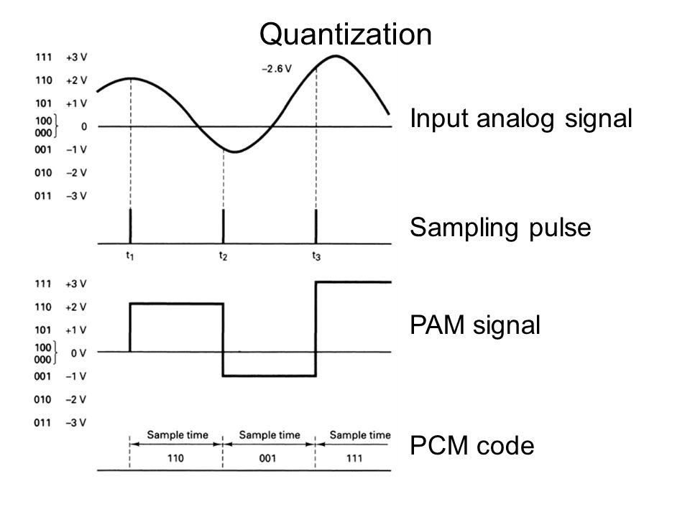

Figure 1 : Sampling and Quantization

Quantization interval ( Q ) is the step size between each two level . supposing the signal amplitude has a range of y . Then Q can be defined by the relation :

Q = Y / 2^n . Which n is the number of bits used to represent the signal amplitudes .

* **Linear Quantization :**

Linear Quantization or uniform Quantization is the most common type of quantization . In this type , the input signal is distributed uniformly on the defined levels . In this type , all sample sizes are equal to each other . Supposing the signal has a time range of x , then sample size is defined by the relation :

Δ =x /2^n . Which n is the number of bits needed to represent the transmitted signal .

* **Nonlinear Quantization :**

Nonlinear or non uniform quantization is another type of Quantization . in some transmissions , the signal is needed to be accurate in some intervals while it’s not important in others . so distributing thw input signal uniformly will cause the signal to be transmitted with high quality and it’s treated the same as the un important one . so non linear method is used such that the signal sample size are very small in some intervals while it’s large in another intervals . For example in interval 0-2 ( not important one ) is represented by one discrete value while the period 6-8(which is important ) is represented by 2 or 4 digital values . In this case , the second one is represented with high quality . Non uniform Quantization can be made by compressing the input signal then apply this signal to a uniform quantifier .

The following figure shows the difference between linear and non linear quantization :

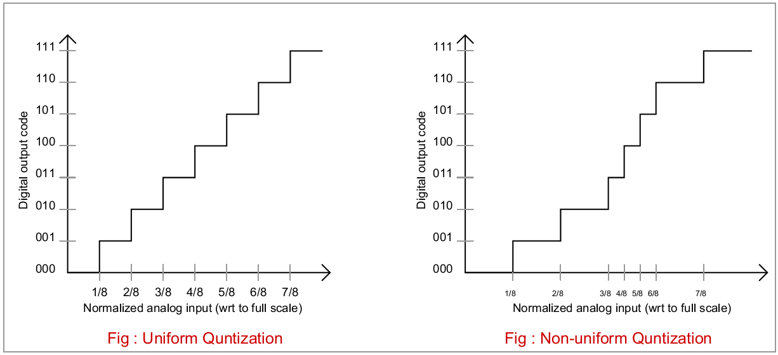

Figure 2 : Uniform and non-uniform Quantization

* **Resolution :**

Since Sending a signal is represented by sending discrete digital values , so the number of levels used to send the signal controls the resolution of the sent message . to clarify more , since the sample size is given by X / 2^n , then when increasing n ( number of bits ) , the sample size becomes less , so more levels and more points are taken to represent smaller periods and samples .

* **Quantization Noise:**

When an [Analog-Digital Converter](http://www.onmyphd.com/?p=analog.digital.converter) converts a continuous signal into a discrete digital representation, there is a range of input values that produces the same output, Which is the mid point of the step size(Q) . The difference between input and output is called the quantization error. Therefore, the quantization error can be between ±Q/2.

* **Encoding :**

Encoding is a procedure comes after quantization in the process of converting the analog signal to digital signal , in this operation the levels resulted from quantization are encoded , which means they are set to a certain voltages resulting digital Values .

* **DPCM ( Difference Pulse Code Modulation ) :**

In PCM the original signal is sampled and quantized , then it’s sent through the transmitter to the receiver . In DPCM , through modulation , a predicted signal is produced depending on the previous received signals . After that , the difference between this signal and the original signal ( sampled ) is taken and quantized using whether two of the methods of quantization ( linear or nonlinear ) and encoded to produce digital values . since the predicted signal is close to the original one , the difference between them is to be very small which means small amplitude samples . the benefit of this way is that the number of bits needed to do quantization .

Figure below shows the block diagram of the DPCM process :

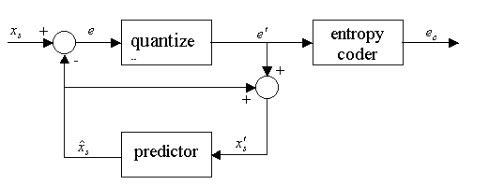

Figure 3 : DBCM Process

* **Procedure , Data and Calculations :**

In this experiment , we used PCM modulator ,PCM demodulator blocks and the program CASSY LAB to display the signals in stages we go though to make quantization .

1. **Part One : Linear Quantization :**

In this part , we connected channel A with the input of PCM modulator (PAM node) ( which consists of samples ) and channel B is connected to the output of PCM demodulator . We used a resolution of 8 bits to quantize the sampled signal . The range of voltages taken is from -10 v to 10v .

The Following figure shows the output signal according to the input signal ( X-Y plane) :

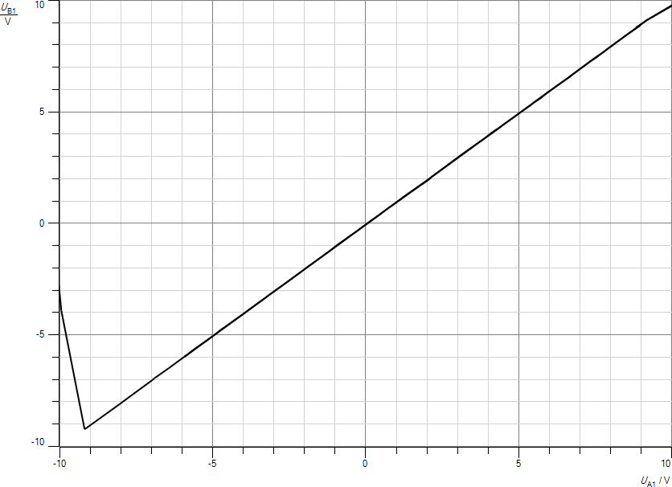

The Figure above shows a linear line . This means that the output signal after quantization and recovering is nearly the same as the input signal samples . This result makes sense since we used high resolution ( 8bits ) such that the step size = ( 10 - -10 ) / 2^8 which is very small sample size . so 2^8 points are quantized through the interval ( -10v to 10v ) .

1. **Part Two : Non-Linear Quantization :**

In this part , instead of using Linear quantization , we used the method on nonlinear quantization in both PCM modulator and PCM demodulator . The Following Figure Shows the result we got :

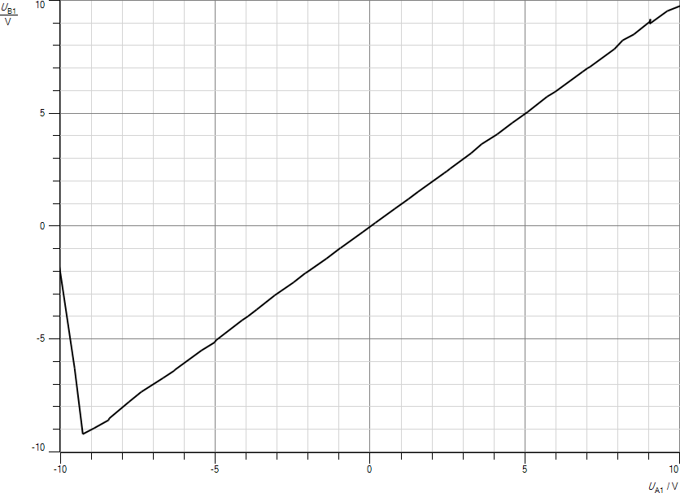

The figure above shows that the output signal samples are similar to the input Samples . This result makes sense because when we used nonlinear quantization in modulation side , we used nonlinear recovery to the samples. This means , the compressed signal in modulation side , it’s expanded in the demodulation side and as a result , the original samples returned .

1. **Part Three : Compressor / Expander Characteristics :**

To See the characteristics of nonlinear Quantization in PCM modulator , we set the PCM modulator to nonlinear quantization and set the PCM demodulator to linear quantization . figure Below shows the result :

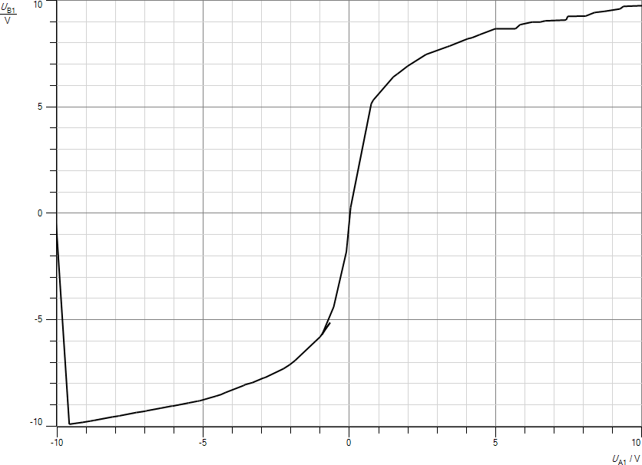

The figure above shows that in modulation side the signal is compressed but it’s not recoverd .

To see the Characteristics of nonlinear quantization in PDM demodulator . we set the PCM modulator to linear quantization and set the PCM demodulator to nonlinear quantization . Figure below shows the result :

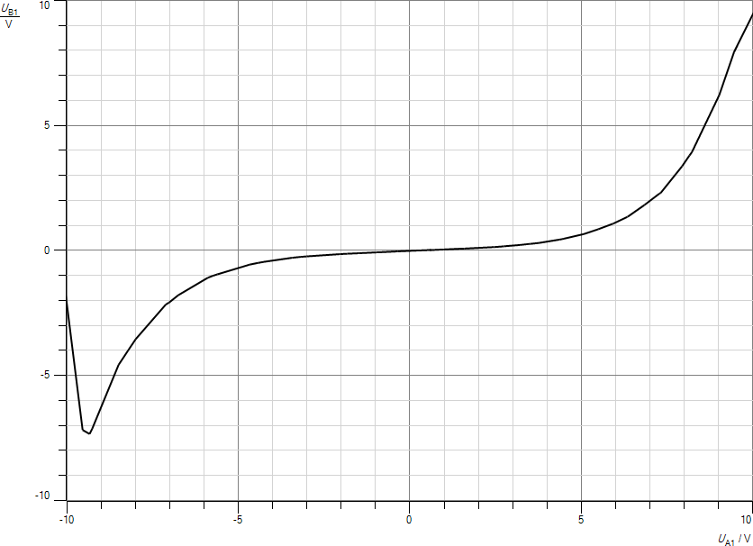

The figure above shows that the signal is expanded in demodulation stage . We can conclude that to perform nonlinear quantization , signal is compressed in some intervals in modulation while it’s expanded to return it’s original shape in demodulation in the same interval .

1. **Part Four : Resolution of Quantizer :**

In the First Part , resolution used in quantization is 8bits . In this part , it’s reduced to 5bits . We did that by Switching off the three LSB . Figure below Shows the Result :

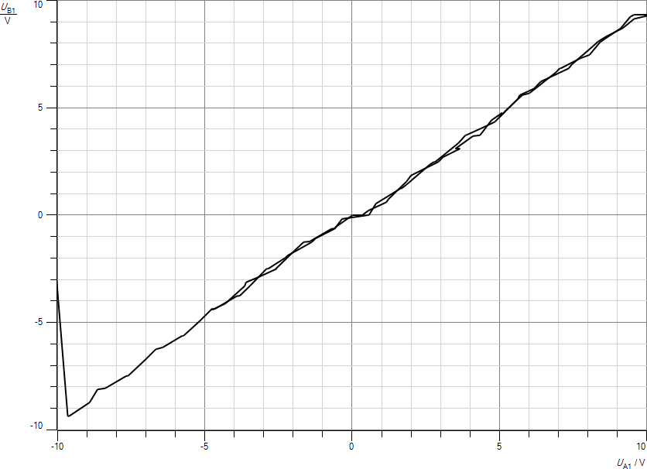

We note from figure above that recovering the samples is not very accurate such that the input and output signals are not the same . This is because we reduced the resolution and the sample size has increased .

1. **Part Five : Encoding :**

In this part an AC signal is added to the PCM modulator and the and is connected to channel A . Channel B is connected to the output of PCM demodulator . Figure Below Shows the output signal using Linear quantization :

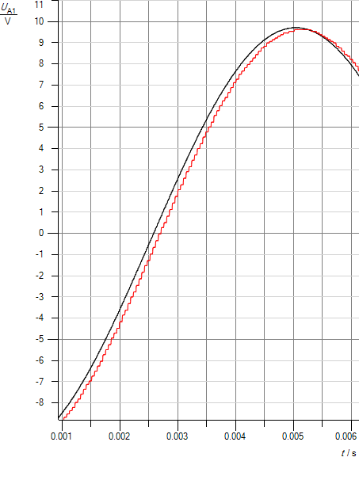

The red signal shows the samples of the output signal after PCM demodulation . This results shows that the output samples are very close to the input signal .

Note : The figure above is a zoomed shot of the original one .

Now , using nonlinear Quantization in modulation and linear in demodulation results the following :

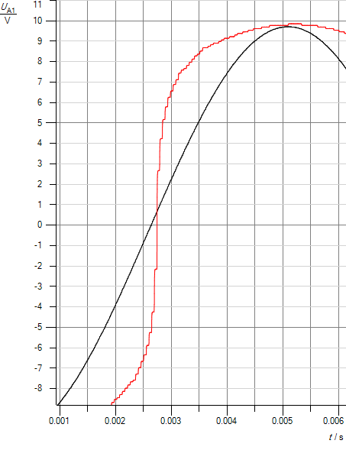

The previous figure shows a variation in the shape of the signal since it’s not demodulated correctly .

Note : The MSB is used for determining the polarity .

1. **Part Six : PCM Transmission :**

In this part , we studied sending a message signal going through PAM modulation – PCM modulation – PCM demodulation – PAM demodulation . we adjusted the sampling frequency to be at the max . We connected a sine wave input signal to the first channel in the PAM and triangle signal in the other channel such that sampling is done iteratively between these two signals .

Figure below shows the Transmission of triangle signal :

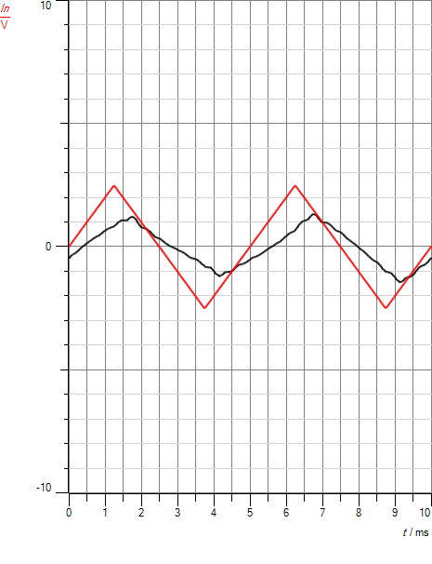

The Figure Below shows the transmission of the sine signal :

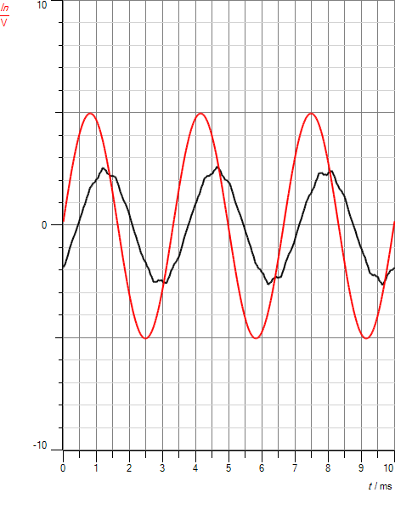

1. **Part Seven : Quantization Noise :**

In this part we displayed the quantization noise curve . we connected channel A to input signal and Channel B to the output of DCM demodulator .

Figure below shows the Quantization Noise :

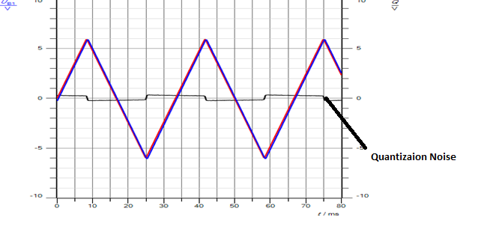

The figure above shows the quantization noise curve which is the difference between the original signal ( triangle ) and the recovered samples . we note here that the noise is very small ( not more than .5 v ) which related to the high resolution ( 8 bits ) used .

Note : Both Channel 1 and 2 of is connected to the function generator such that in sampling , the first half of the period channel 1 is sampled and in the second half channel 2 is sampled . so to avoid returning to 0 in the second half , we connected both channels to the same signal .

Now the same measurement is repeated but with resolution = 5 bits :

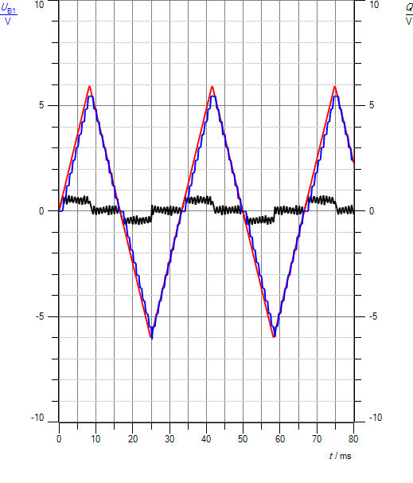

It’s obvious that the Quantization noise has increased since the resolution has decreased which results greater Q and therefore bigger error .

For the same signal , we repeated measurement from 30hz to 300hz to see how the quantization noise is affected . figure below shows the resulted quantization noise :

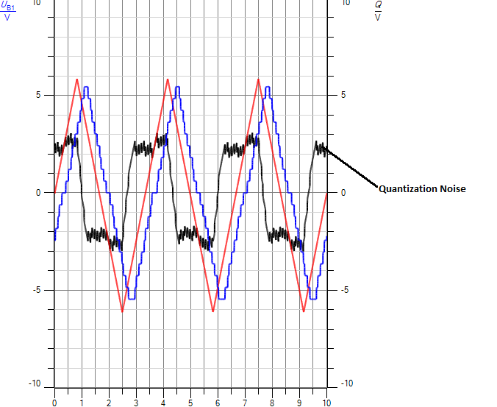

We note that When increasing the frequency of the signal , the noise curve ( black curve ) value will increase , in this case it reaches about 2.5v while in the first part it doesn’t exceed .5v . This is because when increasing frequency , number of sampled points each period is less .

1. **Part Eight : Quantization Noise Variations :**

Now instead of modulating a triangle signal , we put a sine signal with frequency 30hz and quantization resolution = 8 bits . The figure below shows the quantization noise curve :

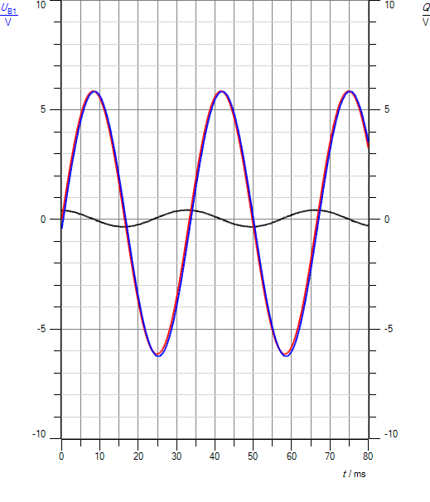

According to the curve we got . the noise curve seems to be close to a sine wave but with very small amplitude ( doesn’t exceed .5v ) .

Now , we changed the frequency from 30hz to 300hz to see the difference . We got the following figure :

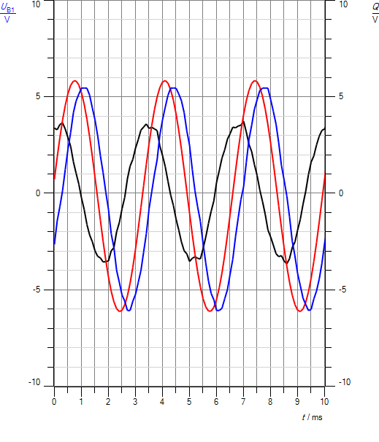

From the figure we note that the noise curve has increased clearly . It reaches nearly 4 volt , Which is big error .

1. **Part Nine : DPCM :**

In This part , we studied the DPCM method in quantization . so we supplied the modulator with a a triangle signal with 30hz and 12 pk-pk voltage . Then , we followed the process of modulation and demodulation by displaying the signals on the cassy lab .

Figure below shows the original signal with the samples signal before quantization :

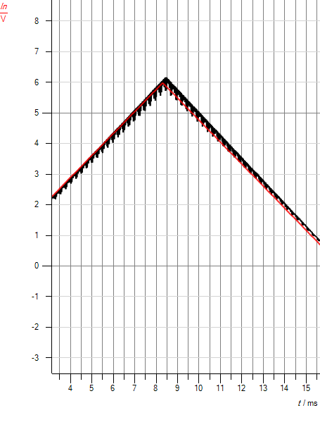

Figure below shows the original signal with predicted signal :

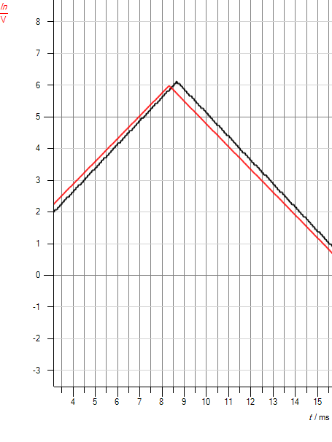

We note here that the predicted signal is very close to the original signal .

Now , figure below shows the original signal with quantized signal :

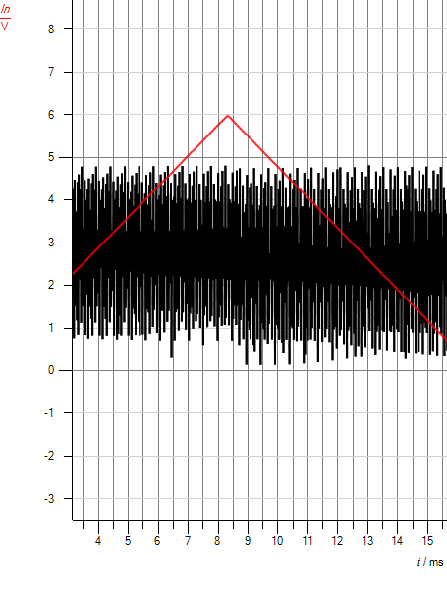

Figure Shows the original Signal with input of the DBCP demodulator :

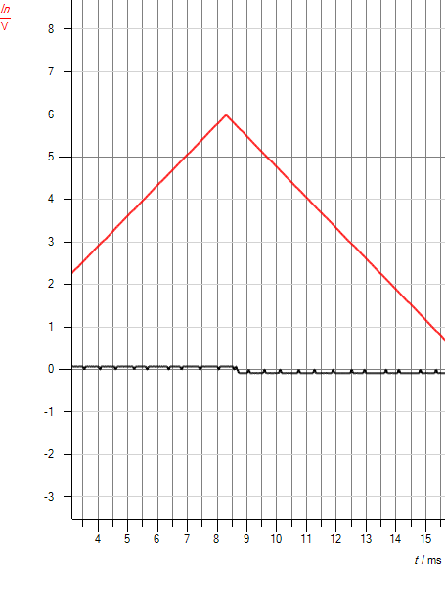

We note here that the amplitude of the input of demodulator is very small which makes sense because we told before that the sent signals are the difference between the predicted and original which is small value .

Then , we displayed the predicted value of the demodulator :

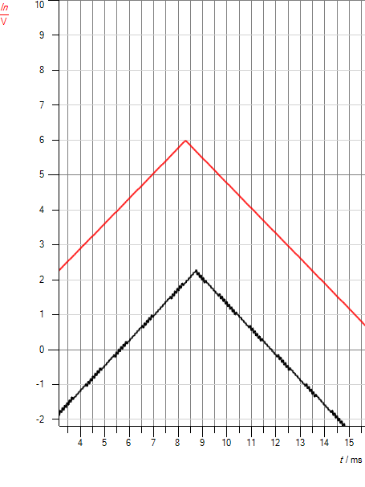

From figure we can see a difference between the original and predicted , this is because the initial state of the demodulator is different from that of modulator which makes that shift in the values .

Now , figure shows the input signal with the demodulated signal :

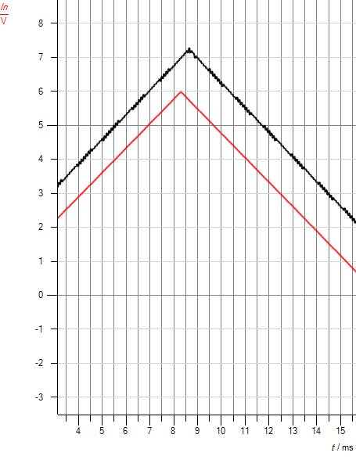

For resolution bits : when using PCM modulation and we want to change the resolution of the quantization we switch off the LSB bits ,, if we removed from the MSB , it will give wrong quantized values . that’s because using PCM modulation we send the original signal and the amplitude of this signal is high ( reaches 10 v and so on ) . so the most upper levels will be canceled and given a value similar to the lower levels .

In DPCM modulation there’s no problem to remove bits from the lower side or the upper side . ( I mean LSB or MSB ) . that because when sending through DPCM we are sending the difference between the original value and the predicated value . usually , this difference value is very small , so we are sending a small voltage ( not very high amplitude ) through transmitter to the receiver . so this signal will never reach for example 10 volts ( it’s usually between 1 and 2 volts ) . so removing from MSB will not affect the signal .

* **Conclusion :**

**By the end of this experiment , we were able to understand the process of Quantization in detail in addition to understand sampling and the operation of PAM better .**

**We learnt what is the purpose of Quantization stage through converting . WE learnt about the types of quantization which are linear and nonlinear quantization . we discussed the problems of each type of them and how it can be performed . In nonlinear quantization for example signal is compresses in modulation stage and expanded in demodulation stage . After that , we were able to see and display the Quantization Noise and conclude the factors that change the noise , factors like changing in the signal frequency such that increasing frequency will increase the noise . while the opposite happens in resolution , increasing the resolution will decrease the noise to it’s min values .**

**Since DCM has problems and high noise in transmission , DBCM is another method to make quantization which in this meth the information sent is the difference between the input and predicted signals .**

-------------------------------------

* **References :**

Quantization and it’s types :

1. <https://www.princeton.edu/~cuff/ele201/kulkarni_text/digitizn.pdf>
2. <https://wiki.analog.com/university/courses/electronics/text/chapter-10>

DBCM :

1. <http://einstein.informatik.uni-oldenburg.de/rechnernetze/dpcm.htm>
2. <https://en.wikipedia.org/wiki/Differential_pulse-code_modulation>