Abstract

In this experiment we will simulate and configure frequency modulation circuit and in order to study and illustrates different behavior in frequency modulation circuits, also we will see the effect of FM modulation in frequency spectrum for both sinusoidal signal and square signal. Finally we will experimentally see the effect of demodulation circuit on different loop filters on different time constants.

Contents
Abstract 1
Introduction 3
Carson's rule 4
Properties of Angle-Modulated Waves 5
Relationship between PM and FM Waves and Generation of FM and PM 5
Spectrum of Angle Modulated Signals 6
Modulation index 7
Demodulation of FM Signals 8
The Phase Looked Loop (PPL) 9
Pre-emphasis and de-emphasis 9
Procedure and discussion 10
I. Frequency modulation 10
1. Dynamic response of FM 11
3. Determination of the frequency deviation 13
4. Measurements in the frequency domain of FM 13
5. Determining the carrier zero crossings by varying the frequency deviation ΔFFM. 14
6. Determine the carrier zero crossings by varying the modulating frequency fM. 15
7. FM spectrum for square wave modulation 15
8. FM demodulation for loop filter τ2 15
9. FM demodulation for loop filter τ1 17
10. FM Pre-emphasis and de-pre-emphasis 19
II. Phase modulation 20
1. Dynamic response of phase modulation 20
2. Characteristic of the PM modulator 20
3. The PM spectrum 21
4. PM demodulation for loop filter 21
5. PM demodulation for loop filter 22
Conclusion 23
References 24

Introduction

In the amplitude modulation we investigated the effect of slowly varying the amplitude of a sinusoidal carrier wave in accordance with an information-bearing signal, keeping the carrier frequency fixed. There is another way of modulating a sinusoidal carrier wave— namely, angle modulation, in which the angle of the carrier wave is varied according to the information-bearing signal. In this second family of modulation techniques, the amplitude of the carrier wave is maintained constant.
An important feature of angle modulation is that it can provide better discrimination against noise and interference than amplitude modulation. Since information that convey message signal are in the crossing of the carrier wave in contrast with amplitude modulation that store message signal information in amplitude of carrier wave.

Let θ(t) denote the angle of a modulated sinusoidal carrier at time t; it is assumed to be a function of the information-bearing signal or message signal. We express the resulting angle-modulated wave as
S(t) = A_{C}

Where A_{C} is the carrier amplitude. A complete oscillation occurs whenever the angle changes 2π by radians. If increases monotonically with time, then the average frequency in hertz, over a small interval from t to t + Δt is given by
f_{Δt}(t) =

Allowing the time interval Δt to approach zero leads to the following definition for the instantaneous frequency of the angle-modulated signal S(t):
f_{i}(t) = =

Where, in the last line, we have invoked the definition for the derivative of the angle with respect to time t.
Thus according to the modulated signal equation, we may interpret the angle-modulated signal S(t) as a rotating phasor of length A_{C} and angle . The angular velocity of such a phasor is d measured in radians per second. In the simple case of an unmodulated carrier, the angle is
t + Φc, for m(t) = 0

And the corresponding phasor rotates with a constant angular velocity equal to t radians per second. The constant Φc defines the angle of the unmodulated carrier at time
t = 0.
There are an infinite number of ways in which the angle may be varied in some manner with the message signal. However, we shall consider only two commonly used methods, phase modulation and frequency modulation, as defined below:
1. Phase modulation (PM) is that form of angle modulation in which the instantaneous angle is varied linearly with the message signal m(t), as shown by
t + Kpm(t)

The term t represents the angle of the unmodulated carrier with the constant Φc set equal to zero for convenience of presentation; the constant Kp represents the phase sensitivity factor of the modulator, expressed in radians per volt on the assumption that m(t) is a voltage waveform. The phase-modulated S(t) wave is correspondingly described in the time domain by
S(t) = A_{C}

2. Frequency modulation (FM) is that form of angle modulation in which the instantaneous frequency f_{i}(t) is varied linearly with the message signal m(t), as shown by
f_{i}(t) = f_{C} + K_{f}m(t)

The constant term f_{C} represents the frequency of the unmodulated carrier; the constant K_{f} represents the frequency-sensitivity factor of the modulator, expressed in hertz per volt on the assumption that m(t) is a voltage waveform. Integrating the above equation with respect to time and multiplying the result by 2π, we get
t + K_{f}

Where the second term accounts for the increase or decrease in the instantaneous phase due to the message signal m(t). The frequency-modulated wave is therefore
S(t) = A_{C}

The following table summarizes the basic definitions from embodied in the generation of angle-modulated waves. These definitions apply to all kinds of message signals, be they of the analog or digital kind.

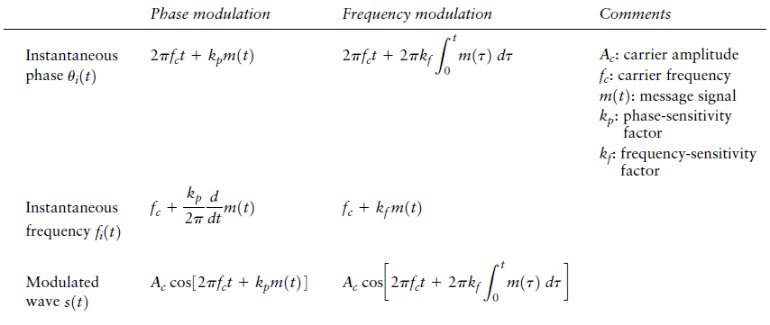

Carson's rule
A rule of thumb, Carson's rule states that nearly all (~98%) of the power of a frequency- modulated signal lies within a bandwidth B_{T} of
Where , as defined above, is the peak deviation of the instantaneous frequency from the center carrier frequency .

Properties of Angle-Modulated Waves
Angle-modulated waves are characterized by some important properties, which follow from the basic definitions summarized in the table above. Indeed, it is these properties that put angle-modulated waves in a family of their own, and distinguish them from the family of amplitude modulated waves, as illustrated by the waveforms shown below for the example of sinusoidal modulation. Figures 4.1(a) and 4.1(b) are the sinusoidal carrier and modulating waves, respectively. Figures 4.1(c), 4.1(d), and 4.1(e) display the corresponding amplitude-modulated (AM), phase-modulated (PM), and frequency-modulated (FM) waves, respectively.
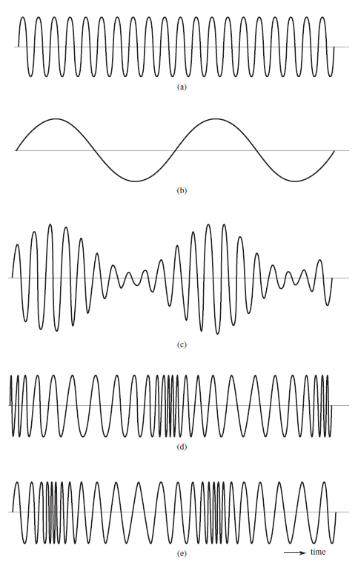

PROPERTY 1 Constancy of transmitted power
PROPERTY 2 Nonlinearity of the modulation process
PROPERTY 3 Irregularity of zero-crossings
PROPERTY 4 Visualization difficulty of message waveform
PROPERTY 5 Tradeoff of increased transmission bandwidth for improved noise performance

Relationship between PM and FM Waves and Generation of FM and PM
Examining the definitions of PM & FM equations, we see that an FM wave may be viewed as a PM wave produced by the modulating wave in place of m(t). This means that an FM wave can be generated by first integrating the message signal m(t) with respect to time t and then using the resulting signal as the input to a phase modulator, as shown in the figure below.
Conversely, a PM wave can be viewed as an FM wave produced by the modulating wave dm(t)/dt Hence, a PM wave can be generated by first differentiating m(t) with respect to time t and then using the resulting signal as the input to a frequency modulator, as in the figure below.
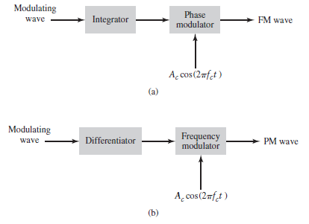
Figure 1: Generation of FM and PM waves

It follows therefore that phase modulation and frequency modulation are uniquely related to each other. This relationship, in turn, means that we may deduce the properties of phase modulation from those of frequency modulation and vice versa.

Spectrum of Angle Modulated Signals
Since frequency modulation is a nonlinear process, an exact description of the spectrum of an frequency-modulated signal for an arbitrary message signal is more complicated than linear process. However if S(t) is sinusoidal, then the instantaneous frequency deviation of the angle-modulated signal is sinusoidal and the spectrum can be relatively easy to obtained. If we assume S(t) to be sinusoidal then
S(t) = A_{m} cos(2πf_{m}t)
Then the instantaneous phase deviation of the modulated signal is
Ф(t) = 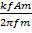 sin (2πf_{m}t)
The modulated signal, for the (FM signal), is given by
S(t) = A cos(2πf_{C} t + β sin2πf_{m}t)
If we want to compute the spectrum of S(t), we can express S(t) as
Sm(t) = Re{fA }
In the preceding expression, is periodic with a period T_{m} = 2π/2πf_{m}t. Thus, we can represent it in a Fourier series of the form
=
Where = J_{n}(β)
Where J_{n}(β) known as Bessel functions. Hence, we can obtain the following expression for the FM signal with tone modulation:
S(t) = A
The spectrum of S(t) is a spectrum of a sinusoidal signal multiplied by a constant (Bessel function ), such a spectrum consist of infinite number of Dirac delta function. The number of significant (energy contained) spectral lines, is limited, so we can use the FM modulation, with finite bandwidth.
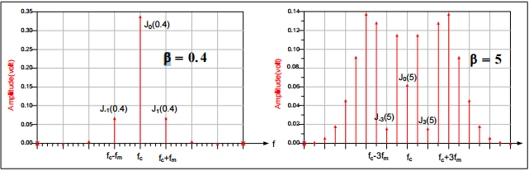
Figure 2: Narrow, and wideband FM spectrum
The spectrum of an FM signal has several important properties:
- The FM spectrum consists of a carrier component plus an infinite number of sideband components at frequencies f ± nf_{m}(n = 1, 2, 3…). But the number of significant sidebands depend primarily on the value β. In comparison, the spectrum of an AM signal with tone modulation has only three spectral components (at frequencies f_{c}, f_{c} + f_{m}, and f_{c} - f_{m} ).
- The relative amplitude of the spectral components of an FM signal depend on the values of J_{n}(β). The relative amplitude of the carrier depends on J₀(β) and its value depends on the modulating signal (unlike AM modulation where the amplitude of the carrier does not depend on the value of the modulating signal).

Modulation index
As in other modulation systems, the modulation index indicates by how much the modulated variable varies around its unmodulated level. It relates to variations in the carrier frequency:
β = = 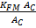
Where is the highest frequency component present in the modulating signal m(t), and is the peak frequency-deviation—i.e. the maximum deviation of the instantaneous frequency from the carrier frequency. For a sine wave modulation, the modulation index is seen to be the ratio of the peak frequency deviation of the carrier wave to the frequency of the modulating sine wave.
If β << 1, the modulation is called narrowband FM, and its bandwidth is approximately.
If β >> 1, the modulation is called wideband FM and its bandwidth is approximately 2.
While wideband FM uses more bandwidth, it can improve the signal-to-noise ratio significantly; for example, doubling the value of , while keeping f_{m} constant, results in an eight-fold improvement in the signal-to-noise ratio.
With a tone-modulated FM wave, if the modulation frequency is held constant and the modulation index is increased, the (non-negligible) bandwidth of the FM signal increases but the spacing between spectra remains the same; some spectral components decrease in strength as others increase. If the frequency deviation is held constant and the modulation frequency increased, the spacing between spectra increases.
Frequency modulation can be classified as narrowband if the change in the carrier frequency is about the same as the signal frequency, or as wideband if the change in the carrier frequency is much higher (modulation index >1) than the signal frequency. ^{[6]} For example, narrowband FM is used for two way radio systems such as Family Radio Service, in which the carrier is allowed to deviate only 2.5 kHz above and below the center frequency with speech signals of no more than 3.5 kHz bandwidth. Wideband FM is used for FM broadcasting, in which music and speech are transmitted with up to 75 kHz deviation from the center frequency and carry audio with up to a 20-kHz bandwidth.

Demodulation of FM Signals
An FM demodulator is required to produce an output voltage that is linearly proportional to the input frequency variation. One way to realize the requirement, is to use discriminators- devices which distinguish one frequency from another, by converting frequency variations into amplitude variations. The resulting amplitude changes are detected by an envelope detector, just as done by AM detector.
S(t) = Acos(2πft + K_{f})
The discriminator output will be
Y_{d}(t) = K_{d}K_{f}S(t)
Where K_{d} is the discriminator constant. The characteristics of an ideal discriminator are shown in the following figure. Discriminator can be realized by using a filter in the stopband region, in a linear range, assuming that the filter is differentiation in frequency domain.
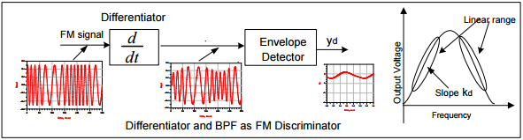
Figure 3: Ideal and real frequency demodulator
An approximation to the ideal discriminator characteristics can be obtained by the use of a differentiation followed by an envelope detector. If the input to the differentiator is S(t), then the output of the differentiator is:
S’(t) = -A[2πft + K_{f}S(t)]sin(2πft + Ф(t))
With the exception of the phase deviation Ф (t), The output of the differentiator is both amplitude and frequency modulated. Hence envelope detection can be used to recover the message signal.

The Phase Looked Loop (PPL)
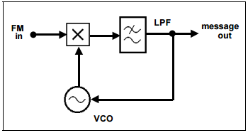
The phase locked loop is a non-linear feedback loop. The principle of operation is simple or so it would appear. Consider the arrangement of the figure above in open loop form. That is, the connection between the filter output and VCO control voltage input is broken. Suppose there is an unmodulated carrier at the input. The arrangement is reminiscent of a product, or multiplier-type, demodulator. If the VCO was tuned precisely to the frequency of the
Incoming carrier, ω_{c} say, then the output would be a DC voltage, of magnitude depending on the phase difference between itself and the incoming carrier. For two angles within the 360⁰ range the output would be precisely zero volts DC. Now suppose the VCO started to drift slowly off in frequency. Depending upon which way it drifted, the output voltage would be a slowly varying AC, which if slow enough looks like a varying amplitude DC. The sign of this DC voltage would depend upon the direction of drift. Suppose now that the loop of the figure above is closed. If the sign of the slowly varying DC voltage, now a VCO control voltage, is so arranged that it is in the direction to urge the VCO back to the incoming carrier frequency ω₀, then the VCO would be encouraged to ‘lock on’ to the incoming carrier.
Next if the incoming carrier is frequency modulated. For a low frequency message, and small deviation, the VCO will follow the incoming carrier frequency. What about wideband FM? With appropriate design of the low-pass filter and VCO circuitry the VCO will follow the incoming carrier for this too.
The VCO is an electronic oscillator designed to be controlled in oscillation frequency by a voltage input. The frequency of oscillation is varied by the applied DC voltage, while modulating signals may also be fed into the VCO to cause frequency modulation (FM) or phase modulation (PM); a VCO with digital pulse output may similarly have its repetition rate (FSK, PSK) or pulse width modulated (PWM).

Pre-emphasis and de-emphasis
Random noise has a triangular spectral distribution in an FM system, with the effect that noise occurs predominantly at the highest audio frequencies within the baseband. This can be offset, to a limited extent, by boosting the high frequencies before transmission and reducing them by a corresponding amount in the receiver. Reducing the high audio frequencies in the receiver also reduces the high-frequency noise. These processes of boosting and then reducing certain frequencies are known as pre-emphasis and de-emphasis, respectively.
The amount of pre-emphasis and de-emphasis used is defined by the time constant of a simple RC filter circuit. In most of the world a 50 µs time constant is used. In the Americas and South Korea, 75 µs is used. This applies to both mono and stereo transmissions. For stereo, pre-emphasis is applied to the left and right channels before multiplexing.

Procedure and discussion

Frequency modulation
One important thing we must know while doing the experiment is that how to set the frequency of the carrier. There are two methods. The first one is by taking the FFT of the carrier and then we change its frequency until its spectrum centers at the required frequency as shown in the following figure.
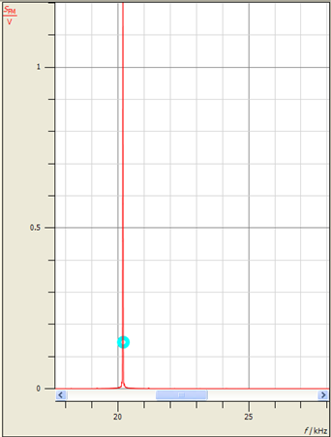
Figure 4: spectrum of the carrier
As we can see, we set the carrier to almost 20KHz frequency.
The second method is done in time domain. In order to set the carrier to 20KHZ, we set the measure time to 1/20K and we change the frequency until we see 1 period.

Dynamic response of FM
In this part of the experiment we have seen the dynamic response of frequency modulation with sinusoidal message signal with 20 v peak-peak and 1Khz frequency and using a carrier signal with frequency of 20Khz, the modulated signal is as shown in the following figure.
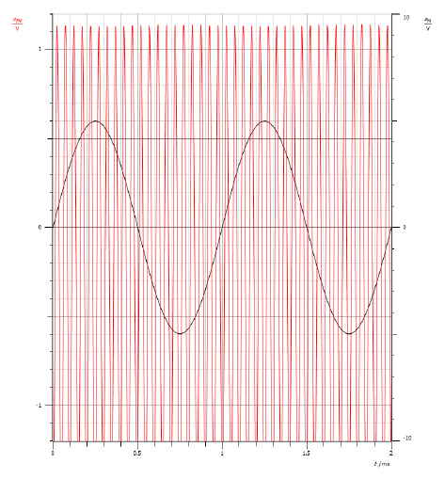
Figure 5: Dynamic response of FM

- The Characteristic of the FM Modulator
In this part we will study the characteristic of FM modulator, the frequency of the carrier is set to 20Khz, and we have used -10V DC-signal as an input signal to the modulator then we have increment the DC value by a step of 1 V and we measure the corresponding fVCO as the following table shows:
DC Value | FVCO | DC Value | FVCO | DC Value | FVCO | DC Value | FVCO
-10 | 19.37 | -5 | 19.70 | 0 | 20.03 | 5 | 20.30
-9 | 19.41 | -4 | 19.76 | 1 | 20.11 | 6 | 20.37
-8 | 19.50 | -3 | 19.83 | 2 | 20.17 | 7 | 20.43
-7 | 19.57 | -2 | 19.90 | 3 | 20.23 | 8 | 20.51
-6 | 19.64 | -1 | 19.96 | 4 | 20.26 | 9 | 20.63
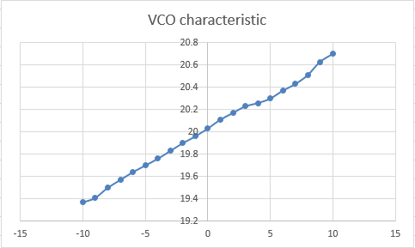
Figure 6: Linear Characteristic of VCO

By using the data obtained from the previous part we can determine the coefficient of FM modulator using the following relation:
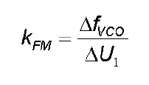

KFM= 1.26K/20 = 63 Coefficient of FM modulator

Determination of the frequency deviation
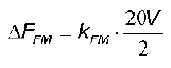
The maximum frequency deviation depends of the coefficient of the FM modulator and the amplitude of the modulating signal as the following relation shows:

From the previous relation we can measure the frequency deviation which is
ΔFFM= 63 * 10 = 0.63Khz = 630 Hz

Measurements in the frequency domain of FM
In this part we will see the frequency response of frequency modulation , first we should set the frequency of the carrier to 20Khz then we apply a message signal with 20V peak- peak with frequency of fm=300Hz and we have obtained the following figure . Then we repeat the same procedure with Fm 200Hz.
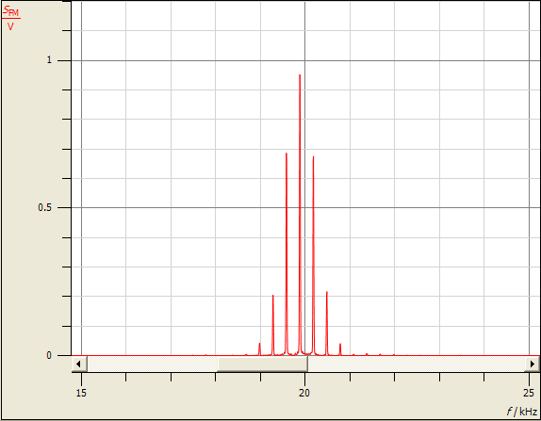
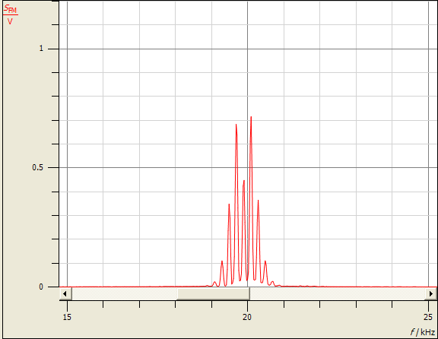
Figure 7: Frequency response of FM modulator with fm 300Hz and 200 Hz
In the above figures, we can notice that the output follows Bessel function, which is a function that comes from finding the Fourier series for single tone input in FM, which follow this form [ S(t) = Ac cos(2f_{c}t + B sin2fmt )].
After doing this the modulated signal takes this form:
Where J_{n}(B) is the Bessel function for a Modulation Index B which depends on the f_{m} and A_{m}.
From the above equation, we obviously see that the frequency spectrum of s(t) is direct with main harmonic centers at fc , and the others are centered at (fc+nfm) where n = …-2, -1, 0, 1, 2, ….

Determining the carrier zero crossings by varying the frequency deviation ΔFFM.
In this part we will experimentally measure the carrier zero crossing by modifying the frequency deviation values , we have used sinusoidal signal with 0Vpp and fm 100Hz and we feed it as an input to the modulator , then we changed the values of message amplitude until the carrier line disappear which is called zero crossing point.
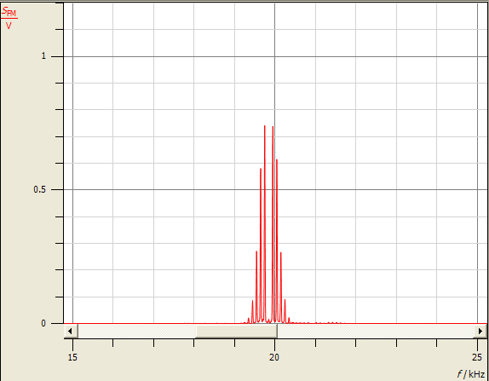
Figure 8: FM spectrum at the first Zero Crossing

There in another way to find the sensitivity for FM (K_{fm}), and by making the amplitude of the harmonic at fc equals to zero. Since when it’s zero, the Value of modulation Index B is known at n=0.
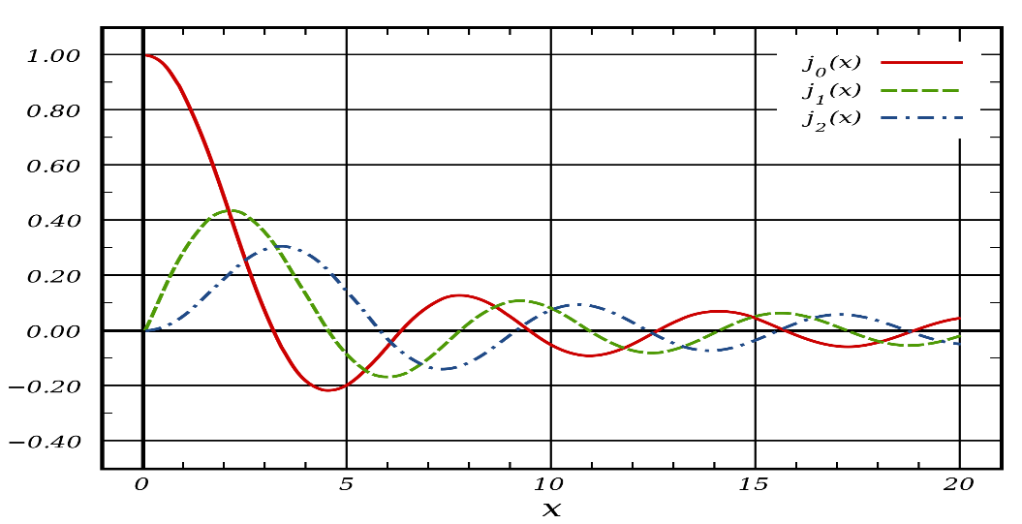
Figure 9: Bessel function for different values of n
From this figure, we can see that when n=0 and the amplitude is zero, B will take these values, 2.5, 5.6, 8.9. So we could just keep changing the A_{m} or f_{m} until we reach zero amplitude at fc so we can find K_{fm} using this formula .

Determine the carrier zero crossings by varying the modulating frequency fM.
In this part we will also find the carrier zero crossing by varying the modulation frequency fm, we have used a message signal with 20v peak-peak, starting from message frequency of 3KHz, then we have decreased the frequency and notice the decay in the carrier line.
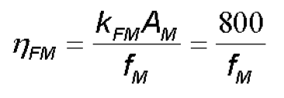
We have found that there was two zero crossing points at fm = 280Hz, and fm = 118Hz, which is corresponding to modulation index β = 2.86, and 6.78 respectively.

FM spectrum for square wave modulation
In this part we will see the FM spectrum of modulated square wave signal with 20 V peak- peak , with 50% duty cycle and frequency of 200Hz ,the following figure show the spectrum of modulated square wave . We notice that the amplitude was non-linear.
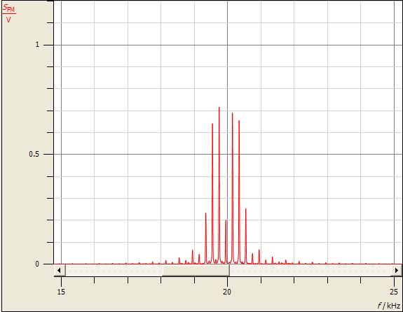
Figure 10: Spectrum of square wave modulated signal

FM demodulation for loop filter τ2
In this part we will demodulated the FM signal using the configuration described in the experiment , we have feed the modulated signal to the FM demodulator circuit and we have set the loop filter to τ2 , the message signal amplitude is 10V peak-peak , and 500Hz frequency . The following figure shows the modulation output.
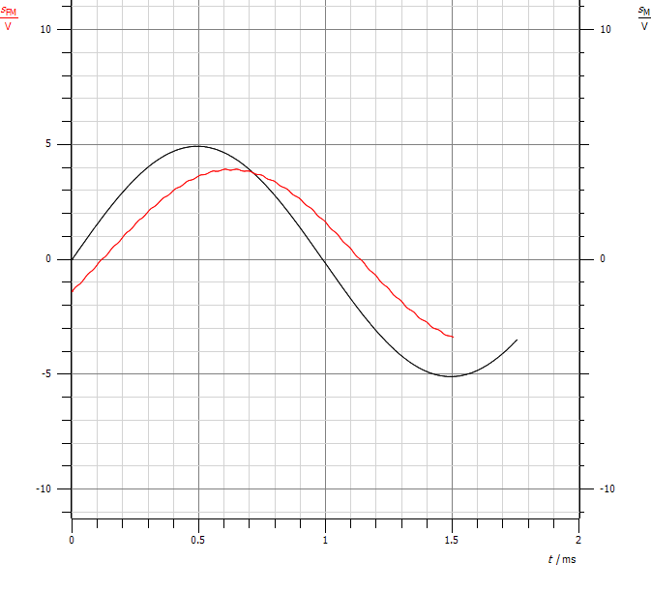
Figure 11: FM demodulated signal Vs original signal
By changing the frequency of the modulated signal from 500Hz to 5KHz and recording the amplitude of the modulated signal we construct the following table:
Frequency (KHz) | Amplitude (volts)
5 | 0.41572
4.5 | 0.48289
4 | 0.58865
3.5 | 0.71348
3 | 0.86773
2.5 | 0.974
2 | 1.077
1.5 | 1.089
1 | 1.115
0.5 | 1.101

The plot for these data points is shown below:
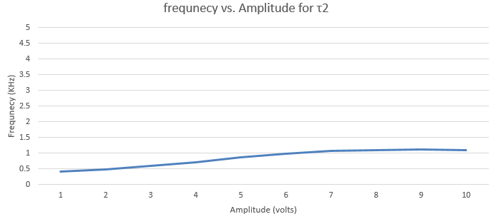
Figure 12 Frequency vs. Amplitude for τ1
Slop = = - 5537.01

FM demodulation for loop filter τ1
In this part we have connected and used the same configuration used in the previous part but while setting the loop filter of the FM demodulator to τ1, the following figure show the output of demodulation using this settings.
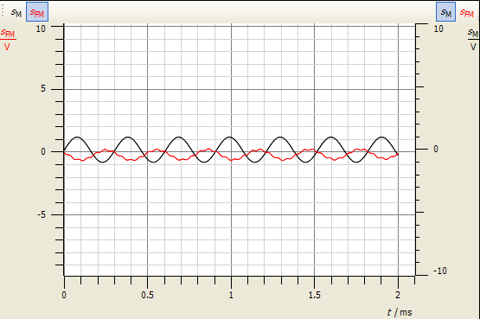
Figure 13: FM demodulation using loop filter τ1

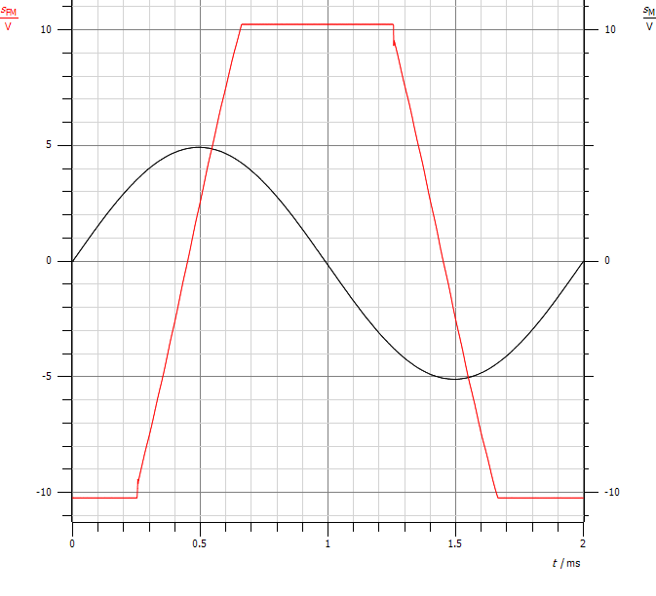
Figure 14: Message and FM Demodulated signal. Input is Vp-p=10 and frequency 500Hz using t1
By changing the frequency of the modulated signal from 500Hz to 5KHz and recording the amplitude of the modulated signal we construct the following table:
Frequency (KHz) | Amplitude (volts)
5 | 0.33304
4.5 | 0.39058
4 | 0.46565
3.5 | 0.56063
3 | 0.73176
2.5 | 0.90586
2 | 0.91706
1.5 | 1.7118
1 | 2.6571
0.5 | 5.032

The plot for these data points is shown below:
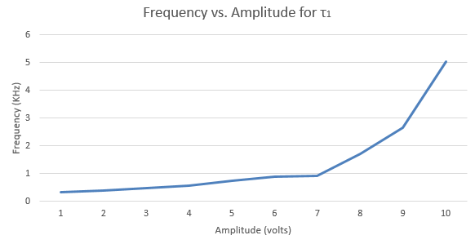
Figure 15 Frequency vs. Amplitude for τ1
Slop = = -1544.22
We found that τ2 supports wider range of amplitudes than τ1. So when we took Vp-p to be 10V as shown in figure 10, the amplitude of the demodulated signal was clipper while this didn’t happen when using τ2.

FM Pre-emphasis and de-pre-emphasis
When we transmit a signal with high frequencies, the noise at these frequencies becomes larger. So in order to keep the signal to noise ratio almost similar, we increase the amplitude of the message with respect to the frequency. From the figure below, we see that after applying the message to pre-emphasis stage, the amplitude increases as the frequency of the message increases.
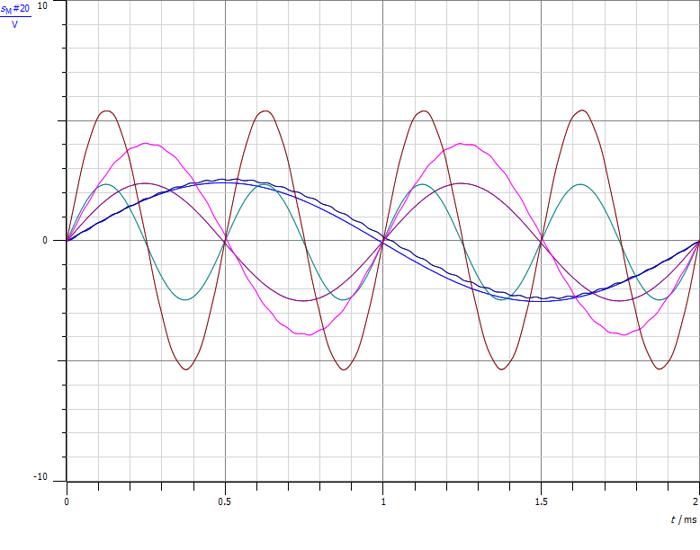
Figure 16: messages with different freq. after applying them the pre-emphasis stage
From the figure, we notice that the message with 500Hz frequency has a very small amplification after the pre-emphasis since the frequency in not large. The second message is with 1KHzfrequency, so the amplification is larger. The third message with 2 KHz is more amplified.
We took three different frequencies in order to be sure that the amplitude amplification was done from the pre-emphasis filter not from the any other source or from the devices or the program.

Phase modulation

Dynamic response of phase modulation
When we applied a sinusoidal input to a phase modulator, the output will be as shown in the following figure.
According to the PM modulation formula, the modulated signal (S(t)) will be Ac cos(2(20K)t+cos(2(1K)t)). As we can see, the amplitude of S(t) is constant while the phase of the carrier should change according to the concept of the phase modulation.
We noticed that the change in the phase is very small so we can’t see the effect of the PM modulation since the carrier is very large (20KHz) while the phase deviation () is very small.

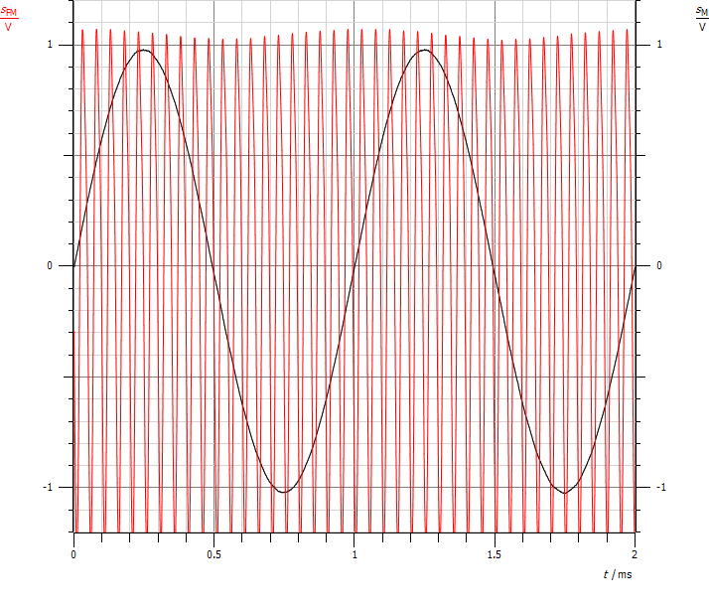
Figure 17: The input signal m(t) & the modulated signal S(t)

Characteristic of the PM modulator
We first set the carrier frequency to 20KHz and then we set the input signal to be DC. In order to determine the characteristic of the PM, we took different input values within range -1V – 1V and then we wrote down the phase values at each DC value in the following table.
DC input | -1.0 | -0.9 | -0.6 | -0.3 | 0.0 | 0.3 | 0.6 | 0.9 | 1.0
Phase(us) | -1 | -2 | -5 | -3 | 4 | 2 | 4 | 8 | 9

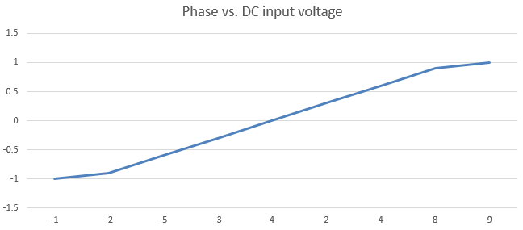
Figure 18Phase vs. DC input voltage
The minus sign for the phase shift in the above table means that the modulated PM signal meads the message signal, On the other hand, the plus sign means that the message signal leads modulated PM signal. By taking two points from the table above to calculate the slope:
Slop = (1--1)/(9--1) = 0.2
After that, we drew these points and then we found the slope of this line. This slope represents K_{PM} which is the phase sensitivity of the PM.

The PM spectrum
The following figure shows the FFT of S(t) = Ac cos(2(20K)t+cos(2(300)t)).
It appears that the modulated PM spectrum for sinusoidal input is almost like the modulated FM spectrum. The reason can be noticed by comparing the formulas of the PM & the FM. When the input is sinusoidal (Ac cos(2f_{c}t )), the modulated signal in FM will be Ac cos(2f_{c}t+2K_{f}). While the PM modulated signal will be Ac cos(2f_{c}t+A_{m} cos(2f_{m}t)). The integration of cos(2f_{m}t) is sin(2f_{m}t) which is similar to the cosine. So, the PM modulation spectrum will be deltas with amplitudes of J_{n}(B) which is the same as the FM modulation.
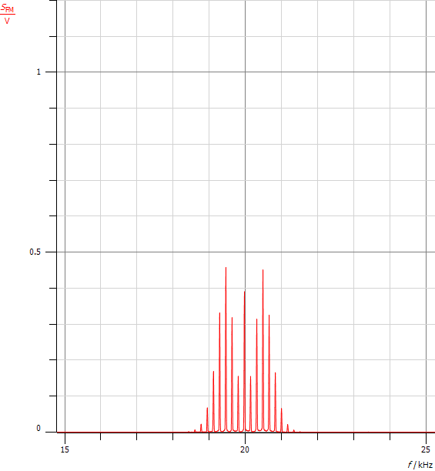
Figure 19: FFT of S(t)

PM demodulation for loop filter 𝜏2
After applying the modulated signal to demodulation circuit which is PLL using the loop filter , the output signal has a large phase shift and that is due to the delay of the filters. The following figure represents both the input signal( cos(2(1K)t) ) & the demodulated signal (recovered message signal). It appears that the recovered signal has the same frequency but different phase by comparing it with the original signal.
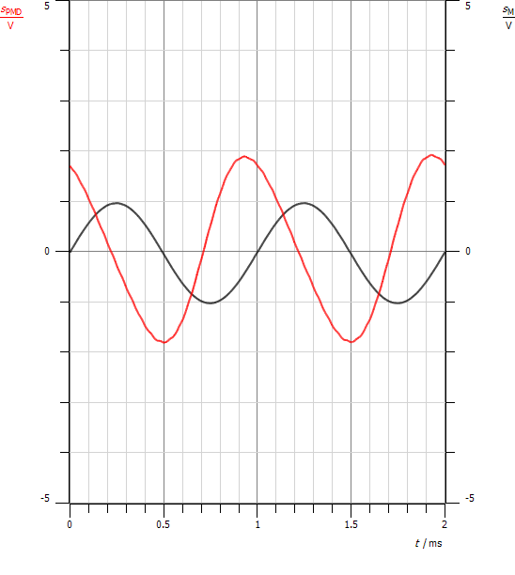
Figure 20: The input signal (m(t)) with the recovered signal

PM demodulation for loop filter 𝜏
After applying the modulated signal to demodulation circuit which is PLL using the loop filter , the output signal has less phase shift than . The following figure represents both the input signal( cos(2(1K)t) ) & the demodulated signal (recovered message signal). It appears that the recovered signal has the same frequency but different phase by comparing it with the original signal.
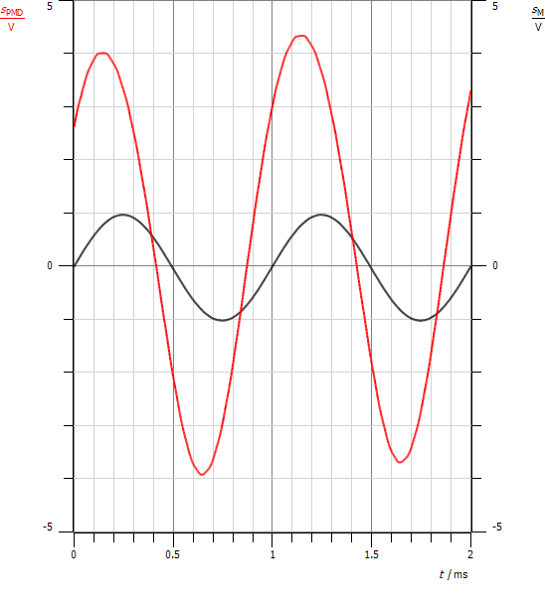
Figure 21: Message signal and the demodulated signal For PM

Conclusion

In this experiment we have studied the angle modulation in its both cases the FM & the PM. We have seen in different part of this experiment the stages of frequency modulation in addition to the behavior of the modulated signal when changing the input frequency or amplitude; also we have seen and studied the effect in frequency domain. We have seen how the spectrum of the PM is similar to the FM spectrum.
In addition to that, we have seen how the phase and the frequency changes according to the nature of the input signal in both FM & PM. Some of input signals change both while others change only one of them.
Moreover, we studied the bandwidth for the FM and its relation with the bandwidth of the AM according to the type of FM (narrow or wide band according to).
We use the pre-emphasis to keep the signal to noise ratio the same for all frequencies. This happens by making amplification with respect to the value of the frequency. After that, de-emphasis stage is used after the demodulation to return the original amplitude at each frequency and get rid of the effect of the pre-emphasis.
At the end, we concluded that the FM can be obtained from PM by integrating the message signal before enter it to the PM. Moreover, the PM can be obtained from the FM by differentiating the input signal before it enters the FM.

References

[1] http://en.wikipedia.org/wiki/Frequency_modulation
Access Time: 21-7-2016 at 8:23PM
[2] http://fas.org/man/dod-101/navy/docs/es310/FM.htm
Access Time: 21-7-2016 at 8:52PM
[3] http://en.wikipedia.org/wiki/Carson_bandwidth_rule
Access Time: 21-7-2016 at 9:22PM
[4] http://en.wikipedia.org/wiki/Voltage-controlled_oscillator
Access Time: 21-7-2016 at 9:43PM
[5] Introduction to Analog and Digital Communications (Second Edition) BY Simon Haykin & Michael Moher

