# Abstract

The aim of the experiment is to introduce pulse amplitude modulation (PAM) and understand Nyquist theory practically. In addition to that, studying the effect of duty cycle and sampling frequency of the pulse train on the modulation process. Moreover, studying how we can multiplex data from several digital bit streams into one high-speed digital stream for transmission over a digital system Time-division Multiplexing.

Contents

Abstract 1

Introduction 3

Pulse Amplitude Modulation (PAM) 3

Types of sampling techniques in PAM 3

Sampling and Hold 4

Time Division Multiplexing 4

Some Important Definitions 4

I. Duty Cycle 4

II. Nyquist Theorem 5

III. Aliasing 5

Procedure and discussion 6

I. Time and Frequency Characteristics of pulse train 6

II. Time Characteristics of Pulse Amplitude Modulation (PAM) 7

a) Measure the Input and output of the channel filter CH1 8

b) Display the time characteristic of the PAM 8

c) Measure the modulating signal sM(t) and the demodulated signal sD(t) as a function of the duty cycle 9

d) Variants 9

III. Spectra of Pulse amplitude modulation (PAM) 10

a) The PAM1 spectrum as a function of the frequency of the modulating signal 10

b) The PAM1-Spectrum as a function of the duty cycle 11

IV. Sub-sampling in the Frequency Domain 11

V. Sub-sampling in the Time Domain 12

VI. PAM time multiplex 12

Conclusion 14

References 15

# Introduction

## Pulse Amplitude Modulation (PAM)

In general, Modulation is the process of putting data (message signal) on other signal that had high frequency (carrier signal) in order to transmit the low frequency message signal over big distances. So some characteristic (amplitude, frequency or phase) of a carrier signal is varied in accordance with the modulating signal (message signal).

Amplitude modulation (AM) is a type of modulation process. In pulse amplitude modulation, the amplitude of regular interval of periodic pulses is varied in proposition to the sample of modulating signal or message signal. This is an analog type of modulation. In the pulse amplitude modulation, the message signal is sampled at regular periodic or time intervals and this each sample is made proportional to the magnitude of the message signal. These sample pulses can be transmitted directly.

## Types of sampling techniques in PAM

There are two types of sampling techniques for transmitting messages using pulse amplitude modulation, they are

* **FLAT TOP PAM:** The amplitude of each pulse is directly proportional to instantaneous modulating signal amplitude at the time of pulse occurrence and then keeps the amplitude of the pulse for the rest of the half cycle.
* **Natural PAM:** The amplitude of each pulse is directly proportional to the instantaneous modulating signal amplitude at the time of pulse occurrence and then follows the amplitude of the modulating signal for the rest of the half cycle.

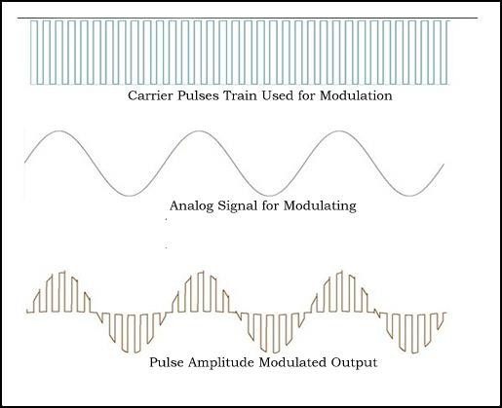

Figure : Pulse Amplitude Modulation example

## Sampling and Hold

Sample and hold circuits are used in linear systems. In some kinds of analog-to-digital converters, the input is compared to a voltage generated internally from a [digital-to-](http://en.wikipedia.org/wiki/Digital-to-analog_converter) [analog converter](http://en.wikipedia.org/wiki/Digital-to-analog_converter) (DAC). The circuit tries a series of values and stops converting once the voltages are equal, within some defined error margin. If the input value was permitted to change during this comparison process, the resulting conversion would be inaccurate and possibly completely unrelated to the true input value. Such [successive approximation](http://en.wikipedia.org/wiki/Successive_approximation_converter) [converters](http://en.wikipedia.org/wiki/Successive_approximation_converter) will often incorporate internal sample and hold circuitry. In addition, sample and hold circuits are often used when multiple samples need to be measured at the same time. Each value is sampled and held, using a common sample clock.

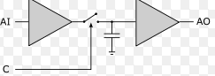

Figure : Sample & Hold circuit

## Time Division Multiplexing

Time division multiplexing (TDM) is a communications process that transmits two or more streaming digital signals over a common channel. In TDM, incoming signals are divided into equal fixed-length time slots. After multiplexing, these signals are transmitted over a shared medium and reassembled into their original format after de-multiplexing. Time slot selection is directly proportional to overall system efficiency. Time division multiplexing (TDM) is also known as a digital circuit switched.

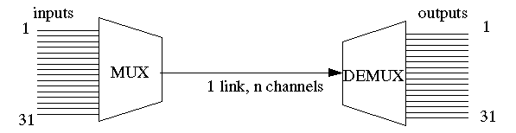In other words, TDM is a common form of sending multiple signals or streams of information on a carrier at the same time in the form of a single, complex signal and then recovering the separate signals at the receiving end.

Figure : TDM

## Some Important Definitions

### Duty Cycle

A duty cycle is the percentage of on[e period](http://en.wikipedia.org/wiki/Frequency) in which a signal is active. A period is the time it takes for a signal to complete an on-and-off [cycle](http://en.wikipedia.org/wiki/Turn_(geometry)). As a formula, a duty cycle may be expressed as:

Where D is the duty cycle, T is the time the signal is active, and P is the total period of the signal.

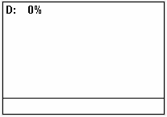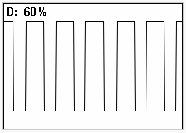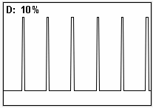

Figure : Pulse Train with different duty cycles

### Nyquist Theorem

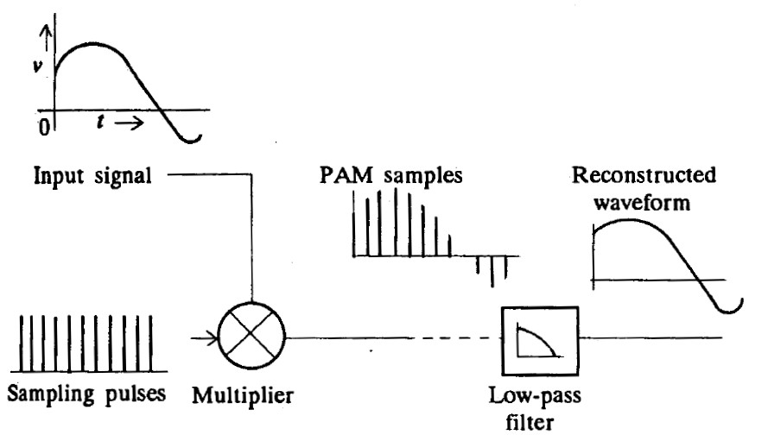The first step in digitizing speech, or for that matter any analog waveform, is to establish a set of discrete times at which the input waveform is sampled. The discrete sample instances may be spaced either at regular or irregular intervals. Most digitization techniques are based on the periodic and regularly spaced sample instances. The minimum sampling frequency required to reconstruct the original waveform from the sampled sequence is given by Nyquist criterion or theorem which can be stated as: If a function x(t) contains no frequencies higher than fH [hertz](http://en.wikipedia.org/wiki/Hertz), it is completely determined by giving its ordinates at a series of points spaced 1/(2fH) seconds apart. Or alternatively stating that if fs ≥ 2fH (where fs = sampling frequency), then the original waveform can be reconstructed by passing the sampled values through a low pass filter which smoothens out or interpolates the signal between sampled values.Sampling is therefore a process of multiplying a constant amplitude impulse train with the input signal. It is an amplitude modulation process, where the pulse train acts as the carrier. Since the amplitude of the pulses is modulated, the scheme is called pulse amplitude modulation (PAM).

Figure : Sampling & Reconstructing

### Aliasing

Aliasing is an effect that causes different signals to become indistinguishable from each other during sampling. It is done when the sampling frequency is not appropriate and when not taking into consideration the Nyquist theorem. Anti- aliasing filters can be used to correct this problem.

# Procedure and discussion

## Time and Frequency Characteristics of pulse train

At this part of the experiment, we wanted to become familiar with the pulse train that will be used in sampling in PAM in both time domain and frequency domain. We set the function generator to rectangular train pulses with 1KHz frequency & 5V amplitude and 10% duty cycle. The following figure represents the pulse train in time domain.

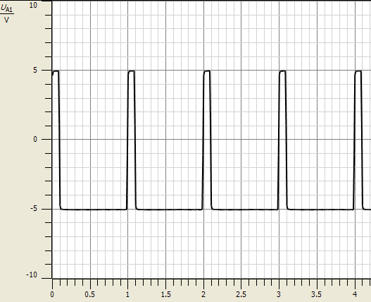

Figure : Pulse train in time domain

As we can see, the pulse is periodic with period equals to 1ms and it is on only at 10% from the period.  
After that, we took the FFT of the pulse train to see the signal in frequency domain. The following figure represents the FFT of the previous pulse train.

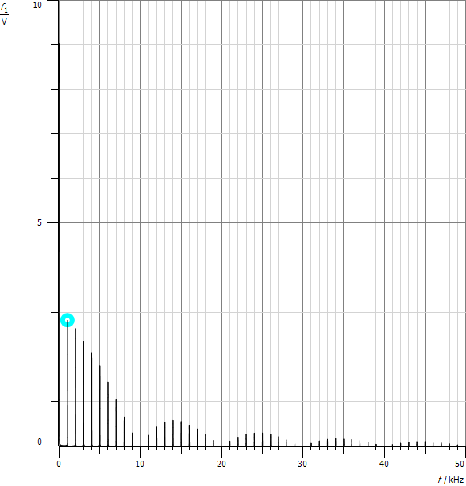

Figure : FFT of the previous pulse train with 10% duty cycle

As we can see, the FFT of the pulse train represents a sampled sinc function which is group of deltas and the space between each two deltas is 1KHz which is the frequency of the pulse train. Moreover, the null points are at n*10KHz since we took the duty cycle to be 10%. We can explain that as following:  
Duty Cycle = $\frac{τ}{Ts}$ where $τ$ is the duration of the period when the signal is on. So, Fs = & the null points happen at $\frac{n}{τ}$. Since D.C in this case is 0.1, Fs = . So the null points will be at n*10*Fs such as 10K, 20K, 30K,…

We must also note that the FFT of a single rectangular signal is a continuous sinc function. So when we peroidize the rectangular signal in time domain, a sampling in frequency domain will happen as we saw previously.

If we let the duty cycle to become 20%, the null points of the sinc in frequency domain will be at n*5KHz as shown in the following figure.

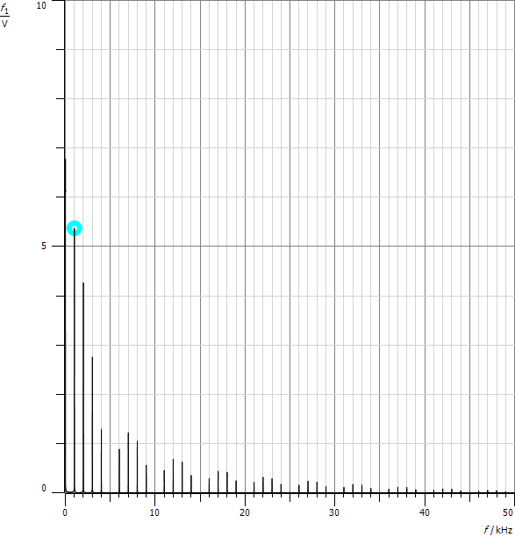

Figure : FFT of pulse train with 20% duty cycle

And when we let the duty cycle to be 30%, we noticed that the first null point appeared at 10KHz. Since the previous null points at 3.3KHz & 6.6KHz are not integer multiple of the sampling frequency (1KHz) so there is no deltas at them.

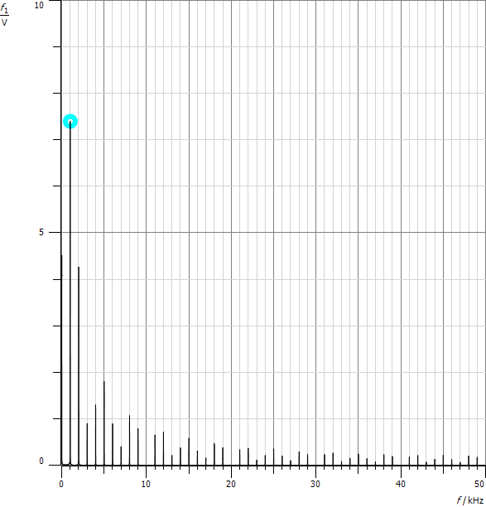

Figure : FFT of pulse train with 30% duty cycle

From the FFT of the pulse train, we can conclude that we need large bandwidth to transmit it since it has a sinc FFT that continues to infinity.

## Time Characteristics of Pulse Amplitude Modulation (PAM)

At first, we set the clock generator frequency to the maximum (5KHz) with 50% duty cycle. We can set this frequency by using the FFT of the output of the clock generator. The space between the deltas must be 5KHz and the null points must be at 2*n*Fs. After that, we set the function generator to be sine wave with 500Hz frequency & 10Vp-p as shown in the following figure.

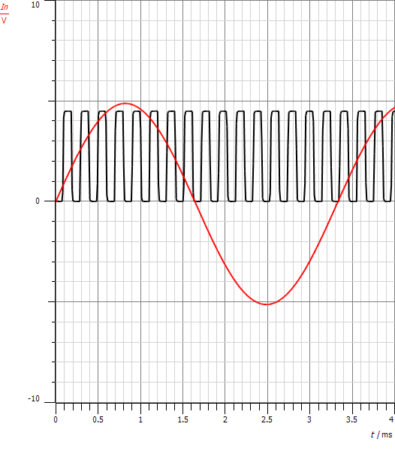

Figure : Sinusoidal input with the pulse train

### Measure the Input and output of the channel filter CH1

We took the first signal to be the input of channel 1 filter while the second signal to be the output of this filter. It appeared that the effect of this filter was a phase shift of its input as shown in the following figure. This filter is used as anti-aliasing filter which cuts frequencies higher that a specific frequency to avoid aliasing.

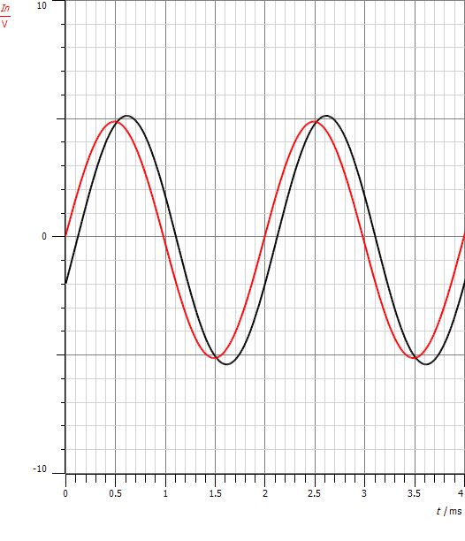

Figure : input& output of channel 1 filter (The input is the leading signal which is to the left)

### Display the time characteristic of the PAM

In order to know the behavior of the PAM, we took the first signal to be the input of the PAM while the second signal to be the output of it. The following figure represents the two signals.

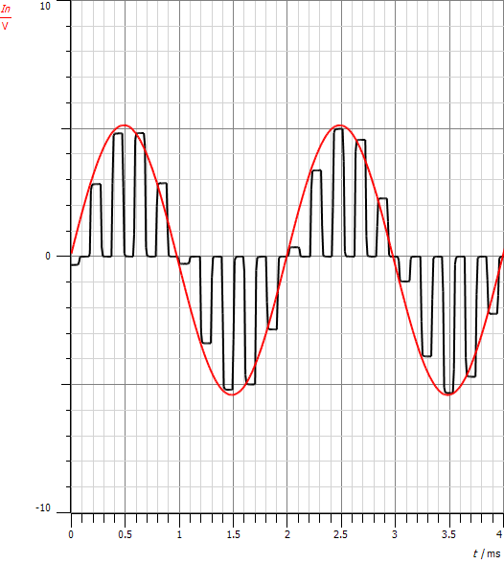

Figure : sinusoidal input with the PAM output

As we can see, the output of the PAM was a pulse train. Each of them has amplitude according to the input signal. We must notice that these pulses have flat amplitude since we chose the PAM to be flat-top. In this case, the PAM takes one sample and holds its value to be the whole amplitude of the pulse. But if we chose the PAM to be natural, then the pulse amplitude will not hold one value but instead, it will have a continuous value according to the input signal. So, the PAM sampled the input signal using a train of pulses and each pulse carries the amplitude of one sample.

### Measure the modulating signal sM(t) and the demodulated signal sD(t) as a function of the duty cycle

We took the first signal to be the sinusoidal input signal with the same previous frequency and Vp-p while the second signal to be the output of the demodulation. The following figure shows these signals. The clock generator frequency was the maximum (5KHz) with 50% duty cycle.

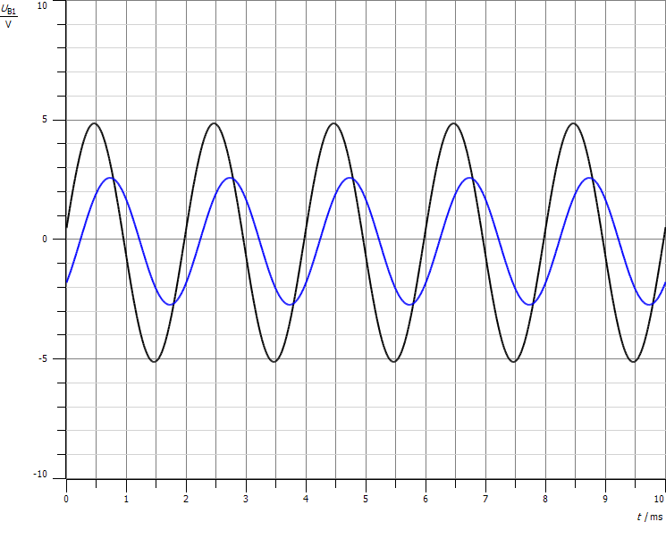

Figure : PAM modulation input with its demodulation output

It appears that the output of the demodulation was the same as the original signal but with phase shift due to the filters and the other components. When we varied the duty cycle of the clock generator to become lower, it helps us to have more signals in Time Division Multiplexing since the ON period will be lesser.

### Variants

We first tried to reduce the sampling frequency in order to see the result. The following figure shows the original signal and the reconstructed.

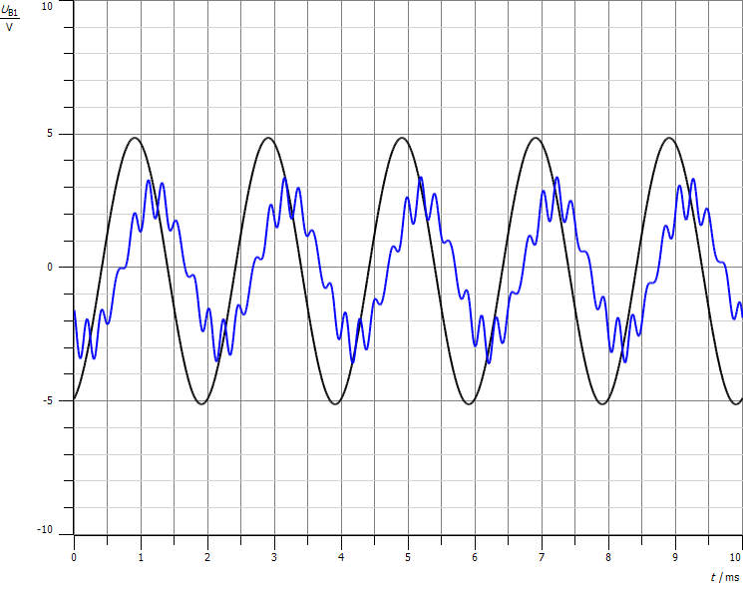

Figure : the original signal and the reconstructed signal

It appears that we were not able to reconstruct the original signal after sampling it. The reason is that Nyquist theorem was not satisfied so aliasing happened.

After that, we tried the input signal to be triangular train with 500Hz frequency. While the pulse train was 5KHz frequency & 50% duty cycle. The following figure represents the input signal with the reconstructed one.

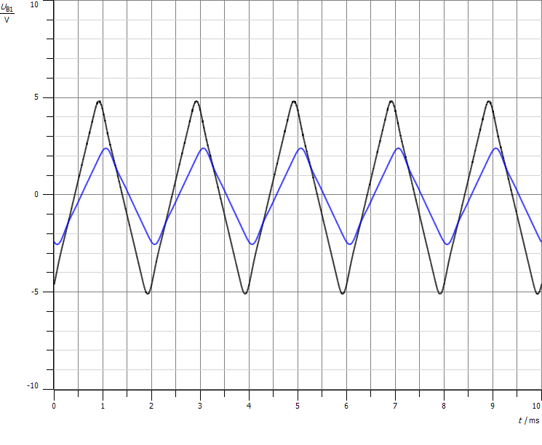

Figure : The original signal (triangular) with the reconstructed one

## Spectra of Pulse amplitude modulation (PAM)

### The PAM1 spectrum as a function of the frequency of the modulating signal

We first set the sampling frequency to be 5 KHz. After that, we set the function generator to be sine signal with 500Hz frequency & 10Vp-p. After that, we took the FFT to the clock generator output and the PAM output as shown in the following figure.

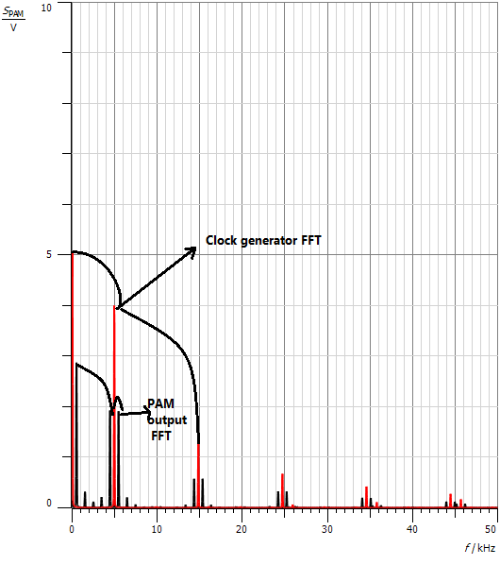

Figure : Spectrum of the clock generator & the PAM output

The deltas of the clock generator are at integer multiple of the sampling frequency which is 5KHz. But since we took the duty cycle to be 50%, the null crossing are at 2*n*5KHz. When doing PAM modulation, the spectrum of the output was the same as the pulse train spectrum but each delta is shifted by $∓$ 500Hz which is the input frequency. The reason is in time domain we multiply the pulse train with the sine input. So in the frequency domain the multiplication becomes convolution. We convolves the spectrum of the sine (which is delta at $∓$ 500Hz) with the train spectrum (which is set of deltas with sinc envelope). So the result will be shifting each of these deltas by $∓500Hz$.

### The PAM1-Spectrum as a function of the duty cycle

We increased the sine frequency to be 1KHz and we changed the pulse train duty cycle to be 30%. The following figure represents the spectrum of both the pulse train and the PAM output spectrum.

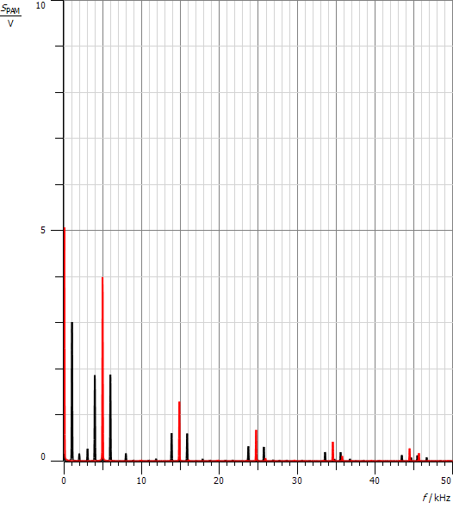

Figure : Spectrum of the clock generator (30% D.C) & the PAM output

## Sub-sampling in the Frequency Domain

We set the function generator to sine with 3KHz frequency while the train frequency was 5KHz. The following figure represents the FFT of both the pulse train and the PAM output.

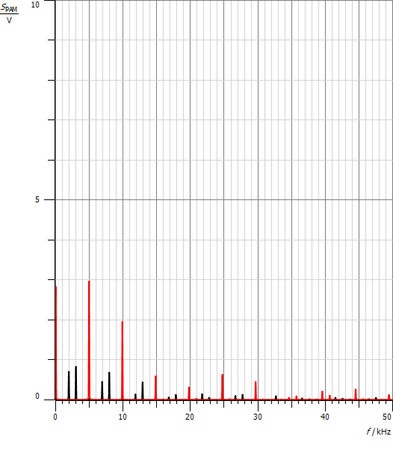

Figure : FFT of the pulse train with the PAM output when the input signal is 3KHz frequency

Each delta in the FFT of the pulse train will be shifted by $±$ 3KHz. They will intersect with each other and aliasing will occur. This resulted from not taking into consideration the Nyquist theorem since we took the sampling frequency to be 5KHz which is not at least twice the maximum frequency of the input signal (3KHz).

## Sub-sampling in the Time Domain

We took the previous values and them we displayed the modulated signal and the demodulated signal in time domain as shown in the following figure.

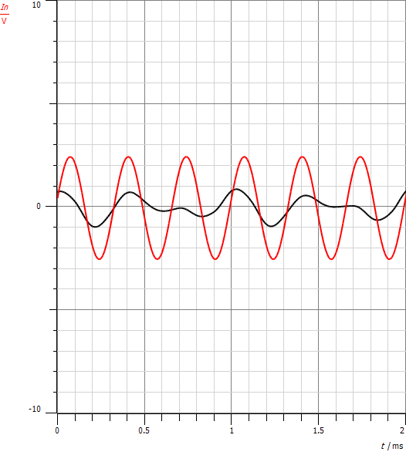

Figure : the modulating signal and the demodulated signal

As we said previously, the Nyquist theorem was not satisfied so the reconstructed signal will not be the same as the original signal since aliasing occurred.

## PAM time multiplex

In this part, we need two function generators as inputs signals. One of them will be transmitted using channel 1 while the other using channel 2. We set the first input signal to be triangle with 200Hz & 5Vp-p. While the second signal to be sine with 300Hz & 10Vp-p.

An important thing we must notice which is the clock generator. It appears that it is divided into two clocks as shown in the following figure.

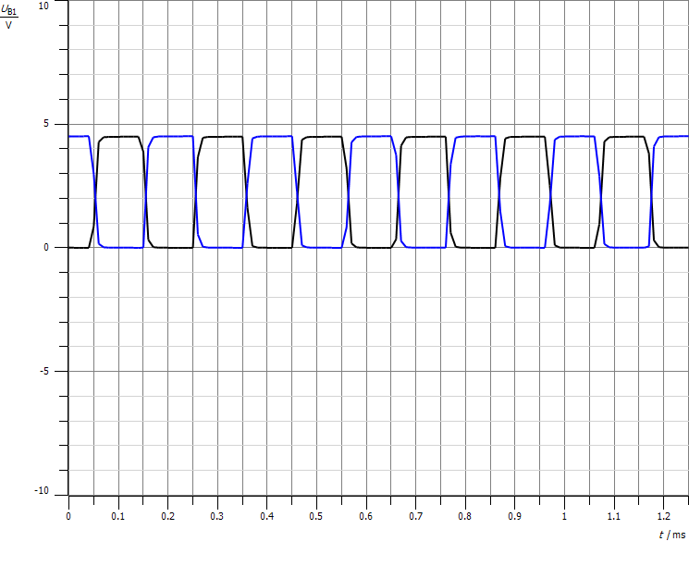

Figure : The two clocks that are generated from the original clock with 50% duty cycle

We can notice that the two clock are identical in period and duty cycle but the main difference is that the on & the off part are opposite. They are used in TDM to transmit 2 signals at different channels using the same sampling frequency. The first half of the period will sample the first signal while the second half of the period will sample the second signal and then they will be transmitter together as shown in the following figure.

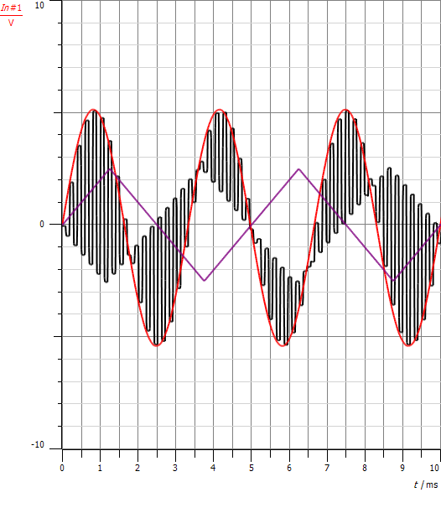

Figure : The two inputs signals & the PAM output when using TDM

As we can see, the first half of the period in each pulse samples the sine input while the second half of the pulse period samples the second triangle input.

The DEMUX at the demodulation contains a switch that opens and closes according to the clock. When it is ON, then the switch opens. There is a switch for $∆t$ which controls the opening and the closing of the DEMUX switch. If we changed it, we get the following demodulated signals.

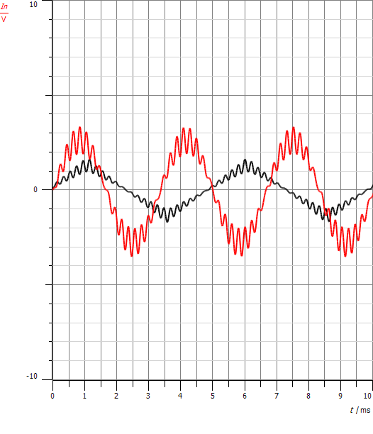

Figure : The demodulated signals when changing $∆$ t

As we can see, a distortion happened since the switching rate at the DEMUX is not the same as the sampling clock frequency.

# Conclusion

In this experiment we have seen that there are two types of PAM signals: PAM that uses Natural Sampling, and PAM that uses Instantaneous Sampling to produce a flat-top pulse which could be generated by using a sample-and-hold type electronic circuit.

Moreover, we concluded that if we reduced the duty cycle of the sampling clock generator, then we can transmit more signals using TDM which uses the same sampling frequency and it transmits the signals in the same channel.

So, the PAM is sampling technique that can be used in communication as modulation and demodulation technique. But we must always take into consideration when picking a sampling frequency the Nyquist theorem to be able to reconstruct the samples signal.

# References

* **Introduction to Analog and Digital Communications (Second Edition)** BY Simon Haykin & Michael Moher
* [**http://en.wikipedia.org/wiki/Amplitude_modulation**](http://en.wikipedia.org/wiki/Amplitude_modulation)  
  Access time: 4-8-2016 at 7:43PM
* [**http://ecevishnu1.blogspot.com/2013_11_01_archive.html**](http://ecevishnu1.blogspot.com/2013_11_01_archive.html)   
  Access time: 4-8-2016 at 7:55PM
* [**http://en.wikipedia.org/wiki/Duty_cycle**](http://en.wikipedia.org/wiki/Duty_cycle) Access time: 4-8-2016 at 8:15PM
* [**http://mmust.elimu.net/BSC(ELEC_COMM)/Year_4/ECE%20421_Comm_Systems_II/S**](http://mmust.elimu.net/BSC(ELEC_COMM)/Year_4/ECE%20421_Comm_Systems_II/S) **ignal_Digitization/PAM/Pulse_Amplitude_Modulation(1).html**Access time: 4-8-2016 at 8:34PM
* [**http://www.wlxt.uestc.edu.cn/wlxt/ncourse/dacs/web/3/jxtj/PPT/chapter3A%20Baseband**](http://www.wlxt.uestc.edu.cn/wlxt/ncourse/dacs/web/3/jxtj/PPT/chapter3A%20Baseband)**%20pulse%20and%20digital%20signaling.pdf**Access time: 4-8-2016 at 8:51PM
* [**http://en.wikipedia.org/wiki/Sample_and_hold**](http://en.wikipedia.org/wiki/Sample_and_hold)  
  Access time: 4-8-2016 at 9:22PM
* [**http://www.techopedia.com/definition/9669/time-division-multiplexing-tdm**](http://www.techopedia.com/definition/9669/time-division-multiplexing-tdm)  
  Access time: 4-8-2016 at 9:47PM