# Abstract

The aim of the experiment is to be introduced to the noise in amplitude modulation. Moreover, getting to know new terms related to noise analysis. In addition to that, comparing the effect of the noise on DSB-SC modulation and SSB modulation.

Table Of Contents

Abstract 1

Introduction 3

I. Types of noise 3

• Shot noise 3

• Thermal noise 3

II. White noise 3

III. Signal-To-Noise Ratio 4

Procedure and discussion 6

Conclusion 10

References 11

# Introduction

In [communication systems](https://en.wikipedia.org/wiki/Communication_system), noise is an error or undesired random disturbance of a useful information [signal](https://en.wikipedia.org/wiki/Signal_(electrical_engineering)) in a [communication channel](https://en.wikipedia.org/wiki/Communication_channel). The noise is a summation of unwanted or disturbing energy from natural and sometimes man-made sources.

## Types of noise

The noise can be external (man-made noise, galactic noise) or internal (arising from spontaneous fluctuation of current or voltage in electronic devices). Example of which are shot noise and thermal noise.

### Shot noise

Shot noise or Poisson noise is a type of electronic noise which can be modeled by a Poisson process. In electronics shot noise originates from the discrete nature of electric charge. The Poisson distribution is often used to model this type of noise. Using this model, the number of electrons emitted in an interval of length T is a random variable with the PDF.

### Thermal noise

Voltages and currents that exist in a network due to the random motion of electronics in conductors is referred to as thermal noise (Johnson’s noise).

Thermal noise is approximately white, meaning that its power spectral density is nearly equal throughout the frequency spectrum. The amplitude of the signal has very nearly a Gaussian probability density function. A communication system affected by thermal noise is often modeled as an additive white Gaussian noise (AWGN) channel.

## White noise

The noise analysis of communication systems is often based on an idealized noise process called white noise. The power spectral density of white noise is independent of frequency. White noise is analogous to the term white light in the sense that all frequency components are present in equal amounts. We denote the power spectral density of a white noise process W(t) as

Sw(f) = Equation 1

Where the factor 0.5 has been included to indicate that half the power is associated with positive frequencies and half with negative frequencies.

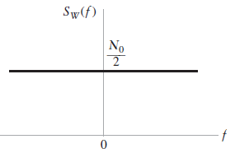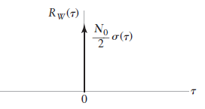

Figure : Characteristic of White noise (Power spectral density & Auto-Correlation function)

Since the autocorrelation function is the inverse Fourier transform of the power spectral density, it follows that the autocorrelation of white noise is given by

 Equation 2

Additive white Gaussian noise (AWGN) is a basic noise model used to imitate the effect of many random processes that occur in nature. The modifiers denote specific characteristics:

Additive because it is added to any noise that might be essential to the information system. White refers to the idea that it has uniform power across the frequency band for the information system. It is an analogy to the color white which has uniform emissions at all frequencies in the visible spectrum. Gaussian because it has a normal distribution in the time domain with an average time domain value of zero.

## Signal-To-Noise Ratio

Signal-To-Noise ratio (SNR) is the measure of quality for analog systems. It is the relation between the power in the original signal and the power in the noise.

The received signal in many communication systems can be modeled as the sum of the desired signal s(t), and a narrowband noise signal n(t) as shown by

X(t) = s(t)+n(t) Equation 3

Signal-to-noise ratio is defined as the ratio of the power of a signal (meaningful information) and the power of noise (unwanted signal)

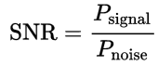 Equation4

The signal-to-noise ratio is clearly measured at the receiver, but there are several points in the receiver where the measurement may be carried out. In fact, measurements at particular points in the receiver have their own particular importance and value.

For instance, if the signal-to-noise ratio is measured at the front-end of the receiver, then it is usually a measure of the quality of the transmission link and the receiver front-end. But if the signal-to-noise ratio is measured at the output of the receiver, it is a measure of the quality of the recovered information-bearing signal.

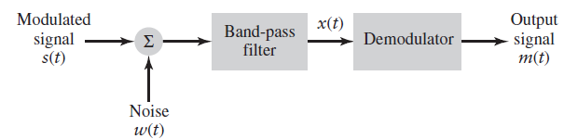

Figure : High-level block diagram of a communications receiver.

The signal plus white Gaussian noise is passed through a band-pass filter to produce the band-pass signal X(t). The signal X(t) is processed by the demodulator to recover the original message signal m(t).The SNR measured at the input to the demodulator is referred to as the pre-detection signal-to-noise ratio.

The signal-to-noise ratio of the recovered message at the output of the demodulator defines the quality of the signal that is delivered to the end user. We refer to this output SNR as the post-detection signal-to-noise ratio.

# Procedure and discussion

In order to be able to find the signal-to-noise ratio for each of DSB-SC & SSB modulation, we used the concept of superposition technique. For each of the mentioned modulation techniques, we first found the power of the modulated signal before the demodulation and without any noise and then we found the power of the noise after entering it to the modulation and before the demodulation. This is done in order to find the SNR before demodulation. After that, we did the same thing we did for the noise and the modulated signal before demodulation but this time after the demodulation in order to find the SNR after demodulation.

The first thing we did was making a simple DSB-SC modulation without any input noise in order to make sure that it works as expected and to find the power in the modulated signal. So, the following figure represents both the modulated signal and the demodulated signal without any noise added.

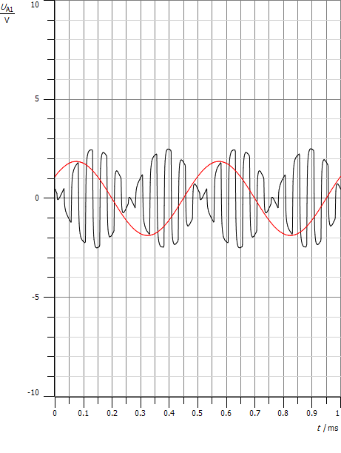

Figure : The modulated signal & the demodulated signal in DSB-SC modulation

There are several ways to find the power in the DSB-SC modulated signals. The method we used was making SSB modulation and finding the power in the modulated signal and then we multiply it by 2 to get the power of the modulated signal in DSB-SC modulation before the demodulation. So, the following figure represents the modulated signal in the SSB along with the modulated signal in DSB-SC.

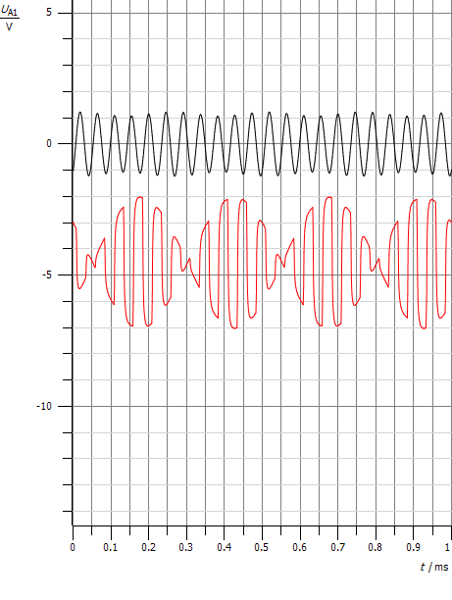

Figure : The modulated signal in both DSB-SC & SSB

Since the input of the modulation was sinusoidal with 5Vp-p & 2KHz , the SSB modulated signal was a sinusoidal. So the power of the modulated signal in SSB is $\frac{{Maximum Amplitude}^{2}}{2}$. From the previous figure, we found that the maximum amplitude of the SSB modulated signal was 1.15 so the power was 0.66125. As we said before, we can find the power of the modulated signal in DSB-SC by only multiplying the power we found previously by 2. So the power in the modulated signal in DSB-SC before demodulation will be 1.3225.

The next step was finding the power of the modulated signal without adding any noise but after the demodulation in both DSB-SC & SSB modulation. The following figure represents the demodulated signal in DSB-SC with the maximum amplitude value.

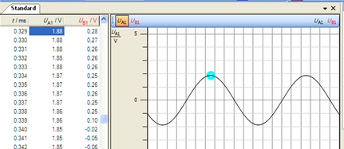

Figure : The DSB-SC demodulated signal

As we can see, the maximum amplitude was 1.88V so the power of the signal after the receiver will be (1.88)2/2 = 1.7672. As for the demodulated signal in SSB modulation, it can be seen in the following figure along with the maximum amplitude value.

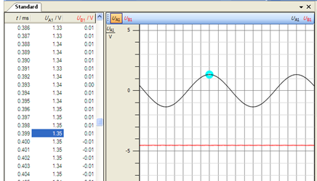

Figure : The SSB demodulated signal

As we can see, the maximum amplitude was 1.35V so the power of the signal after the receiver will be (1.35)2/2 = 0.91125. The following table sums up the results we got previously.

|  |  |  |  |  |
| --- | --- | --- | --- | --- |
| DSB-CS | | | SSB | |
|  | Before Receiver | | After Receiver | Before Receiver | After Receiver |
| Power in modulated signal | 1.3225 | 1.7672 | | 0.66125 | 0.91125 |

The next step was doing the second part of the superposition which was applying only a noise signal. The first value of the noise we took was -30db. In order to find the noise power before demodulation in DSB-SC, we took the FFT of the noise signal and we found the maximum amplitude of the noise in the bandwidth range of the modulated signal. In our case, the input signal was sinusoidal with 2kHz so in DSB-SC, the bandwidth we are interested in as 18KHz to 22KHz since after using 20KHz carrier, we will get two pulse at 18KHz (which comes from 20KHz – 2KHz) and the other will be at 22KHz(which comes from 20KHz + 2KHz). Since the power can be found in the frequency domain by the area under the curve of the squared function, we can find it in our case by taking the maximum amplitude in the bandwidth we are interested in and then square it and multiply it with the bandwidth. We must mention an important note about finding the power of the noise. That is it depends on the implemented modulation and demodulation system rather than the message signal. As a result of this, and by referring to our system that we used in the lab, we found that the bandwidth that we are interested in before demodulation was in DSB-SC 3.4K *2 since we have a LPF at the beginning of the modulation with 3.4KHz cut-off frequency that was designed after taking into consideration some specifications such as the carrier frequency and Nyquist theorem. We multiplied by 2 because we have two pulses around 20KHz. The following figure represents the FFT of the noise signal with -30db.

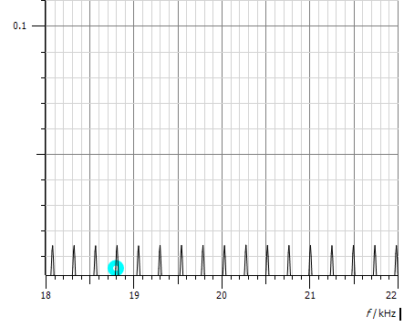

Figure : FFT of the -30db noise signal

After taking only the bandwidth between 18& 2 KHZ, we found that the maximum amplitude was 0.02V. So the power of the noise signal before demodulation will be (0.02)2 * (3.4K * 2) = 2.72.

To find the noise power before demodulation in SSB, we do the same as we did before but we multiply with the bandwidth 3.4 KHz since we have only one pulse in the modulated signal around 20 KHz which is at 22 KHz. So the power will be 1.36.

The last step was finding the noise signal power after passing it to the demodulation part and finding the power as we did previously. We must mention that our interest of bandwidth after demodulation, according to the demodulation system that we used, will be 3.4 KHz since there is a LPF at the end of the demodulation with cut-off frequency of 3.4 KHz. We must also mention that in DSB-SC demodulation, we don’t pass the noise signal to the BPF which exists at the beginning of the demodulator. We found that the maximum amplitude of the DSB-SC demodulated noise was 0.02 so the power will be (0.02)2 * (3.4K) = 1.36.

As for the SSB modulation, we found that the maximum amplitude of the noise signal after demodulation was 0.0186 so the power will be (0.0186)2 * (3.4K) = 1.176. The following table sums up all the previous values we got from applying only noise signal with -30db value.

|  |  |  |  |  |
| --- | --- | --- | --- | --- |
| DSB-CS | | | SSB | |
|  | Before Receiver | | After Receiver | Before Receiver | After Receiver |
| Power in noise | 2.72 | 1.36 | | 1.36 | 1.176 |

After we got all the values we wanted, we can calculate SNR before demodulation and after demodulation and the ratio between them. So SNRPre-detection = and it can be used as a measure of the quality of the transmission link & the receiver front-end. While SNRPost-detection = can be used as a measure of the quality of the recovered information-bearing signal.

We repeated the same previous steps by taking the noise to be -12db. The following table sums up all the data and the results we got at the two values of the noise we took.

|  |  |  |  |  |
| --- | --- | --- | --- | --- |
| DSB-CS | | | SSB | |
| **-30db noise** | Before Receiver | | After Receiver | Before Receiver | After Receiver |
| Power in modulated signal | 1.3225 | 1.7672 | | 0.66125 | 0.91125 |
| Power in noise | 2.72 | 1.36 | | 1.36 | 1.176 |
| SNRPre-detection | 0.486 | | | 0.486 | |
| SNRPost-detection | 1.299 | | | 0.7748 | |

|  |  |  |  |  |
| --- | --- | --- | --- | --- |
| DSB-CS | | | SSB | |
| **-12db noise** | Before Receiver | | After Receiver | Before Receiver | After Receiver |
| Power in modulated signal | 1.3225 | 1.7672 | | 0.66125 | 0.91125 |
| Power in noise | 155.58 | 129.74 | | 77.79 | 93 |
| SNRPre-detection | 0.0085 | | | 0.0085 | |
| SNRPost-detection | 0.0136 | | | 0.0097 | |

# 

# Conclusion

In this experiment, we learned how a real communication system is that differs from the previous systems we analyzed in which that this system takes into consideration the noise cause when transmitting the message signal using the channel and the effect of this noise on the received signal.

Moreover, we became familiar with SNR concept which can be used as a measure of the quality of either the transmission link or the quality of the recovered information. So we became able to know how to calculate these ratios and how to find the power of the signal and the noise.

In addition to that, we compared the effect of the noise on two different techniques of modulation which are DSB-SC and SSB modulation by taking different values of noise.

# References

* **Introduction to Analog and Digital Communications,** Second Edition, By **Simon Haykin & Michael Moher**
* **https://en.wikipedia.org/wiki/Noise_(electronics)**  
  Access time: 11-8-2016 at 6:23PM
* **http://www.radio-electronics.com/info/rf-technology-design/rf-noise-sensitivity/receiver-signal-to-noise-ratio.php**Access time: 11-8-2016 at 7:34PM