

**Control**

**Assignment #1**

**Student name : Ali Abu Hijleh**

**Student number : 1120164**

**Instructor : Dr.Jmal Siam**

**Q1)**

**1)**

t=-4:0.001:10;

x1 = heaviside(t-7);

x2 = heaviside(t-4);

x = x2-x1;

plot(t,x);

axis([2 9 0 2]);

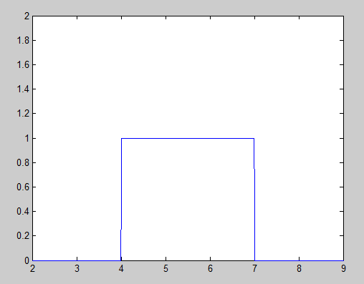

----------------------------------------------------

**2)**

t=-4:0.001:10;

x = 4* rectangularPulse(3,7,t);

plot(t,x);

axis([ 1 9 0 5]);

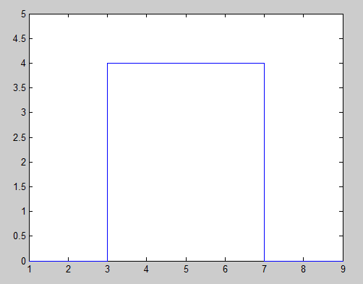

**3)**

t=0:0.001:15;

x = heaviside(t-4) + (t-6).*heaviside(t-6)-2*(t-9).*heaviside(t-9)+(t-11).*heaviside(t-11);

plot(t,x);

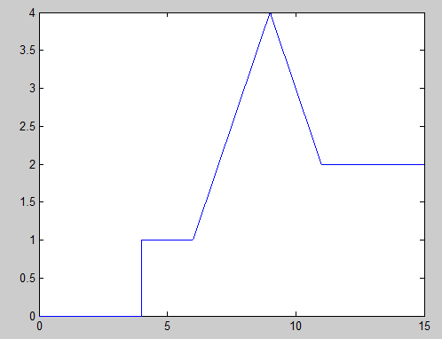

**Q2)**

**1)**

t=0:0.0001:15;

m = sin(200*pi*t) + cos(750*pi*t);

s= sin(200*pi*t) - cos(750*pi*t);

subplot(2,1,1);

plot(t,m);

axis([2 2.04 -2 2]);

subplot(2,1,2);

plot(t,s);

axis([2 2.04 -2 2]);

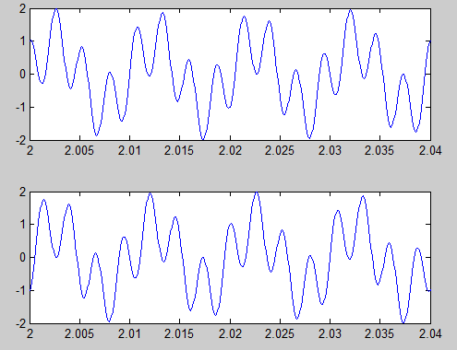

**2)**

t=0:0.0001:15;

m = sin(200*pi*t) + cos(750*pi*t);

s= sin(200*pi*t) - cos(750*pi*t);

subplot(2,1,1);

plot(t,m);

axis([2 2.04 -2 2]);

subplot(2,1,2);

plot(t,s);

axis([2 2.04 -2 2]);

**Q3)**

**1)**

syms t;

dsolve('10*Dy+20*y = 10' , 'y(0) = 0')

**ans = 1/2 - exp(-2*t)/2**

**-------------------------------**

**2)**

syms t;

dsolve('D2y + 2*Dy + 4*y = 5*cos(1000*t)' , 'y(0) = 0')

**ans =**

**sin(3^(1/2)*t)*((625*cos(1000*t - 3^(1/2)*t))/124999500002 - (625*cos(1000*t + 3^(1/2)*t))/124999500002 - (1249995*sin(1000*t + 3^(1/2)*t))/499998000008 + (1249995*sin(1000*t - 3^(1/2)*t))/499998000008 + (1250005*3^(1/2)*cos(1000*t + 3^(1/2)*t))/1499994000024 + (1250005*3^(1/2)*cos(1000*t - 3^(1/2)*t))/1499994000024 + (312499375*3^(1/2)*sin(1000*t + 3^(1/2)*t))/374998500006 + (312499375*3^(1/2)*sin(1000*t - 3^(1/2)*t))/374998500006) - (5*3^(1/2)*cos(3^(1/2)*t)*((sin(t*(3^(1/2) - 1000)) - cos(t*(3^(1/2) - 1000))*(3^(1/2) - 1000))/((3^(1/2) - 1000)^2 + 1) + (sin(t*(3^(1/2) + 1000)) - cos(t*(3^(1/2) + 1000))*(3^(1/2) + 1000))/((3^(1/2) + 1000)^2 + 1)))/6 + C4*exp(-t)*sin(3^(1/2)*t) - (5*3^(1/2)*exp(-t)*cos(3^(1/2)*t)*((3^(1/2) - 1000)/((3^(1/2) - 1000)^2 + 1) + (3^(1/2) + 1000)/((3^(1/2) + 1000)^2 + 1)))/6**

**Q4)**

**1)**

syms t;

dsolve('Dy+ 5*y = 10*heaviside(t)' , 'y(0)=3')

**ans =**

**3*exp(-5*t) + 2*exp(-5*t)*heaviside(t)*(exp(5*t) - 1)**

-------------------------------------------

**2)**

syms t;

dsolve('D2y + 2*Dy + 2*y = 5 *cos(2000*t)' , 'y(0)=1 , Dy(0) =2')

**ans =**

**sin(t)*((5*cos(1999*t))/7992004 + (5*cos(2001*t))/8008004 + (9995*sin(1999*t))/7992004 + (10005*sin(2001*t))/8008004) - cos(t)*((9995*cos(1999*t))/7992004 - (10005*cos(2001*t))/8008004 - (5*sin(1999*t))/7992004 + (5*sin(2001*t))/8008004) + (8000009999997*exp(-t)*cos(t))/8000000000002 + (23999990000001*exp(-t)*sin(t))/8000000000002**

**Q5)**

**1-**

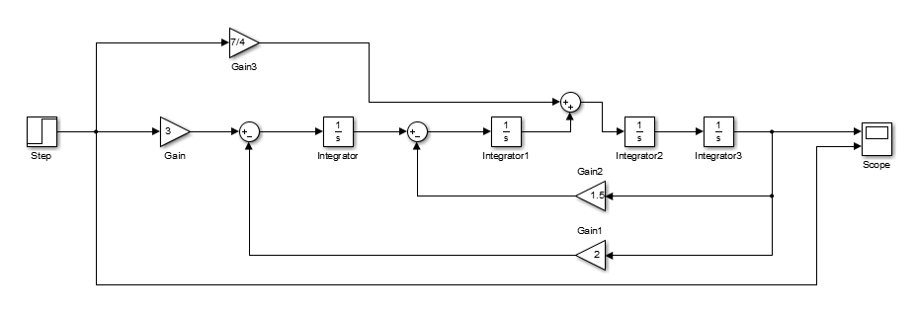

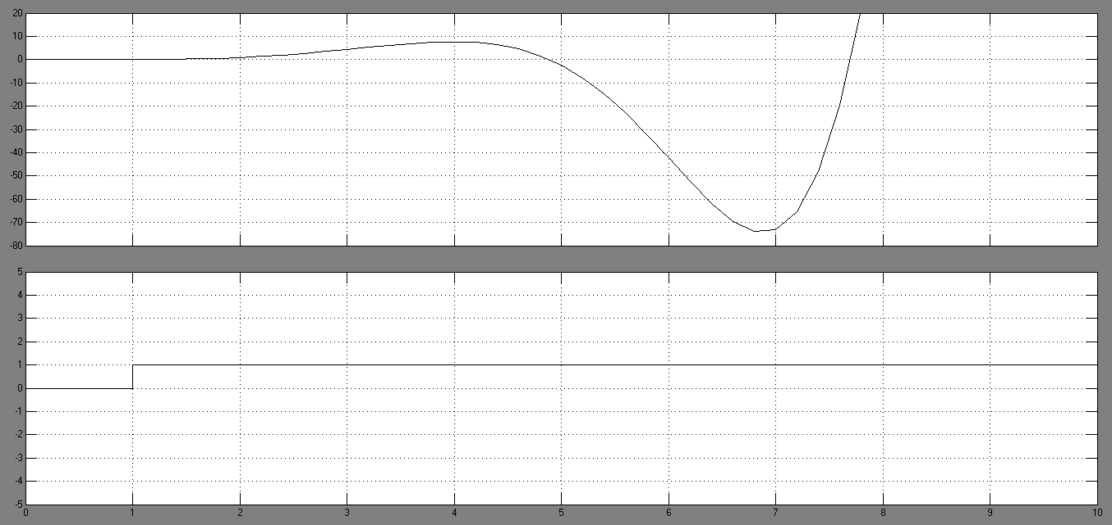

**----------------------------------**

**2-**

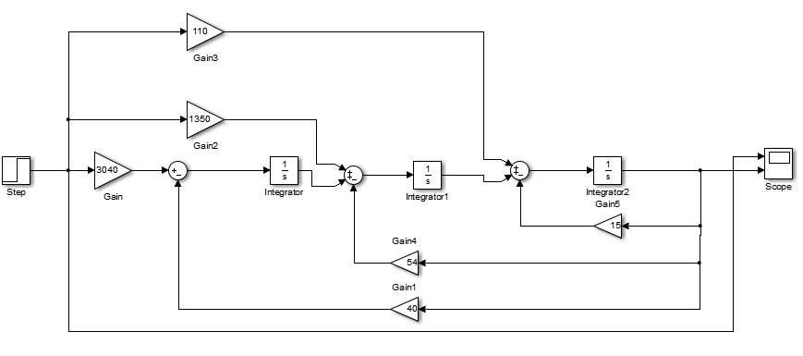

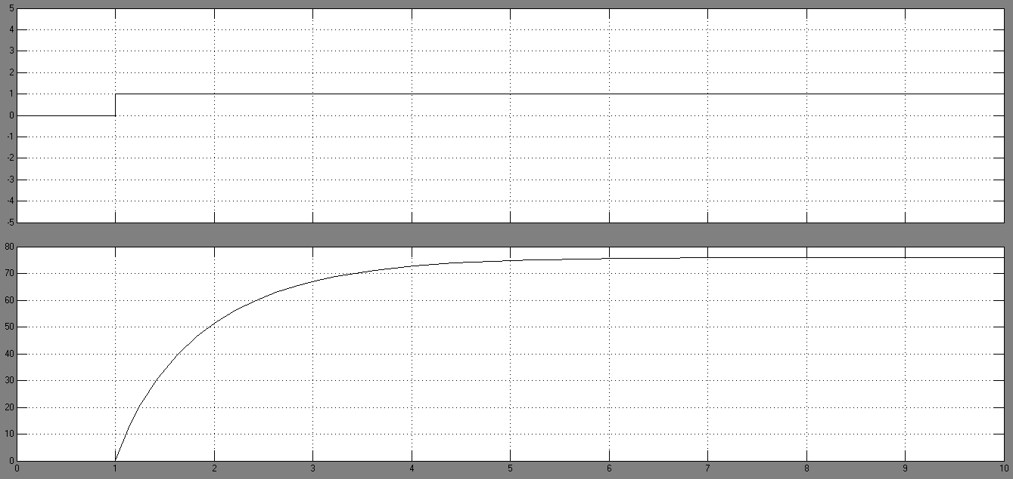

**Q6)**

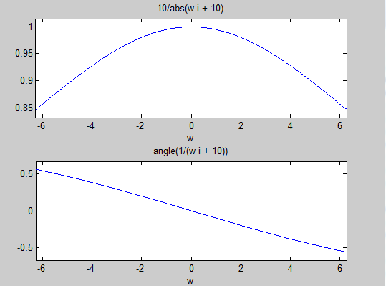

**1)**

syms t w;

y = (10*exp(-10*t)).*heaviside(t);

x = fourier(y,w)

subplot(2,1,1);

ezplot(abs(x));

subplot(2,1,2);

ezplot(angle(x));

**output :**

x =

10/(w*i + 10)

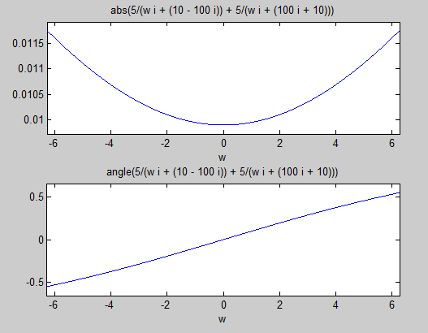

**2)**

syms t w;

y = (10*exp(-10*t).*cos(100*t)).*heaviside(t);

x = fourier(y,w)

subplot(2,1,1);

ezplot(abs(x));

subplot(2,1,2);

ezplot(angle(x));

**Output :**

**x =**

**5/(w*i + 10 - 100*i) + 5/(w*i + 10 + 100*i)**

**Q7)**

**1)**

syms t

f =(10 - 10*exp(-5*t))*heaviside(t);

laplace(f)

**ans =**

**10/s - 10/(s + 5)**

-------------------------------------------------

**2)**

f =(30 - 10*exp(-5*t)*cos(100*t))*heaviside(t);

laplace(f)

**ans =**

**30/s - (10*(s + 5))/((s + 5)^2 + 10000)**

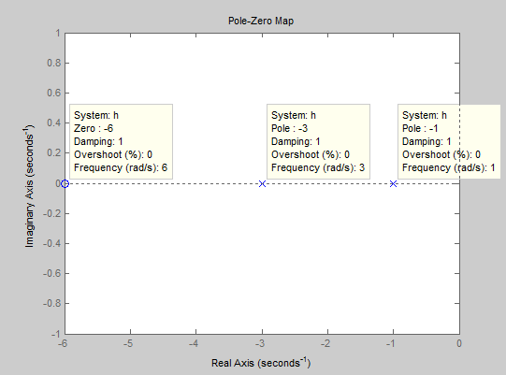**Q8)**

**1)**

h = zpk(-6,[-1 -3] ,1)

pzmap(h)

**h =**

**(s+6)**

**-----------**

**(s+1) (s+3)**

Continuous-time zero/pole/gain model.

--------------------------------------------------------------------------------------

**2)**

h = zpk(-3,[-1 1+2*i 1-2*i ,1)

pzmap(h)

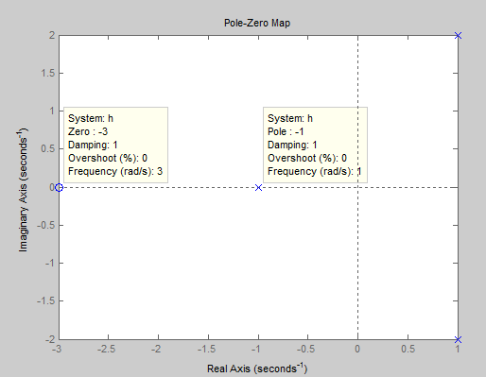

**h =**

**(s+3)**

**--------------------**

**(s+1) (s^2 - 2s + 5)**

Continuous-time zero

/pole/gain model.

**Q9)**

**1)**

syms s

h = (s+6)/((s+1)*(s+3));

ilaplace(h)

**ans =**

**(5*exp(-t))/2 - (3*exp(-3*t))/2**

**2)** syms s

h = (s+3)/((s+1)*(s^2 - 2*s +5 ))

ilaplace(h)

**ans =**

**exp(-t)/4 - (exp(t)*(cos(2*t) - 3*sin(2*t)))/4**