

ELECTRICAL AND COMPUTER ENGINEERING DEPARTMENT

ENEE4403

Power Systems

Project

Power World Simulator Project

Name: Ahmad Waleed Hamed

I.D #: 1120580

Instructor: Dr. Jaser Sa’ed

***Table Of Contents***

Abstract : 3

Methods and materials : 4

Procedure and results : 4

**Abstract**

The aim of this project is to be familiar with the power world simulator which is the one of the power system analysis software and to more understanding of power system analysis by simulate the simple power system contain generator, transformers, transmission lines and loads.

**Methods and Materials**

1. Laptop or Pc.
2. Power world simulator program.

**Procedure and Results**

1. At 70% loaded and with power factor equal 0.9, the complex(S), real (P) and reactive (Q) power at the loads are calculating as the following:

S = 1000*0.7 = 0.7 MV

P = S*PF = 0.7*0.9 = 0.63 MV

Q = S*sin (cos-1(PF)) = 0.305 MVAR

1. The limit MVA for the line is equal the voltage multiply by the rated current of the line as the following:

For XLPE (120 mm2), limit MVA = 335*6.6k = 2.211 MV

For ACSR (95/15), limit MVA = 359*6.6k = 2.369 M

For ACSR (50/8), limit MVA = 359*6.6k = 2.369 MVA

1. *Dy11 transformer:* It is (delta –star) wound transformer, which is the wye winding is HV and delta winding is LV. with a 30-degree lead is denoted .
2. The single line diagram is shown in fig1

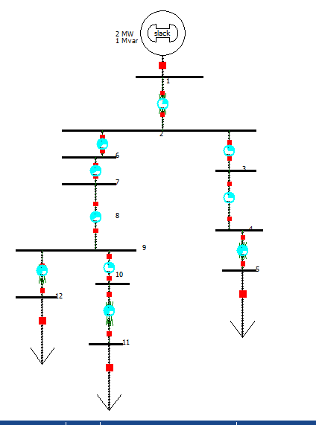

**Fig1:** the single line diagram after that insert to PowerWorld Simulator

1. The capacity of the substation = 2+1j (MVA) = 2.24 with phase shift =26.57 degree
2. The loads consumption:

Load 1= 0.36+0.305j (MVA)

Load 2= 0.36+0.305j (MVA)

Load 3= 0.36+0.0305j (MVA)

1. Total Loss:

|  |  |  |  |
| --- | --- | --- | --- |
| Type of TL | Length | MW Loss | MVAR Loss |
| XLPE(120mm2) | 120m | 0.00011 | 0.00004 |
| ACSR(95/15) | 3.4Km | 0.00345 | 0.00267 |
| ACSR(50/8) | 0.7Km | 0.00130 | 0.01171 |
| ACSR(95/15) | 0.8Km | 0.00021 | 0.00016 |
| XLPE(120mm2) | 3Km | 0.00068 | 0.00026 |
| ACSR(95/15) | 80m | 0.00004 | 0.00003 |

1. The actual voltage on the busses:

|  |  |
| --- | --- |
| The Number OF Bus | Actual voltage(KV) |
| 1 | 33 |
| 2 | 6.6 |
| 3 | 6.5931 |
| 4 | 6.5927 |
| 5 | 0.3982 |
| 6 | 6.5994 |
| 7 | 6.5790 |
| 8 | 6.5499 |
| 9 | 6.5475 |
| 10 | 0.3955 |
| 11 | 0.4000 |

1. The current flows in each line:

|  |  |  |
| --- | --- | --- |
| Type of TL | Length | Current(Ampere) |
| XLPE(120mm2) | 120m | 122.76175 |
| ACSR(95/15) | 3.4Km | 122.76175 |
| ACSR(50/8) | 0.7Km | 122.76181 |
| ACSR(95/15) | 0.8Km | 61.40932 |
| XLPE(120mm2) | 3Km | 61.30642 |
| ACSR(95/15) | 160m | 61.30642 |

1. The power flows in each line:

|  |  |  |
| --- | --- | --- |
| Type of TL | Length | Power Flow(MW) |
| XLPE(120mm2) | 120m | 1.26304 |
| ACSR(95/15) | 3.4Km | 1.26293 |
| ACSR(50/8) | 0.7Km | 1.25940 |
| ACSR(95/15) | 0.8Km | 0.62691 |
| XLPE(120mm2) | 3Km | 0.63077 |
| ACSR(95/15) | 160m | 0.63009 |

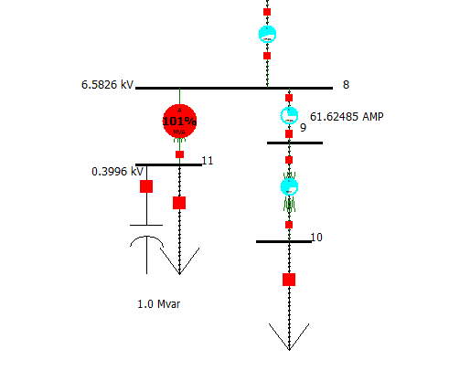

**Fig2:** the effect of adding a suitable shunt capacitor bank

1. The fault current for three-phase faults at each of the buses:

|  |  |  |
| --- | --- | --- |
| The Number OF Bus | Magnitude (Ampere) | Angle (Degree) |
| 1 | 1748.530 | -88.91 |
| 2 | 8679.540 | -88.32 |
| 3 | 8153.770 | -80.96 |
| 4 | 8096.580 | 80.57 |
| 5 | 104850.000 | -61.55 |
| 6 | 8660.300 | -88.01 |
| 7 | 7518.810 | -79.24 |
| 8 | 5914.490 | -57.96 |
| 9 | 7255.070 | -76.39 |
| 10 | 7015.720 | -74.85 |
| 11 | 91873.700 | -59.20 |