

Power Systems Assignment

Section: 1

Instructor: Dr. Jaser Sa’ed

Student Name: Haitham Da’ana

Student ID: 1121331

**Date: 4th January, 2017**

1. The Distribution Generators are loaded at 70%, hence the loads consume 0.7 of the power rating of the transformer which is 1MVA

Sload=0.7*Stransformer

Sload=0.7 MVA @ 0.9 PF

Sload=0.63+j0.305 MVA

1. XLPE(120mm^2)= Vn/10^6=335*1.73*6.6/1000000=2.211MVA

ASCR(95/15)=4.10MVA/sqrt(3)=2.367MVA

ASCR(50/8)=4.10MVA/sqrt(3)=2.367MVA

1. Dy11 : A Transformer that has HV Delta Connection at the Primary Side and Low Voltage Star Connected Secondary with 30 degrees phase shit leading.

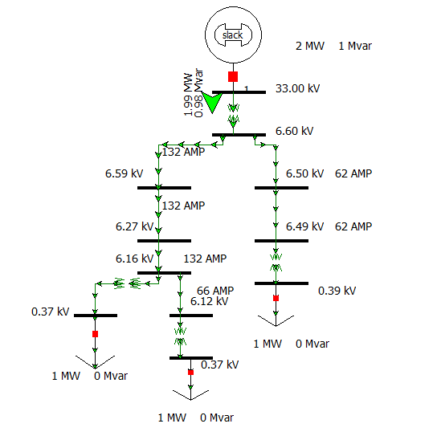

1. The Capacity of Substation is: 1.99MW at 0.9 Power Factor
2. Load Consumption is 0.63MW and 0.305MVAR (Three loads => 1.89MW 0.915MVAR)
3. Generated Power Equal to 1.99MW and 0.98MVA, which means will be 0.1MW, 0.065MVAR (0.11927MVA) losses in transmission lines and transformers.
4. Shown in figure above
5. Shown in figure above
6. Power Flow List:

Bus

Bus Flows

BUS 1 1 33.0 MW Mvar MVA % 1.0000 0.00 1 1

GENERATOR 1 1.99 0.98R 2.2

TO 2 2 1 1.99 0.98 2.2 2 1.0000TA 0.0

BUS 2 2 6.6 MW Mvar MVA % 0.9997 -0.00 1 1

TO 1 1 1 -1.99 -0.98 2.2 2 1.0000NT 0.0

TO 3 3 1 1.35 0.67 1.5 0

TO 4 4 1 0.64 0.31 0.7 0

BUS 3 3 6.6 MW Mvar MVA % 0.9985 0.00 1 1

TO 2 2 1 -1.35 -0.67 1.5 0

TO 5 5 1 1.35 0.67 1.5 0

BUS 4 4 6.6 MW Mvar MVA % 0.9848 0.05 1 1

TO 2 2 1 -0.63 -0.31 0.7 0

TO 10 10 1 0.63 0.31 0.7 0

BUS 5 5 6.6 MW Mvar MVA % 0.9498 -0.68 1 1

TO 3 3 1 -1.29 -0.63 1.4 0

TO 6 6 1 1.29 0.63 1.4 0

BUS 6 6 6.6 MW Mvar MVA % 0.9333 -0.67 1 1

TO 5 5 1 -1.27 -0.61 1.4 0

TO 7 7 1 0.63 0.31 0.7 0 1.0000TA 0.0

TO 8 8 1 0.64 0.31 0.7 0

BUS 7 7 0.4 MW Mvar MVA % 0.9295 -0.64 1 1

LOAD 1 0.63 0.30 0.7 DistGen 0.00 0.00 0.0

TO 6 6 1 -0.63 -0.30 0.7 0 1.0000NT 0.0

BUS 8 8 6.6 MW Mvar MVA % 0.9276 -0.76 1 1

TO 6 6 1 -0.63 -0.31 0.7 0

TO 9 9 1 0.63 0.31 0.7 0 1.0000TA 0.0

BUS 9 9 0.4 MW Mvar MVA % 0.9238 -0.72 1 1

LOAD 1 0.63 0.30 0.7 DistGen 0.00 0.00 0.0

TO 8 8 1 -0.63 -0.30 0.7 0 1.0000NT 0.0

BUS 10 10 6.6 MW Mvar MVA % 0.9840 0.05 1 1

TO 4 4 1 -0.63 -0.31 0.7 0

TO 11 11 1 0.63 0.31 0.7 0 1.0000TA 0.0

BUS 11 11 0.4 MW Mvar MVA % 0.9823 -0.01 1 1

LOAD 1 0.63 0.30 0.7 DistGen 0.00 0.00 0.0

TO 10 10 1 -0.63 -0.30 0.7 0 1.0000NT 0.0

1. When we add a suitable shunt capacitor to the load we will improve the system power factor which means that the capacitor bank will generate and compensate for the lost reactive power losses in the loads. Hence improving power factor and reducing the power losses.
2. Fault Currents:

At the slack bus(1):

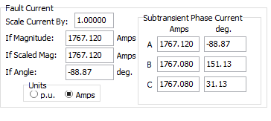

Bus (2)

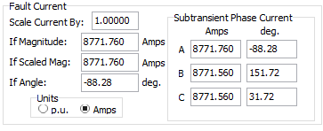

Bus (3)

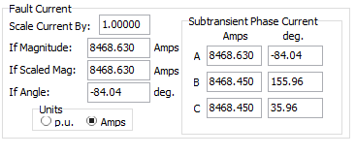

Bus(4)

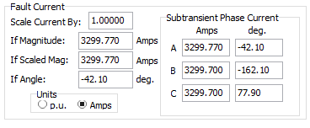

Bus(5)

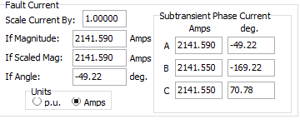

Bus 6

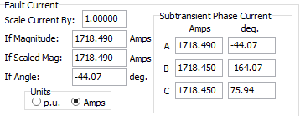

Bus 7

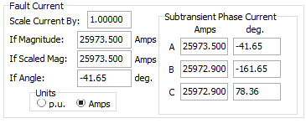

bUs 8

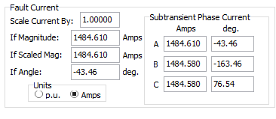

Bus 9

