BZU Logo

**Electrical And Computer Engineering Department**

**Power system**

ENEE 4403

Power world simulator project

By :Mohammad Amer 1130118

**Instructor : Dr. Jaser saad**

**Date :6-1-2016**

**(افضل موعد للنقاش من 11-12 )**

**Abstract :**

**Objectives :**

* To know how to use power world simulator .
* For more understanding of power system .

Requirements :

1. Power word simulator .

Theory :

* Calculate the load Mwat and load MVAR from MVA and power factor
* Calculate the substation Mwat and substation MVAR from MVA and power factor
* Convert the transmition line parameter from Pu / kilo to Pu/mile
* Convert the transmition line parameter from Pu/mile to ohm / mile
* Draw the circuit in the power world simulator
* Enter this values in the power world simulator (line parameter – transformer parameter – load parameter and substation parameter )
* Start to calculate the required question .

(1)

a)

*The transformer limit is 1MVA

*Its 80 % loaded so , the load is 0.8MVA

*The Power factor of the load 0.92

X is the impedance angle = cos-1(PF) =23.07392 degree

Sl=1*0.8=0.8MVA

Pl=0.8 *1*0.92 =0.736 MWatt

Ql=0.8 *1*sinx=0.3135 MVAR

b)

1) XlPE

The MVA limited for the transmition line

S= V(phase) * I(rated)= (6.6)/3^0.5) * 0.335 = 1.2765 MVA

For 3 phase =3*S=3.83 MVA

2) ACSR(95/15)

S= V(phase) * I(raeted)= (6.6)/3^0.5) * 0.359 = 1.368 MVA

For 3 phase =3*S=4.104 MVA

3) ACSR(50/8)

S= V(phase) * I(raeted)= (6.6)/3^0.5) * 0.359 = 1.368 MVA

For 3 phase =3*S=4.104 MVA

C)

DY11 : is a delta – wye transformer the low voltage lages the high voltage by 330 degree (high voltage lead low voltage by 30 degree )

the DY11 shown in figure 1 :

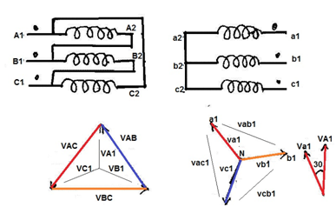

Figure (1)

(2)

D) Insert the single line diagram to the PowerWord Simulator, then find:

The circuit in power world simulator :

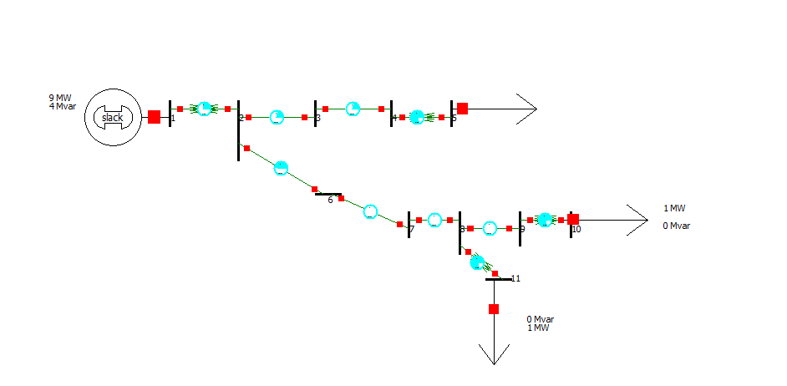

**Figure (2)**

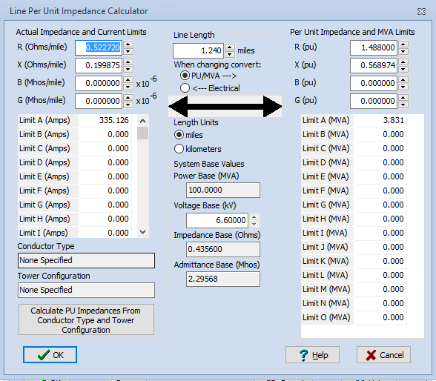**Line 23 line 34**

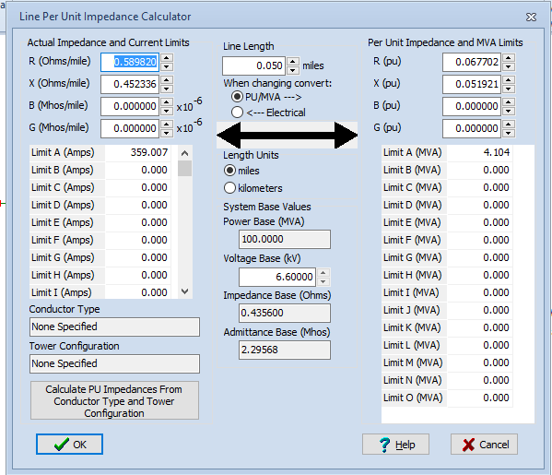

**Figure (3) Figure (4)**

(3)

**Line 26 line 67**

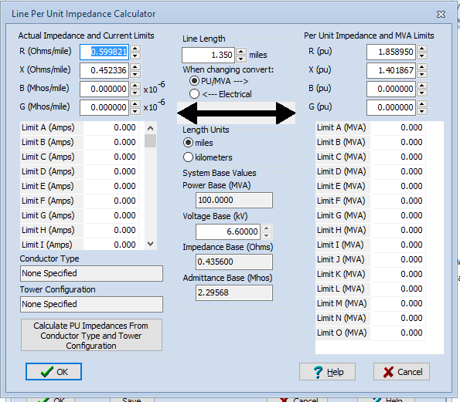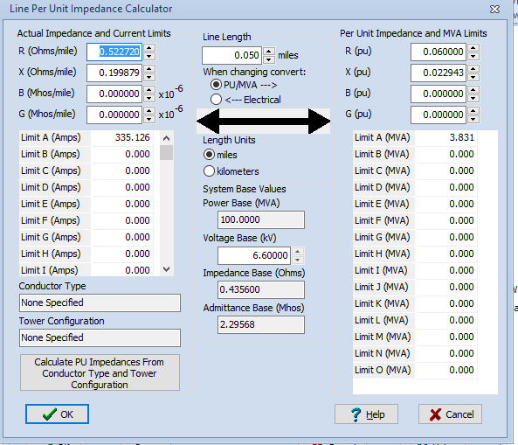

Figure (5) Figure (6)

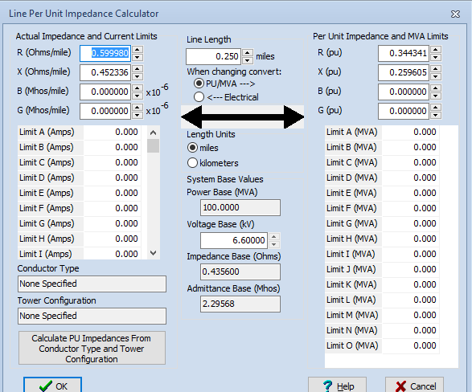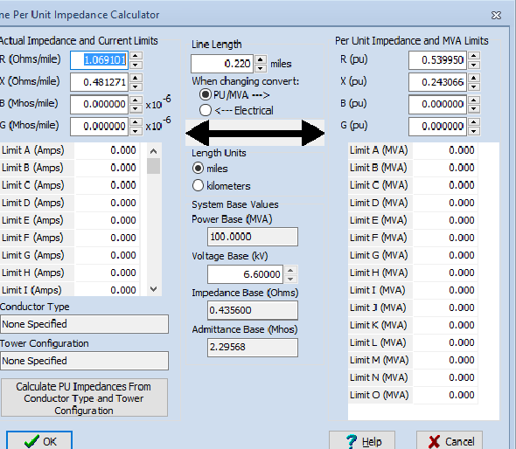Line 78 line 89

Figure (7) Figure (8)

(4)

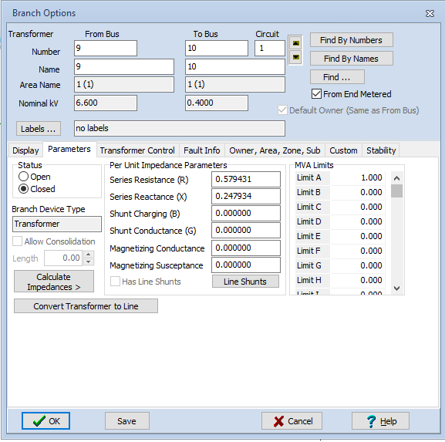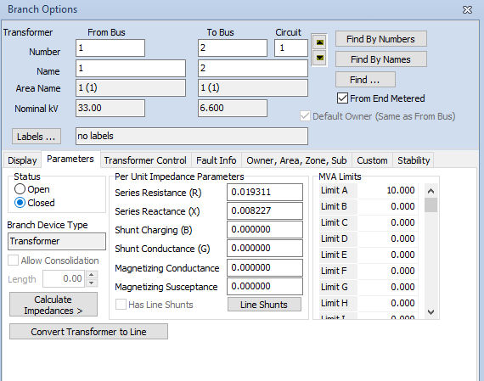Transformer 12 Transformer 45

Figure (9) Figure (10)

Transformer 8 11 Transformer 9 10

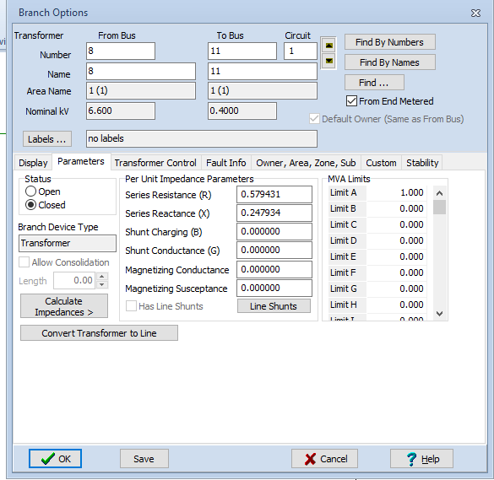

Figure (11) Figure (12)

(5)

1)

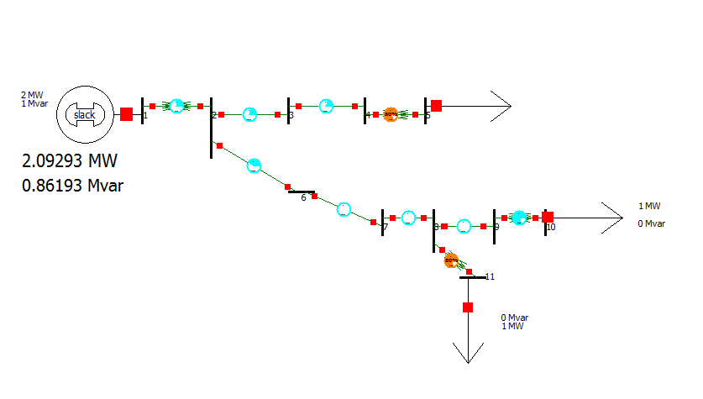

Figure (13)

As shown in figure (13) the capacity of substation :

2.09293 MW……………………. 0.86193 MVAR

2)

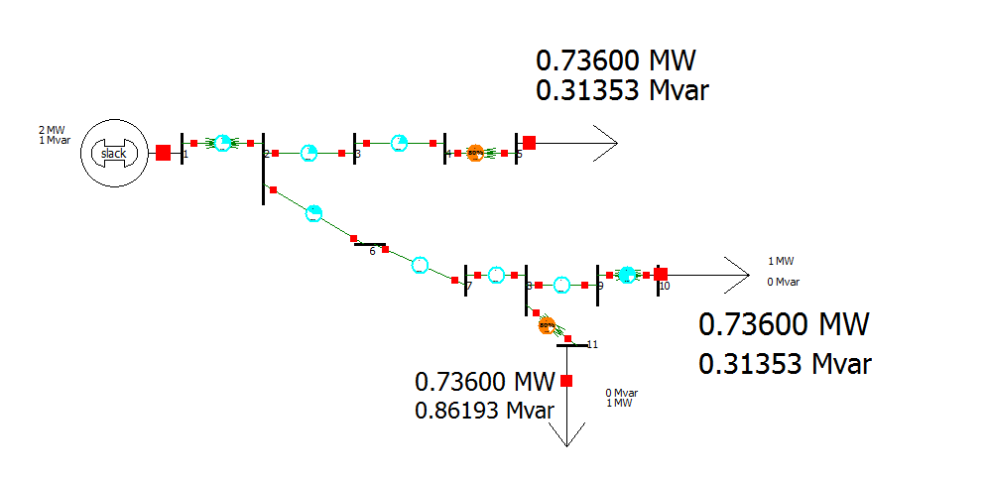

Figure (14)

As shown in figure (14) we can determine the load consumption .

(6)

3)

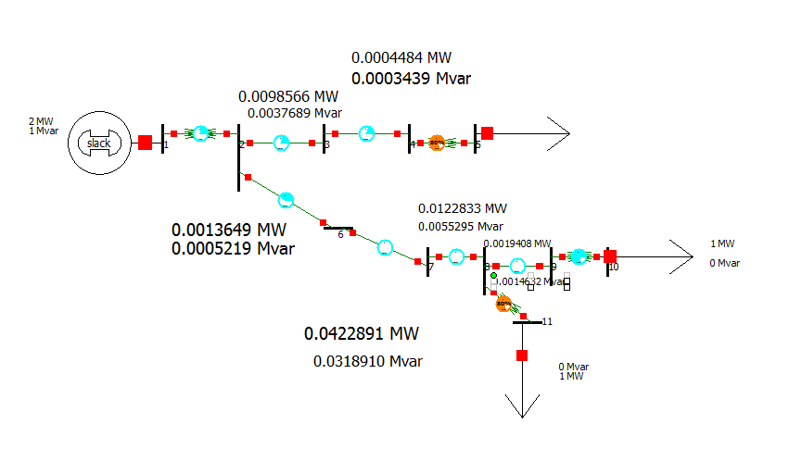

Figure (15)

As shown in figure (15) we can determine the losses

Total MW losses = =0.0681831 MW

Total M VAR losses ==0.0435184 MVAR

Total MVA = (p^2 +Q^2)^0.5 =0.0808875 MVA

4)

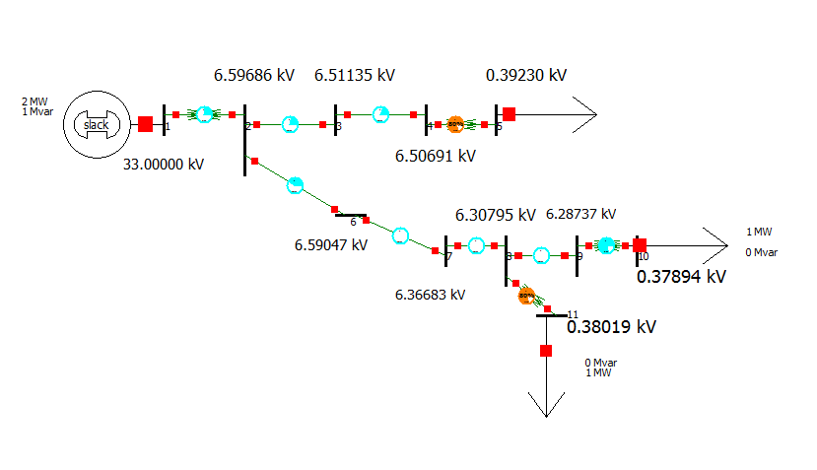

Figure (16)

As shown in figure (16) we can determine the actual value of voltages at each bus

(7)

5 , 6 )

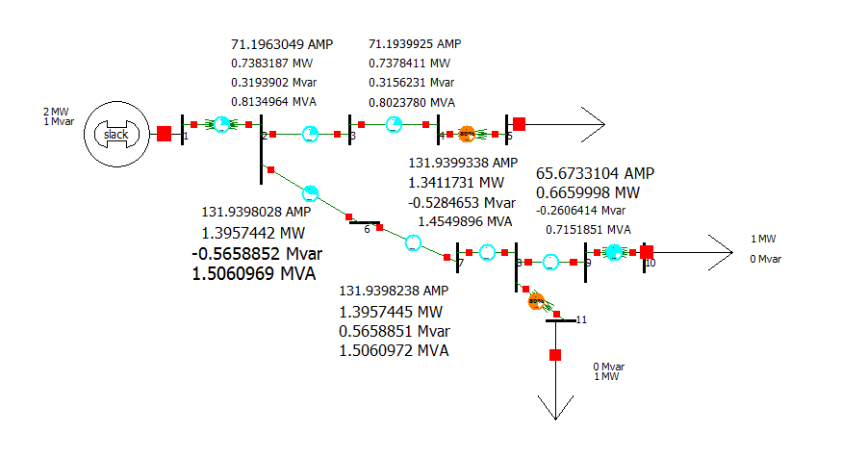

Figure (17)

From figure (17) we can determine the current and power flow in each line

E)

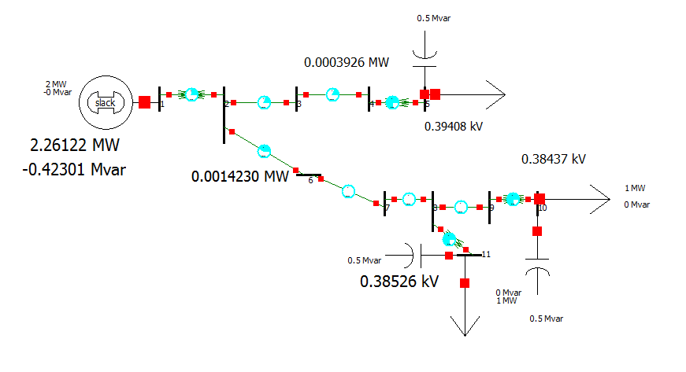

Figure (18)

(8)

* the voltage drop decrease .

* the losses decrease .

* the load supply a reactive power instead of consuming it .

F)

At bus 1

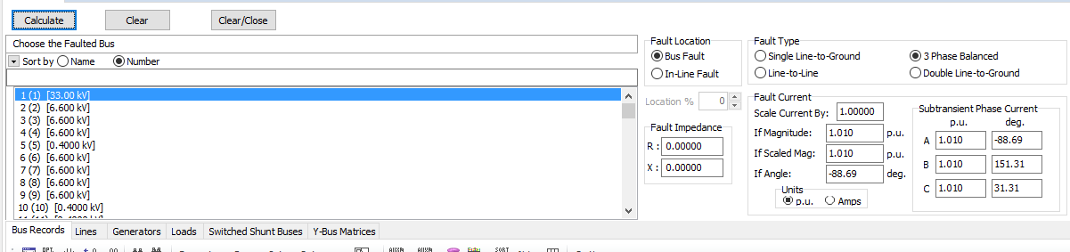

Figure (19)

At bus 2

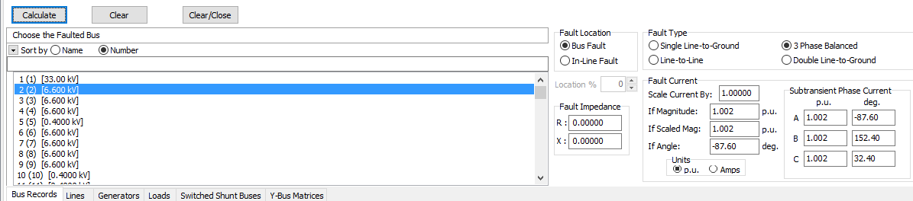

Figure (20)

(9)

At bus 8

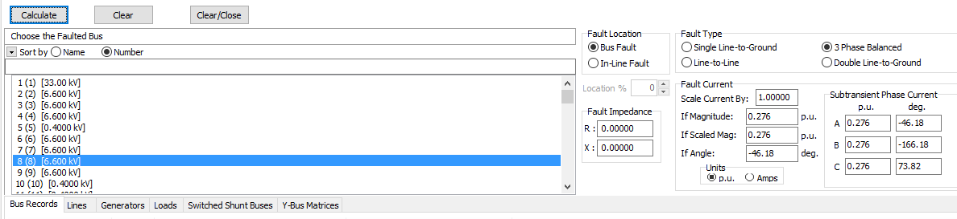

Figure (21)

At bus 9

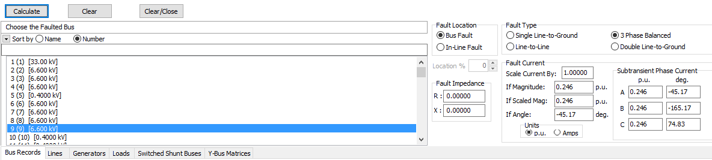

Figure (22)

At bus 5

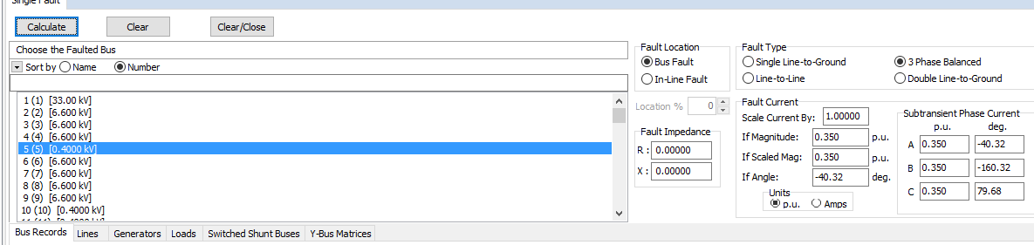

Figure (23)

(10)

At bus 6

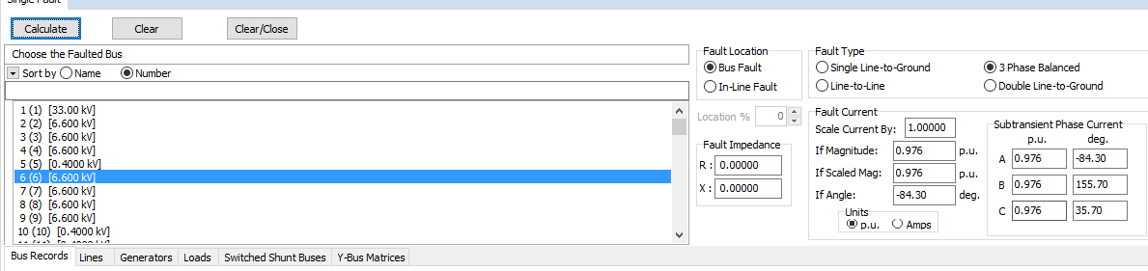

Figure (24)

At bus 7

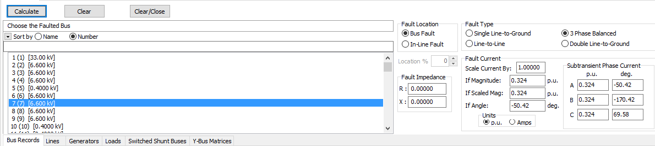

Figure (25)

At bus 10

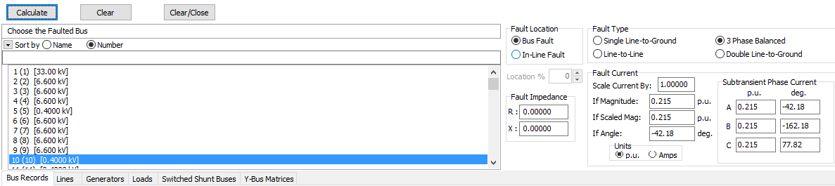

Figure (25)

Note : the other buses is not a real buses but to simplify calculation of line parameters .

(11)

Conclusion :

* Substation implemented by generator to be able to use power world simulator .
* shunt capacitor has the following advantages :

1. make a voltage more near to real value .
2. decrease the transmition line losses .
3. decrease the output MVAR from the substation .

* Not all the buses entered in power word simulator is a real buses .
* These buses entered to simplify the calculation of line parameter of the transmition line because , there are different types of caples such as ( XLPE , ACSR) and each caple has a different parameter .
* Extra buses can be removed by calculated each line impedance alone and take a summation for all of it then replace all of these buses by one buses at the end of all caples .

(12)