**Transmission Lines can be Modeled according to their length as:**

* Short Line Model (*l* ≤ 80km)
* Medium Line Model (80km < *l* < 250km)
* Long Line Model (*l* ≥ 250km)

**Voltage regulation:**

|  |  |  |
| --- | --- | --- |
|  |  | (1) |

ABCD for short line

|  |  |  |
| --- | --- | --- |
|  |  | (2) |

ABCD for medium line

|  |  |  |
| --- | --- | --- |
|  |  | (3) |

The propagation constant (γ) can be expressed as:

|  |  |  |
| --- | --- | --- |
|  |  | (4) |

ZC (the characteristic impedance) can be expressed as:

|  |  |  |
| --- | --- | --- |
|  |  | (5) |

General form for TL

|  |  |  |
| --- | --- | --- |
|  |  | (6) |

ABCD for long line

|  |  |  |
| --- | --- | --- |
|  |  | (7) |

Lossless line

**The surge impedance:**

|  |  |  |
| --- | --- | --- |
|  |  | (8) |

**The propagation constant:**

|  |  |  |
| --- | --- | --- |
|  |  | (9) |

**ABCD Parameters for Lossless Line**

|  |  |  |
| --- | --- | --- |
|  |  | (10) |
|  |  | (11) |
|  |  | (12) |

**π-Model for Lossless Line**

|  |  |  |  |  |
| --- | --- | --- | --- | --- |
|  |  | | (13) | |
|  |  | | (14) | |
|  | |  | | (15) |
|  | |  | | (16) |

**Wave length (Lossless Line):**

The velocity of propagation of voltage and current waves on lossless line can be expressed as:

|  |  |  |
| --- | --- | --- |
|  |  | (17) |

Then, the wavelength of the wave is obtained by:

|  |  |  |
| --- | --- | --- |
|  |  | (18) |

Or

|  |  |  |
| --- | --- | --- |
|  |  | (19) |

**Surge Impedance Loading**

|  |  |  |
| --- | --- | --- |
|  | MW | (20) |

**Voltage profiles:**

|  |  |  |
| --- | --- | --- |
|  |  | (21) |
|  |  | (22) |

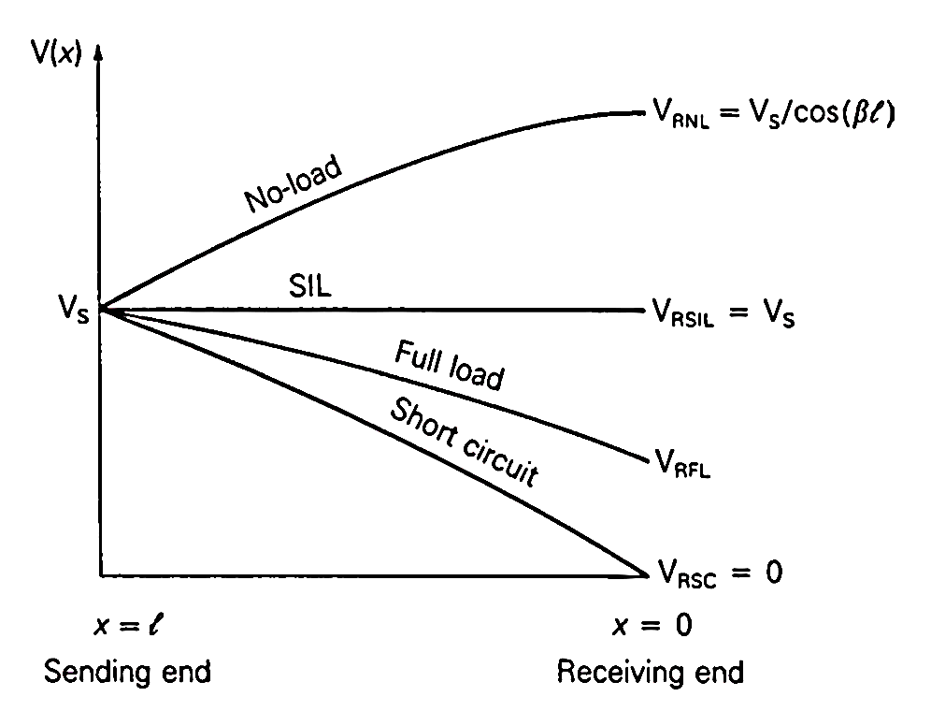

**Steady state stability limit**

|  |  |  |
| --- | --- | --- |
|  |  | (23) |
|  | W | (24) |



**The maximum power in terms of SIL**

|  |  |  |
| --- | --- | --- |
|  | Watt | (25) |
|  | Watt | (26) |

**Maximum Power Flow of Lossless Line**

|  |  |  |
| --- | --- | --- |
|  |  | (27) |
|  |  | (28) |
|  |  | (29) |
|  |  | (30) |

**ABCD Matrix**

|  |  |  |
| --- | --- | --- |
|  |  | Short Line |
|  |  | Compensate for reactive power |
| T-Circuit |  |  |
| π-Circuit |  |  |

Cascaded Network



Cascaded Network

