# **Transmission Line Modeling**

**Transmission Lines can be Modeled according to their length as:**

* Short Line Model (*l* ≤ 80km)
* Medium Line Model (80km < *l* < 250km)
* Long Line Model (*l* ≥ 250km)

Where L is the length of the Transmission-Line

**Transmission lines can be modeled by two main systems:**

* Lumped parameter system
* Distributed parameter system

We use lumped parameters which give good accuracy for short transmission lines and for medium length ones.

If an overhead line is classified as short one, then the shunt capacitance is so small that it can be omitted entirely with little loos of accuracy. Also, we need to consider only the series resistance (*R*) and the series inductance (*L*) for the total length of the line.

**Exploring the three line models:**

## **[1] Short Line Model**

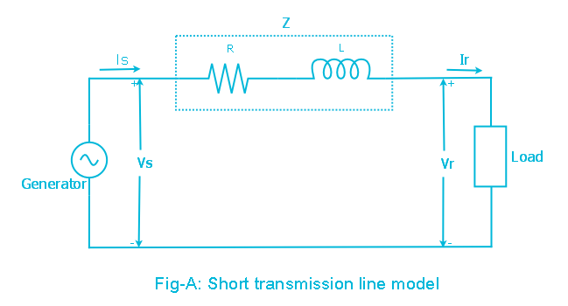

Figure 1: Short Transmission Line Model



Where *R* and *L* are the per-phase resistance and inductance per unit length, respectively, and *l* is the transmission line length.

**Important notes about short line model:**

* Line length (*l*) < 80km.
* Generally, MV/LV Line.
* Capacitance can be neglected.

**Line Electrical Analysis:**

The phase voltage at the sending end is:

|  |  |  |
| --- | --- | --- |
|  |  | (1) |



Figure 2: Two-port representation of a Transmission Line

|  |  |  |
| --- | --- | --- |
|  | → | (2) |

Since we are dealing with a linear, passive and bilateral two-port network; the determinant of the transmission matrix is unity:

|  |  |  |
| --- | --- | --- |
|  |  | (3) |

Also, equation (2) can be rewritten in terms of VR and IR as follows:

|  |  |  |
| --- | --- | --- |
|  |  | (4) |

Now According to equation (1), for the short transmission line model, the transmission parameters are:

   

Voltage regulation of the line may be defined as the percentage change in the voltage at the receiving end of the line (expressed as percentage of full load voltage) in going from no-load to full load.

|  |  |  |
| --- | --- | --- |
|  |  | (5) |

* Voltage regulation is a measure of line voltage drop.

At no-load $I_{R}=0→V_{R\left(NL\right)}=\frac{V_{S}}{A} ∴ A=1$ for short line

## **[2] Medium Line Model**

**Important notes about short line model:**

* 80km < Line length (*l*) < 250km.
* As the length of the transmission line increases, the line charging current becomes appreciable and the shunt capacitance must be considered.
* For medium length transmission lines, half of the shunt capacitance may be considered to be lumped at each end of the line. This is referred to as the nominal π model.

**Model equivalent circuit:**

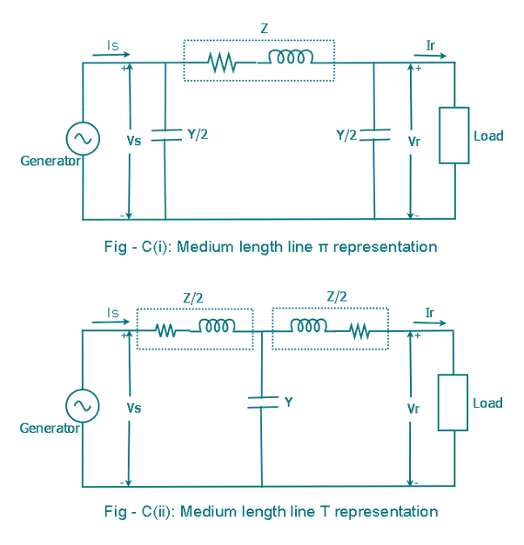

Figure 3: Medium Transmission Line π Model

Where:

*Z* = total series impedance of the transmission line.



*Y* = total shunt admittance of the transmission line.



Under normal condition, the shunt conductance per unit length which is represents the leakage current over the insulators and due to corona, is negligible and *G* is assumed to be zero, *C* is the line to neutral capacitance per km and *l* is the transmission line length.

**Line Electrical Analysis:**

To analyze this circuit (Model) we start by expressing the currents passing through the shunt capacitance and the series impedance in terms of the sending and receiving ends voltages and currents:

1. The current passing through the shunt capacitance at the sending end (*IC1*):

|  |  |  |
| --- | --- | --- |
|  |  | (6) |

1. The current passing through the shunt capacitance at the receiving end (*IC2*):

|  |  |  |
| --- | --- | --- |
|  |  | (7) |

1. The current passing through the series impedance (*IL*):

|  |  |  |
| --- | --- | --- |
|  |  | (8) |

The next step is to get the equations of the voltage (*VS*) and the current (*IS*) in terms of the voltage (*VR*) and the current (*IR*):

1. **KVL around the entire loop:**

|  |  |  |
| --- | --- | --- |
|  |  | (9) |

Now substitute equation (8) in equation (9) yields to



Rearrange this equation gives:

|  |  |  |
| --- | --- | --- |
|  |  | (10) |

1. **KCL at the ending node:**

|  |  |  |
| --- | --- | --- |
|  |  | (11) |

Now substitute equation (8) and equation (10) in equation (11) yields to



Rearrange this equation gives:

|  |  |  |
| --- | --- | --- |
|  |  | (12) |

Now we can express equation (10) and equation (12) in the matrix form:

 → 

$$A=D=1+\frac{YZ}{2} p.u$$

$$C=Y\left(1+\frac{YZ}{4}\right)S$$

$$B=ZΩ$$

Since the *π* model is a symmetrical two-port network (*A = D*).

**ABCD Matrix**

|  |  |  |
| --- | --- | --- |
|  |  | Short Line |
|  |  | Compensate for reactive power |
| T-Circuit |  |  |
| π-Circuit |  |  |

Cascaded Network



Cascaded Network



## **[3] Long Line Model**

For the short and medium length Transmission lines applications, accurate models were obtained by assuming the line parameters to be lumped. For transmission lines’ length of 250km and longer, and for a more accurate solution the exact effect of the distributed parameters must be considered.

Figure below shows a full model of a long Transmission line:



Figure 4: Long Transmission Line Model

**Now taking a part of this transmission line for Electrical analysis:**



Figure 5: Long Transmission Line with distributed parameters

The Known parameters in this network are:





The aim of this analysis is to find *V(x)* and *I(x)* in terms of the known parameters.

1. **KVL around the entire loop:**

|  |  |  |
| --- | --- | --- |
|  |  | (13) |

Rearrange equation (13) gives:

|  |  |  |
| --- | --- | --- |
|  |  | (14) |

Now taking the limit as ∆x → 0 gives



|  |  |  |
| --- | --- | --- |
|  |  | (15) |

1. **KCL at the first junction:**

|  |  |  |
| --- | --- | --- |
|  |  | (16) |

Rearrange equation (16) gives:

|  |  |  |
| --- | --- | --- |
|  |  | (17) |

Now taking the limit as ∆x → 0 gives



|  |  |  |
| --- | --- | --- |
|  |  | (18) |

**Finding V(x):**

Differentiate equation (15) gives:

|  |  |  |
| --- | --- | --- |
|  |  | (19) |

Substitute equation (18) in equation (19) yields to:

|  |  |  |
| --- | --- | --- |
|  |  | (20) |

Assume that:

|  |  |  |
| --- | --- | --- |
|  |  | (21) |

Then rearranging equation (20) gives:

|  |  |  |
| --- | --- | --- |
|  |  | (22) |

Now, solving this differential equation give the following solution:

|  |  |  |
| --- | --- | --- |
|  |  | (23) |

Noting that the propagation constant (γ) can be expressed as:

|  |  |  |
| --- | --- | --- |
|  |  | (24) |

**Finding I(x):**

Rearranging equation (15) gives:

|  |  |  |
| --- | --- | --- |
|  |  | (25) |

Differentiate equation (23) gives:

|  |  |  |
| --- | --- | --- |
|  |  | (26) |

Substitute equation (26) in equation (25) yields to:

|  |  |  |
| --- | --- | --- |
|  |  | (27) |

Substituting the value of the propagation constant in equation (27) gives:

|  |  |  |
| --- | --- | --- |
|  |  | (28) |

Assume that ZC (the characteristic impedance) can be expressed as:

|  |  |  |
| --- | --- | --- |
|  |  | (29) |

Then equation (28) can be rewritten as:

|  |  |  |
| --- | --- | --- |
|  |  | (30) |

Now we have two equations with two unknowns of *A1* and *A2*, to find them we will use the boundary condition at *x* = 0:

From figure (5):

|  |  |  |
| --- | --- | --- |
|  |  | (31) |

Substituting x = 0 in equation (23) gives:

|  |  |  |
| --- | --- | --- |
|  |  | (32) |

Substituting x = 0 in equation (30) gives:

|  |  |  |
| --- | --- | --- |
|  |  | (33) |

Now solving equation (32) and (33) gives:

|  |  |  |
| --- | --- | --- |
|  |  | (34) |

Now, substitute the values of *A1* and *A2* in equation (23) and (30)

|  |  |  |
| --- | --- | --- |
|  |  | (35) |

Rearrange equation (35)

|  |  |  |
| --- | --- | --- |
|  |  | (36) |

Note:

|  |  |  |
| --- | --- | --- |
|  |  | (37) |

So, equation (36) can be written as:

|  |  |  |
| --- | --- | --- |
|  |  | (38) |

Since we are particularly interested in the relation between the sending end and the receiving end, we will find *V(x)* and *I(x)* at *x* = *l*

Let



Then V(x) and I(x) are:

 

Substitute their values in equation set (38) gives the relations:

|  |  |  |
| --- | --- | --- |
|  |  | (39) |

Now we can express them in the ABCD Matrix form as:

|  |  |  |
| --- | --- | --- |
|  |  | (40) |

Note that as before *A = D*, and 

**The Equivalent π Model for long transmission lines**



$$\frac{Y^{'}}{2}$$

$$Z^{'}$$

$$\frac{Y^{'}}{2}$$

Figure 6: The Equivalent π Model for long transmission lines

Using the ABCD Matrix for the π circuit model we can find the Equivalent matrix for this model

|  |  |  |
| --- | --- | --- |
|  |  | (41) |

Where

|  |  |  |
| --- | --- | --- |
|  |  | (42) |

These values can be obtained by equalizing the Transmission matrix from equation (40) and equation (41)

Note, we can find the cosh and the sinh for a complex number using:



## **Loss-Less Line**

It is the ideal Line where it does not show any losses in the transmission process. Also, the signal attenuation will be zero since there is no losses.

To achieve such a Line the resistance must be zero:

 

So, the series impedance and the shunt admittance are expressed as:

 Ω/m  S/m

We are going to analyze lossless line from four points of view:

1. ABCD Parameters
2. Z’, Y’ Model
3. Wave length (λ)
4. Surge impedance loading (SIL)

The first step is to find the characteristic impedance (*ZC*) “noting that in the lossless line it is called the surge impedance” and the propagation constant (γ).

**The surge impedance:**

|  |  |  |
| --- | --- | --- |
|  |  | (43) |

From equation (42) we can see that the surge impedance is purely resistive

**The propagation constant:**

|  |  |  |
| --- | --- | --- |
|  |  | (44) |

From equation (43) we can see that the propagation constant is purely imaginary that means that it contains only the imaginary part (phase constant part) and the real one (attenuation constant part) is gone.

**Analyzing the Lossless Line:**

In order to analyze the Lossless transmission line, the ADCB matrix and the model for the π-circuit of the long transmission line will be used since it is the general case of all three models:

1. **ABCD Parameters for Lossless Line**

Depending on matrix in equation (40) we got:



|  |  |  |
| --- | --- | --- |
|  |  | (45) |

Note that the cosine hyperbolic function (*cosh*) is replaced by a normal cosine (*cos*) which simplify the analysis.



|  |  |  |
| --- | --- | --- |
|  |  | (46) |

The sine hyperbolic function (sinh) is replaced by a sine value.



|  |  |  |
| --- | --- | --- |
|  |  | (47) |

1. **π-Model for Lossless Line**

Depending on equation (42) we got:



|  |  |  |
| --- | --- | --- |
|  |  | (48.1) |
|  |  | (48.2) |



|  |  |  |
| --- | --- | --- |
|  |  | (49) |

Now we can derive the π-Equivalent Circuit of the long transmission line for the lossless line depending on equations (45, 46, 47):



|  |  |  |
| --- | --- | --- |
|  |  | (50) |

**Wave length (Lossless Line):**

A wavelength is the distance required to change the phase of the voltage or current by 2π radians or 360°.

The velocity of propagation of voltage and current waves on lossless line can be expressed as:

|  |  |  |
| --- | --- | --- |
|  |  | (51) |

Then, the wavelength of the wave is obtained by:

|  |  |  |
| --- | --- | --- |
|  |  | (52) |

Or

|  |  |  |
| --- | --- | --- |
|  |  | (53) |

The expression for the inductance per unit length (*L*) and the capacitance per unit length (*C*) can be obtained using the following equations:

The per-phase inductance:

|  |  |  |
| --- | --- | --- |
|  | H/m | (54) |

The per-phase capacitance:

|  |  |  |
| --- | --- | --- |
|  | F/m | (55) |

Neglecting the internal flux linkage of a conductor gives



In this case, the wave length can be as

|  |  |  |
| --- | --- | --- |
|  |  | (56) |

Noting that

|  |  |  |
| --- | --- | --- |
|  |  | (57) |

So, the velocity of propagation of the voltage and current waves can now be calculated:

|  |  |  |
| --- | --- | --- |
|  | m/s | (58) |

**Surge Impedance Loading:**

SIL is the power delivered by a lossless line to a load resistance equal to the surge impedance *ZS*. where, .

The equivalent circuit for studying the SIL is shown in the following figure:



Figure 7: TL with surge impedance loading Circuit

This line represents a single phase line or one phase to neutral of a balanced three-phase line.

From equation (50) we know that *V(x)* and *I(x)* can be expressed for a lossless line as:

|  |  |  |
| --- | --- | --- |
|  |  |  |

From figure (7) we see that:

|  |  |  |
| --- | --- | --- |
|  |  | (59) |

Substitute equation (59) in equation (50) yields to

|  |  |  |
| --- | --- | --- |
|  |  | (60) |

Using Euler identity, we can rewrite equation (60) as:

|  |  |  |
| --- | --- | --- |
|  |  | (61) |

From equation (61) we can see that the magnitude of the voltage *V(x)* is equal to the magnitude of the voltage at the receiving end which means that the voltage is constant along the Transmission Line.

|  |  |  |
| --- | --- | --- |
|  |  | (62) |

From the power point of view, we know that the apparent power is calculates by:



Substituting equation set (61) in the apparent power equation yields to

|  |  |  |
| --- | --- | --- |
|  |  | (63) |

From equation (63) we can see that the real power along the line is constant and the reactive power flow is zero.

At rated Line Voltage the SIL power can be expressed as:

|  |  |  |
| --- | --- | --- |
|  | MW | (64) |

The following table is showing some examples of the SIL power at different tine voltages

|  |  |  |
| --- | --- | --- |
| Vrated (kV) | Ω | SIL (MW) |
| 230 | 380 | 140 |
| 345 | 285 | 420 |
| 500 | 250 | 1000 |
| 765 | 257 | 2280 |

**Voltage profiles:**

1. At no-load condition:

|  |  |  |
| --- | --- | --- |
|  |  | (65) |

Substituting equation (65) in *V(x)* from equation (50) gives:

|  |  |  |
| --- | --- | --- |
|  |  | (66) |

The no-load voltage increases from *VS = cos(βl)* VRNL at the sending end to VRNL at the receiving end (where *x* = 0).

1. At short circuit condition:

|  |  |  |
| --- | --- | --- |
|  |  | (67) |

Substituting equation (67) in V(x) from equation (50) gives:

|  |  |  |
| --- | --- | --- |
|  |  | (69) |

The voltage decreases from *VS = sin(βl) (ZSVRSC)* at the sending end to *VRSC* = 0 at the receiving end.

1. From equation (62) the voltage profile at SIL is flat
2. The full-load voltage profile, which depends on the specification of full-load current, lies above the short-circuit voltage profile.

Figure below summarizes these results, showing a high receiving-end voltage at no-load and a low receiving-end voltage at full load. This voltage regulation problem becomes more severe as the line length increases.

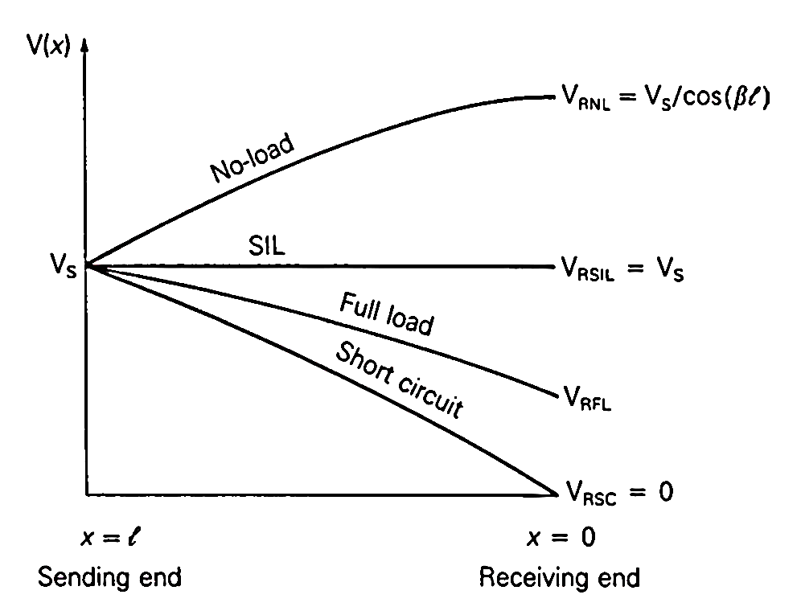

Figure 8: Voltage profiles of a lossless line with fixed sending end voltage for line lengths up to a quarter wavelength

**Steady state stability limit**

The equivalent π circuit of Figure (6) can be used to obtain an equation for the real power delivered by a lossless line with a small change in the angles of the sending and receiving end voltages shown in Figure (9). Assume that the voltage magnitudes *VS* and *VR* at the ends of the line are held constant. Also, let δ denote the voltage-phase angle at the sending end with respect to the receiving end.

$$Z^{'}$$

$$\frac{Y^{'}}{2}$$

$$\frac{Y^{'}}{2}$$

Figure 9: The Equivalent π Model for long transmission lines

1. **KCL at the receiving end junction:**

 → 

|  |  |  |
| --- | --- | --- |
|  |  | (70) |

Now the complex power at the receiving end can be calculated by:





Using Euler identity

|  |  |  |
| --- | --- | --- |
|  |  | (71) |

The real power

|  |  |  |
| --- | --- | --- |
|  |  | (72) |

Since the Line is Lossless then the real power at the sending end is the same as that at the receiving end. Also, we can see that the phase (δ) at the sending end can maximize the real power in the power system when it is 90°, then the real power is equal to:

|  |  |  |
| --- | --- | --- |
|  | W | (73) |

Where Pmax is the maximum power that can be transmitted over this Transmission Line.

Equation (72) is plotted in Figure (10). For fixed voltage magnitudes *VS* and *VR*, the phase angle δ increases from 0° to 90° as the real power delivered increases.



Figure 10: Real power delivered by a lossless line versus voltage angle across the line

Synchronous machine can be connected to the power system supplying a power (*P0*). The Voltage angle of the machine is denoted by (δ0).

1. The machine will operate in stable region when the machines voltage angle is less than 90°.
2. At 90° the steady-state stability limit occurs
3. The machine will be unstable for a phase angle more than 90°.



Figure below illustrates these situations:



If an attempt were made to exceed the steady-state stability limit, then the machine would loss the synchronism.

**Note:** Using a Bundle will reduce the GMR of the Line, therefore the Line inductance (*L*) will be

reduced, so the series impedance of the lossless line will be reduced and finally the transmitted power will increase.

**The maximum power in terms of SIL**

Substituting equation (48.1) in equation (72) gives:

|  |  |  |
| --- | --- | --- |
|  |  | (74) |

Rearranging equation (52) in terms of (β) and substitute it in (74) yields to:

|  |  |  |
| --- | --- | --- |
|  |  | (75) |

From equation (64) we know that:



Therefore, multiplying equation (75) by V2rated in the nominator and denominator gives:



Rearrange the equation obtained in order to get the SIL:



Rewrite each term in a new form gives:

|  |  |  |
| --- | --- | --- |
|  | Watt | (76) |

Now the max power can be expressed in terms of the SIL as:

|  |  |  |
| --- | --- | --- |
|  | Watt | (77) |

Equation (77) reveals that the power transfer capability decreases as the length of the transmission line increases. Figure (11) shows the SIL vs the T.L length curve:

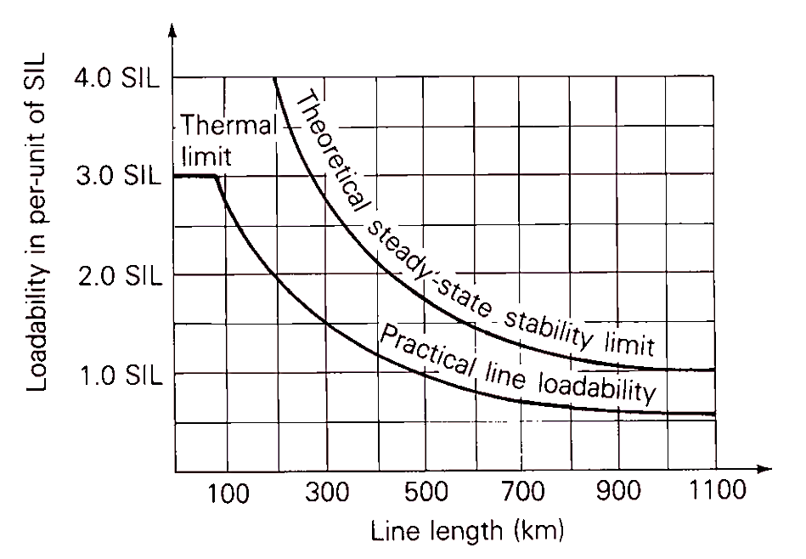

Figure 11: Transmission-line load ability of SIL vs Transmission line length

The following table is showing some examples of the SIL powers and the thermal ratings of some lines at different tine voltages

|  |  |  |
| --- | --- | --- |
| Vrated (kV) | SIL (MW) | Typical Thermal Rating (MW) |
| 230 | 150 | 400 |
| 345 | 400 | 1200 |
| 500 | 900 | 2600 |

**Maximum Power Flow of Lossless Line**

After discussing the maximum power flow in previous section, now it is discussed in terms of the ABCD parameters for a lossy line (Line with losses).

From equation (40) we know that:

 

In this section we are using the following notation to express the A and B parameters:

|  |  |  |
| --- | --- | --- |
|  |  | (78) |

Also, we are using the same notation for the voltage at the sending end and the receiving end:

|  |  |  |
| --- | --- | --- |
|  |  | (79) |

From ABCD matrix in equation (40) solving for the receiving end current gives:



|  |  |  |
| --- | --- | --- |
|  |  | (80) |

The complex power delivered to the receiving end is:



|  |  |  |
| --- | --- | --- |
|  |  | (81) |

The real and reactive power delivered to the receiving end are:

|  |  |  |
| --- | --- | --- |
|  |  | (82) |
|  |  | (83) |

Note that for a lossless line, , , ,. Applying these values to the real part of equation (82) gives:

|  |  |  |
| --- | --- | --- |
|  |  | (84) |

which is the same as the result obtained in equation (72).

The theoretical maximum real power delivered (or steady-state stability limit) occurs when in equation (82), this gives:

|  |  |  |
| --- | --- | --- |
|  |  | (85) |

The second term in equation (85), and the fact that *Z’* is larger than *X’*, reduce PRmax to a value somewhat less than that given by equation (73) for a lossless line.

**Transmission Line Steady State Operation (SSO)**

When we talk about SSO on transmission line what we really mean is how the line performs when we want to transmit certain amount of power through it.



Figure 12: Two bus power system

**Power Flow on Transmission Lines**

As said before, the ABCD parameters matrix can express the transmission line as follows:

|  |  |  |
| --- | --- | --- |
|  |  | (86) |

From equation (86) we can express the current at the receiving end as:

|  |  |  |
| --- | --- | --- |
|  |  | (87) |

And the current at the sending is as:

|  |  |  |
| --- | --- | --- |
|  |  | (88) |

Again, we are using the following notation for the voltage at the sending and receiving ends:

|  |  |  |
| --- | --- | --- |
|  |  | (89) |

Also, assume that

|  |  |  |
| --- | --- | --- |
|  |  | (90) |

Now substitute equation set (90) in equation (87) and (88) gives:

|  |  |  |
| --- | --- | --- |
|  |  | (91) |

Now the complex power at the receiving and sending end can be calculated by:



At the receiving end:



|  |  |  |
| --- | --- | --- |
|  |  | (92) |

The real and reactive power can now be calculated

|  |  |  |
| --- | --- | --- |
|  |  | (93) |

At the sending end:



|  |  |  |
| --- | --- | --- |
|  |  | (94) |

The real and reactive power can now be calculated

|  |  |  |
| --- | --- | --- |
|  |  | (95) |

**Notes:**

1. For a given voltage level Vs and VR are very near to the system voltage and they don’t change much (33 kV……).
2. of transmission line parameters are fixed.

The maximum power that can be transmitted or delivered is obtained when:



And it is expressed as:

|  |  |  |
| --- | --- | --- |
|  |  | (96) |

The minus in the reactive power formula indicates that its capacitive.

**Power flow for short transmission Line (As an example of the above):**

From the ABCD matrix of the short Line we know that:





Substituting the values of A and B in the receiving and sending ends equations gives:

|  |  |  |
| --- | --- | --- |
|  |  | (97) |
|  |  | (98) |

It is known that



Since , then and therefore the angle . Substituting these values in the receiving end power equations gives:

|  |  |  |
| --- | --- | --- |
|  |  | (99) |

As δ is usually small; cos(δ) ≅ 1

|  |  |  |
| --- | --- | --- |
|  |  | (100) |

From these relationships we can conclude the following points:

1. For fixed values of *VS*, *VR* and *X*, the real power depends on the angle *δ* (the phase angle by which *VS* leads *VR*). This angle δ is called the power Angle. When *δ* = 90° the power is maximum. For system Stability considerations *δ* has to be kept below 90°.
2. Power can be transferred over line even when *|VS| ≤ |VR*|. The phase difference δ between *VS* and *VR* causes the flow of power in the line. Power systems are operated with almost the same voltage magnitudes (*i.e., p.u*) at important busses by using methods of voltage control. (because this provides a much better operating conditions for the system.)

The power angle *δ* can be positive or negative. Being positive means that *VS* leads *VR*(Power is flowing from *VS* to *VR* (*VS**VR*). However, if the power angle is negative then *VS* lags *VR*(Power is flowing from *VR* to *VS* (*VR**VS*).

1. The maximum Real power transferred over a line increases with increase in *VS* and *VR*.An increase of 100% in *VS* and *VR*(means that the voltages were doubled) will increases the power transfer to 400%. This is the reason for adopting high and extra high Transmission voltages.
2. The maximum real power depends on the Reactance *X* which is directly proportional to line inductance. A decrease in inductance increases the line capacity. The line inductance can be decreased by using bundled conductors

Another method for reducing the line inductance is by inserting capacitance in series with the line. This method is known as series compensation. The series capacitors are usually installed at the middle of the line.

${positive reactance \atop L}+{negative reactance \atop C}→effictive reactance will be decreased$

1. The Reactive power transferred over a line is directly proportional to (*VS* – *VR*) i.e., voltage drop along the line, and it is independent of power angle. This means that the voltage drop on the line is due to the transfer of reactive power over the line. To maintain a good voltage profile, reactive power control is necessary.

**Voltage Control**

Reactive Power compensation equipment has the Following effect:

1. Reduction in current. Since the voltage is constant at the nominal value



1. Reduction of losses in the system. Since the current decreases.
2. Maintain the voltage profile within limits.
3. Reduction in investment in the system per kw at load supplied.
4. Decrease in kVA loading of generators and lines. This decrease in kVA loading relieves overload condition or releases capacity for additional load growth.
5. Improvement in power factor of generators

**Reactive compensation of a Transmission line**

* Static Var Compensation
* Rotating Compensators (synchronous compensator)
* Using Transformer (Tap Transformer)
* Using Power Electronics (STAT COM)

**Static Compensation**

The Performance of transmission lines, especially those of medium length and longer, can be improved by reactive compensation of series or parallel type.

1. series compensation consists of a capacitor bank placed in series with each phase conductor of the line. series compensation reduces the series impedances of the line, which is the principal cause of voltage drop and the most important factor in determining the maximum power which the line can transmit.
2. Shunt compensation refers to:
3. The placement of inductors from each line to neutral to reduce partially or completely the shunt susceptance of a high-voltage line. Which is particularly important at light loads when the voltage at the receiving end may otherwise become very high (Shunt Reactors).
4. Shunt Capacitors are used for lagging Power factor circuits created by heavy loads. The effect is to supply the necessary reactive power to maintain the receiving end voltage at satisfactory level.