

Faculty of Information Technology

Electrical Computer Engineer Department

Power LAB (ENEE 5102)

**ASSIGNMENT**

Student Name: Ahmad Bodair .  
Student ID: 1130455.

Instructor: Dr. Ahmad Alyan.

Date: 12/6/2017

Calculation:

Load consume power (P) of 308 W and drawing current (I) of 2A at voltage (V) 220V

PFold= eq.1

= $\frac{308}{220×2}$ =0.7

Qold= V $×$ I $×$ sin(cos-1(PFold) eq.2

= 2202sin(cos-1(0.7)

= 314.2228 VAR

Inew= eq.3

= $\frac{308}{220×0.97}$

= 1.44 A

Qnew= V $×$ Inew sin(cos-1(PFnew)

= 2201.44sin(cos-1(0.97)

= 77.192 VAR

where;

Qold is the reactive power consumption by the load befor adding the shunt capacitor.

Qnew is the reactive power consumption by the load after adding the shunt capacitor.

The value of the capacitor (C) that must be used to raise the power factor of the load to 0.97, can be calculated as expressed in eq.4

C= $\frac{Q_{old - }Q_{new }}{V^{2}×2π×f}$ eq.4

= $\frac{314.2228-77.192}{{220}^{2}×2π×50}$ = 15.588 μF.

In matlab/Simulink RL load was used to implement the induction motor and the values of the RL were calculated as expressed in eq.5 and eq.6

$\left|Z\right|$ = $\frac{V}{A}$ = $\frac{220}{2}$ =110A eq.5

Since Z= R+jX eq.6

Thus;

R= $\left|Z\right|$ $×$ PFold eq.7

= 110 $×$ 0.7= 77 Ω

X= $\left|Z\right|$ $×$ sin (cos -1(PFold)) eq.8

= 110 $×$ 0.714= 78.55 Ω

L = $\frac{X}{2π×f}$ eq.9

= $\frac{78.55}{2×π×50}$ = 250.05 mH.

Simulink model:

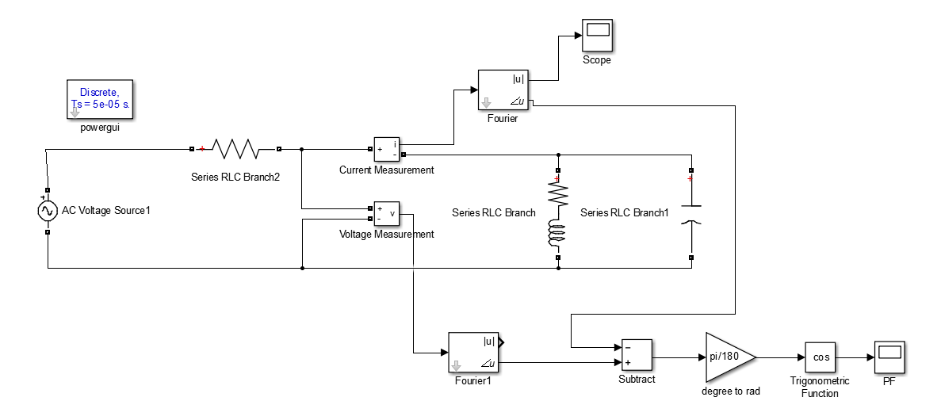

Figure 1: Power factor correction implementation on Simulink

Results:

(a)



(b)



Figure 2: The value of power factor (a) before adding shunt capacitor (b) after adding shunt capacitor.

(a)



(b)



Figure 3: The value of motor current (a) before adding shunt capacitor (b) after adding shunt capacitor.

Table 1: Conclusion table.

|  |  |  |
| --- | --- | --- |
|  | PF | Motor current (A) |
| Before adding shunt capacitor | 0.7 | $$≈2.0$$ |
| After adding shunt capacitor | 0.977 | $$≈1.4$$ |