

ELECTRICAL AND COMPUTER ENGINEERING DEPARTMENT

ENEE4105

Control and Power Electronics Lab

Exp #3 Report

Power-Factor Improvement

Name: Ahmad Waleed Hamed

I.D #: 1120580

Instructor: Dr. Ahmad Alyan

Teaching Assistant: Hammam Hamad

***Table of Contents***

Abstract : 3

Theory : 4

Procedure and Data : 5

Questions and Discussion : 19

Conclusion: 20

**Abstract**

Power factor correction improves electrical power systems performance. In this experiment single and three phase induction motors will be studied. In each part, power factor correction concept will be applied by connecting capacitor bank in parallel with motor to be tested, then some parameters will be measured and recorded such as current, voltage, active and reactive powers under changing motor load.

**Theory**

* **Power factor**

Is the percentage of the real power to the apparent power in the circuit.

* **Power factor correction**

Is the process that improves the power factor in a circuit from lagging to leading. In other words, it reduces the reactive power which is transmitted in the power lines. The following figures show the practical effect of power factor correction process. In general, the main benefit of this process is reducing losses in the transmission lines.

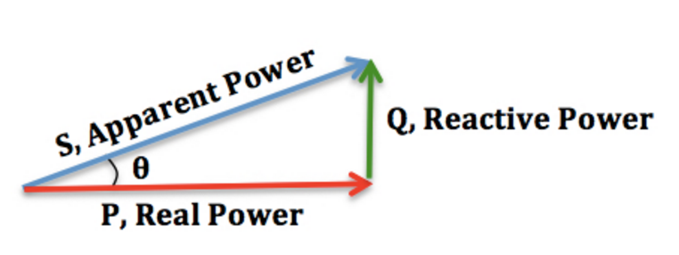

**Fig 1:** Total power before correction

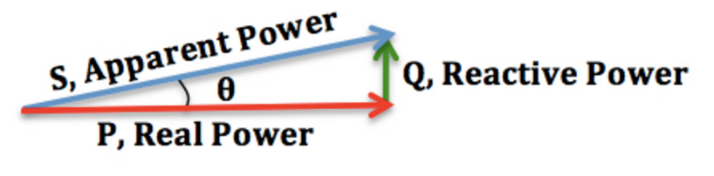

**Fig 2:** Total power after correction

* **Methods of Power Factor Improvement**

1. Capacitors: **Improving power factor** means reduce the phase difference between the [voltage](http://www.electrical4u.com/voltage-or-electric-potential-difference/) and the current. Since most of the loads are of inductive nature, they require some amount of [reactive power](http://www.electrical4u.com/reactive-power-and-its-compensation-in-transmission-lines/) to function properly. This reactive power is provided by the [capacitor](http://www.electrical4u.com/what-is-capacitor-and-what-is-dielectric/), or bank of [capacitors](http://www.electrical4u.com/what-is-capacitor-and-what-is-dielectric/), installed parallel to the load. They act as a source of local reactive power and thus less reactive power flows through the line. Basically they reduces the phase difference between the [voltage](http://www.electrical4u.com/voltage-or-electric-potential-difference/) and current.
2. Synchronous condenser.
3. Phase advancer

**Procedure and Data**

**PARTA: Single-phase induction motor**

At the beginning, the circuit shown in the fig 3 was connected and the input voltage was adjusted to be 220 V.

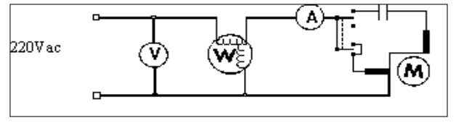

**Fig 3:** The connection of the single phase capacitor start induction motor   
without shunt capacitor

After that, the torque on the motor was increased progressively and the readings of the torque, speed, input power, voltage and current were taken and tabulated in the table 1

|  |  |  |  |  |  |  |  |
| --- | --- | --- | --- | --- | --- | --- | --- |
| **Torque (N.m)** | **Speed (rpm)** | **Iin (A)** | **V (Volts)** | **Pin (W)** | **V*Iin (V.A)** | **PF** | **Q (Var)** |
| **0.0** | **1400** | **1.3** | **212** | **99** | **275.6** | **0.36** | **257.2** |
| **0.2** | **1400** | **1.3** | **210** | **115** | **273** | **0.42** | **247.6** |
| **0.4** | **1350** | **1.4** | **207** | **144** | **290** | **0.5** | **251** |
| **0.6** | **1350** | **1.5** | **203** | **185** | **304.5** | **0.61** | **241.9** |
| **0.8** | **1300** | **1.7** | **197** | **233** | **335** | **0.7** | **240.7** |

**Table 1:** the readings of the speed, input power, voltage and current and the calculated values of power factor and reactive power at each value of the torque

After that, the torque was plotted as a function of the speed and the power factor and shown in fig 4 and fig 5 respectively.

**Fig 4:** The torque speed characteristic

**Fig 5:** the torque vs power factor

In the next step of this part, the capacitor bank was connected across the terminals of the motor as shown in the fig 6

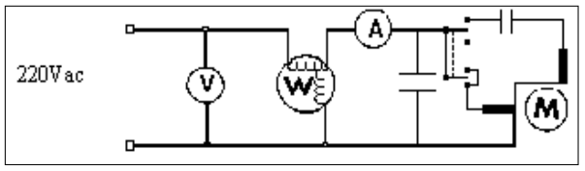

**Fig 6:** The connection of the single phase capacitor start induction motor   
with shunt capacitor

The capacitor bank value was adjusted to be equal 3 uF and the torque on the motor was increased progressively and the readings of the torque, speed, input power, voltage and current were taken and tabulated in the table 2

|  |  |  |  |  |  |  |  |
| --- | --- | --- | --- | --- | --- | --- | --- |
| **Torque (N.m)** | **Speed (rpm)** | **Iin (A)** | **V (Volts)** | **Pin (W)** | **V*Iin (V.A)** | **PF** | **Q (Var)** |
| **0.0** | **1400** | **1.2** | **214** | **89** | **256.8** | **0.35** | **240.88** |
| **0.2** | **1380** | **1.2** | **211** | **120** | **253.2** | **0.47** | **222.96** |
| **0.4** | **1360** | **1.2** | **203** | **152** | **243.6** | **0.62** | **190.36** |
| **0.6** | **1340** | **1.3** | **205** | **182** | **266.5** | **0.68** | **194.67** |
| **0.8** | **1320** | **1.6** | **199** | **232** | **318.4** | **0.73** | **218.07** |

**Table 2:** the readings of the speed, input power, voltage and current and the calculated values of power factor and reactive power at each value of the torque

After that, the torque was plotted as a function of the speed and the power factor and shown in fig 7 and fig 8 respectively.

**Fig 7:** The torque speed characteristic

**Fig 8:** the torque vs power factor

After that, the capacitor bank value was adjusted to be equal 5 uF and the torque on the motor was increased progressively and the same readings were taken and tabulated in the table 3

|  |  |  |  |  |  |  |  |
| --- | --- | --- | --- | --- | --- | --- | --- |
| **Torque (N.m)** | **Speed (rpm)** | **Iin (A)** | **V (Volts)** | **Pin (W)** | **V*Iin (V.A)** | **PF** | **Q (Var)** |
| **0.0** | **1400** | **1.0** | **214** | **89** | **214** | **0.42** | **194.62** |
| **0.2** | **1380** | **1.1** | **212** | **114** | **233.2** | **0.49** | **203.44** |
| **0.4** | **1360** | **1.1** | **209** | **147** | **229.9** | **0.64** | **176.76** |
| **0.6** | **1340** | **1.2** | **205** | **180** | **246** | **0.73** | **167.68** |
| **0.8** | **1320** | **1.4** | **201** | **220** | **281.4** | **0.78** | **175.46** |

**Table 3:** the readings of the speed, input power, voltage and current and the calculated values of power factor and reactive power at each value of the torque

After that, the torque was plotted as a function of the speed and the power factor and shown in fig 9 and fig 10 respectively.

**Fig 9:** The torque speed characteristic

**Fig 10:** the torque vs power factor

After that, the capacitor bank value was adjusted to be equal 10 uF and the torque on the motor was increased progressively and the same readings were taken and tabulated in the table 4

|  |  |  |  |  |  |  |  |
| --- | --- | --- | --- | --- | --- | --- | --- |
| **Torque (N.m)** | **Speed (rpm)** | **Iin (A)** | **V (Volts)** | **Pin (W)** | **V*Iin (V.A)** | **PF** | **Q (Var)** |
| **0.0** | **1400** | **0.7** | **215.7** | **90** | **151** | **0.6** | **121.24** |
| **0.2** | **1380** | **0.8** | **213** | **122** | **170.4** | **0.72** | **118.96** |
| **0.4** | **1360** | **0.9** | **211** | **145** | **189.9** | **0.76** | **122.63** |
| **0.6** | **1340** | **1.0** | **208** | **173** | **208** | **0.83** | **115.48** |
| **0.8** | **1320** | **1.2** | **203** | **217** | **243.6** | **0.89** | **110.69** |

**Table 4:** the readings of the speed, input power, voltage and current and the calculated values of power factor and reactive power at each value of the torque

After that, the torque was plotted as a function of the speed and the power factor and shown in fig 11 and fig 12 respectively.

**Fig 11:** The torque speed characteristic

**Fig 12:** the torque vs power factor

**PARTB: Three-phase induction motor**

At the beginning, the circuit shown in the fig 13 was connected and the voltage was adjusted  
to be 220 V.

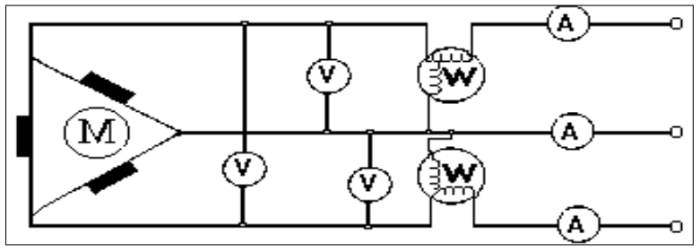

**Fig 13:** The connection of the three phase induction motor delta connected windings   
without capacitors

After that, the torque on the motor was increased progressively and the readings of the torque, speed, input power, voltage and current were taken and tabulated in the table 5

|  |  |  |  |  |  |  |  |  |  |  |  |  |
| --- | --- | --- | --- | --- | --- | --- | --- | --- | --- | --- | --- | --- |
| **Torque (N.m)** | **Speed (rpm)** | **Iin (A)** | **V (Volts)** | **Def1** | **V1** | **I1** | **P1 (W)** | **Def2** | **V2** | **I2** | **P2 (W)** | **Pin (W)** |
| **0.0** | **1400** | **0.4** | **220** | **0.28** | **500** | **0.2** | **28** | **0.54** | **200** | **0.5** | **20** | **54** |
| **0.2** | **1350** | **0.45** | **220** | **0.1** | **500** | **0.2** | **10** | **0.8** | **200** | **0.5** | **42** | **80** |
| **0.4** | **1330** | **0.55** | **220** | **0.9** | **500** | **0.2** | **90** | **0.48** | **200** | **1** | **66** | **96** |
| **0.6** | **1250** | **0.6** | **220** | **0.05** | **500** | **0.2** | **5** | **0.7** | **200** | **1** | **118** | **140** |

|  |  |  |  |  |  |
| --- | --- | --- | --- | --- | --- |
| **Torque (N.m)** | $\sqrt{3}$**V*Iin (V.A)** | **Pout (W)** | **PF** | **Q (Var)** | **eff** |
| **0.0** | **152.24** | **-** | **0.54** | **128.27** | **-** |
| **0.2** | **171.27** | **28.27** | **0.53** | **145.72** | **31.41** |
| **0.4** | **209.33** | **55.29** | **0.89** | **96.04** | **29.72** |
| **0.6** | **228.36** | **80.42** | **0.63** | **176.42** | **55.46** |

**Table 5:** the readings of the speed, input power, voltage and current and the calculated values of power factor and reactive power at each value of the torque

After that, the torque was plotted as a function of the speed and the power factor and shown in fig 14 and fig 15 respectively.

**Fig 14:** The torque speed characteristic

**Fig 15:** the torque vs power factor

In the next step of this part, the capacitor bank was connected as delta connection with C = 2uF across the terminals of the motor as shown in the fig 16

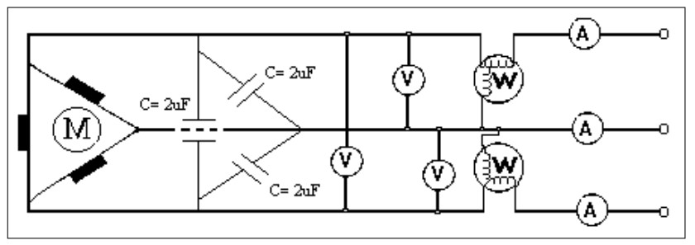

**Fig 16:** The connection of the three phase induction motor delta connected windings   
with delta connected capacitor bank

After that, the torque on the motor was increased progressively and the readings of the torque, speed, input power, voltage and current were taken and tabulated in the table 6

|  |  |  |  |  |  |  |  |  |  |  |  |  |
| --- | --- | --- | --- | --- | --- | --- | --- | --- | --- | --- | --- | --- |
| **Torque (N.m)** | **Speed (rpm)** | **Iin (A)** | **V (Volts)** | **Def1** | **V1** | **I1** | **P1 (W)** | **Def2** | **V2** | **I2** | **P2 (W)** | **Pin (W)** |
| **0.0** | **1400** | **0.3** | **220** | **0.09** | **500** | **0.1** | **4.5** | **0.1** | **200** | **1** | **20** | **24.5** |
| **0.2** | **1350** | **0.3** | **220** | **0.12** | **500** | **0.2** | **12** | **0.23** | **200** | **1** | **46** | **58** |
| **0.4** | **1330** | **0.5** | **220** | **0.18** | **500** | **0.2** | **18** | **0.33** | **200** | **1** | **66** | **84** |
| **0.6** | **1250** | **0.55** | **220** | **0.08** | **500** | **0.5** | **20** | **0.51** | **200** | **1** | **102** | **122** |

|  |  |  |  |  |  |
| --- | --- | --- | --- | --- | --- |
| **Torque (N.m)** | $\sqrt{3}$**V*Iin (V.A)** | **Pout (W)** | **PF** | **Q (Var)** | **eff** |
| **0.0** | **114.18** | **-** | **0.21** | **111.52** | **-** |
| **0.2** | **114.18** | **28.27** | **0.51** | **98.35** | **48.75** |
| **0.4** | **190.3** | **55.71** | **0.44** | **170.76** | **66.32** |
| **0.6** | **209.33** | **78.53** | **0.58** | **170.1** | **64.37** |

**Table 6:** the readings of the speed, input power, voltage and current and the calculated values of power factor and reactive power at each value of the torque

After that, the torque was plotted as a function of the speed and the power factor and shown in fig 17 and fig 18 respectively.

**Fig 17:** The torque speed characteristic

**Fig 18:** the torque vs power factor

In the last step of this part, the capacitor bank was connected as wye connection with C = 6uF across the terminals of the motor as shown in the fig 19

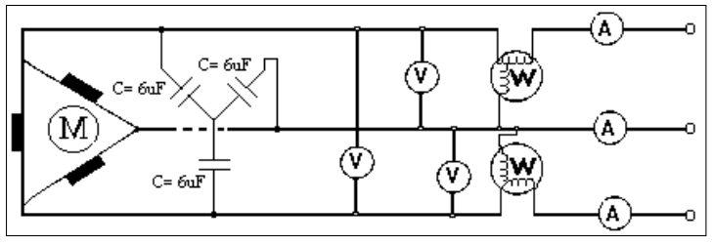

**Fig 19:** The connection of the three phase induction motor delta connected windings   
with wye connected capacitor bank

After that, the torque on the motor was increased progressively and the readings of the torque, speed, input power, voltage and current were taken and tabulated in the table 6

|  |  |  |  |  |  |  |  |  |  |  |  |  |
| --- | --- | --- | --- | --- | --- | --- | --- | --- | --- | --- | --- | --- |
| **Torque (N.m)** | **Speed (rpm)** | **Iin (A)** | **V (Volts)** | **Def1** | **V1** | **I1** | **P1 (W)** | **Def2** | **V2** | **I2** | **P2 (W)** | **Pin (W)** |
| **0.0** | **1400** | **0.2** | **220** | **0.08** | **500** | **0.1** | **4** | **0.1** | **200** | **1** | **20** | **24** |
| **0.2** | **1350** | **0.25** | **220** | **0.09** | **500** | **0.2** | **9** | **0.21** | **200** | **1** | **42** | **51** |
| **0.4** | **1330** | **0.4** | **220** | **0.17** | **500** | **0.2** | **17** | **0.33** | **200** | **1** | **66** | **83** |
| **0.6** | **1250** | **0.5** | **220** | **0.08** | **500** | **0.5** | **20** | **0.59** | **200** | **1** | **118** | **138** |

|  |  |  |  |  |  |
| --- | --- | --- | --- | --- | --- |
| **Torque (N.m)** | $\sqrt{3}$**V*Iin (V.A)** | **Pout (W)** | **PF** | **Q (Var)** | **eff** |
| **0.0** | **76.12** | **-** | **0.32** | **72.24** | **-** |
| **0.2** | **95.15** | **28.27** | **0.54** | **80.33** | **55.44** |
| **0.4** | **152.24** | **55.71** | **0.55** | **127.62** | **67.12** |
| **0.6** | **190.3** | **78.53** | **0.73** | **131.03** | **56.91** |

**Table 6:** the readings of the speed, input power, voltage and current and the calculated values of power factor and reactive power at each value of the torque

After that, the torque was plotted as a function of the speed and the power factor and shown in fig 20 and fig 21 respectively.

**Fig 20:** The torque speed characteristic

**Fig 21:** the torque vs power factor

**Questions and discussion**

**Single-phase induction motor**

1. The power factor was calculated according to this equation

**PF $= \frac{Pin}{V*Iin}$**

After that, the power factor column in table 1 was completed and the power factor vs torque carve was plotted for each part in the same graph as shown in the fig 22

**Fig 22:** The power factor vs torque carves

1. The reactive power was calculated according to this equation

**Q** = $\sqrt{{(V*Iin)}^{2}- {(Pin)}^{2}}$

After that, the reactive power column in table 1 was completed.

**Three-phase induction motor**

1. The efficiency was calculated according to this equation

**Efficiency = $\frac{Pout}{Pin}$,**

**Where: pout= $torque*speed (rad/s)$**

After that, the efficiency before capacitors and after it was calculated, and it’s clearly that the efficiency was improved and increased after we was added the capacitors.

1. The reactive power was calculated according to this equation

**Q** = $\sqrt{{(1.73*V*Iin)}^{2}- {(Pin)}^{2}}$

1. After the reactive power and efficiency was calculated before and after capacitors, it was clear that the efficiency was improved and increased after we was added the capacitors. We can note that the same increased was occurred when we was used delta connection of 2uF capacitors and wye connection of 6uF capacitors. This means that we can small value of capacitors in delta than in wye to improve the efficiency in the same factor.

**Conclusion**

In this experiment we was studied the most famous power factor correction techniques. This techniques is adding parallel capacitor bank, it was clearly that after we added capacitors the power factor improved and the reactive power consumed from the source was decreased, then the efficiency was increased.