

ELECTRICAL AND COMPUTER ENGINEERING DEPARTMENT

ENEE5102

Power Lab

Exp #6 Report

**Studying the Operation of a Power Transmission Line in Condition of Ground Fault**

Ahmad Waleed Hamed

1120580

Instructor: Dr. Ahmad Alyan

Teaching Assistant: Hammam Hamad

# **Abstract**

In this experiment, the operation of the power transmission line was studied and the fault current at the sending and receiving ends of the line was measured in the single line to ground fault. The effect of the ground capacitance on this operation was noticed. Finally, the compensated neutral conductor, called Peterson coil, was used to eliminate this effect.

**Table of Contents**

**Abstract** 1

**Table of Figures** 3

**Theory** 4

**Electrical Fault** 4

**Electrical Fault Types** 4

**Ground Capacitance** 4

**Peterson Coil** 5

**Procedure and Discussion** 6

**Part A:** Power transmission line with neutral cable insulated in condition of ground fault 6

**Questions** 7

**PART B:** Power transmission line with compensated neutral conductor (Peterson coil) in condition of ground fault 8

**Conclusion** 12

**References** 12

# **Table of Figures**

Figure 1: Ground fault current in insulated neutral transmission line [1] 4

Figure 2: Ground fault current transmission line with Peterson coil [1] 5

Figure 3: The transmission line connection to detect the ground fault current in a line with insulated neutral conductor [1] 6

Figure 4: The total ground capacitance (µF) versus the trend fault current at receiving end (A) 8

Figure 5: The transmission line connection to detect the ground fault current in a line with compensated neutral conductor [1] 8

Figure 6: The inductor values (mH) versus the trend fault current at receiving end (A) when CE = 0.4 µF 10

Figure 7: The inductor values (mH) versus the trend fault current at receiving end (A) when CE = 0.2 µF 11

# **Theory**

### **Electrical Fault**

The fault in electrical power system is any abnormal condition caused by equipment failures that will produce a huge amount of current, known as the fault current. This current may damage the power system equipment and devices. Thus, these devices must be protected against the fault using different types of power system protections.

### **Electrical Fault Types**

There are two main types of faults:

1. Symmetrical (balanced) Faults

In this type of faults, the effect of fault on the three phases is equal. The three line to ground fault is the example on this type of faults.

1. Unsymmetrical (unbalanced) Faults

In this type of faults, the effect of fault on the three phases is not equal. The line to line fault, single line to ground and double line to ground are the examples on this type of faults. The analysis of this type of faults is more complicated compare to the first type. The operation of power system in single line to ground fault will discussed in this experiment.

### **Ground Capacitance**

In overhead transmission lines with insulated neutral cable, there is a type of capacitance that appears between the phase and the ground called ground capacitance due to the positive charge of the transmission line conductor and the negative charge of the ground. This capacitance may form a bath of the current in fault condition, which will rise as the ground capacitance increases. The path of this current is shown in figure 1.

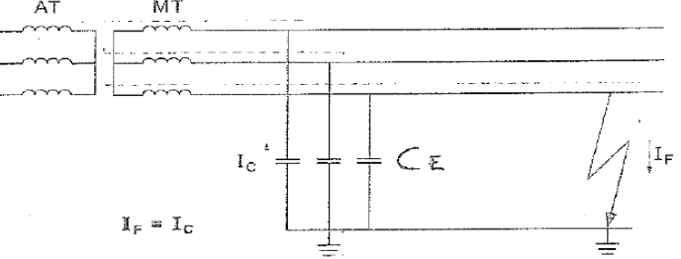

Figure 1: Ground fault current in insulated neutral transmission line [1]

“The main advantages of this transmission lines is reducing the total ground voltage for medium and high voltage faults and the transient arc produced in ground faults will be cleared automatically, but the main disadvantages of this transmission lines is difficult troubleshooting and high operating and fault overvoltage.” [1]

### **Peterson Coil**

To reduce the value of the previous current, the compensated neutral conductor, called Peterson coil, will be connected to ground via the ground resistance. This coil will produce a current out of phase with the previous current and the fault current will be the sum of these two currents. The path of the fault current shown in figure 2.

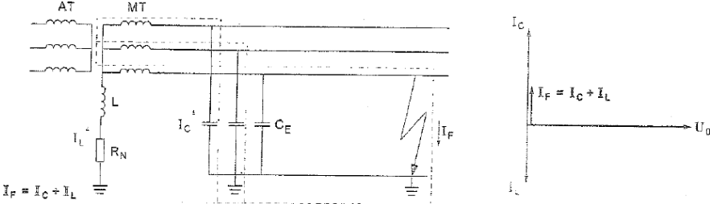

Figure 2: Ground fault current transmission line with Peterson coil [1]

# **Procedure and Discussion**

## **Part A:** Power transmission line with neutral cable insulated in condition of ground fault

At first the circuit shown in figure 3 was connected.

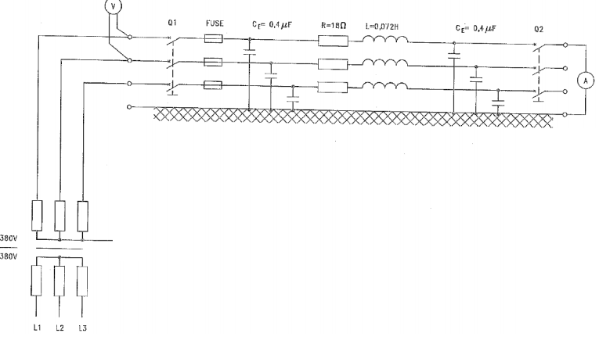

Figure 3: The transmission line connection to detect the ground fault current in a line with insulated neutral conductor [1]

The transmission line parameters was set to the following values:

Resistance (R) = 18 Ohm, Inductance (L) = 0.072 H, Capacitance at sending end (CS) = 0.1 µF and Capacitance at receiving end (CR) = = 0.1 µF

After that, the breakers at sending and receiving end were turned off, and the measuring instruments were connected between the left busway and the terminals at the beginning of the transmission line, and between the end terminals of the line and the right busway. The capacitors at sending and receiving end were connected to the ground using jumpers to produce the capacitance between active conductors and ground called, CE. The left busway was connected to the variable three-phase power supply and the right busway wasn’t connected to any load. The power supply was turned on and adjusted to give line-line voltage, VS, equal 380 V. After that the breakers were turned on. The CE at sending and receiving end was adjusted to different values and the free ground fault current and trend fault current at sending and receiving ends were measured as shown in table 1.

|  |  |  |  |  |
| --- | --- | --- | --- | --- |
| CE sending  CE receiving  (µF) | Sending voltages  VS(V) | Free ground fault current  IF,F(A) | Trend fault current at sending end  IF,S(A) | Trend fault current at receiving end  IF,R(A) |
| 0.1, 0.1 | **380** | 0 | 0.046 | 0.046 |
| 0.1, 0.2 | **380** | 0 | 0.069 | 0.069 |
| 0.1, 0.4 | **380** | 0 | 0.104 | 0.104 |
| 0.2, 0.2 | **380** | 0 | 0.091 | 0.091 |
| 0.2, 0.4 | **380** | 0 | 0.126 | 0.126 |
| 0.4, 0.4 | **380** | 0 | 0.175 | 0.175 |

Table 1: The free ground fault current and trend fault current at sending and receiving ends values at different values of CE at sending and receiving ends

### **Questions**

1. Explain the effect of increasing the values of CE sending and CE receiving on the fault current?

According to the following equation:

$If=\frac{Vs}{Zc,eq}$; $Zc,eq= \frac{1}{j*w*C.eq}$

The value of the fault current is directly proportional to the value of the capacitance. Any increase in the value of the capacitance causes an increase in the value of the fault current.

1. Plot the curve of **Ctotal** (CE sending + CE receiving) versus **IF,R** and explain the effect of adding certain value of resistance in series with the faulted line?

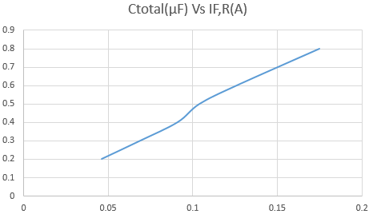

Figure 4: The total ground capacitance (µF) versus the trend fault current at receiving end (A)

If the resistor, RE, was added then the fault current will be reduced according to the following equation:

$$If=\frac{Vs}{RE+Zc,eq}$$

## **PART B:** Power transmission line with compensated neutral conductor (Peterson coil) in condition of ground fault

At first the circuit shown in figure 5 was connected.

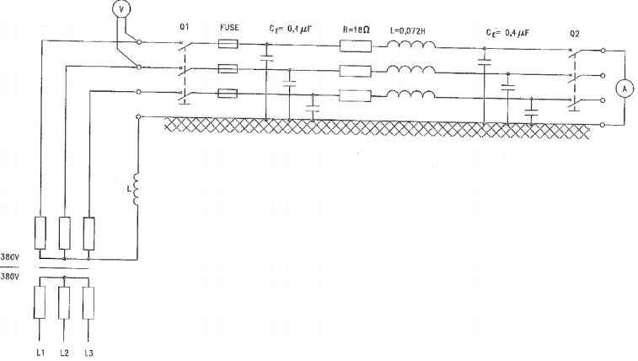

Figure 5: The transmission line connection to detect the ground fault current in a line with compensated neutral conductor [1]

The transmission line parameters was set to the following values:

Resistance (R) = 18 Ohm, Inductance (L) = 0.072 H, Capacitance at sending end (CS) = 0.4 µF and Capacitance at receiving end (CR) = = 0.4 µF

After that, the breakers at sending and receiving end were turned off, the measuring instruments were connected between the left busway and the terminals at the beginning of the transmission line, and between the end terminals of the line and the right busway. The capacitors at the sending and receiving ends were connected to the ground using jumpers to produce the capacitance between active conductors and ground called, CE. The left busway was connected to the variable three-phase power supply and the right busway was not connected to any load. The power supply was turned on and adjusted to give line-line voltage, VS, equal 380 V. After that the breakers were turned on, the values of CE at sending and receiving ends were set to 0.4 µF and the value of the inductor connected in series with the neutral line was varied to some values and the values of the fault current at sending and receiving ends were measured as shown in   
table 2.

|  |  |  |  |  |
| --- | --- | --- | --- | --- |
| CE sending  CE receiving  (µF) | Sending voltages  VS(V) | Conductance of compensation coil L (mH) | Trend fault current at sending end  IF,S(A) | Trend fault current at receiving end  IF,R(A) |
| 0.4, 0.4 | **380** | **6.9** | 0.087 | 0.089 |
| 0.4, 0.4 | **380** | **5.75** | 0.068 | 0.07 |
| 0.4, 0.4 | **380** | **5.18** | 0.059 | 0.06 |
| 0.4, 0.4 | **380** | **4.03** | 0.054 | 0.056 |
| 0.4, 0.4 | **380** | **3.46** | 0.064 | 0.067 |
| 0.4, 0.4 | **380** | **2.3** | 0.125 | 0.127 |
| 0.4, 0.4 | **380** | **1.74** | 0.215 | 0.217 |

Table 2: The trend fault current at sending and receiving ends values at different values of Peterson coil when CE = 0.4 µF

To notice the effect of the Peterson coil, the inductor values versus trend fault current at receiving end was plotted and shown un the figure 6.

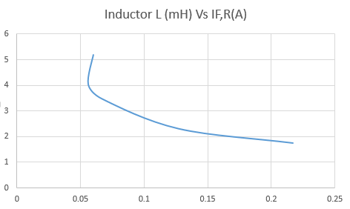

Figure 6: The inductor values (mH) versus the trend fault current at receiving end (A) when CE = 0.4 µF

It was clear from the last figure that when the value of the inductor increased the value of the fault current decreased.

In the end, the values of CE at sending and receiving ends were changed to 0.4 µF and the value of the inductor connected in series with the neutral line was varied to some values and the values of the fault current at sending and receiving ends was measured as shown in table 3.

|  |  |  |  |  |
| --- | --- | --- | --- | --- |
| CE sending  CE receiving  (µF) | Sending voltages  VS(V) | Conductance of compensation coil L (mH) | Trend fault current at sending end  IF,S(A) | Trend fault current at receiving end  IF,R(A) |
| 0.4, 0.4 | **380** | **6.9** | 0.028 | 0.028 |
| 0.4, 0.4 | **380** | **5.75** | 0.037 | 0.038 |
| 0.4, 0.4 | **380** | **5.18** | 0.049 | 0.05 |
| 0.4, 0.4 | **380** | **4.03** | 0.08 | 0.081 |
| 0.4, 0.4 | **380** | **3.46** | 0.11 | 0.11 |
| 0.4, 0.4 | **380** | **2.3** | 0.19 | 0.191 |
| 0.4, 0.4 | **380** | **1.74** | 0.282 | 0.283 |

Table 2: The trend fault current at sending and receiving ends values at different values of Peterson coil when CE = 0.2 µF

To notice the effect of the Peterson coil, the inductor values versus trend fault current at receiving end was plotted and shown in figure 7.

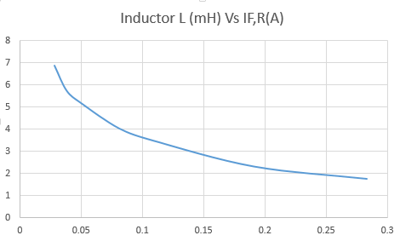

Figure 7: The inductor values (mH) versus the trend fault current at receiving end (A) when CE = 0.2 µF

It was clear from the last figure that when the value of the inductor increased the value of the fault current decreased.

# **Conclusion**

In the first part, the effect of the ground capacitance on the fault current in the single line to ground fault was noticed when the neutral cable was insulated, and a conclusion was reached that if the value of this capacitance increased the value of the fault current will increased. In the second part, the effect of the Peterson coil was seen, where it produced a current out of phase with the current flow in ground capacitors and this lead to reduce the value of the fault current. Also, if the coil value was increased the value of the fault current will decreased.

# **References**

[1] BZU, Electrical Engineering Department, 2016. Power Lab Manual