

ELECTRICAL AND COMPUTER ENGINEERING DEPARTMENT

ENEE5102

Power Lab

Exp #8 Report

**Reluctance Motor and Universal Motor**

Ahmad Waleed Hamed

1120580

Instructor: Dr. Ahmad Alyan

Teaching Assistant: Hammam Hamad

# **Abstract**

This experiment aims to study the characteristics of the two types of motors: the reluctance motors and the universal motors. In each type, the value of the torque was changed to different values and each of the speed, current and power factor were measured. After that the input power, output power and efficiency were calculated and the characteristic curves were plotted.

**Table of Contents**

**Abstract** 1

**Table of Figures** 3

**Theory** 4

**Reluctance Motor:** 4

**Universal Motor:** 4

**Procedure and Discussion** 5

**Reluctance Motor:** 5

**PART A: Basic Circuit:** 5

**PART B: Determining Efficiency and Recording Characteristics:** 6

**Universal Motor:** 10

**PART A: Basic Circuit:** 10

**PART B: Determining Efficiency and Recording Characteristics:** 11

**Questions** 16

**Conclusion** 17

**References** 17

# **Table of Figures**

Figure 1: Arrangement of units for the basic circuit of reluctance motor 5

Figure 2: The speed (n) versus torque (T) 8

Figure 3: The current (I) versus torque (T) 8

Figure 4: The Input Power (P1) versus torque (T) 9

Figure 5: The output Power (P2) versus torque (T) 9

Figure 6: The efficiency (ɳ %) versus torque (T) 10

Figure 7: Arrangement of units for the basic circuit of universal motor 10

Figure 8: The speed (n) versus torque (T) 13

Figure 9: The current (I) versus torque (T) 13

Figure 10: The power factor versus torque (T) 14

Figure 11: The Input Power (P1) versus torque (T) 14

Figure 12: The output Power (P2) versus torque (T) 15

Figure 13: The efficiency (ɳ %) versus torque (T) 15

# **Theory**

## **Reluctance Motor:**

“The reluctance motor is a motor that depends on reluctance torque for its operation. Reluctance torque is the torque induced in an iron object in the presence of an external magnetic field, which causes the object to line up with the external magnetic field. This torque occurs because the external field induces an internal magnetic field in the iron of the object, and a torque appears between the two fields, twisting the object around to line up with the external field. In order for a reluctance torque to be produced in an object, it must be elongated along the axes at angles corresponding to the angles between adjacent poles of the external magnetic field” [1].

## **Universal Motor:**

The universal motor is a motor that has a series characteristic and can be operated with DC and AC power. This motor is very similar to a series DC motor in construction but is modified to allow the motor to operate with AC power by laminate the poles and stator to reduce the core losses. This motor can run at high speed and has a high starting torque and used in many household applications.

# **Procedure and Discussion**

## **Reluctance Motor:**

### **PART A: Basic Circuit:**

At first the circuit shown in figure 1 was connected.

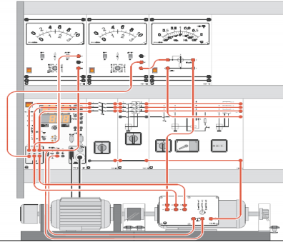

Figure 1: Arrangement of units for the basic circuit of reluctance motor

The main switch on the test machine was turned on and then the AC supply was turned on, the power circuit breaker module was turned on, the RED button (M! =0) was pressed and then the torque mode was selected to flywheel.

The direction of rotation was CCW, the speed was equal to 1500 rpm, the line-to-line voltage was equal to 400 V, the phase voltage was equal to 230 V and the current was equal to 1.1 A. The RED button (M! =0) was pressed to turn off the load and then the power circuit breaker module was turned off. After that, the direction of rotation of the motor was changed by swapping two phases and the same previous results was measured.

### **PART B: Determining Efficiency and Recording Characteristics:**

At first the circuit shown in figure 1 was connected and table 1 was filled.

Table 1: Nominal Data for the Reluctance Motor

|  |  |
| --- | --- |
| Nominal voltage VN when connected in star: | 400 V |
| Nominal voltage VN when connected in delta | 230 V |
| Nominal current IN when connected in star: | 1.43 A |
| Nominal current IN when connected in delta: | 2.48 A |
| Nominal power factor, cos φN: | 0.45 |
| Nominal output power PN: | 250 W |
| Nominal speed nN: | 1500 rpm |

$$Nominal Torque \left(Tn\right)= \frac{nominal power}{w}=\frac{250}{1500*(2π/60)}=1.59 N.m$$

The AC supply was turned on, the power circuit breaker module was turned on, the RED button (M! =0) was pressed and then the torque mode was selected to torque regulation and the nominal torque was applied to the machine.

The line-to-line voltage was equal to 400 V, the current was equal to 1.35 A and the power factor equal to 0.4.

$$Input Power \left(P1\right)=\sqrt{3}*Vl*I*pf= \sqrt{3}*400*1.35*0.4= 374.12 W$$

$$Output Power \left(P2\right)=T*w=1.59*1500*\frac{2π}{60}=250 W$$

$Actual Efficiency ($ ɳ $a\%)= \frac{P2}{P1}= \frac{250}{374.12}*100\%=66.82\%$

$Theoretical Efficiency ($ ɳ $th\%)= \frac{P2}{\sqrt{3}*Vl*I*pf}= \frac{250}{\sqrt{3}*400*1.43*0.45}*100\%=56.07\%$

After that, the normalized load torque was changed from 0 to 1 N.m and the speed. The current and power factor were measured and filled in table 2.

Table 2: Speed, current, power factor and some calculations at different value of the torque

|  |  |  |  |  |  |  |  |  |  |  |  |
| --- | --- | --- | --- | --- | --- | --- | --- | --- | --- | --- | --- |
| T/Tn | 0 | 0.1 | 0.2 | 0.3 | 0.4 | 0.5 | 0.6 | 0.7 | 0.8 | 0.9 | 1 |
| T(N.m) | 0 | 0.159 | 0.318 | 0.477 | 0.636 | 0.795 | 0.954 | 1.113 | 1.272 | 1.431 | 1.59 |
| n(rpm) | 1500 | 1500 | 1500 | 1498 | 1498 | 1500 | 1500 | 1500 | 1500 | 1500 | 1500 |
| I(A) | 1 | 1.1 | 1.1 | 1.1 | 1.1 | 1.1 | 1.2 | 1.2 | 1.3 | 1.35 | 1.35 |
| Cos(φ) | 0.12 | 0.19 | 0.2 | 0.2 | 0.21 | 0.27 | 0.29 | 0.3 | 0.35 | 0.35 | 0.4 |
| n/ns | 1 | 1 | 1 | 0.99 | 0.99 | 1 | 1 | 1 | 1 | 1 | 1 |
| I/IN | 0.699 | 0.769 | 0.769 | 0.769 | 0.769 | 0.769 | 0.839 | 0.839 | 0.909 | 0.944 | 0.944 |
| P1(w) | 83.1 | 144.8 | 152.4 | 152.4 | 160 | 205.7 | 241.1 | 249.4 | 315.2 | 327.4 | 374.1 |
| P1/P1N | 0.22 | 0.39 | 0.41 | 0.41 | 0.43 | 0.55 | 0.64 | 0.67 | 0.84 | 0.88 | 1 |
| P2(w) | 0 | 24.9 | 49.9 | 74.8 | 99.8 | 124.9 | 149.9 | 174.8 | 199.8 | 224.8 | 294.9 |
| P2/P2N | 0 | 0.1 | 0.2 | 0.3 | 0.4 | 0.5 | 0.6 | 0.7 | 0.8 | 0.9 | 1 |
| ɳ $\%$ | 0 | 17.2 | 32.7 | 49.1 | 62.3 | 60.7 | 62.2 | 70.1 | 63.4 | 68.7 | 78.8 |

The RED button (M! =0) was pressed to turn off the load and then the power circuit breaker module was turned off.

The speed (n) versus torque (T) was plotted and shown in figure 2.

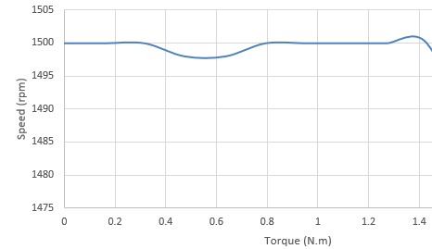

Figure 2: The speed (n) versus torque (T)

The current (I) versus torque (T) was plotted and shown in figure 3.

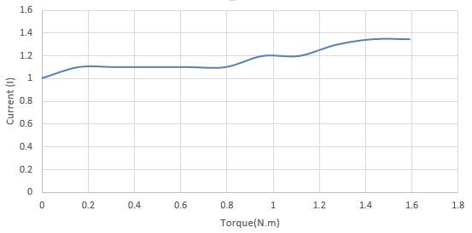

Figure 3: The current (I) versus torque (T)

The Input Power (P1) versus torque (T) was plotted and shown in figure 4.

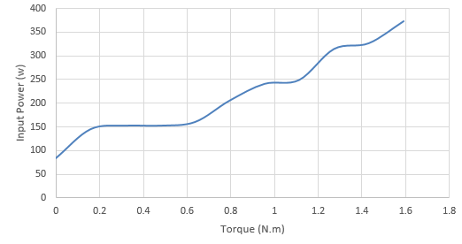

Figure 4: The Input Power (P1) versus torque (T)

The output Power (P2) versus torque (T) was plotted and shown in figure 5.

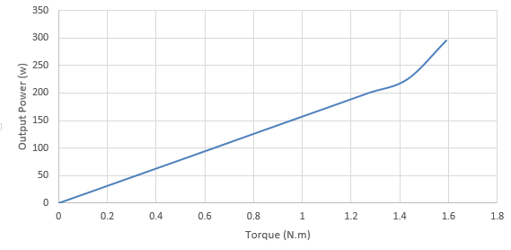

Figure 5: The output Power (P2) versus torque (T)

The efficiency (ɳ $\%$) versus torque (T) was plotted and shown in figure 6.

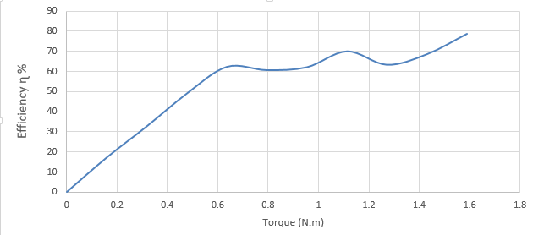

Figure 6: The efficiency (ɳ %) versus torque (T)

## **Universal Motor:**

### **PART A: Basic Circuit:**

At first the circuit shown in figure 7 was connected.

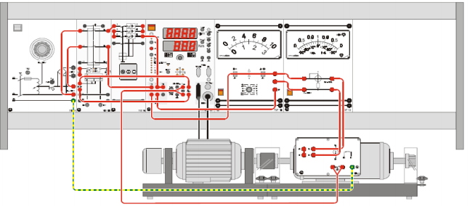

Figure 7: Arrangement of units for the basic circuit of universal motor

The main switch on the test machine was turned on and then the AC supply was turned on at half of nominal voltage (115 V), the power circuit breaker module was turned on. The direction of rotation was CCW. The power circuit breaker module was turned off, then the AC supply was turned off. After that, the direction of rotation of the motor was changed and the same previous result was measured.

### **PART B: Determining Efficiency and Recording Characteristics:**

At first the circuit shown in figure 7 was connected and table 3 was filled.

Table 3: Nominal Data for the Universal Motor

|  |  |
| --- | --- |
| Nominal voltage VN | (140 ~ 230) V |
| Nominal current IN | (2.5 ~ 3) A |
| Nominal speed nN | 3000 rpm |
| Nominal power PN | 200 W |

$$Nominal Torque \left(Tn\right)= \frac{nominal power}{w}=\frac{200}{3000*(2π/60)}=0.63 N.m$$

The main switch on the machine test system was turned on, the AC supply was turned on at half of nominal voltage (115 V), the power circuit breaker module was turned on, the RED button (M! =0) was pressed and then the torque mode was selected to torque regulation and the torque equal to 0.27 N.m was applied to the machine and then the voltage was increased to nominal value (230 V), after that the torque was set to its nominal value.

The speed (n) was measured and equal to 3500 rpm, the current was equal to 2.49 A and the power factor was equal to 0.7.

$$Actual Output Power \left(P2\right)=T*w=0.63*3500*\frac{2π}{60}=230.79 W$$

The actual output power at nominal torque is slightly higher than the nominal output power. If the applied torque was reduced, then the actual output power will decrease to its nominal value.

$$Actual Input Power \left(P1\right)=V*I*pf=230*2.49*0.7=400.89 W$$

$$Actual Efficiency \left(ɳ\%\right)=\frac{P2}{P1}*100 \%= \frac{230.79}{400.89}*100 \%=57.57 \%$$

After that, the normalized load torque was changed from 0 to 1.3 N.m and the speed, current and power factor were measured and filled in table 4.

Table 3: Speed, current, power factor and some calculations at different value of the torque

|  |  |  |  |  |  |  |  |  |  |  |  |
| --- | --- | --- | --- | --- | --- | --- | --- | --- | --- | --- | --- |
| T/Tn | 0.3 | 0.4 | 0.5 | 0.6 | 0.7 | 0.8 | 0.9 | 1.0 | 1.1 | 1.2 | 1.3 |
| T(N.m) | 0.189 | 0.252 | 0.315 | 0.378 | 0.441 | 0.504 | 0.567 | 0.63 | 0.693 | 0.756 | 0.819 |
| n(rpm) | 5122 | 5122 | 5120 | 4700 | 4500 | 4100 | 3700 | 3500 | 3400 | 3100 | 2800 |
| I(A) | 1.7 | 1.7 | 1.67 | 1.8 | 1.9 | 2 | 2.4 | 2.49 | 2.6 | 2.8 | 3 |
| Cos(φ) | 0.85 | 0.82 | 0.82 | 0.8 | 0.8 | 0.78 | 0.7 | 0.7 | 0.68 | 0.65 | 0.6 |
| n/nN | 1.7 | 1.7 | 1.7 | 1.57 | 1.5 | 1.37 | 1.23 | 1.17 | 1.13 | 1.03 | 0.93 |
| I/IN | 0.567 | 0.567 | 0.557 | 0.6 | 0.633 | 0.667 | 0.8 | 0.83 | 0.867 | 0.933 | 1 |
| P1(w) | 332.4 | 320.6 | 315 | 331.2 | 349.6 | 358.8 | 386.4 | 400.9 | 406.6 | 418.6 | 414 |
| P1/P1N | 1.66 | 1.6 | 1.57 | 1.65 | 1.75 | 1.79 | 1.93 | 2 | 2.03 | 2.09 | 2.07 |
| P2(w) | 160.9 | 214.5 | 268 | 295.3 | 329.8 | 343.4 | 348.7 | 366.5 | 391.6 | 389.5 | 381.1 |
| P2/P2N | 0.8 | 1.07 | 1.34 | 1.48 | 1.65 | 1.72 | 1.74 | 1.83 | 1.96 | 1.95 | 1.91 |
| ɳ $\%$ | 0 | 17.2 | 32.7 | 49.1 | 62.3 | 60.7 | 62.2 | 70.1 | 63.4 | 68.7 | 78.8 |

The AC voltage was reduced again to 115 V and the RED button (M! =0) was pressed to turn off the load and then the power circuit breaker module was turned off.

The speed (n) versus torque (T) was plotted and shown in figure 8.

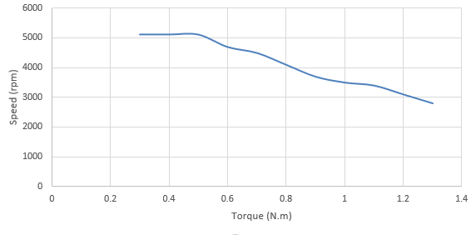

Figure 8: The speed (n) versus torque (T)

The current (I) versus torque (T) was plotted and shown in figure 9.

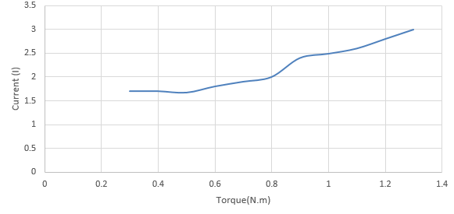

Figure 9: The current (I) versus torque (T)

The power factor versus torque (T) was plotted and shown in figure 10.

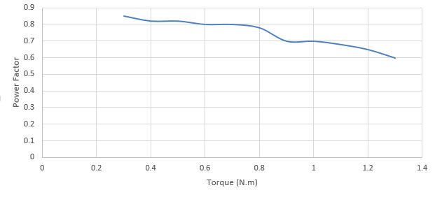

Figure 10: The power factor versus torque (T)

The Input Power (P1) versus torque (T) was plotted and shown in figure 11.

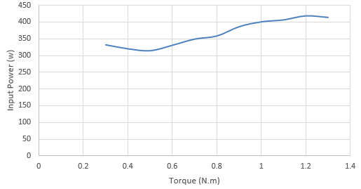

Figure 11: The Input Power (P1) versus torque (T)

The output Power (P2) versus torque (T) was plotted and shown in figure 12.

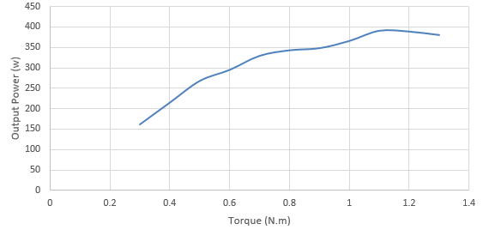

Figure 12: The output Power (P2) versus torque (T)

The efficiency (ɳ $\%$) versus torque (T) was plotted and shown in figure 13.

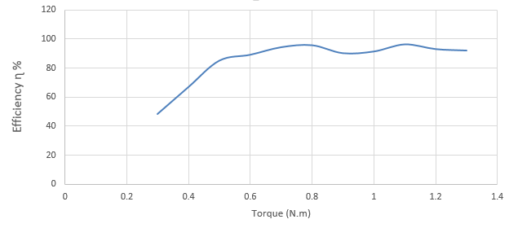

Figure 13: The efficiency (ɳ %) versus torque (T)

## **Questions**

1. Special Purpose Motors.
2. Because there is a large phase between voltage and current.
3. The relationship between the torque and the speed is inverse relationship, but the relationship between the torque and the current is positive relationship, as shown in figures 8 and 9 respectively.
4. The universal motor has infinite speed at no load and nominal voltage, then in this case the acceleration is very large and the speed still increase until the motor damage itself.
5. 1- Connecting a variable resistor in series with the motor.

2- Varying the field strength by field tapping method.

# **Conclusion**

In this experiment, we studied the characteristics of the two types of motors: the reluctance motors and the universal motors. The torque was varied to some specific values until the nominal torque. At each value of torque the speed, current and power factor were measured. After that the input power, output power and efficiency were calculated and the characteristic curves were plotted. We noticed that the reluctance motor has low power factor and it was operated at a constant speed. From the torque speed curve for universal motor, we noticed that if the nominal torque was applied to the motor at nominal voltage then the motor operate at an extremely high speed and the motor may damage itself.

# 

# **References**

1. ELECTRIC MACHINERY FUNDAMENTALS, FIFTH EDITION, Stephen J. Chapman
2. <http://www.brighthubengineering.com/machine-design/73350-universal-motor-speed-controllers/>