

**“Numerical Simulation of System Transient Stability of a Synchronous Generator Connected to Infinite Bus”**

**Power System Protection & Automation**

**Instructor: Dr. Mahran Quraan**

**Students:**

**Haitham Daana – 1121331**

**Ali Khweis -**

**Date: 19/3/2017**

Contents

I. Abstract 2

II. Introduction 3

The Stability Problem: 3

III. Theory 5

1. Transient Stability – Review of Mechanics. 5

2. The Swing Equation 5

3. The Equal Area Criterion 9

IV. Procedure and Results 11

1. Procedure 11

2. Results 12

I. System Behaviour at fault duration of 17 cycles: 12

II. System behaviour in the unstable region: 15

V. Theoretical Calculation 20

VI. Conclusion 24

References 24

# Abstract

The purpose of this of this report is to determine how does the duration faults or disturbances affects the generator transient stability when connected to an infinite bus, using modeling programs like MATLAB/Simulink, in the simulation, a Synchronous Generator is connected to a resistive load, and to the grid by transmission line with specific reactance and resistance. The duration of faults was increased gradually in order to study the behaviour of the generator’s load angle, rotor speed, and voltage.

# Introduction

The increasing demand of power is accompanied by an increased supply of power, more power plant are built, more transmission lines, and power transmitting over large distances, this increases the complexity of the power network, along with the likelihood having more frequent disturbances or faults to occur within the system.

Load changes, switching of breakers, open circuit faults, short-circuits, lightning strikes may cause the power system to become unstable, and the study of the ability of the system to recover from those event is called Stability Analysis.

## The Stability Problem:

Stability studies evaluates the impact of disturbances/faults on the electromechanical dynamic behaviour of the power system, there are two types of stability:

1. Transient Stability.
2. Steady State Stability.

The ***steady state stability*** of a power system is defined as the ability of the system to bring itself back to its stable configuration following a small disturbance in the network (like normal load fluctuation or action of automatic [voltage](https://www.electrical4u.com/voltage-or-electric-potential-difference/) regulator).

*The* ***Transient stability*** of a power system refers to the ability of the system to reach a stable condition following a large disturbance in the network condition. In all cases related to large changes in the system like sudden application or removal of load, switching operations, line faults or loss due to excitation the transient stability of the system comes into play. We are mainly interested in the analysis of the behavior of the system immediately following such a disturbance. Studies of this nature are called transient stability analysis***.*** The term stability is used here to denote the ability of the system machines to recover from small random perturbing forces and still maintain synchronism.

Stability considerations have been recognized to be among the essential tools in electric power system planning. The possible consequences of instability in an electric power system were dramatized by the Northeast power failure of 1965. This is an example of a situation that arises when a severe disturbance is not cleared away fast enough. This blackout began with a loss of a transmission corridor, which isolated a significant amount of generation from its load [1].

# Theory

## Transient Stability – Review of Mechanics.

The analysis of any power system to determine its transient stability involves some mechanical properties of the machines of the system, for after every disturbance the machine must adjust the relative angles of their rotors to meet the conditions of power transfer imposed. The problem is mechanical as well as electrical, Mechanical principles must be kept clearly in mind when considering the problem.

The kinetic energy of a rotating body is:

…….. (1)

$$K.E=\frac{1}{2}J{.ω}^{2} Joules$$

Where J: is the inertia of the body, and $ω$ is the angular velocity of the body. The stored energy of an electrical machine is expressed in megajoules.

And here, we define another constant H, which is called the inertia constant. It’s the amount of megajoules stored of a machine at synchronous speed per megavolt-ampere rating of the machine, so we define,

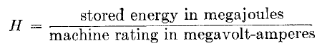

…….. (2)

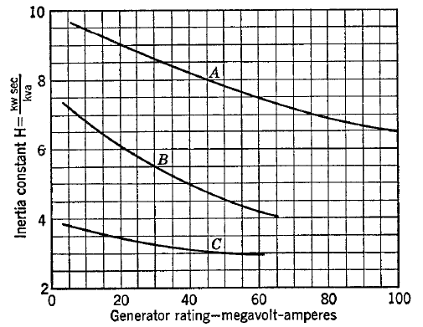

Figure (1): Interia constant of large steam turbogenerators including A 1800rpm condensing, B 3600rpm condensing, C 3600rpm non condensing. [1]

## The Swing Equation

If the torque caused by friction windage, and core loss in machine is disregarded any difference between the shaft torque and electromagnetic torque induced must cause acceleration of the machine, if $T_{m}$ represents the shaft torque and $T_{e}$ represents the electromagnetic torque, the torque causing acceleration is:



…….. (3)

Where $T_{a}$ is the accelerated torque, if positive machine accelerates if negative it de-accelerates, multiplying by the angular velocity of the rotor,



…….. (4)

Where $P_{m}$ is the shaft power, and $P_{e}$ is the electrical power developed by generator, and since the power is equal to torque times angular velocity,



…….. (5)

Where *M* is the momentum of the Machine, and $P_{a}$ is in megawatts if *M* is in megajoule-seconds per electrical degree, the angular acceleration $α$ is in electrical degrees per second squared. The acceleration $α$ is expressed in terms of angular position $θ$ of the rotor is,



…….. (6)

but since $θ$ is continuously changing with time it’s more convenient to measure angular position relative to rotating axis at synchronous speed, if we define $δ$ as the angular displacement to the rotary axis and $ω_{s}$ as the synchronous speed in electrical degree per second, we define,



…….. (7)

taking the derivative with respect to t, we obtain,

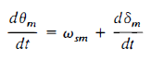

…….. (8)

And taking derivative again,



…….. (9)

Combining the equations, we obtain

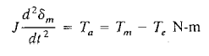

…….. (10)

and,



…….. (11)

and,



…….. (12)

where *M*, is the angular momentum of machine. And this coefficient, is not constant at all load conditions because angular velocity of rotor is not constant all the time, however it doesn’t differ significantly from synchronous speed when machine is stable, and since power is more convenient over torque, we use ***H***, the inertia constant,



…….. (13)

Solving for *M*,



…….. (14)

and substituting *M* in the equation (12), we obtain,



…….. (15)

reducing to per-unit,



…….. (16)

we can also write in this form,

 

…….. (17)

Where $P_{max}$ is the maximum output power of the generator which is equal to,

$$P_{max}=E^{'}.\frac{V_{bus}}{X}$$

Where E’ is the back-emf voltage of the generator and $V_{bus}$ is the voltage of the bus, and $X_{s}$ is the reactance of the generator, when dealing with faults transient reactance is chosen to determine X, transient reactance is the best value to use because the rotor of the machine is constantly changing position with respect to the mmf of the armature current so the flux changes over the rotor face in a similar manner to that of changing flux when transient is evaluated.

The solution of equation (16) gives values of $δ$ for different times and a graph of $δ$ versus $t$ is usually plotted such a graph is called the swinging curve, if the swing curve indicates that the angle of $δ$ start to decrease after reaching maximum value, it usually assumed that the system will not lose stability, and that the oscillations of $δ$ around the equilibrium point will become successively smaller and eventually be damped out. [2]

## The Equal Area Criterion

In a system where one machine is swinging with respect to an infinite bus, it is not necessary to plot and inspect the swing curves to determine whether the torque angle of the machine increases indefinitely or oscillates around an equilibrium position, solution of swing equation, with the usual assessment of constant Pm, a purely reactive network constant linkage behind the transient reactance shows that $δ$ oscillates around equilibrium point, with constant amplitude, if the transient stability limit is not exceeded.

“*The principle by which stability under transient conditions is determined without solving the equation is called the equal area criterion”[2]*

Recalling the swing equation,

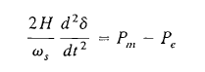

We define the the angular velocity of the rotor relative to synchronous speed,



Differentiating,

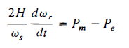

Multiplying both sides by $\frac{dδ}{dt}$

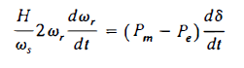

Equation can be re-arranged as,



Multiplying by dt, and integrating,



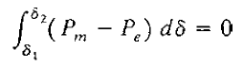The subscript for the $ω_{r1}$ corresponds to that at angle $δ_{1}$ and $ω_{r2}$ coressponds to $δ_{1}$, and since $ω_{r}$ represents the departure time of the rotor speed from synchronous speed, we readily see that if the rotor speed is synchronous at both angles, then the difference between two speeds is zero, hence,

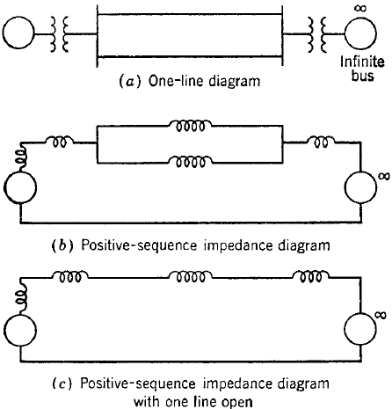Consider the simple oneline diagram shown,

When a generator is supplying power to infinite bus over two parallel transmission lines the opening of one line may cause the generator to lose synchronism, such a system is shown in Figure (1.a)

Figure(2.b) reperesents the system when one of the parallel lines are opened, the positive sequence impedance diagram becomes that of Fig (2.c)

Opening of one line increases the reactance between generator and the bus, increased reactance mean that the torque angle must increase in order to transfer the same power ove the system as carried before opening the line.

The generator is accelerated because the reduced power output resulting from increased reactance is less than the power input.

Figure (2): Oneline diagram for the positive sequence impedances diagram of generator supplying power to infinite bus

Acceleration increase the torque angle, power output curves is plotted against torque angle are shown below,

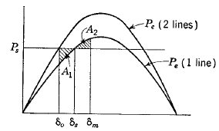

Figure(3): Power Curve before the fault(Line 2), and after the fault.

When one line is opened this causes the output power to drop by the $δ_{0}$ ordinate and the upper power curve to the power determined by the $δ_{0}$, ordinate and the lower power curve. The excess of power input over power output causes acceleration which in turn results in greater torque angle, the torque angle oscillates between $δ_{0}$ and $δ_{m}$ around equilibrium point $δ_{S}$**,** as determined by Equal Area Criterion. As the line Ps is raised, a value of $P_{s}$ will be found where equal areas A1, A2 are determined when $δ_{m}$ is at the intersection of $P_{s}$ and the lower electric power curve, this value of Ps is the transient stability limit for the switching operation described.[2]

# Procedure and Results

# Procedure

The following oneline in Figure (4) diagram was modeled onto MATLAB/Simulink, and the information about each element parameters were entered and loaded onto Simulink.

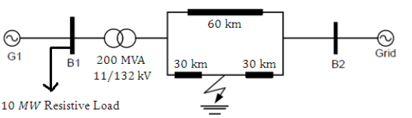

Figure (4): Oneline Diagram of Simple Power System

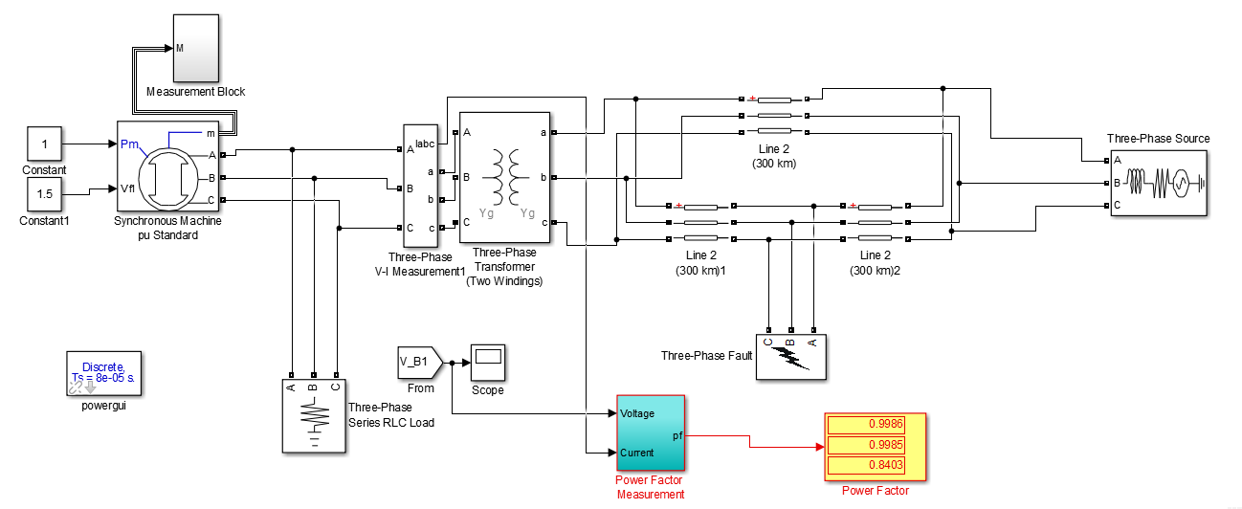The oneline diagram modeled onto Simulink Simulink:

**Figure (5)**

A fault block got added at middle of the line, and was set to start in 20 seconds after starting the generator, so we can insure that the generator is in stable condition, with stable rotor speed and voltage, and there was 10MW resistive load that was added at the generator side, to get better waveforms.

2. Results

Results were divided into two sections, the first section discusses the system before and after a sustained fault of 17 cycles duration (60Hz), the second section for durations longer than 17 cycles, where the system is unstable

### System Behaviour at fault duration of 17 cycles:

1. Rotor Speed and Stator Voltage

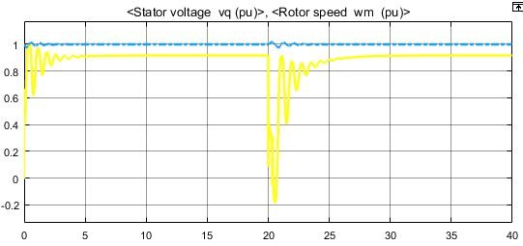

Figure(R.1): Stator Voltage and Rotor Speed

As we can notice from the figure above, the voltages severely drop at the beginning of fault, and the rotor speed oscillates around one point.

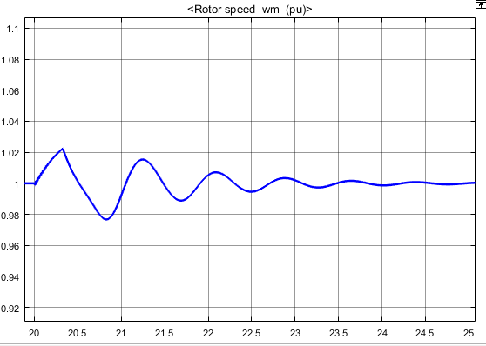

Figure(R.2): Rotor speed in per unit

We can tell by looking at this graph for first time that the derivative of the speed at 20 to 20.4 is positive, which means the rotor is accelerating, from 20.4 to 20.9 the rotor is de-accelerating (fault is cleared and, $P_{m}<P_{e}$) it de-accelerates to 0.98, but at that moment $P_{m}>P_{e}$, it will accelerates again!  
It swing about this previous operation point until revert excess power is damped out!

1. Torque Angle

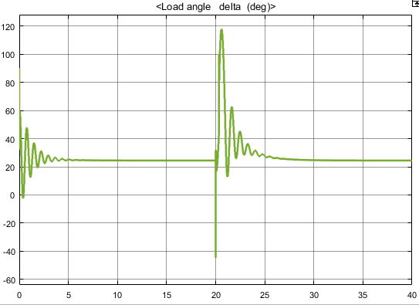

Figure(R.3)

The load angle as we can see is at 24.5 degrees at steady state operation, as soon as the fault occurs it jumps to a maximum of 125 degrees which is at the safe side, it doesn’t exceed the limit where the electrical power is below the mechanical power, as long as it doesn’t reach it, the system will be able to keep itself stable.

1. The Output Reactive & Active Power:

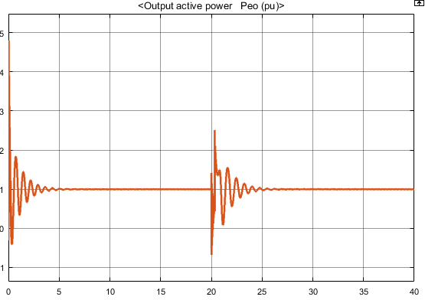

Figure(R.4)

As soon as fault occurs electrical power levels spikes sky-high, due to sudden change in load, but as soon as the fault distinguishes it-self it oscillates around the original point of operation, just like the rotor.

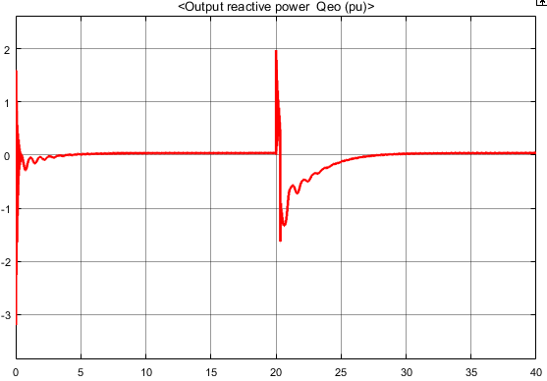

Figure(R.5): Reactive Power

1. The current of the synchronous machine:

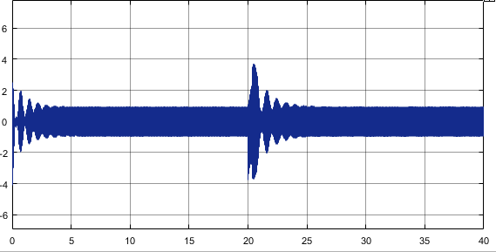

Figure(R.6): The current in armature of the generator

It’s shown that at the moment of fault it peaks to 4 times the load, and that is due to the short-circuit, lower reactance, hence, higher current.

### System behaviour in the unstable region:

1. Voltage of the Generator in unstable condition (Fault Duration > 17 Cycles):

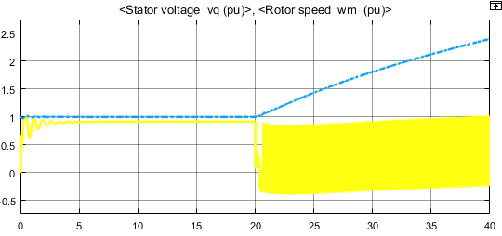

Figure(R.7)

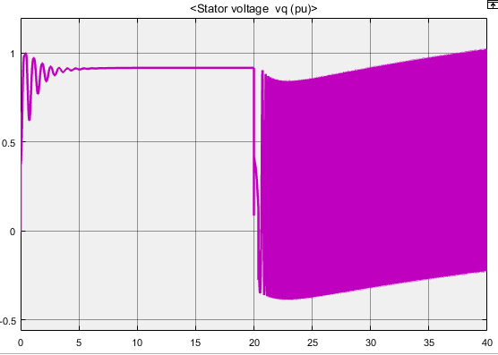

Figure (R.8)

It can be noted from the previous voltage wave form, that the output voltage of the generator is under a severe fluctuation in output.

1. The rotor mechanical speed

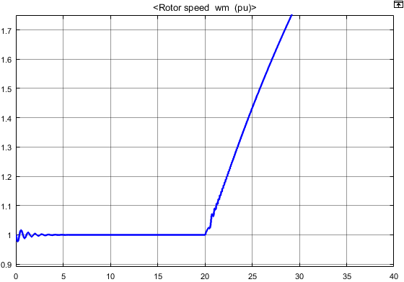

Figure(R.9)

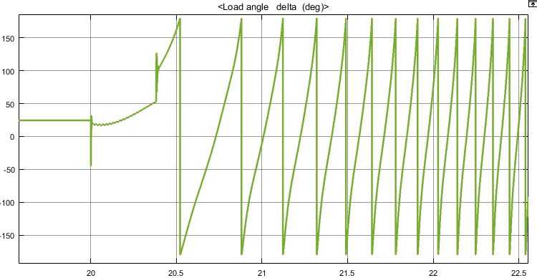

Figure(R.10)

The load angle is fluctuating around the 180 degree, with increase in frequency of oscillations, which gives an indication of the rotor increasing speed!

1. Real and Reactive Power:

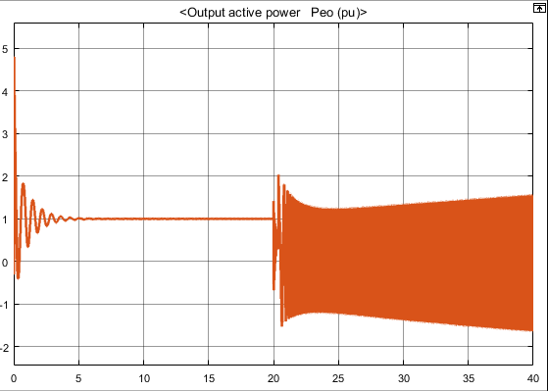

Figure(R.11)

The figure above shows the ***asynchronized*** power output of the generator.

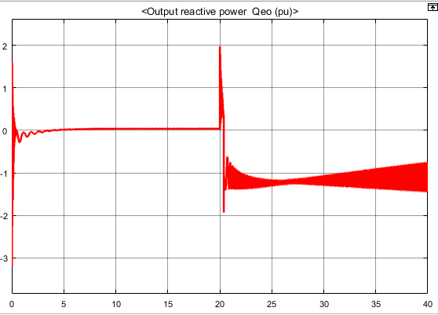

Figure(R.12)

Here the generator is consuming reactive power from the grid.

Most of the results obtained in this section can be clarified by studying the condition of the generator when it is asynchronized, the figure below is an equal area criterion for loss of synchronism of a generator.

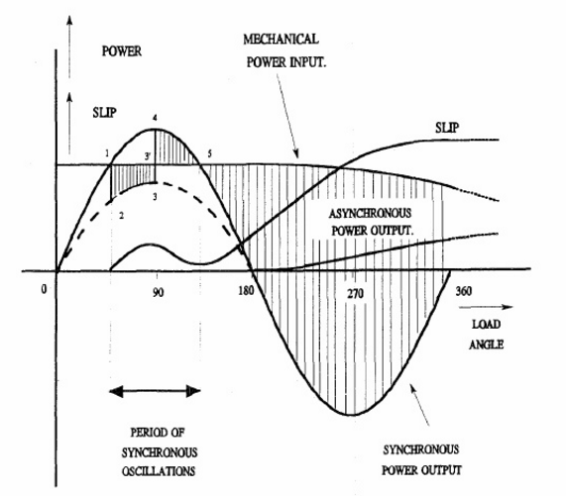

Figure(R.13): Equal Area Diagram for Loss of Synchronism of a Generator

As shown in the diagram, the torque angle is allowed to swing between the points 1, and 5, any swinging above point 5, will cause the generator to lose synchronism, and when it does, if the fault was not cleared away quickly.

the machine will encounter a phenomenon called ‘***Pole Slipping’***, it typically occurs under severe fault conditions which cause a transient torque on the generator which exceeds the ability of the field to hold the generator rotor synchronized to the stator. A generator is most susceptible to this problem when it has a low excitation(Lower Back-emf Voltage), as this produces a weak magnetic field. For this reason, capability diagrams show the stability limit for the machine when in an under-excited state. Outside of this line, pole slipping becomes a real possibility in the event of a system fault.

The 'slip' occurs when the rotor experiences a sudden physical and electrical shift in position relative to the stator, after which the field recovers enough strength to lock the rotor back in synch with the stator. When his occurs, the violent acceleration and deceleration associated with pole slip causes enormous stress on the generator and prime mover, and may result in anything from winding movement to shaft fracture or worse. It is a very serious fault.

# Theoretical Calculation

Calculation and analysis of the oneline diagram to find the critical clearing angle ( $δ_{cr})$ and clearance time ($t_{cr})$, by ignoring the resistive load and.

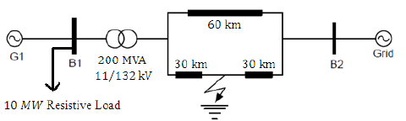

Figure(7)

$$Z_{base}= \frac{{(KV)}^{2}}{MVA}$$

$$Z_{base}= \frac{{(132)}^{2}}{200}=87.12 Ω$$

For the line (60Km), L = 0.9337 mΩ/Km

$X_{1}$ = $j2πfL*60$ = j 17.6 Ω

For the two lines (30Km), L = 0.9337 mΩ/Km

$$X_{2}=j 8.8 Ω$$

$$X_{3}=j 8.8 Ω$$

But,

$$Z_{pu}= \frac{X_{i}}{Z_{base}}$$

So,

🡺

🡺

🡺

For the transformer:

🡺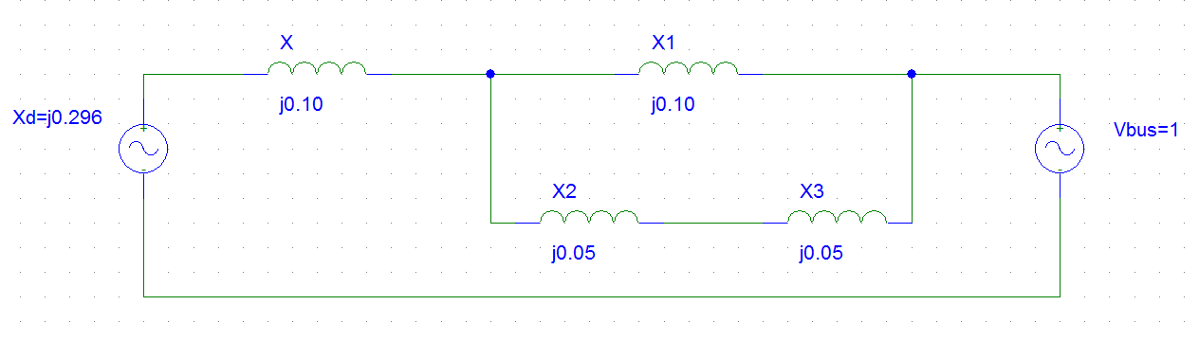

Pre Fault:

=

🡺

🡺

During the Fault:

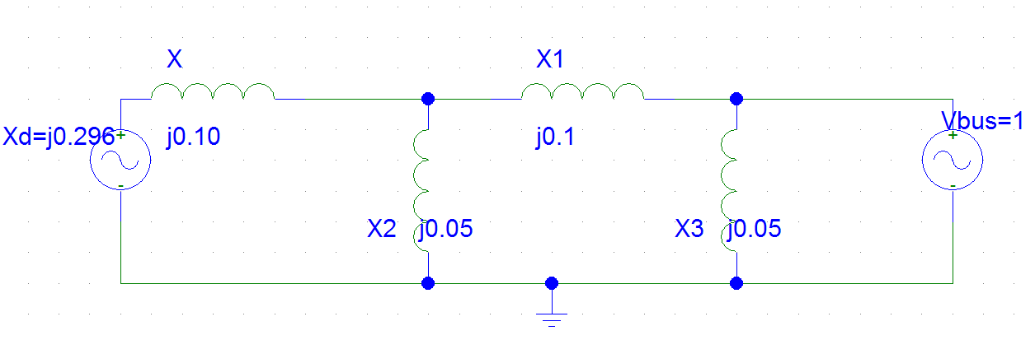

Simplification of the pervious circuit,

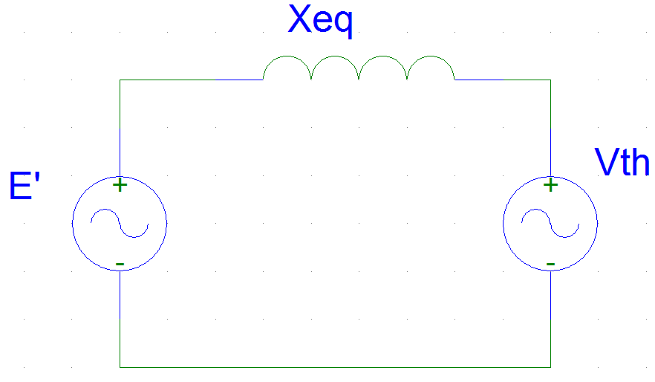

🡺

Post Fault: (Equal Pre Fault)

🡺

🡺Pre Fault

🡺During the Fault

🡺Post Fault

-

🡺

From swing equation:

$$\frac{2*H}{w_{s}}w_{pu }\frac{d^{2}δ}{dt^{2}}= P_{m,pu}-{P^{'}}_{e.pu}$$

Where:

H = 3.7

$$w_{pu }=1$$

$w_{s}=2*pi*f=314.159 rad$/sec

🡺During the Fault

Solving this differential equation shows that the maximum clearing time is, ***20 cycles.***

# Conclusion

This report represented the simulation and analysis of synchronous generator connected to the grid, theoretical calculation of the clearing time was not precise, however they were near the value of the actual clearing time in the Simulink.

It was clear that the size, power rating, and voltage of the machine plays a role in reducing the initial torque angle of the generator which in turn provides more wide range of torque angle for the generator to swing through, which gives the machine the ability to recover from faults with longer durations.

If we were able to raise the machine voltage, it will decrease the initial torque angle, so. Any method which gives us the ability to raise voltage will be affect the torque angle positively, giving the machine higher static stability limit.

## References

[1]: Element of Power Systems Analysis, William D. Stevenson. (1982)

[2]: Power System Analysis, William D. Stevenson, John J Grainger (1994)