

**Birzeit University**

**Faculty of Engineering & Techonology**

**Department of Electrical & Computer Engineering**

**“Swing Equation Modeling”**

**Student : Mohamad Bornat #1130842**

**Instructor:Dr.Mahran Quraan**

**Date: 4-3-2017**

**The swing equation is given by:**

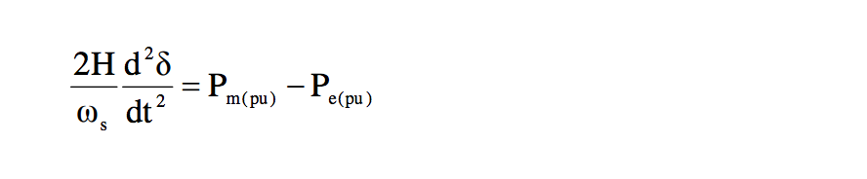

**The critical clearing time equation is given by:**

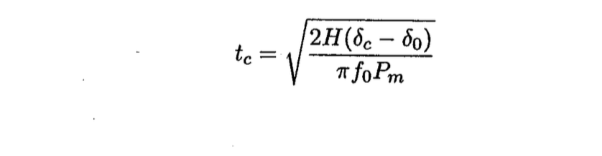

**So the simulink model and results are shown in the next figure :**

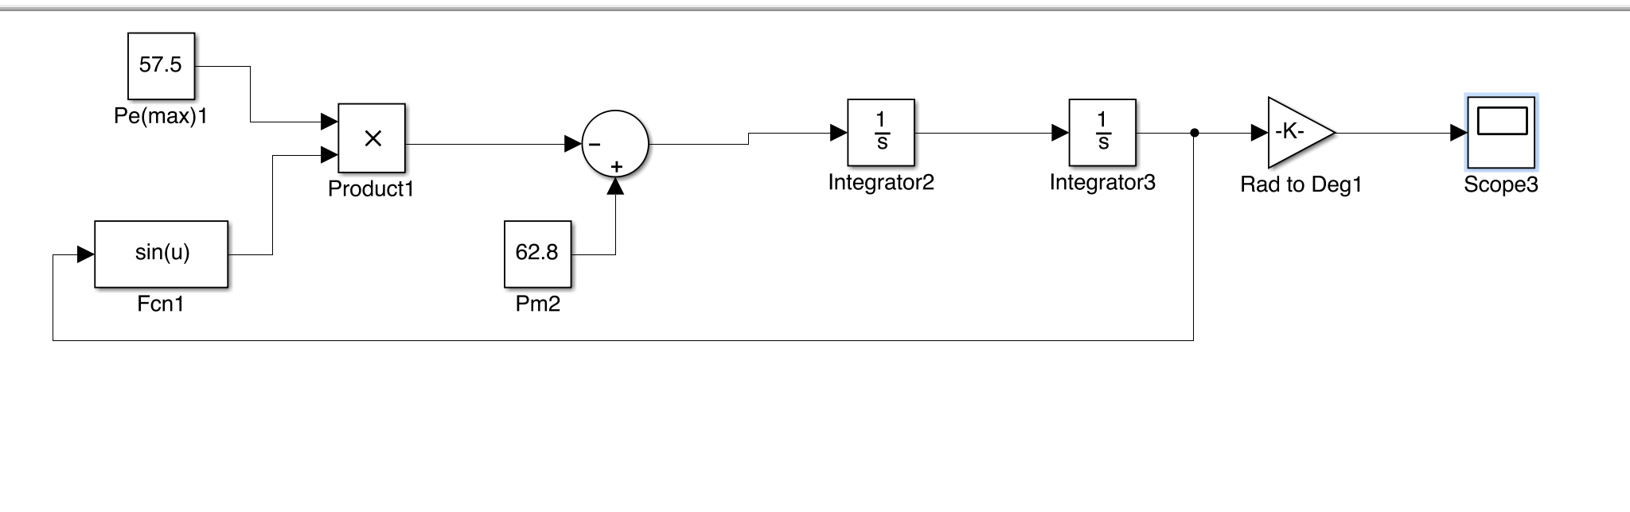

**the results for the given values (H=3,Pe,max=0.9251,Delta critical= 113.5,ws=2*pi*60)**

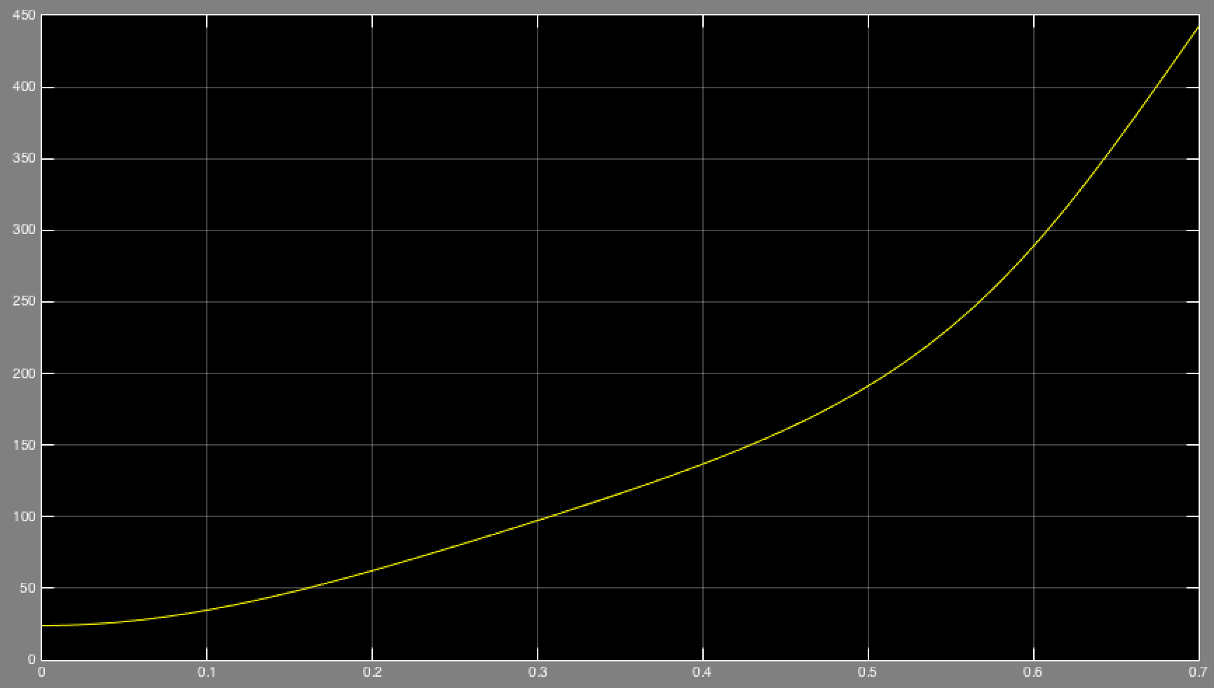

**To find the Tcr we llok near the critical angle 113.5 degrees so :**

**( Tcr= 0.3415)**

