

High Voltage Engineering

ENEE 539

Course Outline



* Introduction
* Mechanical design of overhead power lines
* Substations
* High voltage TL protection
* Generation of high voltage: AC, DC, and impulse generating equipment
* Electrostatics, boundaries and field control
* Dielectric breakdown in solids, liquids, and gases
* Non-destructive insulation test techniques
* HVDC and power electronic systems

Textbooks



* *High Voltage Engineering: Fundamentals*, E. Kuffel, W. S. Zaengl, and J. Kuffel, Newnes: Oxford, 2nd edition, 2000.

Other Resources

* *Electric energy, an introduction,* Mohamad A. El- Sharkawi, 3rd edition, 2013
* *High Voltage Engineering*, M. S Naidu and K. Kamaraju: McGraw Hill, 4th edition, 2009.
* *High Voltage Engineering*, C. Wadhwa, New Age, 2nd edition, 2007.
* *A Text Book of Power System Engineering*, R. K Rajput, Laxmi Publications

(P) LTD, 1st edition, 2012.

Evaluation



* Midterm Exam 30 %
* Short Exams and Assignments 30 %
* Final Exam 40 %

# Definition and function of high voltage Engineering



* It is the knowledge of the behavior of dielectric or electric insulations when subjected to high voltage.
* Basically, high voltage engineering has to guarantee that the **electric stress**, given by the **electric field strength** *E*, is significantly smaller than the **electric strength** (breakdown strength) *EB always*, i.e. under all possible circumstances:

*E*  *EB*

# Application of high voltage Engineering



* The most important applications of high voltage technology are in the field of equipment and systems for the **transmission** and **distribution** of electrical energy.
* Common rated voltages for three-phase AC systems in are 11 kV, 24 kV, 33 kV, 123 kV, 230 kV, 245 kV and 420 kV.
* Higher transmission voltages are used in countries with very long transmission distances between power plants and metropolitan areas. Meanwhile, voltages in the range of 1 MV are used for extreme transmission applications (e.g. in China and India).

# Application of high voltage Engineering

* *High voltages* are *necessary for power transmission* because of the quadratic dependence of transmission-line losses, *PL*, from current *I*.
* These losses are given for a line-to-ground voltage (phase voltage) *V*Ph

by:

*PL* 

3*I* 2 *R*,

*S*  3*V*ph *I*



* If a high apparent power has to be transmitted, losses can most effectively be reduced by reduction of the current *I*, i.e. by increasing the voltage *V*Ph.

# Application of high voltage Engineering



* There are upper voltage limits, because insulation costs increase with voltage.
* If the standard voltage levels are considered, often it is economical to choose a rated voltage in kV close to the transmission distance in km.
* In areas with high transmission power, voltages are significantly higher in order to reduce currents and line losses to a tolerable degree.

## Other applications of high voltage



* in *telecommunications* (high power transmitters),
* in *X-ray technology* (acceleration of electrons by high voltages),
* in *laser* technology (electric gas discharges for stimulation of atoms),
* in *research* applications (generators for acceleration of particle beams),
* In *production technology* (electrostatic lacquering and coating, material treatment and high-speed formation by shock waves),
* in protection against lightning and overvoltages,
* in *environmental protection* (electrostatic filters),



## Other applications of high voltage

* in *recycling* technology (fragmentation and separation of materials by electro-acoustic shock waves),
* in the electroporation of biological cells (sugar beets, fruits, wine),
* in *electronic components* (e.g. capacitors),
* or in *ignition devices* (e.g. spark plugs in motor vehicles).

# High voltage Engineering



* + In electric power transmission engineering, high voltage term is usually considered any voltage over 52 kV:
    - Below 1 kV : LV (Low Voltage)
    - 1 kV – 52 kV : MV (Medium Voltage)
    - 52 kV – 300 kV : HV (High Voltage)
    - 300 kV – 1 MV: EHV ( Extra High Voltage)
    - I MV and above: UHV (Ultra High Voltage)
  + In high voltage engineering, we should always be careful about the peak value of the ac voltage, because this is the maximum voltage in the system and may be responsible for initiating breakdown or failure.

# Voltage stresses



* + Normal operating voltage does not severely stress the power system’s insulation
  + The operating voltage determines the dimensions of the insulation which forms part of the generation, transmission and distribution equipment.

# Voltage stresses



* + The voltage stresses on power systems arise from various overvoltages. These may be of
* External overvoltages are associated with lightning discharges and are not dependent on the voltage of the system. As a result, the importance of stresses produced by lightning decreases as the operating voltage increases.
* Internal overvoltages are generated by changes in the operating conditions of the system such as switching operations, a fault on the system or fluctuations in the load or generations.

# Voltage stresses



* + In designing the system’s insulation the two areas of specific importance are:

1. determination of the voltage stresses which the insulation must withstand, and
2. determination of the response of the insulation when subjected to these voltage stresses.
   * The balance between the electric stresses on the insulation and the dielectric strength of this insulation falls within the framework of insulation coordination

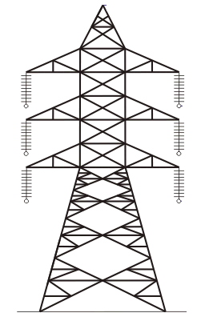

# Mechanical Design of Overhead Line

* + - Main Components of overhead line
      * *Conductors*
      * *Supports*
      * *Insulators*
      * *Cross-arms*

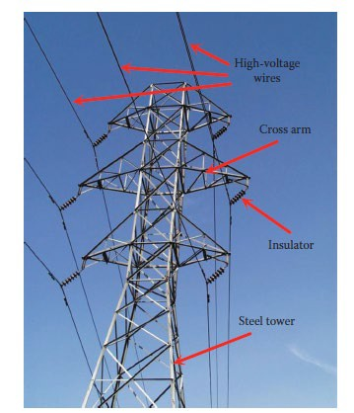

# Mechanical Design of Overhead Line

* + - Main Components of overhead line
      * *Conductors*
      * *Supports*
      * *Insulators*
      * *Cross-arms*



# Mechanical Design of Overhead Line

* + Main Components of overhead line
* *Conductors*: They carry power from sending end station to receiving end station.
* *Supports*: They keep conductors at a suitable level above the ground. (poles or towers).
* *Insulators*: They provide insulation to high voltage wires with metal structure and also provide mechanical support to the conductor.
* *Cross-arms*: They provide support to the insulators.

# Mechanical Design of Overhead Line

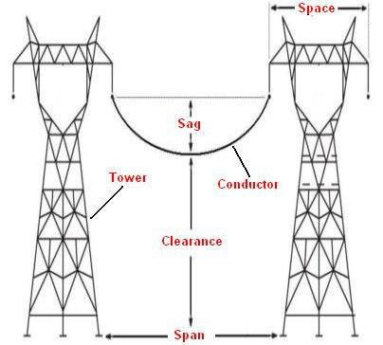

* Parameters of overhead line
  + *Sag*
  + *Space*
  + *Span*
  + *Clearance*

# Mechanical Design of Overhead Line



* Definition overhead line parameters
  + *Sag*: The difference in level between points of supports and the lowest point on the conductor.
  + *Space*: The distance between the conductors on the same tower.
  + *Span*: The distance between two towers.
  + *Clearance*: The minimum distance between the conductor and ground.

# Mechanical Design of Overhead Line ‘Sag and tension calculations’



* The conductors, in overhead transmission lines, are supported at the towers ( or poles for low voltage lines).
* The conductors are pulled and stringing effected. When the conductor is supported in this fashion, it will sag or dip under its own weight and it takes the shape of parabola (Sag << Span).
* The difference in level between the points of supports and the lowest point on the conductor is know as sag.
* For calculating the sag and tension of a conductor, we will consider the following two cases:
  + When supports are at equal levels
  + When supports are at unequal levels



# Mechanical Design of Overhead Line ‘Sag and tension calculations’

### supports at equal levels

Let,

*l*: span length

*w*: weight of conductor per unit length

*T*: tension in the conductor

# Mechanical Design of Overhead Line ‘Sag and tension calculations’



* Consider a point P on the conductor. Its coordinates are x and y, taking O as the origin.
* If the curvature is considered so small that curved length is equal to its horizontal projection, i.e *OP* = *x*, then the forces acting on the portion *OP* are:
  + The weight *wx* of the conductor acting at a distance *x*/2 from *O*
  + The tension *T* acting at *O*

# Mechanical Design of Overhead Line ‘Sag and tension calculations’

* Taking moments of these forces about point P, we get:

*T*  *y*

 *wx* *x*  *y* 

2

*wx*2

2*T*

* The maximum sag (dip) is represented by the value of *y* at either of the supports *A* or *B*.



* At supports *A* (or *B*)*, x* = *l/2* and *y* = *S*

*wl* 2

Sag, *S* 

8*T*

# Mechanical Design of Overhead Line ‘Sag and tension calculations’



* The following factors affecting the sag.
  + *Weight of the conductor*: heavier the conductor, greater will be the sag
  + *Span length*: Sag is directly proportional to the square of the span length
  + *Working tensile strength:* Sag is inversely proportional to Working tensile strength.
  + *Temperature:* Sag increases with increase in temperature.
* In order to reduce the conductor material required and to avoid extra pole height for sufficient clearance above ground level , the sag should be kept to a minimum

# Mechanical Design of Overhead Line ‘Sag and tension calculations’

* Factor of safety
  + Every conductor has certain ultimate strength.
  + If tension increases beyond this value, mechanical failure of conductor occurs.
  + This ultimate strength is called “breaking stress”, while the normal tension is called working stress.
  + The ratio of breaking stress to working stress is defined as a factor of safety,

*F.O.S*:

*F.O.S* 



Breaking stress Working stress

 Ultimate strength

Tension



# Mechanical Design of Overhead Line ‘Sag and tension calculations’

*Example*

***User***

*2021-03-11 18:35:29*

--------------------------------------------

example #1

A transmission line has a span of 240 m. Calculate the sag if the weight of the conductor per unit length 0.578 kg/m, ultimate tensile strength is 5200 kg, and factor of safety is 2.

# Mechanical Design of Overhead Line ‘Sag and tension calculations’

*Solution*

*wl* 2

*S* 

8*T*

*w*  0.578 kg/m

0.578 2402

*l*  240 m

*T*  5200

2

 2600 kg

*S*  8 2600

 1.6 m



# Mechanical Design of Overhead Line ‘Sag and tension calculations’

### supports at unequal levels

Let,

*l*: span length

*h*: difference in levels between two supports

*x*1 : distance of support *A* from *O x*2 : distance of support *B* from *O*

*w*: weight of conductor per unit length

*T*: tension in the conductor



# Mechanical Design of Overhead Line ‘Sag and tension calculations’

### supports at unequal levels

Let,

*l*: span length

*h*: difference in levels between two supports

*x*1 : distance of support *A* from *O x*2 : distance of support *B* from *O*

*w*: weight of conductor per unit length

*T*: tension in the conductor

# Mechanical Design of Overhead Line ‘Sag and tension calculations’

*wx* 2 *wx* 2

* Now,

Sag, *S*1

 1 , 2*T*

*S*2  2

2*T*

*wx* 2

*wx* 2

*w*  2

2  *w*   

*wl*  

*h*  *S*2

− *S*1  2  1

2*T* 2*T*

*wl*

1

2

*x*  *x*  2*Th*

 2*T x*2

* *x*1

 2*T x*2

* *x*1

*x*2  *x*1  2*T*

*x*2  *x*1



* + Also,

*l* *x*1 *x*2

*h*  *wl*

2*T*

*x*2

− *x*1  

# Mechanical Design of Overhead Line ‘Sag and tension calculations’

* + Solving for *x*1 and *x*2, we get

*x*1 *x*2

 *l*  *Th*

2 *wl*

 *l*  *Th*

2 *wl*



* and, after finding *x*1 and *x*2, The values of *S*1 and *S*2 can be calculated.

# Mechanical Design of Overhead Line ‘Sag and tension calculations’



***User***

*2021-03-11 18:54:59*

--------------------------------------------

Example #2

*Example*

A transmission line conductor crossing a river is supported from two towers at heights of 30 m and 80 m above the water level. The horizontal distance between the towers is 450 m. If the tension in the conductor is 1500 kg and weight of the conductor is 1.4 kg/m length, find the minimum clearance of the conductor and water and then calculate the clearance mid-way between supports.

# Mechanical Design of Overhead Line ‘Sag and tension calculations’

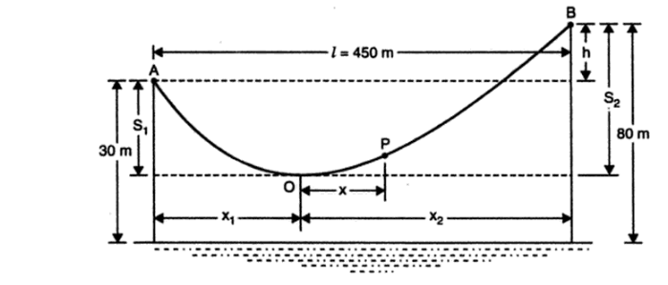

*Solution*

# Mechanical Design of Overhead Line ‘Sag and tension calculations’

*h*  80  30  50 m

*x*  *l*

* *Th*

 450

− 1500  50

 106 m

1 2 *wl* 2 1.4  450

*x*  *l*

* *Th*

 450

 1500  50

 344 m

2 2 *wl* 2 1.4  450

Sag, *S*1

 1.4 1062

2 1500

 5.24 m

clearance 



30  5.24 

* 1. m

# Mechanical Design of Overhead Line ‘Sag and tension calculations’

Let the mid-point *P* be at distance *x* from *O*, then

*x*  *l*  *x*

 450

106

 119 m

2 1 2

Sag at the mid-point *P*,

*Smid*

 *wx*2

2*T*

 1.4 1192

2 1500

 6.61 m

Clearance at the

mid - point

*P*  *Smid*

* Clearance at *O* 

 6.61



24.76

 31.37 m



# Mechanical Design of Overhead Line ‘Sag and tension calculations’

***User***

*2021-03-11 19:19:58*

--------------------------------------------

Example #3

*Example*

* + - An overhead transmission line at a river crossing is supported from two towers at heights of 40 m and 90 m above water level, the horizontal distance between the towers being 400 m. If the working stress is 2000 kg, find the clearance between the conductor and water at a point mid-way between the towers. Weight of conductor is 1 kg/m.

*Solution*

# Mechanical Design of Overhead Line ‘Sag and tension calculations’

*h*  90  50 

40 m, *T*

 2000

kg, *l*

 400 m, *w*

 1 kg/m

*x*1 



*x*2 

*l*  *Th*

2 *wl*

*l*  *Th*

2 *wl*

 400 

2

 400 

2

2000  40

1 400

2000  50

1 400

 50 m

 450 m

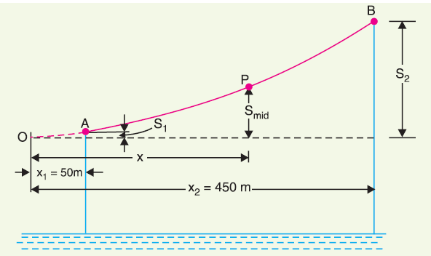

# Mechanical Design of Overhead Line ‘Sag and tension calculations’

Mechanical Design of Overhead Line ‘Sag and tension calculations’

* Now *x*2 is the distance of higher support *B* from the lowest point *O* on the conductor, whereas *x*1 is that of lower support *A*. As the span is 400 m, therefore, point *A* lies on the same side of *O* as *B*
* Horizontal distance of mid-point *P* from lowest point *O* is

*x*  Distance of



*A* from *O*  *l*

2

 50 

400

2

 250 m

# Mechanical Design of Overhead Line ‘Sag and tension calculations’

* Sag at point *P*,
* Now, *S*1 and *S*2

*Smid*

 *wx*2

2*T*

 1 2502

2  2000

 15.6 m

2

*wx*

*S*1  1 

2*T*

1 502

2  2000

 0.625 m

2

*S*2  2 

*wx*

2*T*

1 4502

2  2000

 50.625 m

# Mechanical Design of Overhead Line ‘Sag and tension calculations’

* Height of point *B* above mid-point

 *S*2

* *Smid*

 50.625 15.6

 35.025 m

* + Clearance of mid-point *P* above water level

 90  35.025  54.975 m

* + or, clearance of mid-point *P* above water level

 40  *S*1



* *Smid*

 40  0.625 15.6

 54.975 m

# Mechanical Design of Overhead Line ‘Sag and tension calculations’



***User***

*2021-03-11 19:36:52*

--------------------------------------------

Example #4

*Example*

A transmission line over a hillside where the gradient is 1 : 20, is supported by two 22 m high towers with a distance of 300 m between them. The lowest conductor is fixed 2 m below the top of each tower. Find the clearance of the conductor from the ground. Given that conductor weight 1 kg/m and the allowable tension is 1500 kg.

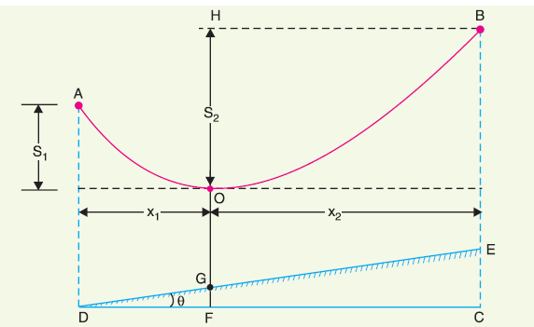

*Solution*

# Mechanical Design of Overhead Line ‘Sag and tension calculations’

Mechanical Design of Overhead Line ‘Sag and tension calculations’

* + The conductors are supported between towers *AD* and *BE* over a hillside having gradient of 1 : 20.
  + The lowest point on the conductor is *O* and sin *θ* = 1/20.
  + The Effective height of each tower (*AD* or *BE*)

 22  2 

20 m

* Vertical distance between towers is 1

*h*  *EC*

 *DE* sin**

 300

20

 15 m

* Horizontal distance between two towers is

*DC*    300 m

*DE* 2  *EC* 2

3002 152

# Mechanical Design of Overhead Line ‘Sag and tension calculations’

*h*  15 m, *T*

 1500

kg, *l*

 300 m, *w*

 1 kg/m

*x*1 



*x*2 

*l*  *Th*

2 *wl*

*l*  *Th*

2 *wl*

 300

2

 300

2

− 1500 15 1 300

 1500 15 1 300

 75 m

 225 m

# Mechanical Design of Overhead Line ‘Sag and tension calculations’

Sag, *S*2

2

 2 

*wx*

2*T*

1 2252

2 1500

 16.87 m

*wx*2

1 752

*BC* 

*BE*  *EC*

 20 15

 35 m

Sag, *S*1

 1 

2*T*

2 1500

 1.875 m

clearance  *OG* 

*HF*  *S*2

* *GF* 

clearance  *OG* 

*AD*  *S*1

* *x*1

tan** 

 *BC*

* *S*2
* *x*1

tan** 

 20 1.875  75 0.05

 14.38 m

 35 16.87  75 0.05  14.38 m

# Mechanical Design of Overhead Line ‘Sag and tension calculations’



### Effect of wind and ice loading.

* + - The previous formulae for sag are true only in still air and at normal temperature when the conductor is acted by its weight only.
    - However, in actual practice, a conductor may have ice coating and simultaneously subjected to wind pressure.
    - The weight of ice acts vertically downwards *i.e.*, in the same direction as the weight of conductor.
    - The force due to the wind is assumed to act horizontally *i.e*., at right angle to the projected surface of the conductor.
    - Hence, the total force on the conductor is the vector sum of horizontal and vertical forces of both wind and ice.

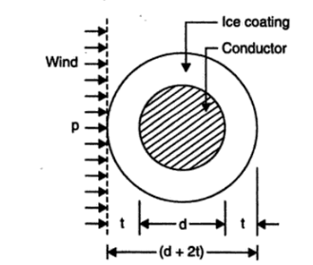

# Mechanical Design of Overhead Line ‘Sag and tension calculations’

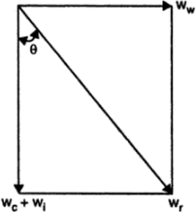

Mechanical Design of Overhead Line ‘Sag and tension calculations’

* + Total weight of conductor per unit length, *wt*, is given by:

*w*

2

2

*wt* 

*wc*

* *wi*   *w*

where

*wc* : weight of

conductor

per

unit

length

*wi* : weight of

ice

per

unit

length

*ww* : wind



force

per

unit

length

# Mechanical Design of Overhead Line ‘Sag and tension calculations’

* + Weight of conductor per unit length

*wc* : conductor

material density  volume per

unit

length

* + Weight of ice per unit length

*wi* 

density of

ice  volume per

unit

length

*wi*  density of

ice  **

4

*d*

 2*t* 2  *d* 2 1 

 density of

ice **

*t**d*

 *t* 1,

*t* : radial

thickness of

ice coating

# Mechanical Design of Overhead Line ‘Sag and tension calculations’

* + Wind force per unit length

*ww* 

wind

pressure per unit

area  projected

area

per

unit

length

*ww* 

wind

pressure  *d*

 2*t* 1

# Mechanical Design of Overhead Line ‘Sag and tension calculations’

* + When the conductor has wind and ice loading also, the following points may be noted
    - The conductor sets itself in a plane at an angle *θ* to the vertical where

tan**  *ww*

*wc*  *wi*

*w l* 2

* + - The slant sag in the conductor is given by: *S*  *t*



8*T*

* + - Hence *S* represents the slant sag in a direction making an angle *θ* to the vertical*.*

The vertical sag  *S* cos**

# Mechanical Design of Overhead Line ‘Sag and tension calculations’



***User***

*2021-03-11 21:00:27*

--------------------------------------------

example #5

*Example*

A transmission line has a span of 150 m between level supports. The conductor has a cross-sectional area of 2 cm2. The tension in the conductor is 2000 kg. If the specific gravity of the conductor material is 9·9 gm/cm3 and wind pressure is 1·5 kg/m length,

* Calculate the sag.
* What is the vertical sag?

# Mechanical Design of Overhead Line ‘Sag and tension calculations’

* + Span length, *l* = 150 m;
  + Working tension, *T* = 2000 kg
  + Wind force/m length of conductor, *ww* = 1·5 kg
  + Weight of conductor/m length,

*wc* 

sp. gravity  volume of

1 m conductor 

 9.9  2 100

 1980 gm

 1.98 kg

* + Total weight of 1 m length of conductor is

*w*

*w*





*c w*

*wt* 



2 2 1.982

1.52

 2.48 kg

# Mechanical Design of Overhead Line ‘Sag and tension calculations’

* + - The angle *θ*

**  tan1 *ww*

*wc*

 tan1

1.5

1.98

 37.23

* The slant sag

*w l* 2

2.481502

*S*  *t* 

8*T*

8 2000

 3.48 m

* The vertical sag*.*

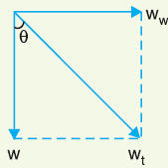

vertical sag

 *S* cos**

 3.48 cos 37.23

 2.77 m

# Mechanical Design of Overhead Line ‘Sag and tension calculations’



***User***

*2021-03-11 21:44:48*

--------------------------------------------

Example #6

*Example*

A transmission line has a span of 200 m between level supports. The conductor has a cross-sectional area of 1·29 cm2, weight of conductor is 1170 kg/km and has a breaking stress of 4218 kg/cm2. Calculate the sag for a safety factor of 5, allowing a wind pressure of 122 kg per square meter of projected area. What is the slant and vertical sags?

# Mechanical Design of Overhead Line ‘Sag and tension calculations’

* + Span length: *l* = 200 m
  + Working tension:

*T*  42181.29

5

 1088 kg

* + Weight of conductor/m length:

*wc* 

1170  1.17 kg

1000



* + Diameter of conductor:

*d*    1.28 cm

4  area

**

4 1.29

**

# Mechanical Design of Overhead Line ‘Sag and tension calculations’

* + Wind force/m length of conductor:

*ww* 

pressure  projected

area in m2

 122  1.28102

1 1.56 kg

* + Total weight of 1 m length of conductor is

*w*

*w*





*c w*

*wt* 



2 2 1.172

1.562

 1.95 kg

# Mechanical Design of Overhead Line ‘Sag and tension calculations’

* + - The angle *θ*

**  tan1 *ww*

*wc*

 tan1 1.56

1.17

 53.13

* The slant sag

*w l* 2

1.95 2002

*S*  *t* 

8*T*

81088

 8.96 m

* The vertical sag*.*



vertical sag

 *S* cos**

 8.96 cos 53.13

 5.37 m

# Mechanical Design of Overhead Line ‘Sag and tension calculations’



*Example*

***User***

*2021-03-11 21:52:36*

--------------------------------------------

example 7

* + A transmission line has a span of 275 m between level supports. The conductor has an effective diameter of 1·96 cm and weight of 0·865 kg/m. Its ultimate strength is 8060 kg. If the conductor has ice coating of radial thickness 1·27 cm and is subjected to a wind pressure of 3·9 gm/cm2 of projected area, calculate sag for a safety factor of 2 if the weight of 1 cm3 of ice is 0·91 gm.

# Mechanical Design of Overhead Line ‘Sag and tension calculations’

* + Span length: *l* = 275 m
  + Working tension:

*T*

 8060 

2

4030 kg

* + Weight of conductor/m length:

*wc* 

0.865 kg

* Diameter of conductor:

*d*  1.96 cm

# Mechanical Design of Overhead Line ‘Sag and tension calculations’

* Ice coating thickness:

*t*  1.27 cm

* Volume of ice per meter length of conductor

 * t**d*

 *t* 1  **

1.27  1.96 1.27100

 1288 cm3

* Weight of ice per meter length of conductor is

*wi* 



0.911288

 1172 gm

 1.172 kg

# Mechanical Design of Overhead Line ‘Sag and tension calculations’

* Wind force/m length of conductor:

*ww* 

pressure  projected area in m2

*ww*  pressure  *d*  2*t* 100

 3.9  1.96 

2 1.27100 1755 gm

 1.755 kg

* Total weight of 1 m length of conductor is

*w*

2



2

*wt* 



*wc*

* *wi*   *w*

0.865 1.1722

1.7552

 2.688 kg

# Mechanical Design of Overhead Line ‘Sag and tension calculations’

* The angle *θ*

** 

tan1 *ww*

 tan1

1.755

 40.75

*wc*  *wi*

0.865 1.172

* The slant sag

*w l* 2

2.688 2752

*S*  *t* 

8*T*

8 4030

 6.3 m

* The vertical sag*.*



vertical sag

 *S* cos**

 6.3cos 40.75 

4.77 m