Answer all Questions

1- The truck travels at a speed of 4 m/s along a circular road that has a radius of 50 m. For a short distance from s = 0, its speed is then increased by where s is in meters. Determine its speed and the magnitude of its acceleration when it has moved s = 10 m.
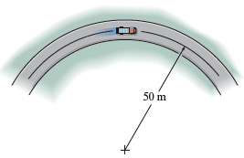

2- The path of motion of a 5-lb particle in the horizontal plane is described in terms of polar coordinates as r = (2t+1) ft and θ = (0.5t² − t) rad, where t is in seconds. Determine the magnitude of the unbalanced force acting on the particle when t = 2 s.

3- Determine the velocity of the 60-lb block A if the two blocks are released from rest and the 40-lb block B moves 2 ft up the incline. The coefficient of kinetic friction between both blocks and the inclined planes is μ_{k} = 0.10.
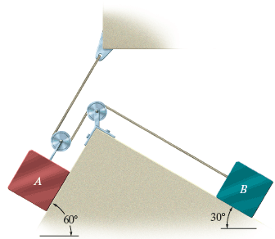
4- A boy A having a weight of 80 lb and a girl B having a weight of 65 lb stand motionless at the ends of the toboggan, which has a weight of 20 lb. If A walks to B and stops, and both walk back together to the original position of A, determine the final position of the toboggan just after the motion stops. Neglect friction.
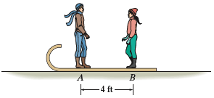

5– The 10-lb block is originally at rest on the smooth surface. It is acted upon by a radial force of 2 lb and a horizontal force of 7 lb, always directed at 30° from the tangent to the path as shown. Determine the time required to break the cord, which requires a tension T = 30 lb. What is the speed of the block when this occurs? Neglect the size of the block for the calculation.
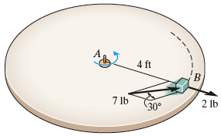

6- The two hockey pucks A and B each have a mass of 250 g. If they collide at O and are deflected along the colored paths, determine their speeds just after impact. Assume that the icy surface over which they slide is smooth. Hint: Since the y′ axis is not along the line of impact, apply the conservation of momentum along the x′ and y′ axes.

7- The collar has a mass of 30 kg and is supported on the rod having a coefficient of kinetic friction μ_{k} = 0.4. The attached spring has an unstretched length of 0.2 m and a stiffness k = 50 N/m. Determine the speed of the collar after the applied force F = 200 N causes it to be displaced s = 1.5 m from point A. When s = 0 the collar is held at rest.
