**Experiment No. (4)**

**Air Conditioning Unit**

**Introduction** :

Air conditioning unit ETG20 from GUNT simulates an actual AC unit. It can provide , conditioned air at preset conditions of temperature and relative humidity. The unit as shown in figure 1 contains the main components of a commercial AC unit: rectangular ducts that include a filters, fan, cooling coil, heating coil, humidifier, air registers, grills, and dampers.

The unit can be operated manually or on automatic mode; in the automatic mode the operator specifies the output air temperature and relative humidity, then the unit will run such that those conditions are reached. In the manual mode the, operator can select the fan speed, heating rate (kW), steam humidifying setting then the air temperature and humidity at inlet and exit will be read from the control screen.

**Objectives:**

The AC unit is a real size system, the main objective is to train student on the operation of the AC unit.

Specific objectives of these experiments are:

• Identify components of an AC system

• To see types of air grilles and distribution systems.

• Operate an AC system

• Control of an AC system

• Manually operate of an AC system

• Use the Psychometric chart and find air properties

• Understand basic air conditioning processes

• Carry out AC processes and present on Psychometric chart

• Perform heating and cooling calculations

• Perform steam addition and condensation calculations

• Experience the control of air flow and distribution in an AC system.

**System description**

**Figure 1 shows schematic of the AC unit and the main parts of the unit.**

**It is important for the student to become familiar with all the unit components**

**and parts before running the experiments. Check the location of temperature and pressure sensors.**

**e.. I UIIU ·IQ)'UUL**

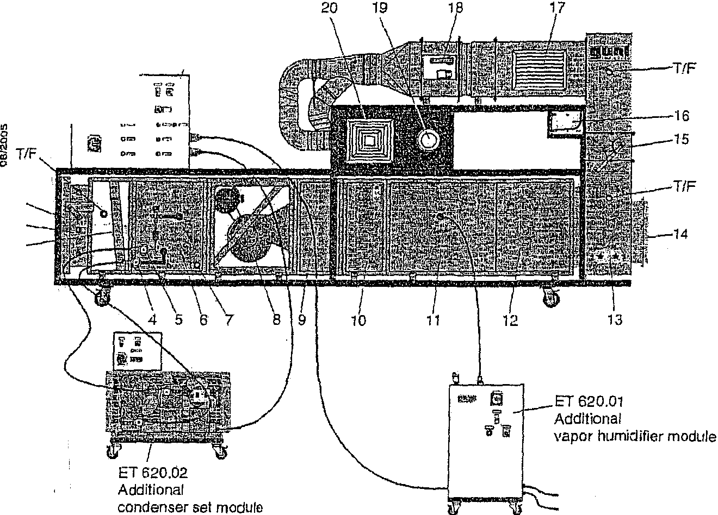21

rGTI 6'51

•=

§ 1

1l 2

I **3**

; ***s·***

*:* **a:l**

'. E

·c>

***!E***

.

*!* -

;..

:,;

. ",.;

£

***l***

. .!!

\ **.c::**

• 0>

;· ;;: -· . -').1 Overall view consisting of ET620 with additional elements ET620.01 and ET620.02

F1g

1 Weather protection grtlle 12 Inspection flap

2 Louvered fiaps 13 Inspection cover

3 Filter 14 Connection flange for an external system

4 Refrigerant entry port 15 Shut-off flap

5 Refrigerant *exit* port 16 Inclined lube manometer

6 Cooling section (evaporator) 17 Ventilation grille

*7* Condensate drain 18 Fire damper

8 Fan 19 Disk valve

9 Flow distributor 20 Ceiling air outlet

10 Heating section 21 Switch cabinet

11 Humidification section T/F Openings for combined sensors

Temperature/Humidity

**Figure 1**

**Figure 2 shows the vapor compression refrigeration unit which provides the cooling coil with the cooling effect. Figure 3 shows the main control board with read outs and selection knobs and light signals.**

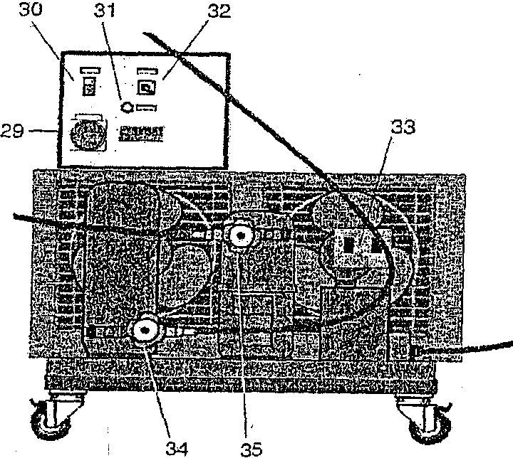

Fig. 2.2 ET620.02 Zusatzmodul

VeriiOssigersatz

**Figure 2**

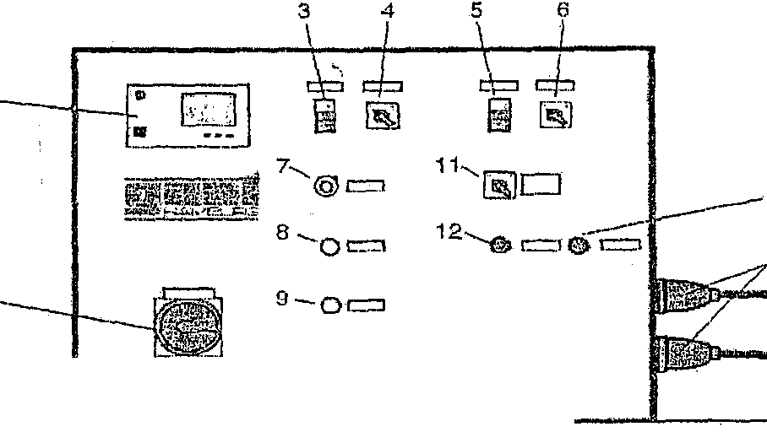

2

29 Main switch

30 On/off switch

31 Indicators

32 Manual/Auto changeover switch

33 Overpressure switch

34 Refrigerant return flow, vacuum side

35 Refrigerant outlet, high pressure side

15

16

13·-c!ll=

10-0= 14--@' =

**Main switch**

2 Controller

3 Fan push button

4 Fan operating mode changeover switch

5 Heater push button

6 Heater operating *mode* changeover switct1

7 Fan speed setting knob

8 Indicator lamp, minimum air flow achieved

9 Indicator lamp, humidifier in operation

10 Indicator lamp, condenser set in operation

11 Heater stage selection switch

12 Warning lamp, filter clogged

13 Warning lamp, STW

14 Warning lamp, STB

15 Wal'riing lamp, Fire damper

16 Electrical connections for ET620.01 and ET620.02

**Figure 3**

**Air flow** through the unit could be controlled through the louvered flaps at the duct inlet. Figure 4 shows the setting angle and the corresponding opening percent of the air inlet.

o· 20 40 60 80 90°

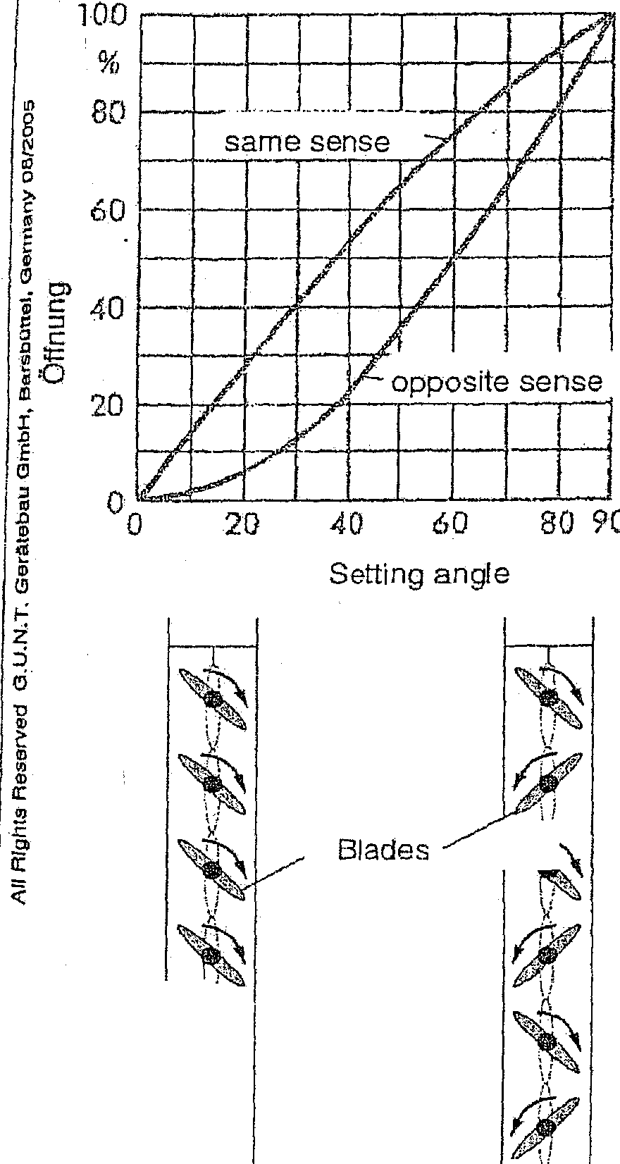

0

Setting angle

:--1

\•

\'·; '

Blades

:.

same sense opposite sense

Fig, 2.4 Opening characteristics of

Iouvered flaps

Figure 4

**Filter** function is to filter out and trap solid and gaseous contaminants in the air. How do you decide if the filter needs to be cleaned or changed ( filter is clogged?)?

**Fan**

Air is circulated through the unit by a draft fan, the fan is variable speed, in the manual mode the setting can be selected, in the automatic mode fan % will be shown in the control screen.

**Cooling section:** cooling is achieved by the refrigerant that runs in the heat exchanger.( evaporator) of the vapor compression refrigeration unit. The used refrigerant is R404a. Condensation can occur if the air is cooled below the dew point? How would you find the dew point of the air drawn into the AC unit?

**Heating section:** Electrical heaters are used to provide the heating. In the manual mode the heating rate can be selected (off, 5kW, lOkW, 15 kW, and

20kW). Unit is provided with a safety temperature feature that turns of the heating coil once the air temperature reaches 75 °C.

**Humidification section**

Steam is provided by the humidifier unit to increase the humidity of the _air. Percent of humidifier can be set in the manual mode, see figure 5.

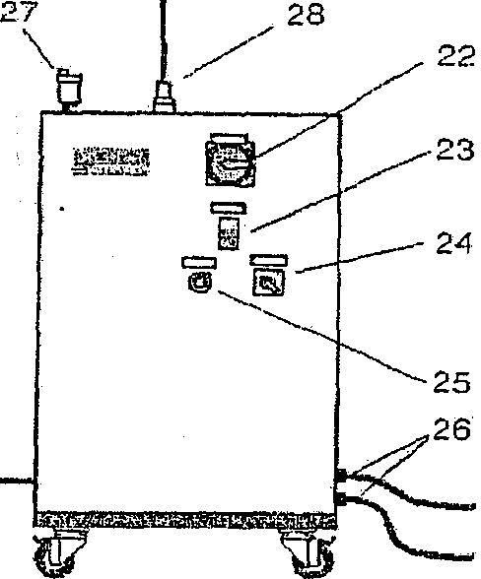

22 Main switch

23 On/off switch

24 Manual/Auto changeover switch

25 Adjusting knob 0...100%

26 Water inlet and water outlet

*27* Automatic bleed valve

28 Spigot for vapor disct1arge

Fig. 2.3 ETE\20.01 Zusatzmodul

Dampfluftbefeuchter

Figure 5

**Grills**

Unit isprovided with wall grills, ceiling grills and disk valve to provide the room with the conditioned air, see figure 1.

**Manometer**

An inclined manometer can measure the pressure difference between the selected points in the duct. Pressure difference may result from pressure losses and friction in the various equipments or as air flows in the duct.

**Operation & Control**

The systems are operated and monitored using the display on the PLC. The process information recorded by the PLC can be called up in the menu structure. ·

The unit can be operated in either manual or automatic modes, the automatic mode is the normal mode of operation, in which all control and regulations runs automatically based on the specified parameters (for example temperature and relative humidity) . All safety features are active.

Manual operating mode: In this case it is possible to influence set point, block of release individual switching and to monitor system status. Manual operation mode should only be run by trained personnel. It is essential to ensure that the associated vanes, valves are open before running the unit.

You can switch from automatic to manual using the switches in the main

controller board.

**Main controller display**

Main menu of the PLC screen include the following functions, selecting the entry and pressing enter key takes you to the next menu.

• Warning alarm

• Setpoint temperature

• Setpoint humidity

• Switch

• Control parameters

• Limit values

• Heater level

• Humidifier

• Language

*Warning alarm:* (no alarm, filter blocked, insufficient flow rate, safety temperature monitor, safety temperature limiter).

*Setpoint temperature:* you can set the temperature of the air in the automatic mode. Adjust the set temperature and then press the Enter key (*), When the set temperature is flashing you can use the ? and ? keys to increase or decrease the set temperature. Press the Enter key to confirm the new v lue.

*Setpoint humidity:* relative humidity percent is set here.

*Switch:* the modes and status of the chiller, fan, heater and humidifier can be set here.

Chiller: auto, off, on. Fan: auto, off, on.

Heater: switched on or off. For the heater on you can select one of

the four levels L1= 5kW, L2 = 10 kW, L3 = 15 kW, L4 = 20 kW. Humidifier: Auto either upper limit or lower limit, or manual mode select ( 0- 100 %).

*Control parameters:* to be set by technician.

*Limit values:*

Supply max air temperature Supply min air temperature Humidity max for inlet

Air temp. Max : maximum ambient air temperature

Air temp. Min : minimum ambient air temperature.

*Heater level: heater* level currently actuated is displayed here.

*Humidifier:* Power currently demanded from humidifier is displayed here.

*Language:* English, German, Spanish or French. . I

i

**Shutdown**

Vapor humidifier:

Switch off the vapor humidifier

Switch off the main switch

Shut off the water supply

Condenser set

Switch off the condenser set

Switch off the main switch

Air conditioner

Switch off the heater

Set the fan speed control knob on zero

Switch off the main switch

**Theoretical Considerations**

Air is considered as a mixture of dry air plus water vapor, properties of this Air-water- vapor mixture is presented in the psychometric chart. As shown in the chart the following properties are included: dry bulb temperature of simply temperature, wet bulb temperature, specific humidity, relative humidity, specific volume, and enthalpy.

Air conditioning processes can be represented in the chart, main processes include: sensible heating or cooling, humidification and dehumidification at constant dry bulb temperature, heating with humidification, and cooling with dehumidification.

Air volume flow rate can be computed from manometer readings (pressure drops) based on Bernoulli's equation as

$$V= \sqrt{2Pv}/ρ$$

Where Pv  is the velocity pressure (difference between total and static pressures. The air density is calculated using ideal gas equation *(p =P/RT* P is the barometric pressure).

If the pitot-tube is located in the center of the duct then the average velocity is 0.9 times the velocity as measured by the pitot-tube.

Airflow = velocity x duct cross section.

Dry air mass flow rate is the air volume rate divided by the specific volume of air as given in the psychometric chart.

Heat transfer across the coil (heating or cooling loads of coil) is given as

Q = mdry air* ( hout - hin)

Where mdry air the mass flow rate of dry air, hout is the air enthalpy after the coil and hin the air enthalpy before the coil.

Amount of condensed or added water vapor can be calculated as, mwater = *(ω2 - ω1*)* mdryair

if *ω2* > *ω1* vapor is added, while if *ω2* < *ω1* then vapor has condensed.

Note that the enthalpy of air mixture is based on, h = hair + *ωh*vapor

hair = Cp T , while hvapor is taken as the saturated vapor enthalpy hg

**Experimental part:**

**1) Air conditioning processes**

In this part the AC unit to be operated on the manual mode under the supervision of the lab technician. In this part you carry out the processes as required by the instructor, you record all the readings inlet and outlet air temperature and relative humidity, manometer reading, fan speed etc.....

The AC processes include the following:

**a. Sensible heating**

Cooling coil is off, heater at 5 kW, humidifier is off.

Operate the unit for about one hour or until steady state is reached.

I) Describe the air conditioning process.

2) Plot your results as temperature and relative humidity at inlet and exit.

3) Locate inlet and exit conditions at steady state on the psychometric

chart and the heating process.

4) Find all air properties from the chart (wet bulb temperature, specific humidity, enthalpy, specific volume).

5) Calculate per kg. dry air the heat added to the air, estimate the air velocity from such data, and compare it with the measure values from the manometer.

b. **Sensible cooling**

Heater is off, humidifier is off, for full opening of air inlet flaps; operate the AC system for 80 minutes or until steady state is reached, recording inlet, exit temperatures, and humidity every 5 minutes.

1) Note the transient behavior of the system, by plotting above variables versus time.

2) Explain the trends of relative humidity at inlet and exit.

3) Show inlet and exit states on the chart, then find all properties (wet bulb temperature, specific humidity, enthalpy, specific volume).

4) Calculate the air velocity and volume and mass flow rates from manometer readings.

5) Calculate the cooling per kg of dry air, plot cooling load versus time.

6) At steady state show process on the chart and compare it with expected one, explain the difference.

**c. Constant temperature humidification**

Cooler is off, heater is off, air flow at full setting, humidifier is on at

30%, then record inlet and exit conditions for 80 minutes or until reaching steady state.

1) Plot your results versus time, comment on the curves.

2) Locate inlet and exit points on the psychometric chart and find

\ value of all other properties and present in a table (for time greater·

than 60 minutes).

3) Show processes on the psychometric chart, describe the process.

4) Calculate the amount of added vapor per kg of air.

**d. Heating with Humidification**

Cooler is off, full air flow rate, heater rating 5 kW, for humidifier

selections at 20% record all values for air inlet and exit. Operate for 1 hour

1) From the psychometric chart find value of all properties and

present in table.

2) Show all conditioning processes on the chart.

3) Calculate per kg of dry air heat added to air and vapor added to air.

**e. Cooling with dehumidification**

Heater is off, humidifier is off, air flow at full rate, and cooling is on, then operate the AC unit recording inlet and exit conditions ( every 5 minutes) till vapor condensate flows out of the system.

1) Show inlet and exit states on the chart and find value of all properties. Show processes on the chart.

2) What is the dew point of the air, does it agree with the experimental

results?

3) Calculate the amount of condensed vapor.

**e. Dehumidification and heating**

Operate the AC unit manually from inlet air conditions to achieve comfort conditions of 50% relative humidity and dry air bulb temperature of 20 °C.

1) On the psychometric chart locate the inlet and exit conditions.

2) Discus you procedure with instructor before carrying it out.

3) Record all settings and data during experiment.

4) Suggest another approach to achieve the same comfort conditions.

**2) Effect of air flow**

Air flow rate through the system can be changed by either changing the louvered flaps opening or by changing the fan speed. When operated on the auto mode you cannot control the fan speed it will be set by the PLC.

1) Repeat run as specified by your instructor using three different louvered flaps openings.

2) Read manometer and calculate air velocity then volume ( in CFM) and mass flow rates.

3) Find air properties from chart at inlet and exit,

4) Carry out the calculations for the coils.

5) Show theeffect of air flow rate on the air conditioning process by plotting cooling loads, specific humidity versus air flow rate.

Air Conditioning System

Data Sheet

Time T1 I FI I T2 F2 Pressure !

I

I I

I I I

I

!

I

!

I I

I

I

I

I I

I

I

I

I

I

I

I

I

I

I I