***EXPERIMENT No.(2a)***

***CHARACTERISTICS OF AXIAL MACHINES***

***INTRODUCTION :***

The universal Axial flow machines apparatus has been designed to enable students to study the performance of an axial flow machine of variable blade angle in both the pump and turbine modes of operation with water as the operational fluid. The design of the apparatus is such that the visual effects of blade cavitation could easily be seen.

In axial flow machines, the flow is in the direction of the axis of rotation. The given apparatus can be operated either as an axial flow pump or an axial flow turbine . This depends upon the machine gives power to the fluid *(PUMP)* or the fluid gives power to the machine *(TURBINE)* .

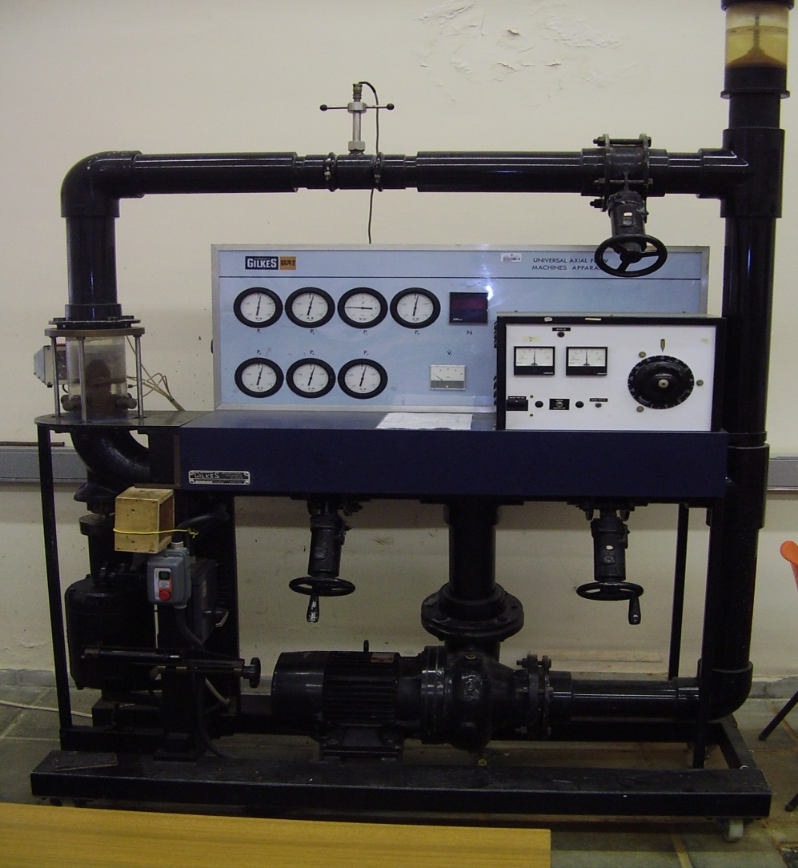

*Figure (1) Axial Pump*

***Pump operation :***

The blade angle () and diffuser blade angle () can be changed as follows :

***ROTOR ANGLE () degrees DIFFUSERANGLE () degrees***

10 +10 , -10

30 +10 , -10

Set α = 10 and β = +10

1. For operating as a pump , open valves 1, 2 and 3.
2. Operate the pump at a certain speed (N1) rpm. Record Q, the various pressures, the Torque force ( After balancing the dynamometer ) .
3. Change the discharge by valve (1) and return the speed to the same N1, record pressures, Q, Torque .
4. Repeat the previous procedure two times changing N.
5. Change angles as given below

α β

10 +10 , -10

30 +10 , -10

***Pump efficiency :***



Torque T = 0.178 F N.m

 where P7 & P1 are in bars

Angular velocity = 2N / 60 rad/s.

1. Draw the characteristics curve for the pump ( H - Q ), plot efficiency versus Q on the same graph.
2. Comment on the effect of α , β on characteristics curves.

***Pressures :***

P1 : Pump inlet / Turbine outlet.

P2 : Pump nose / Turbine exit.

P3 : Blade inlet ( Pump ) / Blade outlet ( Turbine ).

P4 : Blade center.

P5 : Blade outlet ( Pump )/ Blade inlet ( Turbine ).

P6 : Diffuser inlet ( Pump ) / Guide vanes ( Turbine ).

P7 : Pump outlet / Turbine inlet.