Internal combustion engine
Experiment # 11 Diesel engine
Apparatus: Diesel test bed/ ICE lab

Objectives:

Overall objective is to test the performance of the Diesel engine. Specific objectives of the experiment include:

- Get to know main components of a diesel engine
- Measure torque and power of engine
- Measure fuel consumption of engine
- Calculate the specific fuel consumption of engine
- Plot torque and power curves versus engine speed
- Measure the air consumption
- Calculate air fuel ratio
- Calculate thermal efficiency of the engine.

Apparatus description:

The main components of the test bed are:
Universal support frame
Hydraulic dynamometer
Control pane; for air and fuel flow measurements
Water cooling system
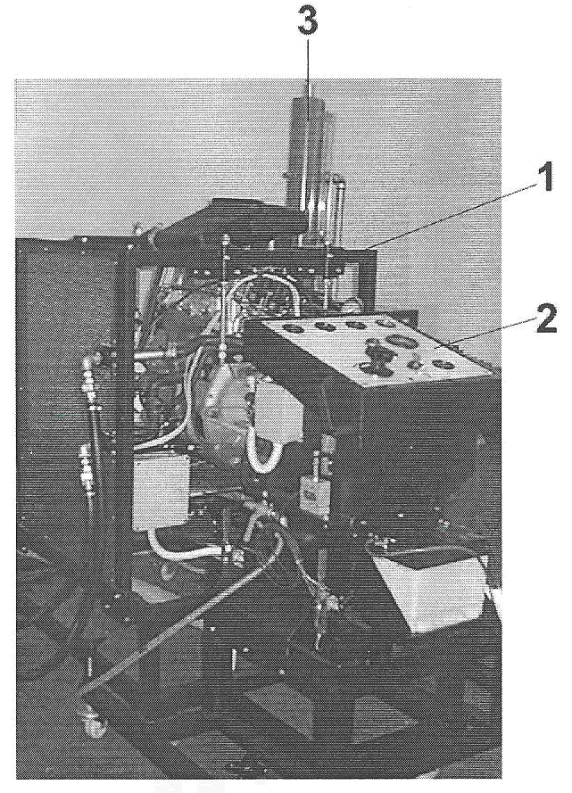

Figure 1 Diesel test bed.

3.1 Universal support frame consists off:
Support frame for test engine
Electrical cable connector
Engine tested
Braking system
Load cell
Exhaust manifold

3.2 Hydraulic dynamometer
Hydraulic dynamometer is made up of a dynamometer, wheel –mounted support frame and a control panel. It can be coupled to the test engine regardless of its type.

3.3 Control panel
As shown in figure it includes
Coolant temperatures
Oil temperature
Oil pressure
Vacuum meter
Braking action
Key operated ignition

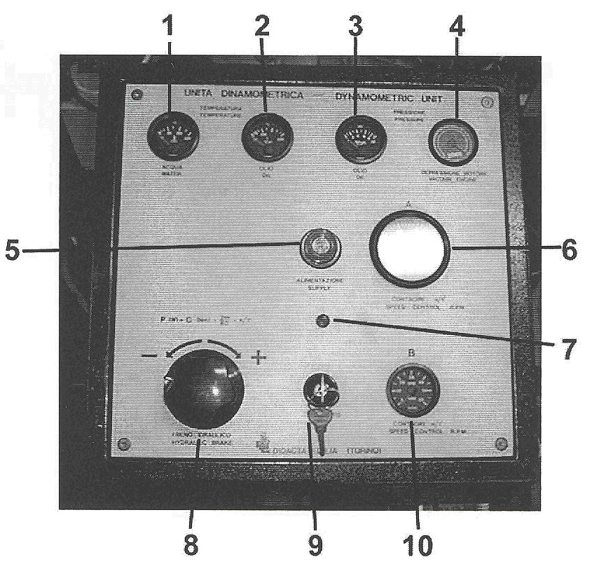
Figure 2 Control panel.

3.4 Water cooling system
The water cooling system keeps the water temperature below some set temperature with the aid of a thermostat controlled valve. The valve opens enabling cold water to flow into the column and mix with the contained water resulting in decreasing the temperature.

3.5 Air flow and fuel flow measuring system
The air and fuel flow measuring system makes it possible to determine the quantities of air and fuel consumed by the engine.

Air flow is measured by means of a manometer and a calibrated flange and orifice, the air flow as volume or mass flow can be read from the chart based on the manometer reading.

The fuel flow is measured by means of graduated burette. The quantity of used fuel by the engine is determined by dividing quantity of fuel consumed by the time it takes to consume this fuel quantity. When timing the fuel consumption close the valve that supplies diesel from the tank.

4. Starting the engine testing system

Check the functionality of the coolant circuit
Check the functionality of the fuel circuit
Check the functionality of the electrical connections
Check the functionality of the battery
Check the oil level
Check the fuel level
Check the water level
Start the cooling water
Adjust the water flow rate to 200-300 liter/hour
Open the fuel feed
Turn on the data acquisition unit
Start the motor by turning the key in the control panel
Set the throttle valve at minimum.

Apply small load by means of the hydraulic brakes to adjust engine speed to 1500 rpm.
Check the thermostat controlled valve on the cooling system setting 85-90 ºC.

When temperature of water reached operating value you can start the testing process.

Make sure when the oil in the sump reaches and exceeds the operating temperature the cooling fan located under the engine turns on.

Experimental procedure

- Start the engine and take it to the required temperature. (as explained above)
- Set the throttle valve at value specified by instructor (5, 12.5, 25, ), decrease the breaking torque to the minimum so to obtain highest possible rotation speed.
- Record the torque and the rpm read the manometer and convert it to volume and mass flow rates using the curves on the panel.
- Close the tank valve and time the consumed fuel.
- Increase the braking torque so to decrease the rpm in steps of 100 rpm each time (or as asked by instructor) recording: torque, rpm, air flow and fuel consumption, continue till maximum torque is reached.
- Now gradually decrease the load to obtain an increase in the rpm again in steps of 100 recording the rpm and the torque, air flow, and fuel flow until reaching the minimum torque.
- Repeat the experiment at another two throttle valve settings.
- Measure temperature and pressure in the lab.

Theory

Power P can be calculated from the torque and the angular velocity as:

P = M* n / 9549.3
Where power in kW, torque in Nm, n in rev/minute

Fuel measurement is carried out by measuring time interval taken to consume known volume of fuel as,

C = (V/t)ρ

Where V fuel volume read from the burette
t time as measured by stop watch.
ρ fuel density

Specific fuel consumption is calculated as fuel consumption rate divided by power

Air to fuel ratio is calculated as,

AF = air flow rate / fuel flow rate
AF can be mass or mole ratios depending on the units used for flow.

Thermal efficiency is defined as specific output engine power divided by the fuel calorific value.

η =Power/(fuel flow rate * heating value)

Refer to thermodynamic text book for theoretical diesel cycle efficiency.

Analysis & calculations

- Write down in a table: rpm, torque, manometer readings, air volume and mass flow rates, diesel consumed and time for its consumption.
- Calculate the average value at each rpm, and then calculate the power, air fuel ratio, and specific fuel consumption.
- Plot the torque and power versus rpm, and locate the maximum values.
- Plot the specific fuel consumption versus speed for all throttle settings.
- Plot the engine efficiency versus speed for all throttle settings.
- Compare above curves with expected ones (theoretical) and comment on the deviation.
- Convert power to power in standard air (760 mm Hg, 288 K) using the following equation:
P std = P (760/ pressure) * (√ T/288)

