***EXPERIMENT No.(5)***

***PELTON TURBINE TEST***

***INTRODUCTION :***

Turbines are generally classified either as impulsive turbines or as reaction turbines. The Pelton turbine (wheel) is an impulse turbine in that the conversion of the pressure head of the fluid into kinetic energy takes place entirely in the stationary nozzle and the role of the runner is solely to convert this kinetic energy into mechanical work. It consists basically of three components, an inlet nozzle, an impeller and casing.

The water leaves the nozzle at high velocity and strikes the buckets which themselves move in the same direction. The buckets are shaped such that the direction of the fluid`s relative motion is turned through almost 180o. The small angle of drift ( = 4o to 7o) see Fig. 7.1 from the 180o deflection is made to prevent a complete reflection of the water jet so that it would not hit the back of the next following bucket, and hence, prevents reducing it`s speed.

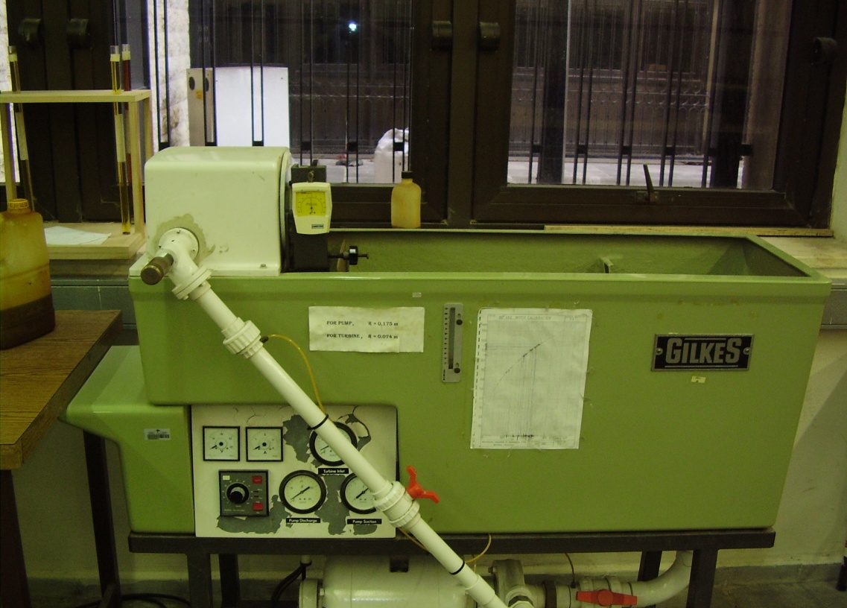

*Figure (1) Pelton Turbine*

***THEORY :***

Applying the momentum equation on the control volume, see Fig.7.2a (assuming steady flow conditions ) the force reduces to



Torque is given by



therefore



where



efflux of moment of momentum across the surface of the control volume [ integrated over the whole surface area of the control volume ].

**r** radial distance between the center of the runner to the point on the bucket where the water jet hits it.

**v** mean velocity of water jet.

dA element of area.

ρ mass density of fluid.

For a unit depth of the bucket the torque delivered by the machine is the integral of equation 7.3 which is the efflux of fluid through the control surfaces. Therefore

T = Q r [ vt1 - vt2 ] ---------(7.4)

where (see Fig. 7.2b)

vt1= vr1 = v1- u tangential velocity of water jet relative to bucket at inlet.

vt2 = vr2 cos(180 - ) tangential relative velocity

= - vr2 cos of the jet leaving the bucket

u = r velocity of bucket.

ω angular velocity of the runner.

Substituting into equ. 7.4 yields

T = Q r vr [ 1 - cos ] --------(7.5)

Input power to the turbine (mechanical power) is given by

P = T = Q r vr [ 1 - cos ] --------(7.6)

The kinetic energy (maximum power) arriving at the wheel is

Pmax = 1/2 Q v12 ----------(7.7)

The hydraulic efficiency of the turbine is given by



where H is the inlet turbine head.

***APPARATUS :***

The apparatus consists of a centrifugal pump that discharges water up to a nozzle at a rate that can be controlled by means of an adjusting knob.

The nozzle forms a water jet and hits the bucket of the runner.

The disc flywheel is connected to shaft of runner.

***EXPERIMENTAL PROCEDURE :***

In order to investigate the characteristic curves for the Pelton turbine, the head supplied by the centrifugal pump should be maintained const., either by use of the throttle valve or by variation in supply pump speed. The turbine load and speed are varied, using the brake assembly, for constant inlet head at various guide vane or spear settings. A suggested inlet head is 14m with guide vane or spear settings -

Full, 7/8, 3/4, 1/2, 3/8, 1/4 and 1/8 open and turbine speeds varied in increments of 250 rpm.

The reading of flow quantity, turbine speed and torque should be recorded at varying speeds. This should be repeated at alternative guide vane or spear settings.

***QUESTIONS :***

1. Plot curves Q vs N rpm for constant turbine head H = 14m.
2. on the same graph paper show the efficiency curves.