***EXPERIMENT No.(3a)***

***PETROL ENGINE***

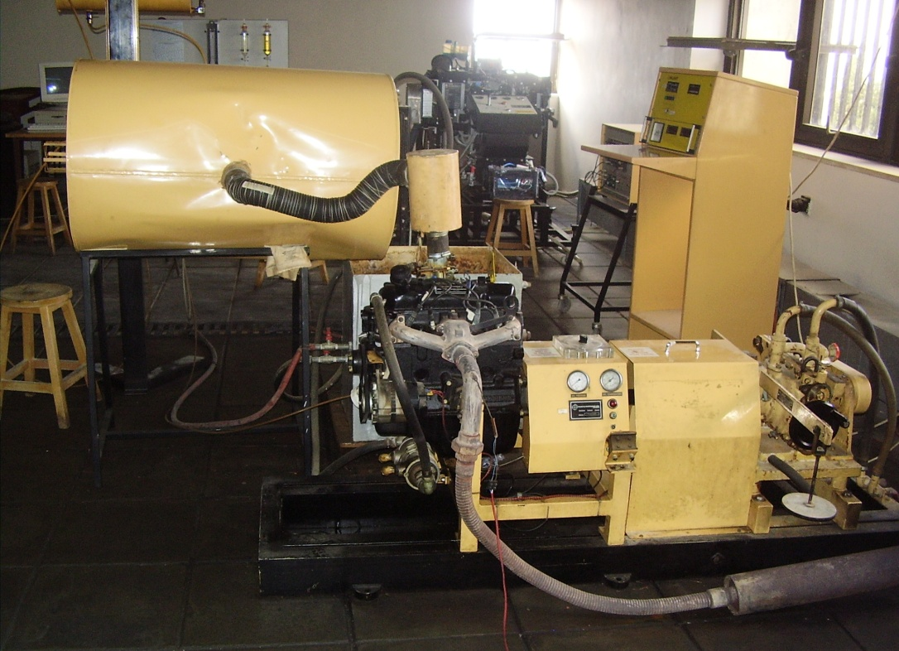

*Figure (1) Petrol Engine*

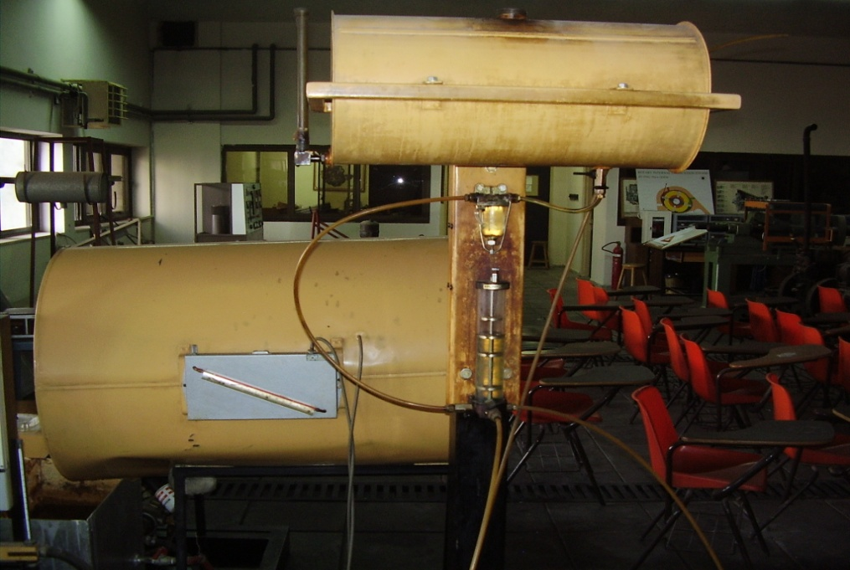

*Figure (2) Fuel for Petrol Engine*

***1. TORQUE AND POWER - SPEED CHARACTERISTICS CURVES***

Particularly in the case of automobile spark-ignition engines , the full-throttle (maximum power) torque-speed curve is of interest, as showing one of the most important characteristics of the engine in terms of vehicle performance, and illustrating the effect of volumetric efficiency (breathing capacity) on output .

To obtain the characteristic, the engine should be warmed up at full throttle opening and at some speed around the mid point of its range.

Adjust mixture strength and where applicable timing, to give maximum torque. Increase dynamometer loading to reduce engine speed to the lowest value at which the engine will run smoothly. Where applicable adjust spring balance level to bring torque arm pointer into line with the fixed pointer on dynamometer casing and record speed, preferably by counter and stop watch. While the speed is being measured make several observations of spring balance reading and record average value.

The rate of doing work, or power, is measured in Watts (Newton-meters per second) or kilowatts, and is the product of torque and angular velocity.



where:

P = Power , kilowatts

n = revolutions per minute

Plot Torque and power versus speed. Comment on power curve.

T vs s

P vs s

***2. MEASUREMENT OF AIR FUEL RATIO AND TEMPERATURES***

The Fuel gauge, consists of a glass tube containing four knife-edged spacers. The spacers are so positioned as to contain an accurately calibrated volume of fuel between them.

The test procedure is first to fill the fuel gauge to a level above the top spacer by opening the air vent cock on the top of the gauge. The valve connecting the gauge to the fuel supply is then closed, when the engine draws fuel from the gauge. As the fuel level passes the top spacer a stop watch is set in motion and, with an electrical dynamometer, the revolution counter is engaged. During the fuel consumption the dynamometer spring balance reading is observed and the average value recorded. The measurement may be terminated when the fuel passes any one of the lower spacers, but the duration of the test should not be less than about 50 secs. As the fuel passes the lower spacer the stop watch is arrested and the counter disengaged. Record air flow, cooling water flow rate, inlet and outlet temperatures as well as exhaust gases temperature.

On completion of the test be sure to re-open the valve connecting the fuel gauge with the fuel tank and to close the vent cock, otherwise the engine will run out of fuel.

Fuel consumption is calculated as follows :

V = 3600 VG -------------(2)

t

where:

VG = calibrated volume of fuel gauge, litres

t = time to consume calibrated volume, secs.

V = fuel consumption, litres/hour

Calculate air fuel ratio (A/F). Plot A/F versus speed.

Plot on one diagram Inlet and Outlet water temperatures, exhaust temperature versus speed.

***3. SPECIFIC FUEL CONSUMPTION AND POWER OUTPUT***

An important characteristic of an internal combustion engine is the specific fuel consumption since this gives a measure of the thermal efficiency of the engine. It is defined as follows :

v = V / P ------------(3)

v = specific fuel consumption l/kW.h

Plot specific fuel consumption (s.f.c) versus speed.

Engine performance is usually reported in terms of the ***brake mean effective pressure*** (b.m.e.p.). This is the calculated mean pressure that would have to act upon the pistons during each working stroke to achieve the observed power output if there were no mechanical losses.

The power output of the engine, in terms of the b.m.e.p. is given by :



where :

‾p = b.m.e.p. , kN/m2

Vs = swept volume of engine, litre3

K2 = 2

The swept volume is given by :



where : Engine Type Bore 4.108

d = cylinder diameter, mm : 79.735 mm (3.125 in)

s = piston stroke, mm : 88.9 mm (3.5 in)

N = number of cylinders : 4

Rearranging equation (4) :



Plot b.m.e.p versus speed.