BTC – Historic Centre Regeneration in the West Bank

BUILDING CONSTRUCTION ASSESSMENT for INVENTORYING PURPOSE

*Proposals*

*Corrado Minervini*

Table of Contents

**1** **Inventory: basic concepts 3**

**1.1** **Previous Inventory exercises 3**

1.1.1 The French Inventory form sample 3

1.1.2 Riwaq Inventory Forms 4

**2** **Inventorying Proposals 6**

**2.1** **Baseline Notes 6**

2.1.1 GIS for Inventorying 7

2.1.2 Research Centres Contribution 7

**2.2** **Inventorying: 1st level 7**

2.2.1 Urban Morphologies 8

2.2.2 Historic Value Assessment 8

2.2.3 Damage Assessment 10

**2.3** **Inventorying: 2nd level 11**

2.3.1 Urban Landscape Consistency 11

2.3.2 Building elements and components similarities 15

2.3.3 Construction Stability Analysis 18

2.3.4 Summary and Conclusions 20

***List of Tables***

Table 1: The intervention modes 9

Table 2: Architectural recurrent features 12

Table 3: Classes of importance of architectural features consistency and Recommended Actions 14

Table 4: Example of traditional and new door and window features 15

Table 5: Examples of technical card studying the local architectural features 17

Table 6: Building Construction Stability Analysis 19

Table 7: Damage/Vulnerability Analysis results 20

Table 8: Correlation Consistency / Damage 21

Table 9: Levels of Correlations 22

# Inventory: basic concepts

The Inventory of Cultural Property is a register of cultural and historic property. The overall aim of the inventory is to identify and inform the general public on the heritage of cultural property assets still concealed and mostly unknown. The inventory usually registers both movable and unmovable assets. The movable Cultural Relics are safekept in museums, the unmovable instead are scattered on the territory and the majority of them are private assets, therefore their legal status is legally controversial. All in all, for several reasons, the unmovable assets are at great risk. Their assessment and inventory is needed not only to preserve their memory but also to start an active process from being known and recognized to their preservation and development.

As a matter of facts, in most of cases and most of all for Historic Centres, preservation cannot be effective without development, though the latter could be harmful to preservation if not correctly managed. At the same time preservation without development leads to mummification, in the best cases, or decaying.

The scope of inventorying consists of identifying, analysing and eventually reviewing use and conditions of HCs; taking into account that *Inventories can never be completed or fully updated because (…) intangible cultural heritage is constantly changing and evolving*.[1]

In this light only an incremental inventory concept could keep records of previous inventories and at the same time compare them and add more info in order to get the most detailed data and pave the way to explore potential development opportunities on the basis of the best knowledge of resources.

## Previous Inventory exercises

Inventories are always different and does not exist a standard format for inventory forms. In the 80’s UNESCO published a “Manual on Systems of Inventorying Immovable Cultural Property” (M.H. Sykes, 1982). Nowadays because of the application of new technologies inventorying has gone far beyond, however the objectives are not changed. Namely they are: the knowledge of their existence and condition 8at one hand) and finally the acquisition of CH data to proceed with detailed master plans.

### The French Inventory form sample

In France the Inventory is mandated to sensitize the French general public to their national heritage, and such an objective is reached through expositions produced with survey materials and giving the HCs a leading role within the tourist economic engine.

Historic buildings which merit protection by law are identified and included within the “*Inventaire General des Monuments et des Richess*”. However since all entries cannot be studied to the same degree, two types of entry are made:

* a *pré-inventaire normalise*, which notes all works within its broad selection criteria, and
* the in-depth *inventaire fundamental*, which studies some selected works by means of supporting dossiers of historical research, description and bibliography[2]

Once a preliminary (PIN) entry is made it can be expanded and enriched as new information is found. Storage of data as key words and free text allows the system to be easily understood and interrogated.

The appropriateness and the effectiveness of the French inventory system has inspired the following proposals.

### Riwaq Inventory Forms

In between 1998 and 2003 Riwaq has assessed the majority of the existing historic buildings[3] through a thorough survey of the historic buildings in Palestine. This Registry provides the first complete inventory of the historic buildings in Palestine. The Registry is an encyclopaedia of architectural information on some 50,320 historic buildings in 422 Palestinian localities–16 major cities, including East Jerusalem, and 406 villages throughout the 11 governorates in the West Bank and the 5 governorates in the Gaza Strip[4]. The results were published in the 2004 and are nowadays available on the WEB[5]

The assessment card used was quite comprehensive and based on given categories and weighted evaluations.

Basically the following information was collected:

1. Ownership (private, public, uncertain),
2. Damage level (on the basis of visual observation and evaluation),
3. Existence of vertical or horizontal extension,
4. Number of floors,
5. Roof structure,
6. Building material,
7. House type,
8. Historic info,
9. Floor materials.

A Narrative report (description of façade, openings, building technologies, sketches etc) finally describes the architecture and its surrounding. A building serial number was also linked to each building surveyed.

The information collected were sometimes too detailed vis-à-vis the assessment scope and the use of the assessment. A key information related to the historic value of the building could have created at least two categories of buildings: those with identity value and those with a more peculiar cultural value like artistic or technical[6]. As a matter of fact the “importance of the building”[7] category identifies the “important buildings” sometimes through subjective criteria.

# Inventorying Proposals

The following proposal aims at providing the Local Institutions with a method and a flexible tool to collect data and information on HCs and historic buildings with the specific purpose of using them in the planning and rehabilitation design activity.

The proposed tool is flexible because

1. it is based on an incremental assessment method (further data and datasheets could be added to the EXCEL database)
2. it links with geographic information (GIS) and data are mapped out automatically
3. it is printable in A4 format.

The past inventorying exercise, carried out by Riwaq and RHC (BTC)[8], was very rich and complex. This inventory system capitalizes on the previous experiences and strictly focuses on effective data and information which could immediately lead to:

* Building rehabilitation feasibility vis-à-vis its damage and vulnerability
* Type of rehabilitation required vis-à-vis its historic value and consistency with the historic built environment
* Building rehabilitation cost and economic feasibility vis-à-vis the owner annual capital available for housing investment and loan carrying capacity.

However, complementary with such an effective inventorying tool, which provides the analysis of HBs in view of rehabilitation, a quick survey method is also proposed in order to get an overall picture of the HCs location, condition and value in Palestine.

Summarising two levels of inventorying are described:

1st level: to identify the key features of the HCs in the West Bank (Light Assessment) in order to keep records of all the HCs and eventually classify them according to the historic values of their buildings, the potential residential capacity and the urban morphological features.

2nd level: to analyse in detail all the urban and building features and create a matrix matching the building physical conditions with the historic values, the social and economic resources of the local residents if any.

## Baseline Notes

Both inventorying methods will be using

* fieldwork surveys to collect the needed information[9]
* EXCEL sheets to store information and produce the first set of analysis as described above,
* a key modern tool linking the alphanumeric data to geographic information, namely the GIS[10], and
* the results of researches carried out by Research Institutes on the historic urban fabric and the typical Vernacular Architecture elements and components (§ 2.3.2).

### GIS for Inventorying

GIS will be used

1. to produce the basic maps for the surveyors,
2. to link data to geo-information and map the survey and the analysis,
3. to query the system on building features (like the location of not damaged and empty buildings built in the XV century).

The link between the surveyed building and the GIS alphanumeric database is established when the surveyor first identifies the housing units (buildings and ideally the related parcels, if any) and mark them on a base map issued by the GIS system, together with a temporary ID number. Once the housing units are digitized and linked to their ID, all the surveyed data and information are transferred to the GIS database.

### Research Centres Contribution

The contribution of scholars and research institution to building up an effective inventory system is key.

There are at least three possible research fields in need of support by the local universities (and not only):

1. the study on the urban morphologies features of HCs[11] (§ 2.2.1),
2. the systematic collection and collation of Vernacular Architecture elements and components of the different historic periods,
3. the study on modern materials and technologies that could be used and integrated in the old building structure and urban fabrics[12].

## Inventorying: 1st level

The first level target all the HCs, is complementary with the 2nd level of inventorying and compatible with the RHC survey. Two sets of information are collected:

* at the scale of settlements:
  + urban morphology types
  + first assumption on area and boundary, if not already defined by the Master Plan;
* at the building scale
  + historic values to identify the kind of most likely interventions in buildings and eventually in the HCs
  + number of floors to allow the calculation of the potential inhabitants
  + number of actual inhabitants
  + building units to be digitized on the GIS map and inform on the number of units in the HC
  + level of damage (see § 2.2.3 Damage Assessment).

### Urban Morphologies

Historic centres are to be identified on the basis of scientific research on urban morphologies and historiography. Surely many studies were carried out by local and international scholars on Palestinian HCs. Local universities, with the support of an International Expert could collect and collate all these studies and definitively use homogeneous and consistent criteria for the identification of HCs in Palestine.

Once identified, these urban areas will be immediately subject to regeneration plans whether within Local Master Plans or as stand alone plans managed directly and temporary by the MoLG.

### Historic Value Assessment

The building historic value assessment is usually made in the preliminary phase of a Detailed Urban Plan (DUP) if not done by the National Institutions for the Protection of Monuments. The aim of such an assessment is to identify the most likely approach and treatment adequate to the assessed historic value of the building as shown in the table below.

|  |  |  |
| --- | --- | --- |
| *Cultural values* | *Comments* | *Intervention Mode* |
| Identity | The identity value is expressed by the architectural common and plain attributes typical of the Vernacular Architecture. The identity value is the value, which links the local culture to the basic building construction mode and culture. | Preserve the overall building image |
| Artistic | The artistic value is expressed by decorations, details and the irreproducible (or high value) workmanship. Sculptured window and door frames for instance and/or decorative elements on the façade like balustrades and sculptures. | Preserve and restore every single decoration and valuable existing details |
| Technical | The technical value consists of the peculiar technological solutions applied to the architectural structure and components like very complex vaults or combination of arches and ramparts, articulated staircases. | Preserve and restore the existing |
| Rarity | The rarity value consists of the uniqueness of the historic building. Usually the rarity value is confirmed by high-level CHP institutions like UNESCO or by the inclusion in the National CH list. | Restoration > Anastylosis |

|  |  |  |
| --- | --- | --- |
| *Social values* | *Comments* | *Intervention Mode* |
| Community | The community value is expressed by the social and/or communal activities performed within the historic building. This is the case of facilities like municipal hall, hospitals, educational facilities and other kinds of historic service buildings | Restoration and Reconstruction |
| Educational | The educational value consists of the potential educative information the historic building might bring out. This historic value is based on the likely contribution to the knowledge and appreciation of historic buildings by future generations. The educational values are usually attributed to buildings, which could be considered emblematic to the period they belong to or to the building construction technologies used. | Restoration |
| Political or  Religious | The political value resides in the attributed political significance. It is variable and very subjective | Preservation (Restoration might induce a risk of interpretation) |

|  |  |  |
| --- | --- | --- |
| *Economic values* | *Comments* | *Intervention Mode* |
| Functional | The functional value consists of peculiar original function to be preserved | Restoration |
| Economic | The economic value is to be found within the potential economic effectiveness of the historic building | Reconstruction |

(*adapted from Feilden and Jokilehto, 1998*)

**Table 1: The intervention modes**

|  |  |
| --- | --- |
|  | *Definitions of intervention modes[13]* |
| Protection | Physical protection includes the addition of roofs, shelters, coverings, etc., or even removing an endangered object to safety. |
| Preservation[14] | Preservation measures include regular inspections and cyclical and routine maintenance. |
| Conservation[15] | The general concept of conservation implies various types of treatments aimed at safeguarding buildings, sites or historic towns; these include maintenance, repair, consolidation, and reinforcement. |
| Consolidation | Consolidation is the physical addition or application of adhesive or supportive materials to the actual fabric of the cultural property in order to ensure its continued durability or structural integrity. |
| Restoration[16] | Restoration is a highly specialised operation based on a critical-historical process of evaluation, and must not be based on conjecture. |
| Reconstruction | Reconstruction means building anew. (…) Although reconstruction may prove to be an appropriate strategy following disasters such as fire, earthquake or war, its validity is more questionable when it is used as a measure to improve the presentation of heritage sites. |
| Anastylosis | Anastylosis is a type of ‘restoration’ ; it aims to make the spatial character of a ruined structure visually more comprehensive by reinstating its lost original form, using the original material that is both in suitable conditions and is located at the site. |

(*adapted from Feilden and Jokilehto, 1998*)

All the buildings of a historic centre might be assessed according to the above-mentioned values. However, apart from some peculiar historic buildings, the overwhelming majority of those consist of Vernacular Architectures whose most specific values are basically:

1. Historic values (generally called), which express the characteristics related to local history often (but not always) associated to Artistic values, which express peculiar qualities of the local architecture assumed in its aesthetic, structural, lay-out and type, and
2. Landscape values, which express the peculiar value of the built environment characteristic made explicit in the Venice Charter (1964) vis-à-vis the historic value of the setting of an historic building or an historic city.

The former values contribute to recognise the flavour of a specific urban habitat or a settlement, and make it different from another. The urban identity of a town is made explicit through the peculiar and sometimes unique features of their building construction elements. Those elements are similar to each other and recurrent.

The latter values instead consist of the link, the grammar of an urban morphology: the architectural features are combined in a contiguous sequence. The consistency, in other words that homogeneous aspect typical of the historic centres, is due to the combination of contiguous architectural elements. The similarity (urban identity) of the architectural elements and components on one side and the contiguity relationships (urban consistency) of the architectural features are the fundaments of the language[17] of the Vernacular Architecture when it is articulated within a historic habitat.

### Damage Assessment

At the first inventorying level a basic Visual Damage Assessment[18] provides information on four different damage categories according to the visible condition of the façade and the roof.



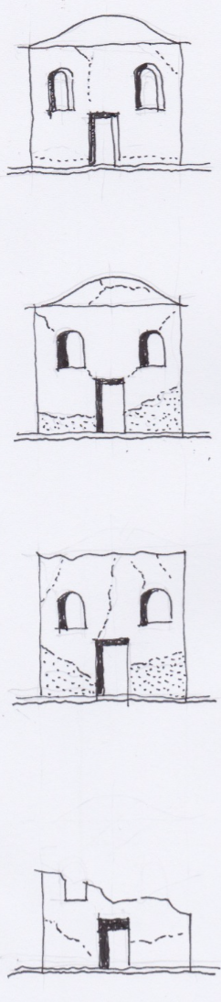

In this phase a more detailed Damage Assessment (Annex 1), estimating the degree of damage of the building elements and components, investigates :

1. Walls & Floor Structure (Reinforced concrete columns / beams / floor slabs, external walls, plaster and painting)
2. Internal Construction elements (wall and floor finishing, WC / shower, water and electrical installations)
3. Roof (Complete structure, gables, full roof cover, insulations, chimney & flashings)
4. Windows and doors (Door and window including frames, glazing & iron mongery)

A third Damage Assessment type has been designed to the second Inventorying level for a more systematic Damage Assessment approach to be taken into account for the Building Stability Analysis.

## Inventorying: 2nd level

Is a very detailed assessment of buildings - their elements and components – within HCs.

Basically it is a collection of information[19], to create a matrix where three inventory elements find the most likely rehabilitation proposal.

The inventory elements are:

* the urban landscape consistency and the building elements and components similarities,
* the building physical conditions (resulting from the Damage Assessment and the building vulnerability analysis),
* the socio-economic situation of the local resident.

### Urban Landscape Consistency

The urban landscape consistency analysis is carried out over eleven architectural dominant features

1. Height (Number of floors of the building),

2. Alignment (Alignment of the building with the built line of the street),

3. Volume (Composition of the building volume - protruding, intruding and structural superfetation).

4. Façade composition (Position, dimension, proportion and rhythm of openings (doors and windows) in the façade),

5. Roof design (Shape of the roof and presence of dormer windows),

6. Materials (Finishing material of the façade),

7. Window and doorframes (Material of the windows and door frame),

8. Colour (Colours of the façade and of doors and windows frame),

9. Decorative elements ((All the decorative elements of the facade: handrails, decorations, down take water pipes, etc.),

10. Non-structural superfetation (All the not structural elements and volumes, such as commercial signage, etc., added on the building street façade),

11. Technological superfetation (All the technological elements, such as air conditioning, etc, visible on the front street façade).

**Table 2: Architectural recurrent features**

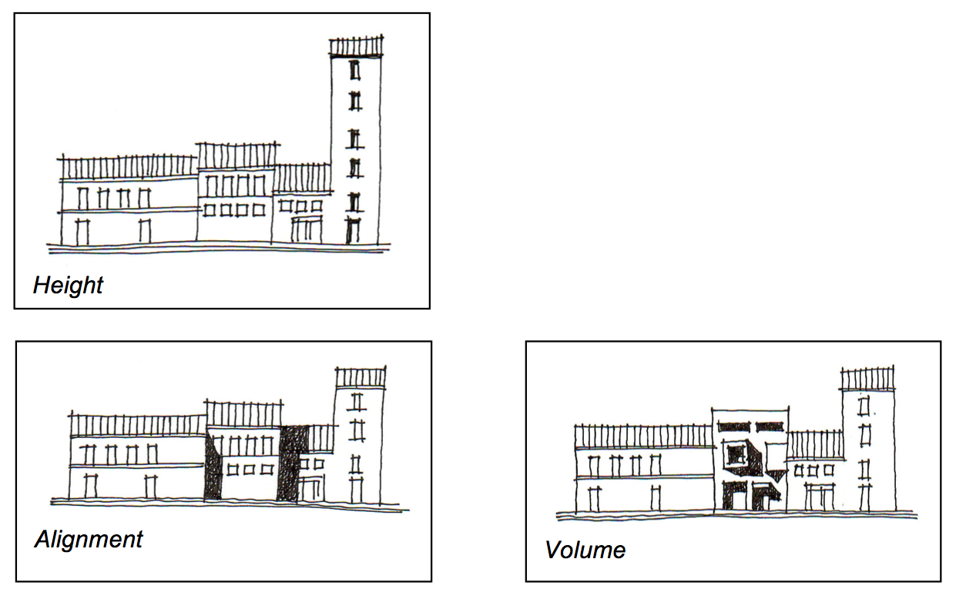

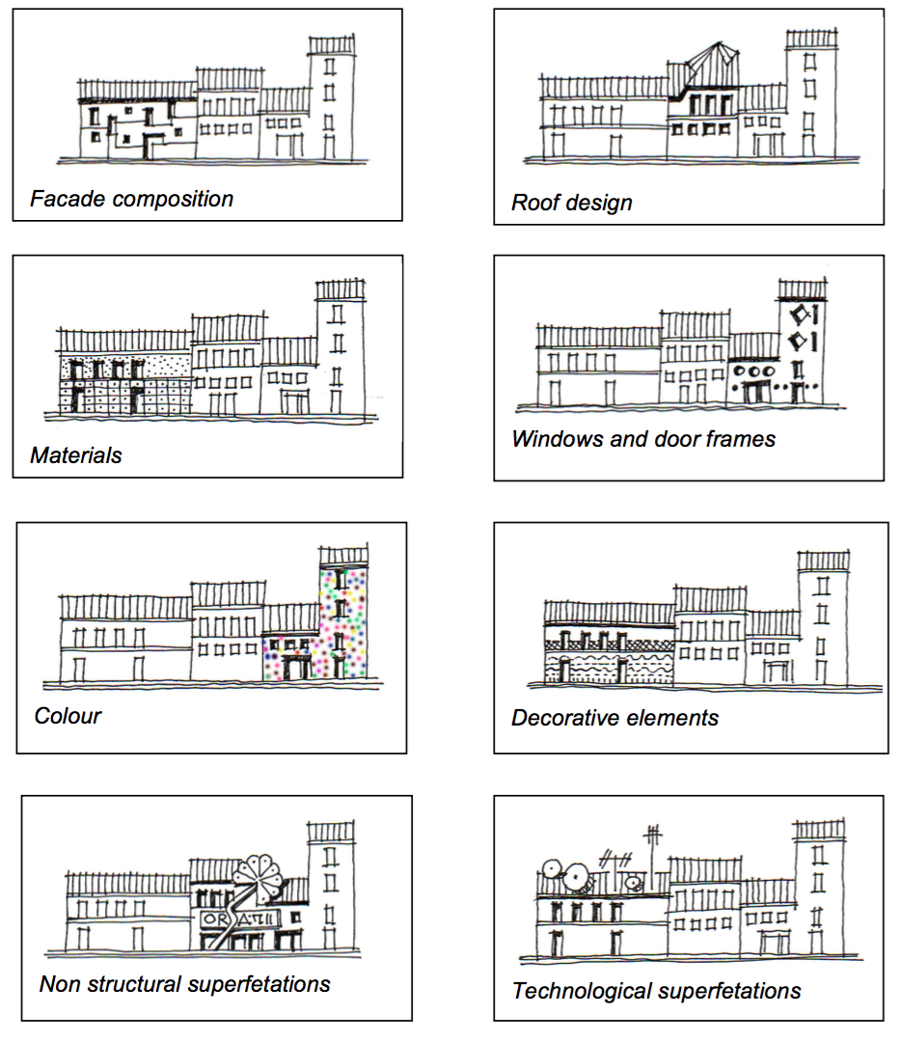

The Consistency Analysis is applied to historic and new buildings of a determined historic area.

It is based on the field-survey of the above mentioned eleven architectural features with urban relevance which are then evaluated according to four project design options: Replace, Integrate, Adjust and No Action. These options are merely indicative and not compulsory.

|  |  |  |
| --- | --- | --- |
| *1.* | *Replace* | for buildings that are not compatible with the overall urban landscape. Obviously, replacement does not necessary means full demolishing. However in case of demolition/reconstruction, it has to be done according to the prescribed guidelines. |
| *2.* | *Integrate* | for buildings which do not fit in the urban landscape but that can still be made compatible with that thanks to some kind of action, such as modifying the window size and pace, adding or changing the finishing of the façade, substantial changes of the details. |
| *3.* | *Adjust* | for buildings almost compatible with the urban landscape, where they only need small actions to fit in better (such as changing details, or changing the colour of the plaster.) |
| *4.* | *No Action* | for building perfectly fitting in the context, and no works needed. |
| *Note: Separate surveys are envisaged to be made for historic buildings and for new buildings* | | |

For instance, given four different colours to four different groups of architectural consistency feature, like in the Table here below, the four types of recommended Actions could be based on the following assumptions:

**Table 3: Classes of importance of architectural features consistency and Recommended Actions**

|  |  |  |  |
| --- | --- | --- | --- |
| *Class 1* | *Class 2* | *Class 3* | *Class 4* |
| Height | * Alignment[20] * Volume * Façade Composition * Roof Design | * Finishing Material * Windows and Door Frames * Colour * Decorative Elements | * Not Structural Sup * Technological Sup. |

|  |  |
| --- | --- |
| *Replace* | Never. |
| *Integrate* | If the material is not consistent  If the height is not consistent  If all the 4 orange evaluation elements are not consistent  If 3 of the 4 orange evaluation elements and at least 1 of the 4 yellow elements are not consistent  If 2 of the 4 orange evaluation elements and at least 2 of the 4 yellow elements are not consistent |
| *Adjust* | If 1 of the 4 orange evaluation elements are not consistent in combination or not with one (that is not material) or more of the 4 yellow elements are not consistent.  If 2 of the 4 orange evaluation elements and 1 (that is not material) of the 4 yellow elements are not consistent.  If any of the 4 yellow elements, except material, is not consistent.  If any of the 2 pink elements is not consistent. |
| *No Action* | If all the evaluation elements are consistent |

### Building elements and components similarities

The urban landscape consistency analysis has however a complementary aspect: the study of the most peculiar building elements and components, which are recurrent in the HCs though different according to the construction period and the related style. The Vernacular Architecture elements and components are usually collected, analysed and presented in the prescriptive guidelines as as models to be pursue.

The identification of these elements and components of a given built environment (rural or urban) is made through a photo survey of the most peculiar architectural volumes, façade lay-out, architectural components and elements such as doors and windows, roof and roof details, building materials, shop fronts and signs, like in the following example

**Table 4: Example of traditional and new door and window features[21]**

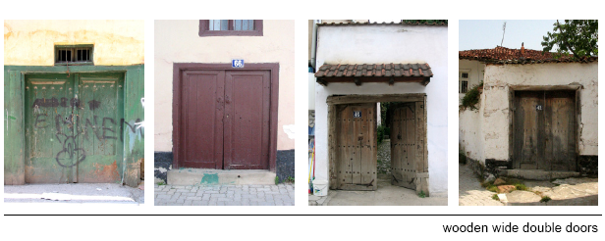

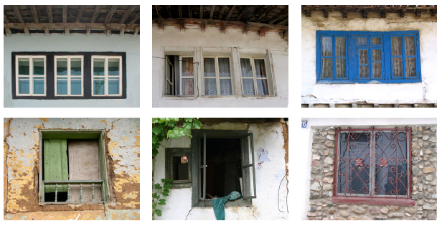

From the collection, classification and filing of the most peculiar architectural elements (whether original or modern) and their analysis an abacus of the most likely proposals could be set up. It presents the reference models to be taken into account in case of replacement, adjustment, integration or new construction within a historic built environment to preserve. The technical cards are then included within the Prescriptive Guidelines of the DUP Regulatory Framework.

**Table 5: Examples of technical card studying the local architectural features[22]**

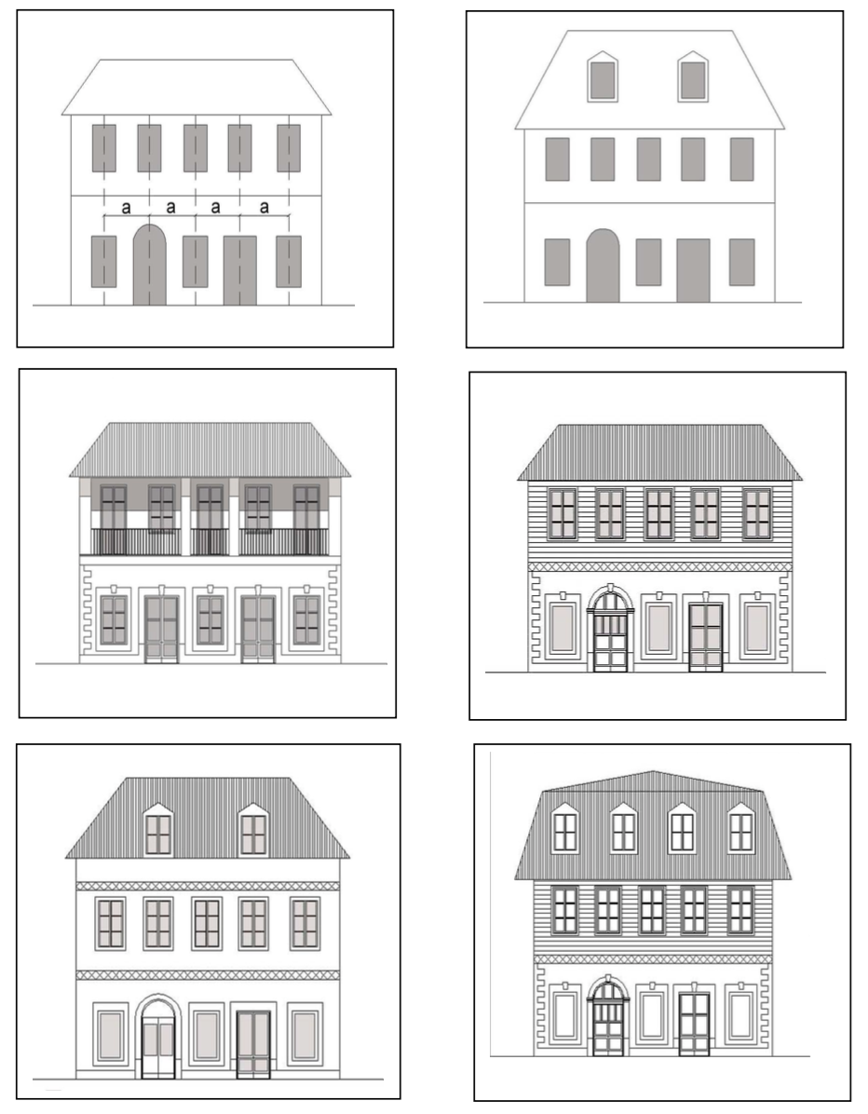

### Construction Stability Analysis

The Construction Stability Analysis is the combination of the Damage Assessment with the Analysis of the Building Vulnerability Degree.

The Damage Assessment defines the degree of lost of constructive features (see table below). The following building construction components are assessed:

* the External Load Bearing Walls,
* the Internal Bearing Walls,
* the Ground Floor,
* the First Floor,
* the Second Floor,
* the Roof Structure & Covering.

The type and the percentage of failure provide cost related information whilst the

* the percentage of damaged roof, and
* the percentage of structural damages to load bearing walls and floor beams or slabs

define three classes of damage: high, low and medium damage. The building construction is therefore highly damaged if its failure is higher than 65%, low damaged if its surveyed failure values are less than 35%, and medium damaged if the surveyed failures lies in between 35% and 65%.

Once identified the class of damage the assessed building belongs to, the vulnerability analysis can be finalised as shown in the Table n. 6.

The Vulnerability Assessment instead defines the degree of strength of a building.

Three levels of vulnerability have been taken into account: high, low and medium.

In order to assess the level of vulnerability the following variables have been assumed:

* the year of construction;
* the percentage of failure of floors;
* the percentage of failure of roof;
* the last rehabilitation, if any, in the last 25 years;
* the percentage of tile-lintel roof area;
* the coefficient C[23]

There is high vulnerability:

1. if the construction is older than 50 years, the % of floors failure is higher than 70% and the coefficient C is less than 0,4;
2. if the percentage of floors failure is higher than 50% and the coefficient C is less than 0,14;
3. if the construction is older than 50 years and the percentage of roof failure is higher than 70%;

There is low vulnerability:

1. if the coefficient C is higher than 0,14 and the building has been rehabilitated in the last 25 years;
2. if the coefficient C is higher than 0,14 and the percentage of tile-lintel roof area in higher than 90%;
3. if the coefficient C is higher than 0,14 and the roof is in good conditions (% of roof failure less than 20%);

The medium vulnerability occurs in the remaining cases.

The Building Construction Stability Analysis and the related the recommendations for rehabilitation project design derive from the link between the structural and constitutional weakness of the historic building (its vulnerability degree) and its level of Damage.

**Table 6: Building Construction Stability Analysis**



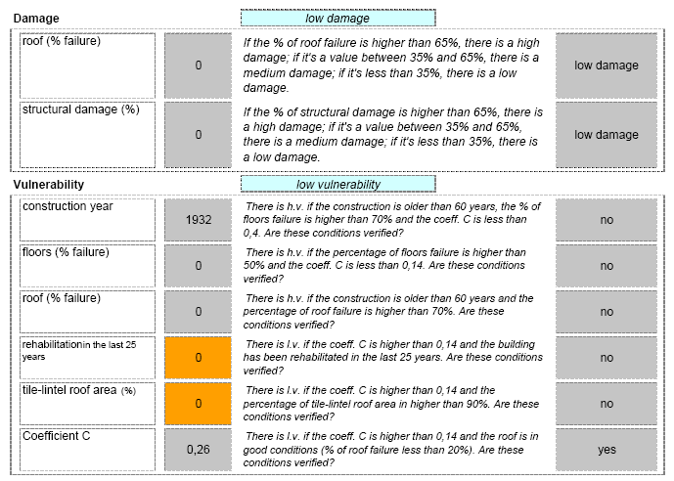

The combination of the level of damage and the level of vulnerability gives then the following suggestions:

**Table 7: Damage/Vulnerability Analysis results**

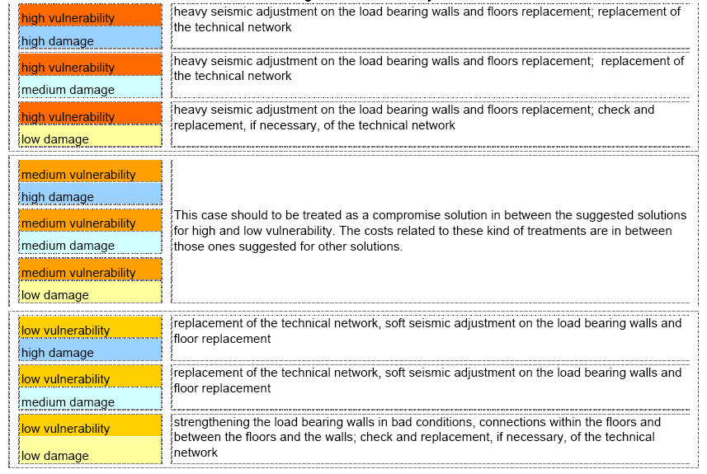

### Summary and Conclusions

Given the above-mentioned three types of assessments and analyses (affordability, historic value and construction stability – namely damage and vulnerability) a third degree equation could be set up[24]. It is solvable only whether correlations among the three variables are established. In that case a unique solution is identified for each single building and parcel. The lack of financial resources and the huge quantity of data and information necessary for setting up a rather comprehensive survey and preservation and development plan for a city centre make the equation the most suitable and practical solution.

In this regard an attempt has been made in order to have at least directions (in terms of actions to be implemented and costs) within the planning process.

The table below indicatively shows the relations that could be established between the results of the Consistency and Damage Analysis. A simple Excel application (Annex 2) has been used to get fast results from sequences of hypothetic relationships (some of them are rendered by the red arrows), which could be easily modified and appropriately adapted to the urban habitat at issue.

**Table 8: Correlation Consistency / Damage**

*Note: Only some of the relationships have been highlighted by the red arrows.*



|  |  |  |  |  |
| --- | --- | --- | --- | --- |
| *Analysis* | *Results* | | | |
| Consistency | No Action  (1) | Adjust  (2) | Integrate  (3) | Replace  (3) |
| Damage | < 20%  (1) | Low Damage  (2) | Medium Damage  (4) | High Damage  (4) |

Finally the overall analysis provides rough cost estimate and directions for Actions to be undertaken. Following that the socio-economic characteristics of the owner and his affordability is to be taken into account and the last correlation needs to be established. In other words once the type of restoration, refurbishment, renewal or rehabilitation is identified and the approximate cost is calculated the most appropriate technology and materials are to be detailed for each architectural components. The costs of the different alternative solutions need then to match with the housing investment affordable figures of each single family taking into consideration the grants and/or the credit strategies eventually available in the country.

Summarising the correlations that have been presented in this paper could be visualised in the following table.

**Table 9: Levels of Correlations**

|  |  |  |
| --- | --- | --- |
| *First* | *Second* | *Third* |
| Damage/Vulnerability Analysis | Damage/Consistency | Actions/Estimated costs |
| Consistency/Identity Analysis |
|  |  | *Building Technologies: Local material availability and manpower capacity* |
| Social/Economic (PRA) Analysis | Affordable Housing Investments/Grants and Credit Strategies | Affordable Actions |
| Family Financial Assessment |

1. Unesco, http://www.unesco.org/culture/ich/doc/src/01856-EN.pdf
2. The PIN (*Pre-inventaire normalisé*) notes succinct identification and location, information. The IF (*inventaire fondamental)* studies in depth.
3. More than 90% of the historic buildings were surveyed according to RIWAQ (<http://www.riwaqregister.org/en/eRdef.aspx?prt=3>).
4. <http://www.riwaq.org/2010/historical-building.php>
5. <http://www.riwaqregister.org/>
6. see Feilden, B. M., Jokilehto, J., Management Guidelines for World Cultural Heritage Sites, ICCROM, Rome, 1998. Chapter 9 Urban Planning and World Heritage Towns.
7. *The Importance of the Building: the researcher estimated the importance of the building on the basis of historical, architectural, religious and aesthetic criteria listed in the table*. Item 23 of the assessment card (<http://www.riwaqregister.org/en/eRdef.aspx?prt=14&fileId=Questionnaires%20Used.htm>)
8. The RHC inventorying exercise was applied to 40 HC cases, lasting 5 months, involving a number of qualified surveyors. It aimed at the accurate selection of clusters to test HC regeneration principles and methods.
9. The fieldwork activity of the first assessment level would deploy average two surveyors for one-hectare land in a working day.
10. The GIS is already available on open source platform.
11. It is highly possible that Israeli and British Research Centres have carried out these studies already.
12. Such a study is particularly needed because new and modern materials and technologies, if appropriately used, could contribute to reduce substantially the building rehabilitation costs and can also contribute to reuse the old housing facilities (like for instance the roof for the rain water harvesting and the building cisterns for rainwater storage) while cutting off the related risks like the rising dump.
13. From “*Management Guidelines*”Feilden, B. M., Jokilehto, J. “Management Guidelines for World Cultural Heritage Sites”, ICCROM, Rome, 1998. *Chapter pp.*
14. Preservation and Conservation might be considered synonymous. However Preservation might refer to the recurrent maintenance activity whilst conservation to the specific activity of keeping the building in the state it has been found disregarding the use.
15. The Conservation treatment aims at the object durability or structural integrity.
16. Restoration also includes *Anastylosis*.
17. To R. Jakobson (1956, 1978) similarity and contiguity (proximity), in other words metaphor and metonymy, reassume the essence of the language.
18. The following Notes are adapted from IMG (International Management Group): an EU Technical Task Force created during the Balkan War in order to carry out damage assessment and propose technical solutions and related cost estimate for the reconstruction phase.
19. It is set in a .XLS format to produce a preliminary analysis and rehabilitation proposal linking the collated elements.
20. In the case of the Throne Villages, small rural villages or HC areas where buildings are scattered and not aligned, such a consistency element is ignored.
21. From the Prizren Pilot Preservation and Development Plan, Cultural Heritage without Border and the post university course “Habitat, Technology and Development” – Polytechnic of Torino (Italy), Kosovo, August 2005.
22. From the Kolasin Master Plan, Montenegro 2003.
23. The Coefficient C is assumed to be the ratio of the shearing strength to the shearing stress (Ciavattini, M. 1993).
24. A forth type of assessment related to the alternative solutions of technologies and materials (to be matched by the owner’s family affordability) has not been developed in this article though it is taken into consideration within all the planning exercises this article makes reference to.