BTC – Historic Centre Regeneration in the West Bank

BUILDING CONSTRUCTION ASSESSMENT for INVENTORYING PURPOSE

*DATA Entry Instruction and Explanations*

*Corrado Minervini*

**SURVEY and ASSESSMENT CARDS - Data Entry Instructions**

Table of Contents

**1** **PRELIMINARY DATA – Survey card 5**

1.1 General Information 5

*1.1.1* *Building Code 5*

*1.1.2* *Class of Importance Code 6*

*1.1.3* *Filled in by 6*

*1.1.4* *Date 6*

1.2 Location 6

*1.2.1* *Municipality 6*

*1.2.2* *Town/Village 6*

*1.2.3* *Parcel Number 6*

1.3 Building Main Features 7

*1.3.1* *Building Construction Type 7*

*1.3.2* *Number of inhabitants 8*

*1.3.3* *Property Type 8*

*1.3.4* *Present Use 8*

1.4 Treatment Chronology 9

*1.4.1* *Construction 9*

*1.4.2* *Reconstruction/Restoration 9*

1.5 Physical features 9

*1.5.1* *Parcel area 9*

*1.5.2* *Additional building on the parcel 9*

*1.5.3* *Number of floors 9*

*1.5.4* *Average floors height (h) [m] 10*

*1.5.5* *Average covered area (At) [sqm] 10*

*1.5.6* *Area of resistant elements (Ax, Ay) [sqm] 10*

1.6 Value attributes 11

*1.6.1* *Cultural values 11*

**2** **consistency analysis – Survey card 13**

2.1 Analysis of the architectural elements 13

*2.1.1* *Height 13*

*2.1.2* *Alignment 13*

*2.1.3* *Volume 13*

*2.1.4* *Façade composition 13*

*2.1.5* *Roof design 13*

*2.1.6* *Materials 13*

*2.1.7* *Windows and doors frames 13*

*2.1.8* *Colour 14*

*2.1.9* *Decorative elements 14*

*2.1.10* *Not structural superfetation 14*

*2.1.11* *Technological superfetation 14*

2.2 Recommendations relating to consistency with the historic context 14

*2.2.1* *Recommendations for historic buildings: 15*

*2.2.2* *Recommendations for new buildings: 15*

**3** **damage Analysis – Survey card 16**

**4** **calculation of the coefficient “c” – Survey card 18**

**5** **damage and vulnerability assessment – Survey card 19**

5.1 Damage assessment 19

5.2 Vulnerability assessment 19

**Basic Introduction**

In the following pages there are instructions and explanations on data to be entered on a data collection form drafted on EXCEL sheets.

One EXCEL file is to be filled per each single building unit in the concerned Historic Centre. Each EXCEL file is made of eight data sheets:

* The first (preliminary data) collects all information on location, use, physical and historic features,
* The second and the third reports on the consistency analysis of the old and new buildings, namely their consistency vis-à-vis their historic context,
* The forth and the fifth assess the damage and vulnerability of the historic buildings, namely their actual physical strength vis-à-vis their constitutional strength,
* The sixth draw sconclusion about the building construction stability.

Once the first six data sheets are filled, the *Summary* and the last data sheet (for *GIS data transfer*) are automatically completed. Finally the last EXCEL data sheet has to be copied and pasted into a new EXCEL file collating information from all the Historic Centre buildings, and buffering the building data and GIS shape files.

As a matter of facts such a data collection form is a software application on EXCEL platform and therefore very transparent (formulas are visible and data processing is understandable). On the other hand there is a high risk that data are wrongly entered. Consequently cells with formulas could be deleted thus jeopardising the building assessment final results.

In this regard it is strongly recommended to **fill only the** **ORANGE cells.**

From a data collection exercise made in September 2015 the following notes have been drafted.

*Consistency*

1. The consistency analysis is applicable to both old and new buildings. The consistency analysis for new buildings has to be reported on the third spread sheet.
2. The consistency analysis is applicable only to external and visible part of the concerned building unit.
3. In case of two adjacent old and new buildings, both belonging to the same building unit, the consistent analysis is applicable to the whole façade made of the old and new one.

*Areas of Resistance*

1. The area of resistance has not to be calculated for new buildings for which the construction stability is not assessed.
2. In case of a two storey high building the areas of resistance are calculated only for the weakest floor, namely the floor with the highest number and largest openings.
3. In case a smaller opening stands on the top of a larger one the smaller opening is not taken into account.

# PRELIMINARY DATA – Survey card

The collection of Preliminary Data aims at the assessment of the main features of the building object concerned.

* General Information
* Location
* Building Main Features
* Treatment Chronology
* Physical Features
* Value Attributes
* Existing Documentation

## General Information

### Building Code

The Building Code is to be inserted into the proper ORANGE cell according to the code previously attributed to the building units by Municipal Technical Officers on CAD or GIS platform.

The building units are identified according to the ownership, common entrance, building type and traditional functions.

Annexes and Service Buildings are NOT to be included in this survey though they are reported in the survey basic map. The Annex buildings are those built at a later stage (usually with different building construction technology) and integrated as premises in the main building unit. The Service Buildings are those

The MTOs will be responsible for drafting a basic map in order to identify the building units prior to the survey and digitize closed polygons for the following layers:

* Building units (a letter – A for the residential building units - followed by four digit sequential number, for instance A0001, A0002, A0003, etc..
* annex and service buildings (A0001a, if annex ,or A0001s, if service building)
* public spaces: roads (R), alley (AL) and plaza (PL),
* private or semi-public open spaces (courtyards, gardens and back-house): A0001o, A0002o, A0001,2o (in case the courtyard is co-owned by A0001 and A0002),

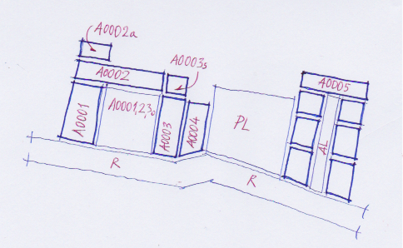

### Class of Importance Code

A code is attributed historic buildings according to their class of importance. This is decided at the central government level vis-à-vis the building object significance whether national, regional or municipal.

*Class of Importance*

|  |  |
| --- | --- |
| ***Importance*** | ***Code*** |
| **Nat**ional | **Nat** |
| **Loc**al | **Loc** |

### Filled in by

Each person who fills in the database should have a code or simply write his/her surname followed by the initial letter of the name and in the proper highlighted cell.

### Date

To be entered as DD MM YY. For instance 19 of February 2015 is to be entered as follows: 18 02 15.

## Location

### Municipality

Full name.

### Town/Village

Full name.

### Parcel Number

The parcel number is to be taken from the Cadastral Map if existing.

Alternatively the building could be identified by dividing the HC into Neighbourhoods and subdividing these into Blocks. Finally the building is qualified by

* a sequent number for the buildings belonging to a block,
* a sequent number for the blocks belonging to a neighbourhoods,
* one letter defining each neighbourhood.



However if the building units were already given an identification number within the basic map as prepared by the Municipal Technical Officers (see § 1.1.1.) a new identification code would not be needed.

## Building Main Features

### Building Construction Type

The Building Construction Types are classified according to the construction technology used, the overall external feature and the period of time they were built.

Six Building Construction Types have been identified:

|  |  |  |
| --- | --- | --- |
|  | *Building Construction Type* | *Explications* |
| 1. | Simple Vernacular Architecture | Building Construction made of one or two vaulted rooms made of masonry walls and built at the same time. |
| 2. | Composite Vernacular Architecture | Complex, organic and articulated house made of several rooms and sometimes with a courtyard. Built in one specific period of time. |
| 3. | Compound | Set of adjacent and pretty simple building constructions – usually made of one room only – built in different stages, using different technologies and services by an alley (cul-de-sac) |
| 4. | Liwan (1) | Family house with more than one room and entrances leading to a hall (Liwan), on both sides of a hall are the living rooms. The hall is as deep as the whole building and shows two and occasionally three cross vaults. |
| 5. | Special Building | Religious, administrative and social buildings with special features, used by the general public (mosque, khan, diwan, olive oil mill, public oven).  Urban service building like buildings used as info or meteo points or transformer substations. |
| 6. | New Building Construction | Built in modern times with modern technologies – mostly reinforced concrete. |

(1) Hadid M., *Architectural Styles Survey in Palestinian Territories*, August 2002

### Number of inhabitants

Enter the total number of inhabitants in the residential building units. Unless the residents themselves reply to this question, usually the exact number is difficult to know but the number of families to be multiplied by the average family members in the municipality.

### Property Type

The type of property is to be entered. Four types of property are included in the drop down menu: private, public, religious and uncertain (when the property is not known).

*Type of Property*

|  |  |
| --- | --- |
| ***Type of Property*** | ***Code*** |
| **Pu**blic **P**roperty | **PUP** |
| **Pr**ivate **P**roperty | **PRP** |
| **W**a**q**f **P**roperty | **WQP** |
| **Un**certain **P**roperty | **UNP** |

### Present Use

The present use of each building floor is assessed asking the users, the Municipal Technical Officer or the neighbours. The options are reported below.

|  |  |  |
| --- | --- | --- |
|  | *Building (floor) Use* | *Explications* |
| 1. | Not in Use | Newly constructed and not used yet or abandoned |
| 2. | Residential | Currently in use for residential purposes |
| 3. | Productive | Currently in use for productive purposes (commercial, office/bureaux, crafting, tourism, ) |
| 4. | Social | Location where social activities are developed like associations, diwan, community centres. |
| 5. | Special | Religious and administrative buildings, health facilities etc. |
| 6. | Other | Urban service building like buildings used as info or meteo points or transformer substations. |

|  |  |
| --- | --- |
| ***Building Use*** | ***Code*** |
| **N**ot in **U**se | **NU** |
| **R**esidential | **RU** |
| **P**roductive | **PU** |
| **S**ocial | **SU** |
| **Sp**ecial | **SPU** |
| **Ot**her | **OTAct** |

## Treatment Chronology

### Construction

The code to be entered coincides with the year in which the building was constructed. In case it is not available, enter the decade the building was approximately built, making reference to the following historic periods:

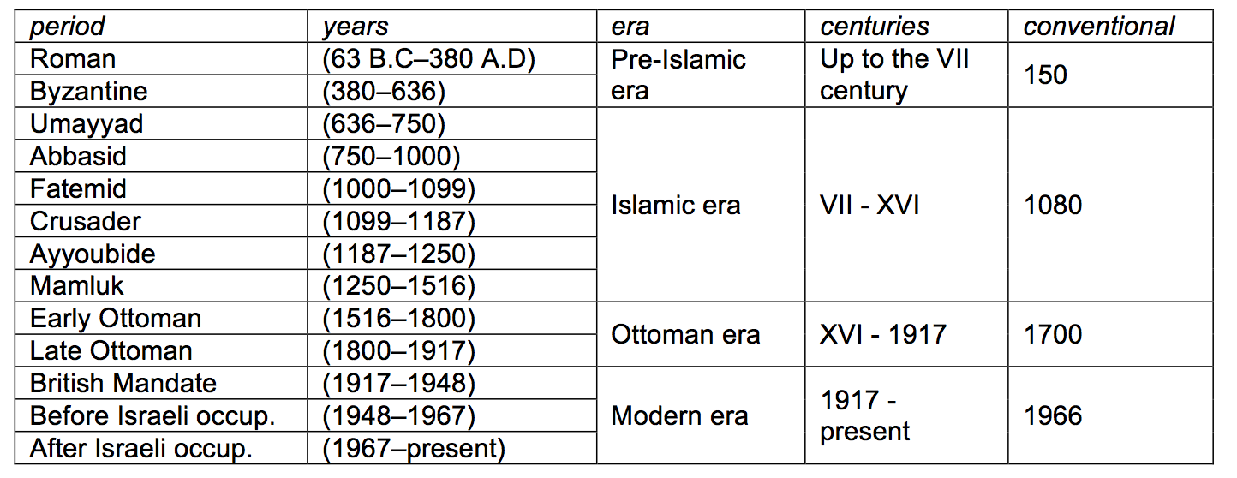

### Reconstruction/Restoration

The year the building was reconstructed and / or restored is to be entered.

## Physical features

In this table there are the values about the physical features of the building concerned:

Parcel area, presence of additional buildings on the parcel, number of floors, average covered area, average height and area of resistant elements.

### Parcel area

The area of the parcel is to be entered in sqm.

### Additional building on the parcel

The presence of additional buildings on the parcel is to be surveyed. The number and description of additional buildings is to be entered.

### Number of floors

The number of floors of the building is to be entered. In case of visible height of the roof floor and/or presence of dormer windows, the roof floor is considered as a floor.

### Average floors height (h) [m]

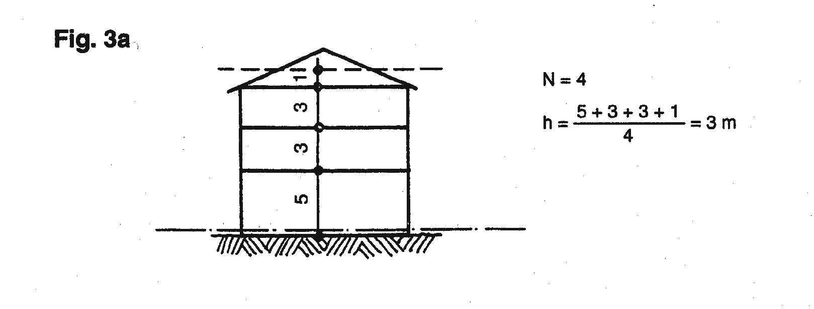

*Note: the dashed line shows the reference height.*

### Average covered area (At) [sqm]

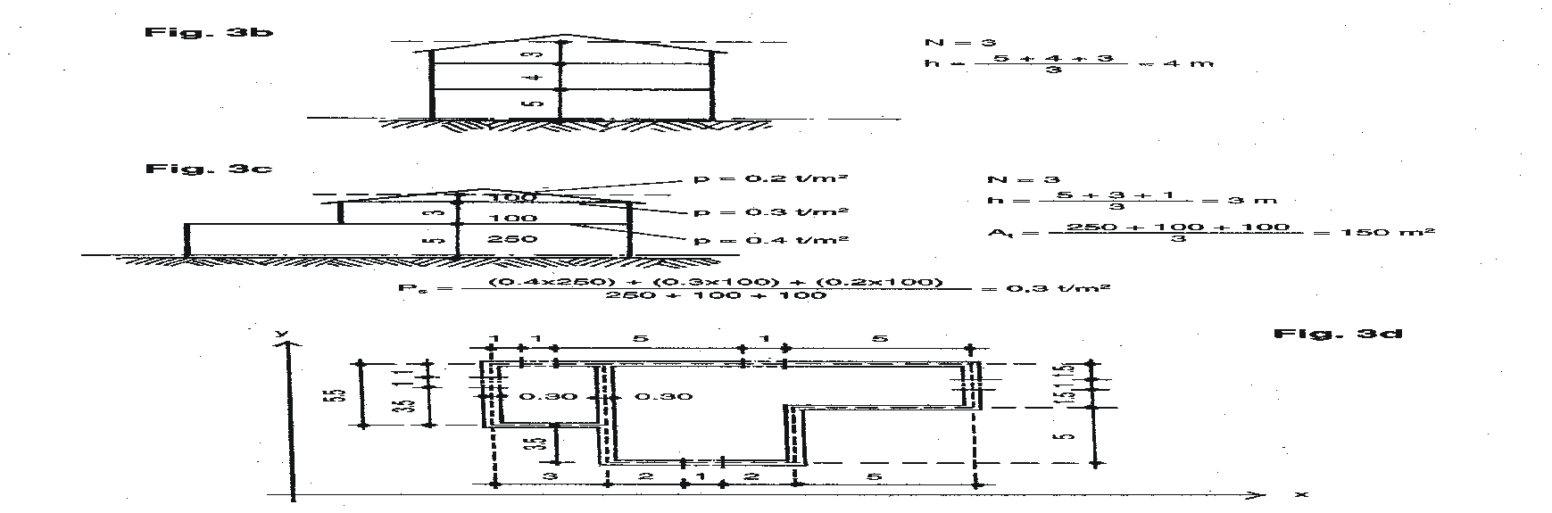

*Note: the dashed line shows the reference height.*

### Area of resistant elements (Ax, Ay) [sqm]

Total area (in horizontal view) in direction x or y of the resistant elements **[*sqm*]**

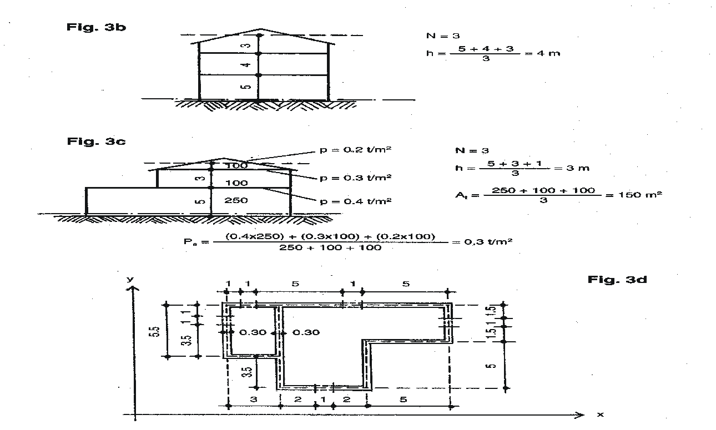

**Ax** = [(1 + 5 + 5) + 5 + 3 + (2 + 2)] x 0.30 = 6.9 [sqm]

**Ay** = [5.5 + (7 + 1) + 5 + (1.5 + 1.5)] x 0.30 = 6.45 [sqm]

*Note: in this case just full elements have to be considered. Cut off from the calculation window and doors.*

## Value attributes

The values attributed to the building are the following: cultural values, social values and economic values.

### Cultural values

Cultural values are divided in:

*Identity value* is based on recognition.

*Relative artistic & technical value* is based on research.

*Rarity value* is based on statistics.

Each value is entered by a code and it is described in the comment column. The related treatments are linked to it.

*Historic Values & Suggested Treatment*

|  |  |  |  |
| --- | --- | --- | --- |
| ***Cultural values*** | ***Code*** | ***Comments*** | ***Suggestions on Treatments*** |
| **Ide**ntity | **IDE** | The identity value is expressed by the symbolic attributes to the overall architecture | Preserve the overall building image |
| **Art**istic | **ART** | The artistic value is expressed by its decorations, details and the irreproducible workmanship | Preserve and restore every single decoration and valuable existing details |
| **Tec**hnical | **TEC** | The technical value consists of the appropriate technological solutions | Preserve and restore the existing |
| **Rar**ity | **RAR** | The rarity value consists of the uniqueness of the historic building | Restoration > Anastylosis |

|  |  |  |  |
| --- | --- | --- | --- |
| ***Social values*** | ***Code*** | ***Comments*** | ***Suggestions on Treatments*** |
| **Com**munity | **COM** | The community value is rendered by the social activities performed within the historic building | Restoration and Reconstruction |
| **Edu**cational | **EDU** | The educational value consists of the potential educative information the historic building might bring out | Restoration |
| **Pol**itical | **POL** |  | Preservation (Restoration might induce a risk of interpretation) |

|  |  |  |  |
| --- | --- | --- | --- |
| ***Economic values*** | ***Code*** | ***Comments*** | ***Suggestions on Treatments*** |
| **Fun**ctional | **FUN** | The functional value consists of peculiar functions to be preserved | Restoration |
| **Eco**nomic | **ECO** | The economic value is to be found within the potential economic effectiveness of the building | Reconstruction |

*Physical Treatment Approaches*

|  |  |
| --- | --- |
|  | ***Definitions of treatment approaches[1]*** |
| Protection | Physical protection includes the addition of roofs, shelters, coverings, etc., or even removing an endangered object to safety. |
| Preservation[2] | Preservation measures include regular inspections and cyclical and routine maintenance. |
| Conservation[3] | The general concept of conservation implies various types of treatments aimed at safeguarding buildings, sites or historic towns; these include maintenance, repair, consolidation, and reinforcement. |
| Consolidation | Consolidation is the physical addition or application of adhesive or supportive materials to the actual fabric of the cultural property in order to ensure its continued durability or structural integrity. |
| Restoration[4] | Restoration is a highly specialized operation based on a critical-historical process of evaluation, and must not be based on conjecture. |
| Reconstruction | Reconstruction means building anew. (…) Although reconstruction may prove to be an appropriate strategy following disasters such as fire, earthquake or war, its validity is more questionable when it is used as a measure to improve the presentation of heritage sites. |
| Anastylosis | Anastylosis aims to make the spatial character of a ruined structure visually more comprehensive by reinstating its lost original form, using the original material that is both in suitable conditions and is located at the site. |

# consistency analysis – Survey card

This analysis is done taking into consideration the architectural elements of the building and its consistency with the historic context. The consistency analysis is based on 11 architectural elements and components:

## Analysis of the architectural elements

### Height

Number of floors of the building. In case of visible height of the roof floor and/or presence of dormer windows the roof floor is considered as a floor.

*Instruction for the survey*: check if the number of floors is in accordance with the DUP norm (the allowed height are GF+1 or GF+2 in the flat area, GF+1, GF+2 or GF+3 for the hill).  Check the presence and height of the roof floor; if the roof floor has a visible height and/or has dormer windows count it as a floor, if it has just skylights do not count it has a floor. The evaluation is defined as “ok” if the number of floors is in accordance with the limits defined in the DUP.

### Alignment

Alignment of the building with the built line of the street.

*Instruction for the survey*: check the alignment of the building front compared to the built line of the context (street or square). The evaluation is defined as "ok" if the building is aligned with the built line of the street.

### Volume

Composition of the building volume (protruding, intruding and structural superfetation).

*Instruction for the survey*: check the composition of the building volume (protruding, intruding and structural superfetation). The evaluation is "ok" if the volume of the building is not in contrast with the traditional context.

### Façade composition

Position, dimension, proportion and rhythm of openings (doors and windows) in the facade.

*Instruction for the survey*: check the façade layout (vertical and horizontal symmetric axes), the position, dimension, proportion and rhythm of the openings. The evaluation is "ok" if the facade composition is not in contrast with the traditional context.

### Roof design

Shape of the roof and presence of dormer windows.

*Instruction for the survey*: check number and shape of the pitches. Check the presence of dormer windows. The evaluation is "ok" if the roof design respects the traditional one.

### Materials

Finishing material of the façade.

*Instruction for the survey*: check the finishing material of the facade. The evaluation is "ok" if the finishing materials are not in contrast with the traditional one (natural stones, mud bricks, plaster).

### Windows and doors frames

Material of the windows and door frame.

*Instruction for the survey*: check the windows and doors frame materials. The evaluation is “ok” if the material of doors and windows frame is as the traditional one or not in contrast with it.

### Colour

Colours of the façade and of doors and windows frame.

*Instruction for the survey*: check if the colour of the facade is as the traditional ones. The evaluation is “ok” if the colour of the façade is one of the assumed consistent colours for the historic centre among the most common and widespread ones.

### Decorative elements

All the decorative elements of the facade: handrails, decorations, down take water pipes, etc.

*Instruction for the survey*: check if the decorative elements are in contrast with the historic context. The evaluation is “ok” if the decorative elements are not in contrast with the traditional ones.

### Not structural superfetation

All the not structural elements and volumes, such as commercial signage, etc., added on the building street facade.

*Instruction for the survey*: check the presence of not structural superfetation on the street facade of the building. The evaluation is “ok” if there are not additions visible on the facade.

### Technological superfetation

All the technological elements, such as air conditioning, etc, visible on the front street facade.

*Instruction for the survey*: check the presence of technological superfetation on the street facade of the building. The evaluation is “ok” if there are no technological additions or additions visible on the facade.

## Recommendations relating to consistency with the historic context

Each architectural element has a different class of importance evidenced by the assigned colour.

|  |  |  |  |  |  |  |  |  |  |  |
| --- | --- | --- | --- | --- | --- | --- | --- | --- | --- | --- |
| Height | Alignment | Volume | Façade Composition | Roof  Design | Finishing Materials | Windows and  Doors Frames | Colour | Decorative  Elements | Not Structural Additions. | Technological  Additions. |

There are four types of recommended design: Replace, Integrate, Adjust and No intervention:

**Replace**buildings that are not compatible at all in the urban landscape. Obviously replace does not mean to demolish, but in case of reconstruction of such buildings it has to be done according to the guidelines.

**Integrate**buildings which do not fit in the urban landscape but that can still be made compatible with some intervention, such as adding or changing the finishing of the façade, great changes in the details....

**Adjust**buildings almost compatible with the urban landscape, only need small interventions to fit better (such as changing details, or changing the colour of the plaster...)

**No intervention**

building perfectly fitting in the context, no works needed.

The analysis is divided into two sections: recommended projects for historic and new buildings.

### Recommendations for historic buildings:

**Replace**Never

**Integrate**

If the material is not consistent

If the height is not consistent

If all the 4 orange evaluation elements are not consistent

If 3 of the 4 orange evaluation elements and at least 1 of the 4 yellow elements are not consistent

If 2 of the 4 orange evaluation elements and at least 2 of the 4 yellow elements are not consistent

**Adjust**

If 1 of the 4 orange evaluation elements are not consistent in combination or not with one (that is not material) or more of the 4 yellow elements are not consistent.

If 2 of the 4 orange evaluation elements and 1 (that is not material) of the 4 yellow elements are not consistent.

If any of the 4 yellow elements, except material, is not consistent.

If any of the 2 rose elements is not consistent.

**No intervention**

If all the evaluation elements are consistent

### Recommendations for new buildings:

**Replace**If the height is not consistent

If all the 4 orange evaluation elements are not consistent

If 3 of the 4 orange evaluation elements and all the 4 yellow elements are not consistent

**Integrate**

If the material is not consistent

If 3 of the 4 orange evaluation elements and at least 1 of the 4 yellow elements are not consistent

If 2 of the 4 orange evaluation elements and at least 3 of the 4 yellow elements are not consistent

**Adjust**

If 1 of the 4 orange evaluation elements are not consistent in combination or not with one (that is not material) or more of the 4 yellow elements are not consistent.

If 2 of the 4 orange evaluation elements and 1 (that is not material) of the 4 yellow elements are not consistent.

If any of the 4 yellow elements, except material, is not consistent.

If any of the 2 rose elements is not consistent.

**No intervention**

If all the evaluation elements are consistent

# damage Analysis – Survey card

In this spread sheet building construction materials, construction techniques, type of failures and causes of failure are described.

Each building structure includes the damage of its components.

The codes are to be entered only in the following fields:

* Construction materials
* Construction techniques
* Type of failure
* Causes of failure
* Percentage of failure

*Construction Materials*

|  |  |
| --- | --- |
| ***Materials*** | ***Code*** |
| **Bearing walls (int. & ext.)** |  |
| **W**oo**d** | **WWD** |
| **Ea**rth | **WEA** |
| **Br**ick | **WBR** |
| **St**one | **WST** |
|  |  |
| **Floorings** |  |
| **Ea**rth | **FEA** |
| **T**i**l**e | **FTL** |
| **W**oo**d** | **FWD** |
|  |  |
| **Roof structures & covering** |  |
| **W**ood & **T**ile | **RWT** |
| **C**oncrete & **T**ile | **RCT** |
|  |  |
| **Ot**her (in the note write the description) | **OTMAT** |

*Tab. 9. Type of Failure*

|  |  |
| --- | --- |
| ***Type of Failure*** | ***Code*** |
| **Structural Damage** |  |
| **S**ettling (ground failure) | **SS** |
| **C**rack | **SC** |
| **D**eformation, strain | **SD** |
| **L**oss of elements/materials | **SL** |
| **B**reaking | **SB** |
|  |  |
| **Desegregation of materials** |  |
| **L**oss of cohesion | **DL** |
| **D**etaching of the surface layers | **DD** |
|  |  |
| **Humidity** |  |
| **W**ater percolation | **HW** |
| Humidity **S**eepage | **HS** |
| Salt **E**fflorescence | **HE** |
|  |  |
| **Biological** |  |
| **M**usk, lichens | **BM** |
| Macro-**F**lora | **BF** |
| **A**nimals/insects | **BA** |
|  |  |
| **Other** | **OTTYP** |

*Causes of Failure*

|  |  |
| --- | --- |
| ***Causes of Failure*** | ***Code*** |
| **N**atural (Decay) | **N** |
| **H**uman (war damage) | **H** |
| **S**tructural (built in or indirectly cause by e.g. superfetation) | **S** |

# calculation of the coefficient “c” – Survey card

“C” is the coefficient used to define the vulnerability degree.

It’s resulted by studies of the models for seismic analysis of buildings. It’s a proportion between the resistance to shearing stress and the shearing stress.

It’s calculated considering:

**(N)** the number of floors, **(At)** average covered area, **(Ax e Ay)** total area of the resistant elements towards two perpendicular directions, **(h)** average floors height, **(pm)** walls specific weight (2 t/mc), **(ps)** floor permanent load (= 0.2 t/mc for wooden or steel floor, =0.3 t/mc for steel floor, =0.4 t/mc for reinforced concrete floor), **(τk)** tangent resistance at the ground level (=3 t/mq for pebble stone wall, =7 t/mq squared stone wall or brick wall).

This is the formula for calculation the coefficient “C”:

C=a0* τk* (1+(q*N/1,5a0* τk *(1+γ)))1/2/qN

a0 = min value between Ax and Ay / At

γ = min value between Ax and Ay /max value between Ax and Ay

q = ps+(Ax+Ay)*h*pm/At

# damage and vulnerability assessment – Survey card

## Damage assessment

The damage assessment defines the degree of lost of constructive features. It is based on

1. percentage of damaged roof, and
2. percentage of structural damage to load bearing walls and floors.

Three classes of damage are defined: high, low and medium damage.

Both the categories of architectural structure (roof, and bearing walls + floors) are assumed to be

* highly damaged if their respective failure is higher than 65%,
* low damaged if their surveyed failure values are less than 35%,
* medium damaged if the failure has been surveyed in between 35% and 65%,

The comprehensive damage assessment is made on the basis of the following matrix where 3 has been attributed to high values, 2 to medium values, 1 to low values. Finally the orange cases (from 5 to 6) are assumed as highly damaged cases, the yellow ones (4) aium cases, the pink ones (from 2 to 3) as low damaged cases.s med

















## Vulnerability assessment

The vulnerability assessment defines the degree of stability of a building.

Three levels of vulnerability have been taken into account: high, low and medium.

In order to assess the level of vulnerability the following variables have been assumed:

* The year of construction;
* The percentage of failure of floors;
* The percentage of failure of roof;
* The last rehabilitation, if any, in the last 25 years;
* The percentage of tile-lintel roof area;
* The Coefficient ‘C’.

There is high vulnerability:

1. if the construction is older than 50 years, the % of floors failure is higher than 70% and the coefficient C is less than 0,4;
2. if the percentage of floors failure is higher than 50% and the coefficient C is less than 0,14;
3. if the construction is older than 50 years and the percentage of roof failure is higher than 70%;

There is low vulnerability:

1. if the coefficient C is higher than 0,14 and the building has been rehabilitated in the last 25 years;
2. if the coefficient C is higher than 0,14 and the percentage of tile-lintel roof area in higher than 90%;
3. if the coefficient C is higher than 0,14 and the roof is in good conditions (% of roof failure less than 20%);

The medium vulnerability there is in the case of elimination of the two last cases.

The combination of the level of damage and the level of vulnerability gives the following suggestions:

|  |  |  |
| --- | --- | --- |
| high vulnerability |  | heavy seismic hazard adjustment on the load bearing walls and floors replacement; replacement of the technological network |
| high damage |
|  | | |
| high vulnerability |  | heavy seismic hazard adjustment on the load bearing walls and floors replacement; replacement of the technological network |
| medium damage |
|  | | |
| high vulnerability |  | heavy seismic hazard adjustment on the load bearing walls and floors replacement; check and replacement, if necessary, of the technological network |
| low damage |

|  |  |  |
| --- | --- | --- |
| medium vulnerability |  | This case should to be treated as a compromise solution in between the suggested solutions for high and low vulnerability. The costs related to these kind of treatments are in between those ones suggested for other solutions. |
| high damage |
|  |
| medium vulnerability |
| medium damage |
|  |
| medium vulnerability |
| low damage |

|  |  |  |
| --- | --- | --- |
| low vulnerability |  | replacement of the technological network, soft seismic hazard adjustment on the load bearing walls and floor replacement |
| high damage |
|  | | |
| low vulnerability |  | replacement of the technological network, soft seismic hazard adjustment on the load bearing walls and floor replacement |
| medium damage |
|  | | |
| low vulnerability |  | strengthening the load bearing walls in bad conditions, connections within the floors and between the floors and the walls; check and replacement, if necessary, of the technological network |
| low damage |

1. Refer to: Feilden, B. M., Jokilehto, J. , “Management Guidelines for World Cultural Heritage Sites”, ICCROM, Rome 1998.
2. Preservation and Conservation might be considered synonymous. However Preservation might refer to the recurrent maintenance activity whilst conservation to the specific activity of keeping the building in the state it has been found disregarding the use.
3. The Conservation treatment aims at the object durability or structural integrity.
4. Restoration might also include *Anastylosis*.