**Birzeit University**

**Mechanical & Mechatronics Engineering Department**

**Heat Transfer ENME 431-1**

**Quiz # 1 Form A**

**Instructor: Dr. Afif Akel Hasan 1st. semester 2020/2021**

**Question (50 point)**

Consider the plate of cooking grill that has a thickness of **L**, base area of **A=0.6*1.2 m2**, and thermal conductivity of **k**. The lower surface of the plate is subjected to uniform heat flux q"o generated by the resistance heaters, and the outer surface loses heat to the air at Tair =**Tœ** by convection with coefficient **h**. Grill in a room whose walls are at Twall and steady state condition is maintained.

1. List all your assumptions.[5]
2. Simplify the heat diffusion equation to the specific case of the plate grill.[12]
3. Write the boundary conditions needed to solve the heat diffusion equation.[ 10]
4. If q"**o =** 4.0kW/m2, calculate convection losses from grill top surface to the air.[8]
5. For (d) above Calculate **h** if Ts=110 oC and Tair =20oC, give its units [7]
6. What is another possible mode of heat losses from the grill surface, give formula for such heat losses? [8]

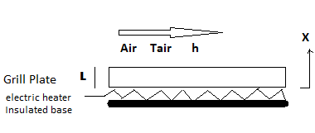

**Formulas**

 















