**Birzeit University- Mechanical & Mechatronics Engineering Department**

**Heat Transfer ENME 431-1**

**Quiz # 1 Form B**

**Instructor: Dr. Afif Akel Hasan 1st. semester 2020/2021**

**Question (50 points)**

A plane wall with constant properties is initially at a uniform temperature To. Suddenly, the surface at x=Lis exposed to a convection process with a fluid at T∞>To having a convection coefficient h. Also, suddenly the wall experiences a uniform internal volumetric heating that is sufficiently large to induce a temperature within the wall, which exceeds that of the fluid. The left face is insulated.

1. List assumptions to solve problem. [5]
2. Write the differential equation and identify boundary and initial conditions.[20]
3. On T- x coordinate sketch the temperature distribution for time zero, other two times after that [9]
4. On q" – t coordinate sketch the heat transfer flux at the locations x = 0 , and x= L.[6]
5. If heat generation is 1 kW/m3 inside the 0.2m thick wall, what is the convection heat loss from surface?[10]

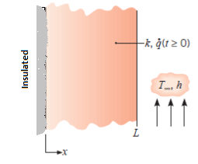

**Formulas**

 















