**Birzeit University**

**Mechanical & Mechatronics Engineering Department**

**Heat Transfer ENME 431-2**

**Quiz # 1**

**Instructor: Dr. Afif Akel Hasan 1st. semester 2020/2021**

**Question (50 points)**

Consider a long solid tube, insulated at the outer radius r2 and cooled at the inner radius r1, with uniform heat generation W/m3 within the solid, for steady state;

1. List all your assumptions.[5]
2. Simplify the heat diffusion equation to the specific case of the cylinder.[10]
3. Write the boundary conditions needed to solve the heat diffusion equation.[ 10]
4. If **=** 2.0kW/m3, calculate convection losses from inner surface per unit length.[10]
5. Calculate for above ( d) **h** if Ts=100 oC and T∞ =30oC [8]
6. Sketch temperature profile T(r), and heat flux within cylinder $\ddot{q}(r)$ [7]

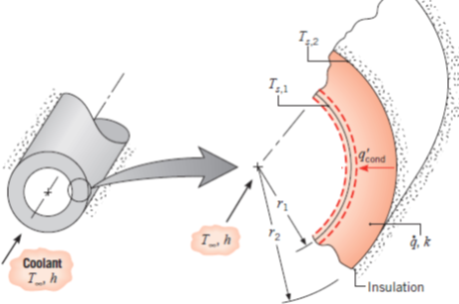

**Formulas**

 















