**Question 1:** Generate and plot the following signals using MATLAB

1. X_1 (t)= u(t-2)- u(t-9)

syms t

X1 = heaviside(t-2) - heaviside(t-9);

fplot (t,X1,[-2 11])

ylim([-1 2])

xlabel (' time-axis ');

title (' X(t) = u(t-2) - u(t-9) ');

1. A finite pulse (π(t)) with value = 8 and extintoin bet 6 and 14

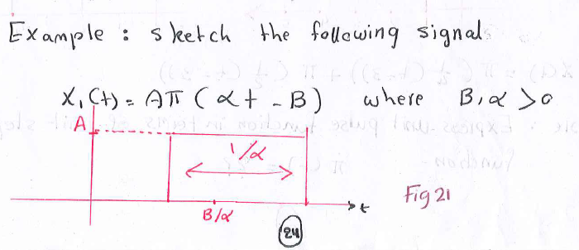

syms t

x = 8.*rectangularPulse(6,14,t);

fplot(t,x,[4 16])

ylim([0 10])

xlabel('time');

ylabel('X(t)');

title('X(t)=8.?(1/8(t-10))');

1. X_3 (t)= u(t-4) +r(t-4)-2r(t-7) +r(t-13) in the time interval [0 16]

syms t

X3 = heaviside(t-4)+(t-4).*heaviside(t-4)-2.*(t-7).* heaviside(t-7)+(t-13).*heaviside(t-13);

fplot(t,X3,[0 16])

xlabel('time-axis');

title('X(t)=u(t-4)+r(t-4)-2r(t-7) +r(t-13))');

**Question 2:**

* **Generate and plot the signals y1(t)= sin (4000πt), y2(t)= cos (450πt), and plot the signals m(t)= y1+y2 and n(t)= y1-y2**

The code:

syms t

y1=sin(300*pi*t); % frequency = w/(2pi) ---> sin(wt)

y2=cos(800*pi*t);

m = y1+y2;

n = y1-y2;

g = y1*y2;

subplot(3,2,1);

fplot(y1,[0,0.006]) % period = 1/freq --> 1/150

title ('Y1');

subplot(3,2,2);

fplot(y2,[0,1/400])

subplot(3,2,3);

fplot(m,[0,1/gcd(150, 400)])

subplot(3,2,4);

fplot(n,[0,1/gcd(150, 400)])

subplot(3,2,5);

fplot(g,[0,1/gcd(550,250)]) % refers to photo

suptitle(‘graphs’)

**Question 4:** Write the programs that determine the response of the linear time invariant system to the given input and the given initial conditions

a) dy(t)/dt+ 7y(t) = 10u(t) , y(0) = -3;

syms y(t) t

fun = diff(y,t) + 7*y == 10*heaviside(t);

cond1 = y(0) == -3;

sol = dsolve(fun,cond1)

b) (d^2 y(t))/(dt^2 )+3 dy/dt + 2y(t)= 5cos(1500t) , ( y (0) =1, y’ (0) =2 );

syms y(t) t

dy = diff(y,t);

fun = diff(y,t,2)+3*diff(y,t,1)+ 2*y == 5.*cos(1500*t);

con1 = y(0) == 1;

con2 = dy(0) == 2;

conds = [con1 con2];

sol = dsolve(fun,conds);

simple_sol = simplify(sol)

**Question 5:**

Use Simulink (MATLAB) to simulate the following systems then show and plot the step response of the system.

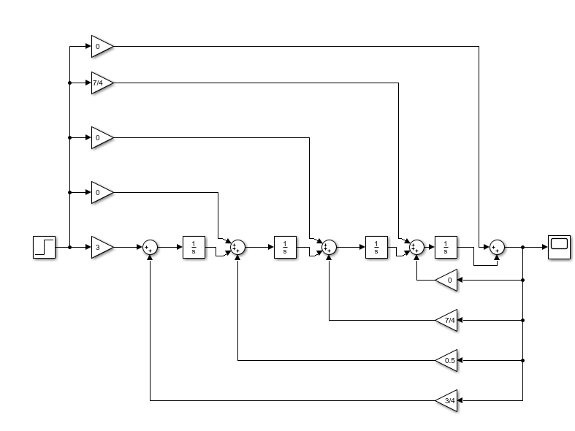

**Question 6:** Write a program that computes and plots the convolution of the functions

y (t) = (10e-0.5t) ᴨ((t-7)/4), y(t) = (10e-0.5t) ᴨ((t-12)/8)

syms t tao

y1 = 10.* exp(-0.5*tao).*rectangularPulse(5,9,tao);

y2 = 10.* exp(-0.5*(t-tao)).*rectangularPulse(8,16,t-tao);

conv_ans = int(y1*y2,tao,-inf,inf);????

fplot(conv_ans,[0 30])